WILD FURY, ROSENTHAL FILMS and ROAR FILM present
in association with ZDF and ARTE, SCREEN TASMANIA,
MELBOURNE INTERNATIONAL FILM FESTIVAL PREMIERE FUND and SCREEN QUEENSLAND

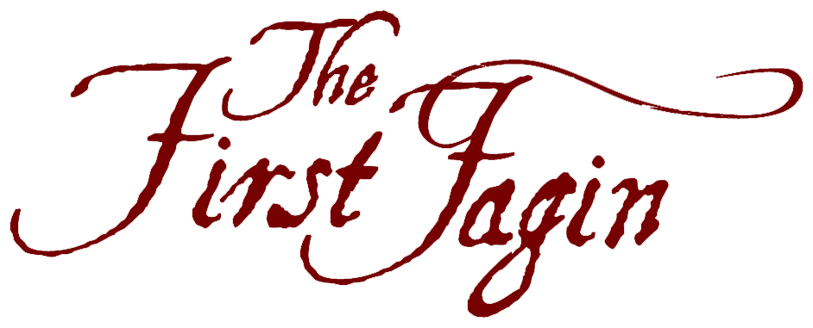

Starring RYK GODDARD and CARRIE MCLEAN
Narrated by MIRIAM MARGOLYES
Produced by VERONICA FURY, ALAN ROSENTHAL & STEPHEN THOMAS
Co-producer HELEN GAYNOR
Written & Directed by ALAN ROSENTHAL & HELEN GAYNOR

Based on the book
THE FIRST FAGIN: THE TRUE STORY OF IKEY SOLOMON
written by JUDITH SACKVILLE-O’DONNELL

www.roninfilms.com

Production Format: HD 16:9 | Release Formats: DCP 1:85 | HD Cam 16:9 | Digital Betacam 16:9
Sound: Dolby Surround Sound 5.1 | Duration: 87’00”

Distributed in Australasia by



___________________________________________________________________________________

PUBLICITY DISTRIBUTOR

TRACEY MAIR PUBLICITY RONIN FILMS
PO Box 2506 PO Box 680
Byron Bay NSW 2481 Mitchell ACT 2911
Ph: 02 6680 7106 Ph: 02 6248 0851
Fax: 02 6680 7108
Mb: 0419 221 493 Fax: 02 6249 1640
Email: traceym@tmpublicity.com Email: admin@roninfilms.com.au

© 2012 The Crown in Right of Tasmania, Melbourne International Film Festival,
Screen Queensland Pty Limited, Wild Fury Pty Limited & Alan Rosenthal

TABLE OF CONTENTS

One Line Synopsis and Short Synopsis Page 3

One Page Synopsis Page 4

Director’s Statement – Helen Gaynor Page 5

Director’s Statement – Alan Rosenthal Page 6

Producers’ Statements / “Making of” Notes Page 7 & 8

Key Credits Page 9

Helen Gaynor Biography – Director / Writer Page 10 & 11

Alan Rosenthal Biography – Writer / Director / Producer Page 12

Veronica Fury Biography – Producer Page 13 & 14

Stephen Thomas Biography – Producer Page 15

Key Creatives Biographies Page 16 & 17

Main Cast Biographies Page 18 & 19

Credits Page 20, 21 & 22

ONE LINE SYNOPSIS

From New York to Hobart, and from the darkest jails and prison ships of England to the penal colony of Port Arthur, THE FIRST FAGIN brings to life the passionate love and dramatic adventures of Ikey Solomon, family man, fence, and Charles Dickens' inspiration for the character of Fagin in Oliver Twist.

SHORT SYNOPSIS

When Charles Dickens created the character of Fagin in Oliver Twist, he gave birth to one of the most infamous personas in English literature. Few people know that Dickens' portrait of Fagin drew inspiration from the life of the Jewish receiver and fencer of stolen goods, Ikey Solomon. Much has been written about Ikey's exploits: his amazing and daring prison escapes have captured people's imaginations through the generations. THE FIRST FAGIN recreates the life of Ikey Solomon, the most famous criminal of his age. From London's dens of vice, to Newgate jail to Australia's prison shores, Ikey takes us on a journey into crime, punishment, adventure and love whilst struggling against the transportation system of 19th century England.

ONE PAGE SYNOPSIS

The setting is England, early nineteenth century. Times are chaotic, rough and cruel. English society is experiencing some of the greatest changes in its history, remoulded by the industrial revolution and the end of the Napoleonic wars. It is the stuff of the great Dickens’ novels.

Ikey Solomon, lover, thief, convict, fence, was the most famous criminal of his time, and inspiration for the character of Fagin in Oliver Twist.

His story is true.

The son of Jewish immigrants from Bavaria, Ikey roves the rough streets of London until he meets Ann, the love of his life. But there are limits to what a working class Jewish man can do to support a family in the East End. Petty theft is the answer, but Ikey is caught and sentenced to the Hulks, the notorious prison ships. Released after six years, he finds a new way to make crime pay and rockets to fame and notoriety as the most successful fence in London.

But the police have their eyes on Ikey, and arrest him for burglary – a hanging offence. Incarcerated in Newgate jail, he makes a sensational break from prison and flees to America. Headlines acclaim his break. Pamphlets on his life are sold on every corner. The legend of Ikey has started, and it will only grow.

Ann, left in London, now faces a furious and humiliated police force, while Ikey builds a base for them in far-off New York. But unknown to her, Ikey’s own brother is working with the police to frame her. Ann is convicted and transported to Van Diemen’s Land on trumped up charges. Out of madness and passion, and risking his life, Ikey leaves the safety of New York to travel to Van Diemen’s Land, a small island at the other end of the world - and a penal colony for the British Empire. His goal is to reunite with the love of his life.

A major risk is involved, but Ikey thinks he is out of reach of the British law. He, Ann and his children are passionately reunited and Ikey sets up business as a free man. Their future looks rosy as Ann, still a convict, is assigned to Ikey’s care. But fate steps in once again, this time in the form of a zealous and harsh Governor Arthur. He cannot abide the idea that local law will allow an escapee like Ikey Solomon to walk free in his prison island. Ignoring rules, Governor Arthur brutally hijacks Ikey, and imprisons him on a ship bound for London, to stand trial in the Old Bailey.

It is there, as Ikey’s trial unfolds before the London crowds, that a young Charles Dickens gathers his research for the background and trial of one of his most famous literary characters, Fagin, in the novel Oliver Twist. Ikey is found guilty on one of eight charges and sentenced to 14 years transport…back to the notorious Van Diemen’s Land. Here Ikey spends time in two of the empire’s most infamous prisons: Richmond Jail and the Port Arthur settlement. His health and mind almost broken by the cruel treatments and conditions, he is finally granted a Ticket of Leave (parole), but he is banned from returning to Hobart, where his family and Ann (still a convict) are living.

The family reunites in New Norfolk but Ikey is not the man he was. Jealousy and paranoia lead to a bitter reunion and the family splits apart for the last time. The system has finally destroyed the family.

Ikey ends his days alone in Hobart, seeking solace in the Jewish community. His latter days were not to be peaceful however. After the release of Dickens’ novel Oliver Twist, he spends the last years of his life denying the rumours that the infamous scoundrel Fagin is based on his character.

DIRECTOR’S STATEMENT

Helen Gaynor

THE FIRST FAGIN is the directing culmination of over twenty years of working in both drama and documentary. To be able to combine these on one project has been a joy.

Casting the right actors was crucial. Ikey and Ann’s story is the stuff of great drama, full of triumphs and tragedies played out on the world stage. The love between Ikey and Ann is central to this tale and spans thirty years. Ryk and Carrie had to convince me, and my co-director Alan, that they could carry their love story and the aging that the story required.

Their strong improvisational training allowed me to use a new technique for the auditions, rehearsals and on-set. I shifted the directorial relationship from the traditional drama mode to that of an observational documentary director following Ikey and Ann. As director I observed and interacted with their life in the same way I would on a contemporary observational documentary shoot. This technique, which started with the audition, moved to Skype chats in character in pre-production while I was in Melbourne and they were in Tasmania. We built the method and relationships into the rehearsal room and onto set.

This technique was also applied to all the other guest roles and contributed greatly to the strength of performances.

The other element that contributes greatly to the strength of the performances was Tasmania itself. Talented actors came out of the woodwork, happy to accept the smallest role, so keen were they for any opportunity to ply their craft. Not only did we have a technique that was very effective in bringing out authentic performances, we had a talented and enthusiastic cast - a director’s dream.

From the production side of things, we had a very tight shooting schedule and again I was blessed with a very talented crew. The First Assistant, DOP and Production Designers all understood the stripped down requirements of shooting docudrama. The shooting style was simple and “documentary “ in feel – following and capturing the action and drama that the actors offered on set rather than imposing itself on their performance. The art, wardrobe, hair and makeup departments created wonderful looks from little and once again Tasmania itself helped us achieve our goals. The ability to shoot many different locations on one property, the enthusiasm of the locals and the ease of movement made it an ideal set up for a low budget with high production demands.

This production is a truly global product. THE FIRST FAGIN is a both a love story and a labour of love.

DIRECTOR’S STATEMENT

Alan Rosenthal

When I heard about the story of Ikey Solomon it seemed to me one of the most amazing drama and love stories I'd ever heard. It was a story that had to be told: the story of a London Jew who experienced the worst prisons of England and Australia. The story was also unique in that it gave us a chance to look at the effect of transportation on an entire family, not just one individual. Finally I've always been fascinated by social history and Ikey's story gave us a unique chance to explore crime and punishment in 19th century Australia, in a way which hadn't been done before.

The challenge of the film was that it wasn't straight drama, but also used a hybrid of documentary techniques, such as the use of experts and period artwork. Finding the experts was easy. For artwork we had to scour museums throughout England and Australia, and then negotiate fees that wouldn't bankrupt us.

As a writer, one of the main challenges was to get the facts and the politics of the period right.
I read innumerable tracts about social conditions of the time, prison reform, and the horrors of transportation. This was because I wanted the film to be a study of crime and punishment in the 19th century as much as Ikey's moving story. Finally I also tried to penetrate the mind of the principals so that they became real people, and also to get their language right. Here a rereading of Dickens’ novel "Bleak House" was of immense help and for days I would tell my wife "prithee, give me thou the coffee." No, just kidding. But the writing was fun.

PRODUCERS’ NOTES

Alan Rosenthal

Sometimes the journey from idea to screen can be as fascinating as the film itself. Such was the case with THE FIRST FAGIN.

The initial idea came to me over a dinner party at the home of Helen Gaynor, old friend and a wonderful filmmaker. As the wine poured Helen told me of her recent visit to a Tasmanian jail. Intertwined with its fascinating history, the jail boasted that a Jewish London convict who had been imprisoned there in the 1830s was thought to be the model for Fagin in “Oliver Twist.” Immediately, the bulb went off, and I told Helen “Fantastic. There could be a film here.” That night I googled everything I could find dealing with Ikey Solomon, and found a Melbourne lady, Judith Sackville-O’Donnell, had even written a book about him a few years earlier.

A day later I met Judith, and optioned the rights to make a docudrama.

Back in Jerusalem where I live, I started researching and writing proposals. Then like the sailor on the desert island who puts his messages in bottles, started casting around for backers, in England, Canada, Australia, you name it. To my joy the ZDF drama department in Germany, decided they liked the idea. After giving them a full treatment they decided they were in. And that was the push that started the ball rolling.

But obviously we needed an Australian co-producer. Here again I turned to an old friend, Veronica Fury, whose work and talent I so admired. Then over meetings with Veronica in Barcelona, Adelaide and grungy cafes in London we gradually mapped out a strategy. Veronica would look after finances, and I’d keep an eye on the artistic side. And…we’d film in Australia, and get Helen to come in and supervise the main directing, with myself attending to the more documentary side.

The rest is history, except for one thing. In co-productions, it’s very easy to finish up wanting to kill your co-producers. Here, as a bloody foreigner, I finished up with an immense admiration for Veronica, Helen, and all the Australian film crew. Never have I worked with such a cooperative, easy and wonderful talented bunch. In life you need luck. I was lucky.

Veronica Fury

THE FIRST FAGIN is an important, untold story for Australian audiences and reveals an amazing part of Australian history. It links our turbulent colonial history to not only the notorious and enigmatic Ikey Solomon but one of the most revered authors of all time, Charles Dickens, and his infamous character Fagin. We believe the film will resonate strongly with lovers of literature and Australian history alike, as well as fans of Dickens great works.

The film represents a huge cooperative production effort from Wild Fury, Roar Film and the outstanding creative team. This comes in time for the 2012 Bicentennial celebrations of Charles Dickens.

PRODUCERS’ NOTES continued

Stephen Thomas

When Veronica Fury first approached Roar about THE FIRST FAGIN we were excited by its obvious potential. Here was an epic love story with a compelling premise in the hands of a highly skilled and committed team, and the timing was perfect - the year of the Charles Dickens bi-centenary. What was most important for us, however, was that the team was absolutely committed to shooting in Tasmania. Over the course of the next 15 months we witnessed the dream turn into reality.

As the project gathered momentum we saw a Tasmanian film industry fresh from the rigours of The Hunter really kick into action. Most crew, including many key crew, were sourced locally but what was even more exciting for us was the fact that the entire production was cast in Tasmania, including both leads. Screen Tasmania’s timely and generous production investment was recognition of the significance of this unprecedented Tasmanian representation as well as the exciting, hopefully ongoing, project partnership between Wild Fury and Roar Film.

The shoot itself went off without a hitch during November and December 2011. The Tasmanians blended seamlessly with the interstate and international crew. Veronica’s enthusiasm and energy, Alan Rosenthal’s passion for the story and Helen Gaynor’s calm, creative and capable stewardship of the dramatic shoot meant that for many Tasmanians, THE FIRST FAGIN, was an amazingly enriching experience. We’d like to think that the Roar Film team played an important role here, too.

This is an important Australian film; unique in that it blends a tragic love story with a moving and accurate portrayal of the Tasmanian convict diaspora. The film also leaves the viewer with the tantalising question, could Charles Dickens’ greatest villain actually be based on the transported convict, Isaac Solomon? Although it seems there may never be a definitive answer to this question, one thing is certain; in the case of ‘Ikey’ Solomon, the truth was most certainly stranger than fiction.

KEY CREDITS

Narrated by
MIRIAM MARGOLYES

Ikey Solomon
RYK GODDARD

Ann Solomon
CARRIE McLEAN

Experts
DR ALISON ALEXANDER
DR TRUDY COWLEY
DR PETE HAY
PROFESSOR JANET McCALMAN

Written and Directed by
ALAN ROSENTHAL
HELEN GAYNOR

Produced by
VERONICA FURY
ALAN ROSENTHAL
STEPHEN THOMAS

Based on the book by Judith Sackville-O’Donnell
THE FIRST FAGIN: THE TRUE STORY OF IKEY SOLOMON

Co-Producer
HELEN GAYNOR

Director of Photography
JAEMS GRANT ACS

Editor
WAYNE HYETT ASE

Composer
GUY GROSS

THE PRODUCTION HAS BEEN REALISED WITH ZDF IN CO-OPERATION WITH ARTE
COMMISSIONING EDITOR: PETER ALLENBACHER

DEVELOPED & PRODUCED WITH THE ASSISTANCE OF
SCREEN QUEENSLAND

PRODUCED WITH THE FINANCIAL ASSISTANCE OF
MELBOURNE INTERNATIONAL FILM FESTIVAL (MIFF) PREMIERE FUND

EXECUTIVE PRODUCER: MARK WOODS
An initiative of the State Government of Victoria, Australia

DEVELOPED & PRODUCED IN ASSOCIATION WITH
SCREEN TASMANIA

© 2012 The Crown in Right of Tasmania, Melbourne International Film Festival, Screen Queensland Pty Limited,
Wild Fury Pty Limited & Alan Rosenthal

ISAN 0000-0003-11EE-0000-1-0000-0000-Y
DIRECTOR’S BIOGRAPHY AND FILMOGRAPHY

Helen Gaynor
WRITER, DIRECTOR AND CO-PRODUCER

Biography

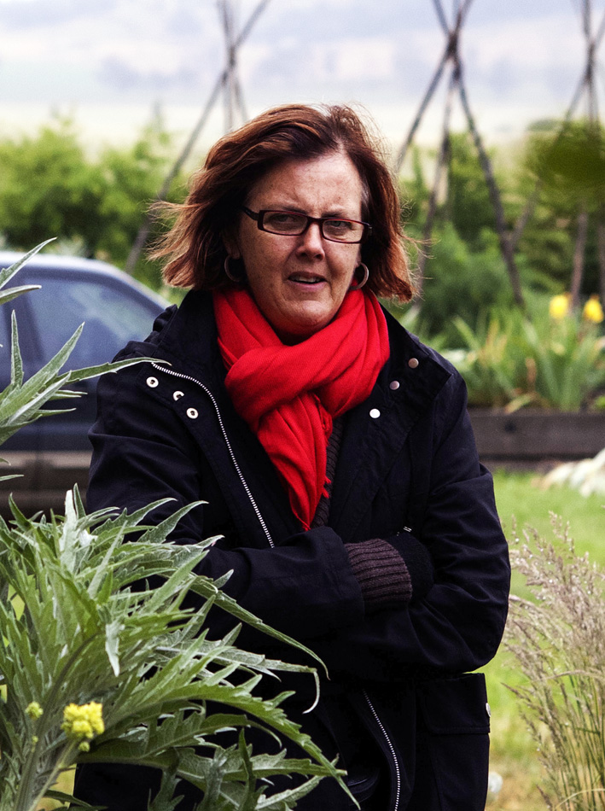
Helen Gaynor has been directing documentary and drama for Australian television screens for over twenty-five years.

Helen commenced her directing career in drama. She has directed some of Australia’s best-known television series including Neighbours and Home and Away as well as high-end productions such as Big Sky and MDA.

Her documentary projects have been commissioned by major public broadcasters and she is sought after by major producers as a director/shooter for major documentary series.

She has combined her directing work with a teaching career that has taken her from the Australian Film, Television and Radio School (AFTRS) to the International School of Film and TV (EICTV) in Cuba. She is in the final stages of her Masters at the film school at the University of Melbourne.

Helen was born in Melbourne on 7 December 1958. She is married to Arpad Mihaly with whom she has two daughters, Zsuzsa (13) and Roza (7). She lives in the inner city Melbourne suburb of Northcote and combines her directing work with teaching, studying and parenting,

Filmography
DOCUMENTARY CREDITS

Holy Switch
Director/Camera - Roar Film / ABC TV 2012
A three- part series that follows a series of young people of faith who swap faith communities for two weeks to experience “the other side”

Addiction
Director/Camera - ABC TV / Beyond Productions 2010
2 x 52 minute episodes following a number of people struggling to overcome various drug addictions in a private rehabilitation clinic in Melbourne’s Eastern Suburbs

Last Chance Saloon
Director/Camera - SBS TV / Renegade factual – 2010
4 x 25 minute series looking at alcoholism in Australia via the work of Brian Cox. “Coxy” is an ex skid row drunk who for the last 20 years has taken people into his own house to help them recover from alcoholism and set up a new life. Nominated Best Factual Series: 2010 Logie Awards

Asylum FC
Director/Camera
SBS TV / Renegade factual / AL Jazeera 2009
55 minute and 43 minute documentary. Follows the Zimbabwean Homeless soccer team as they apply for
asylum in Australia and build a new life in this country

Community Cop
Director/Camera - SBS TV / Screen Australia 2007 – 2008
52 minute observational hybrid documentary following the work of the Flemington Police community liaison officer and members of the local African community as they work to resolve differences that have resulted in violent clashes on the local public housing estate

Welcome 2 My Deaf World
Director/Camera – 360 Degree Films /SBS TV 2005- 2006
55-minute observational hybrid documentary following the last six months at school for two very ordinary teenagers who live in the extra ordinary world of the deaf.
WINNER: Aurora Audience Award: Reel Life on Film
NOMINATED: Best Documentary. Australian Film Institute Awards, 2006

Nurses
Director/ Camera - ABC TV 1999-2000
4x30 min documentary series following the lives and work of four nurses at the Alfred hospital
Format: Pan. DVC Pro

For the Defence
Director/camera - ABC TV / December Films 1998-9
An intimate portrait of the life and work of three criminal defence lawyers. Dur: 55 mins, Format: Panasonic DVC pro

The Election of the Century
Director/Camera - SBS TV / Open Channel Productions, 1994
The first non-racial elections in South Africa’s history provides Australian Electoral Commission officer, Ched Flego, with the opportunity of a life time - to be involved in the election of the century
Dur: 55 mins. Format: SP Betacam
Nominated for best documentary, UN Media peace Prize

Impunidad
Producer/Director/Camera - SBS TV: CAM Productions, 1993
Through personal stories, Impunidad explores the culture of state sponsored terror in Guatemala, and the fight to expose it.
Dur: 50 mins. Format: Hi-8
Chris Award, Columbus International Film & Video Festival
Silver Plaque Award, Chicago International Film & TV Festival

DRAMA CREDITS

MDA
West Side Pictures / ABC TV
Weekly drama series set in a medical legal practice

Neighbours
Network Ten: The Grundy Organization
Single camera OB, multi-camera studio, TV family drama series

Something in the Air
Simson/LeMesurier / ABC TV
Multi camera drama series set in a small country town radio station

Belihan Hati
Pearson TV Asia /RCTI Indonesia
Telemovie for serial drama about twins separated at birth

L’il Horrors
December Films / The Seven Network
Single camera (digital) children’s puppet animation series

High Flyers
Network Ten: Southern Star/JDL Productions
Single Camera children’s drama series about a Children’s circus school

Big Sky
Network Ten: Southern star/Xanadu
16mm TV adult series drama about the adventures of a regional airline

The Adventures of the Bush Patrol
Network Seven: Rosenbaum/Whitbread Productions
Single camera OB and Multi-camera studio, children’s TV drama

Home & Away
Network Seven:
Single Camera OB / multi-Camera studio, series TV drama

Chances
The Nine Network:
Single camera OB, multi-camera studio, adult series TV drama

A Country Practice
Network Seven: JNP Productions
Single camera OB, multi-camera studio, adult series TV drama

Inside Running
ABC TV: Single camera OB, multi-camera studio, TV series drama

House Rules
ABC TV: Single camera OB, multi-camera studio TV drama series

DIRECTOR’S BIOGRAPHY

Alan Rosenthal
WRITER AND DIRECTOR

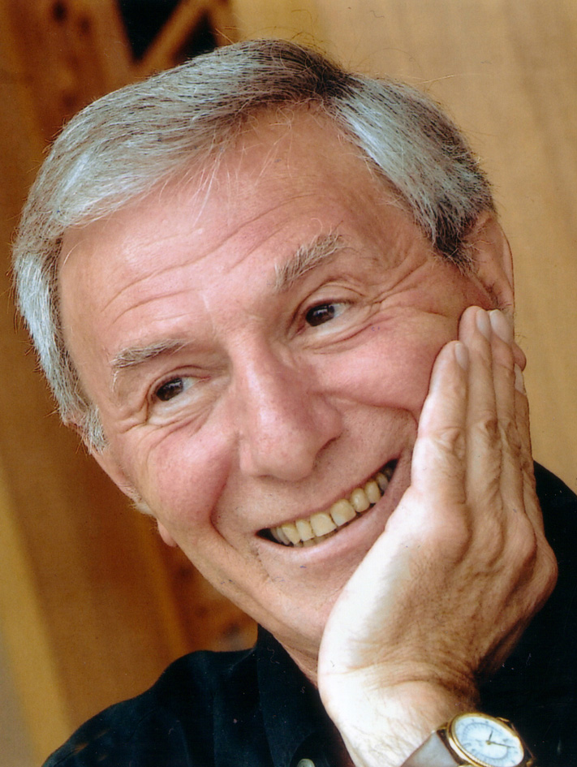
Alan Rosenthal, born in London, has an MA from Oxford University in Law, an MA from Stanford University in Communications and is a Solicitor of the Supreme Court, England. He has written eight books including, 'Writing, Directing and Producing Documentary Films", "Why Docudrama" and "Jerusalem, Take One: Memoirs of a Jewish Filmmaker".

Alan has taught at Stanford University and the Hebrew University and is a frequent guest teacher at the Australian Film, Television and Radio School. He has won many awards throughout his career including the Christopher Award (highest US Humanitarian award), a Cine Eagle, an International Documentary Association Award, a Blue Ribbon American Film Festival and the Peabody Journalism Award.

Alan has made over 50 films for ARTE, ZDF, Channel 4, PBS, 14/WNET, CBC, ABC (USA), BBC and Israel TV. His major films as writer, producer and director over the last few years include;

Heritage Series – PBS
Into the Future – Channel 4 UK
Eichmann's Secret Memoirs – NDR Germany
Stalin's Last Pogrom – Israel TV
Waves of Freedom – ARTE

PRODUCER’S BIOGRAPHY AND FILMOGRAPHY

Veronica Fury
PRODUCER

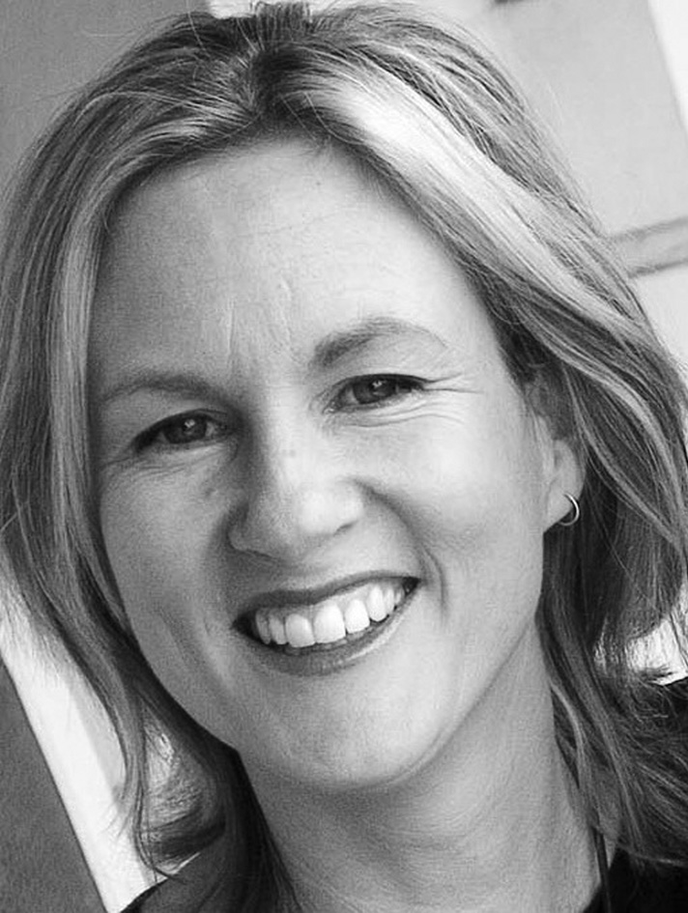
Veronica Fury is an Australian Producer and Managing Director of Wild Fury Pty Ltd, a hugely successful Screen Australia funded Enterprise partnership with Bettina Dalton (Absolutely Wild Visuals) and Hugh Marks (Network Nine/Southern Star). Veronica produces award-winning screen content for audiences around the world, working with television broadcasters like ABC and SBS in Australia and major international broadcasters such as ZDF Arte, TG4 and Arte France. The Wild Fury group also produces content for the likes of WNET, NDR, HNK, Discovery and Nat Geo to name a few.

Projects produced include Black Soldier Blues (2006), The Glamour Game Series (2007), Fairweather Man (2008 – NSW Premier’s Awards Best Script), World Champion Santa (2009), Constructive Mob (2010), Machete Maidens Unleashed! (2010 – Toronto International Film Festival), Bringing Uncle Home (2011), The Trouble with St Mary’s (2011), The Curse of the Gothic Symphony (2011) and Dancing Down Under series (2012).

Veronica is currently producing the docudrama The First Fagin for MIFF Premiere Fund 2012 and ZDF/Arte. Fury has a large number of documentary projects in various stages of production including Mysteries of the Human Voice for ARTE France, Inside AFL for ABC and Electric Boogaloo for Drafthouse USA.

IN PRODUCTION

2012 – THE FIRST FAGIN 55/75 Min DocuDrama. Screen Tasmania, Screen Queensland & MIFF Premiere Fund 2011, Broadcaster: ZDF/ARTE Producer: Veronica Fury, Writer/Co-Director: Alan Rosenthal, Co-Director: Helen Gaynor

2012 – Inside AFL 5 x Half hour documentary series, Screen Queensland & Screen West.
Broadcaster: ABC. Producer: Veronica Fury & Kelrick Marin.

2012 – Koalas: Cracking the Code. 55min Documentary one off. Screen QLD, Screen Australia,
ABC, NTGI, WNET
Producers: Bettina Dalton, Veronica Fury. Writer and Director: Paul Scott.
Broadcaster: ABC and NTGI.

2012 – Wild Australia 4x52 minutes and 5x43 minutes. National Geographic Australia,ZDF/Arte,
NDR LMA, Screen Australia, Screen Queensland, Screen NSW
Broadcaster: National Geographic Australia. Producers: Veronica Fury and Bettina Dalton,
Writers: Peter Moers and Betting Dalton, Director: Rory McGuiness

2012 – ABC 3on3 26 x 5min interstitials. Producer: Veronica Fury Director: Daniel Marsden and
Vanessa Oxlade. Broadcaster: ABC 3

FILMOGRAPHY

2012 – Dancing Down Under 10 x 26 Mins – Documentary Series. ABC, Screen Australia, Screen NSW, Screen Queensland.
Producer: Veronica Fury, Director: Susan Lambert

2011 – Bringing Uncle Home 26 Mins – Documentary. ABC, Screen Queensland
Producer: Veronica Fury & Grania Kelly, Writer/ Director: Grania Kelly

2011 – The Curse of the Gothic Symphony 55/85 Min - Documentary. ABC, Screen Australia, Screen Queensland & MIFF Premiere Funds 2011
Producer: Veronica Fury, Director: Randall Wood.

2011 – The Trouble with St Mary’s 55 Mins - Documentary ABC, Screen Australia & Screen Queensland
Producer: Veronica Fury, Writer/Director: Peter Hegedus

2011 – Constructive Mob 26 Mins – Documentary ABC, Screen Queensland
Producer: Veronica Fury, Writer/Director: Douglas Watkin

2010 – Machete Maidens Unleashed! 55/85 Mins - Documentary. ABC, ABC Commercial, Screen Australia, Screen Queensland, Film Victoria & MIFF Premiere Funds 2010
Producer: Veronica Fury, Writer/ Director: Mark Hartley

2009 – World Champion Santa 26 Mins – Documentary. Broadcaster: ABC
Producer: Veronica Fury, Writer/ Director: David Downey, Script Editor: Randall Wood.

2008 – Fairweather Man 52 Mins – Documentary. Broadcaster: ABC
Producers: Veronica Fury, Writer/Director: Aviva Ziegler, Assoc Producer: Debra Beattie
Nominated AFI Award 2008, GZ DOC Fest 2008, Tahiti Film Festival 2010, FIFA 2010, NSW Premiers Literary Award 2010

2007 – The Glamour Game – Series 2 x 52 Mins – Documentary. Broadcaster: SBS
Producer: Veronica Fury, Writer/Directors: Susan Lambert/Aviva Ziegler, Consultant Producer: Megan McMurchy

2005 – Black Soldier Blues 52 Mins – Documentary. Broadcaster: SBS
Producers: Mark Chapman & Veronica Fury, Director: Nicole McCuaig, Writer: Nicole McCuaig & Veronica Fury

2004 – Chimney Sweep 5 Mins – Documentary. Broadcaster: George Negus Tonight - ABC
Produce/Director/Writer: Veronica Fury Official selection Redfest

2004 – The Embalmer 5 Mins – Documentary. Broadcaster: George Negus Tonight - ABC
Writer/Director: Bonnie Hart, Producers: Phoebe Hart & Veronica Fury

DEVELOPED/FINANCING with MARKET INTEREST

Mysteries of the Human Voice 55 Min - Documentary Developed by Screen Queensland.
Broadcast interest: ARTE FRANCE (Commissioning)
Producer: Veronica Fury, Writer/Director: Stefan Moore

Electric Boogaloo 90 Mins - Documentary. Celluloid Nightmares (XYZ), Drafthouse, Koch Media.
Producer: Veronica Fury, Writer/ Director: Mark Hartley

Comic Book Heroes 2 x 26min – Documentary series, Developed by ScreenWest, Screen QLD
Broadcaster interest: ABC
Producer: Veronica Fury, Writer/Director/Co-Producer: Nick Dunlop

PRODUCER

Steve Thomas
PRODUCER

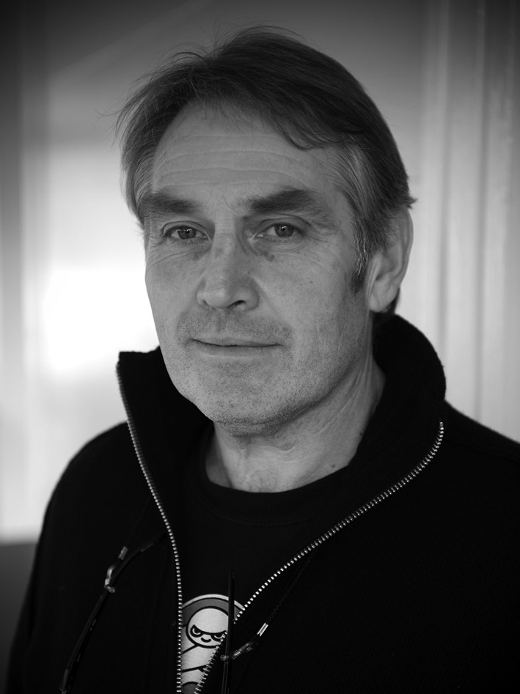
Steve Thomas is a producer and director whose work encompasses broadcast and online documentary, educational multimedia and drama. His broadcast credits include Pulp Town, Shacks (series), The End of the Game, The Fishermen, Real Life Water Rats (series), Alive and Kicking (series), Portrait of a Distant Land, The Mission (series) and Bali High Wedding.

Major interactive documentaries include Film Australia’s Wilderness, Dust On My Shoes, From Wireless to Web, DIY Doco, Australian History Timeline and Founders and Survivors Storylines. He has also developed and produced major online education modules for the London Grid for Learning and a number of other UK and Australian education organisations.

His work has received numerous Australian and international commendations.

KEY CREATIVES – BIOGRAPHIES

Jaems Grant ACS
DIRECTOR OF PHOTOGRAPHY

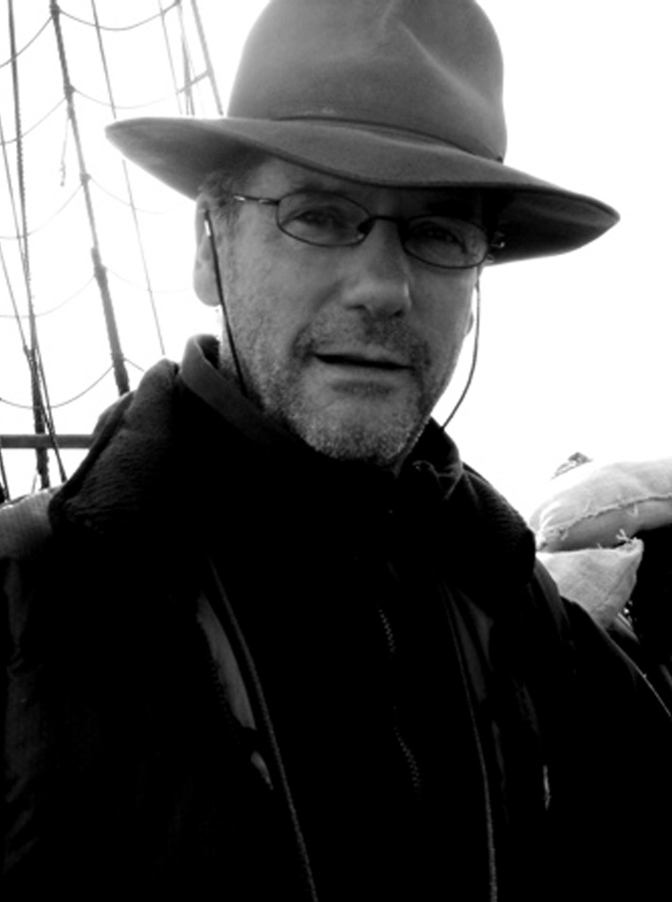
Jaems was introduced to hands-on filmmaking in 1974 when a photographic student at Prahran Institute of Technology. Jaems was experimenting with sculptural and photographic installations, when the young producer Bob Weis approached him to come and work on a feature film that came to be known as Pure S*#!.

His appetite whet, Jaems went on to study film at Preston Institute under Bert Deling (the director of Pure S*#!) and shot about 10 short films in his first year. After completing his studies, Jaems decided to pursue his interest in documentary filmmaking from behind the camera. Over the next few years he and director Chris Warner made many documentaries for the Victorian Education Department.

In 1979 Jaems shot the award winning short film recorded on 16mm Working Up. Directed by Chris Warner, it was Jaems’s first job as Director of Photography on a drama film. From there, Jaems was inspired to move more into the realm of drama, shooting the television series In Between for SBS, Lift Off and Round the Twist for the ABC, and TV features and feature films such as Jigsaw, A Kink in the Picasso, Blowing Hot and Cold, Hungry Heart and then in 1998 Head On.

With the advent of the digital age, Jaems Grant has been involved in shooting documentaries, dramatised documentaries, TV series, and television commercials in every new format that has been introduced into the medium.

Over the years Jaems has been an active member of the Australian Cinematography Society and was recognised by the National Executive of the ACS for his work in cinematography by achieving his accreditation in 1989.

During his career, Jaems has been invited to various film schools in Melbourne to teach students about the art of cinematography, and about the equally important practical side of filmmaking, how to capture images that enhance the story within the financial restrictions and time constraints of a shoot.

In the last 10 years Jaems has worked on some of the best television shows produced in Australia including Halifax F.P., Loot, The Floating Brothel, Rush, Penicillin: The Magic Bullet, City Homicide, Winners and Losers, Charles Bean’s War, Offspring, Australia on Trial, and most recently THE FIRST FAGIN and The Mystery of the Hansom Cab.

He has won over 30 awards for cinematography including Gold awards for the films Head On, Only the Brave, The Last of The Ryans, and also for the dramatised documentary Pozieres. He has been awarded two Golden Tripods at the National Australian Cinematography Society Awards, in 2004 for Love letters From A War, and in 2007 for Penicillin: The Magic Bullet.

Jaems has been a judge for the National A.C.S Awards, The Melbourne International Film Festival and for the Australian Film Institute Awards.

He continues to lovingly lug a camera around Melbourne and other exotic places…

Wayne Hyett ASE
EDITOR

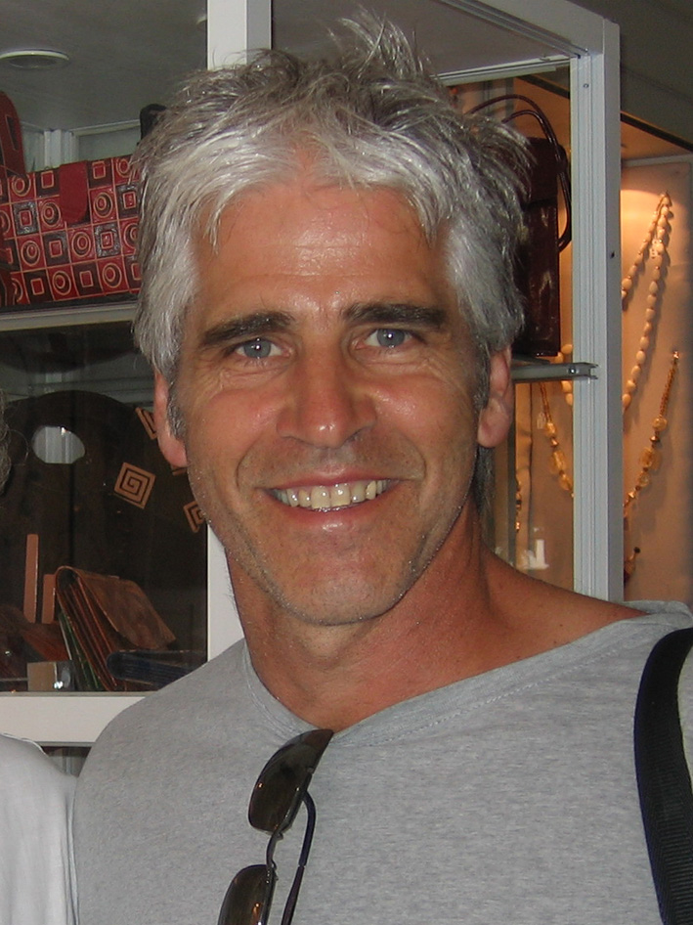
Locally produced children’s drama and documentaries have been a speciality for editor Wayne Hyett A.S.E. His career, spanning nearly 30 years, also includes feature films, adult drama series and documentary dramas for all Australian networks and international audiences.

Drama credits include The Castle, The Murray Whelan Series, Stingers, The Games, Wicked Science, The Elephant Princess and Pirate Island. His documentary highlights include the major ABC series Captain Cook – Discovery and Obsession, award winning science films Catching Cancer and Immortal and social documentaries The Kindness of Strangers and Once Bitten.

In 2004 he was awarded accreditation by the Australian Screen Editors Guild “In recognition of excellence in screen editing and outstanding contribution to Australian screen culture”.

About THE FIRST FAGIN he said:

“The life of Ikey Soloman had a strong resonance with my own family’s ancestral journey to the prison colony. Working on this film brought home to me the extraordinary hardship and courage shown by those transported to this harsh land. An epic tale perfect for the big screen.”

Guy Gross
COMPOSER
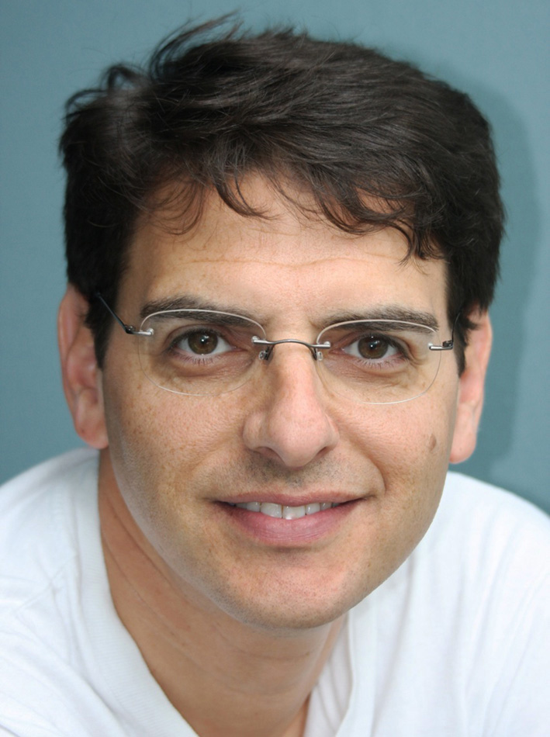
Guy Gross is one of Australia’s leading film and television composers and recipient of the APRA/AGSC International Achievement Award, considered the most prestigious accolade for an Australian screen composer. Over his 25 year career, Guy has composed music for hundreds of hours of television, including dramatic mini series, children’s animation, documentaries, commercials and also a number of Australian feature films, most recently A Few Best Men.
From his British Academy Award (BAFTA) nominated score to the international hit The Adventures of Priscilla, Queen of the Desert to the US SCI-FI series Farscape, his film scores cover a huge variety of styles. Testament to this diversity, Guy has received numerous peer awards from the Australian Guild of Screen Composers (AGSC) and The Australian Performing Rights Association (APRA) including awards for Best Music for a Documentary, Children’s Series, Short film, Animation, Promotional Video, Advertisement, TV Theme and twice for Best Music for a TV Series.

His most notable documentary scores were for the ratings hit Who Killed Dr Bogle and Mrs Chandler and also the ABC series The Howard Years.

THE FIRST FAGIN was a special project for Guy as it called upon his classical skills to capture the period drama and also his Jewish background to reflect the main characters’ heritage.

MAIN CAST BIOGRAPHIES

Ryk Goddard
IKEY SOLOMON
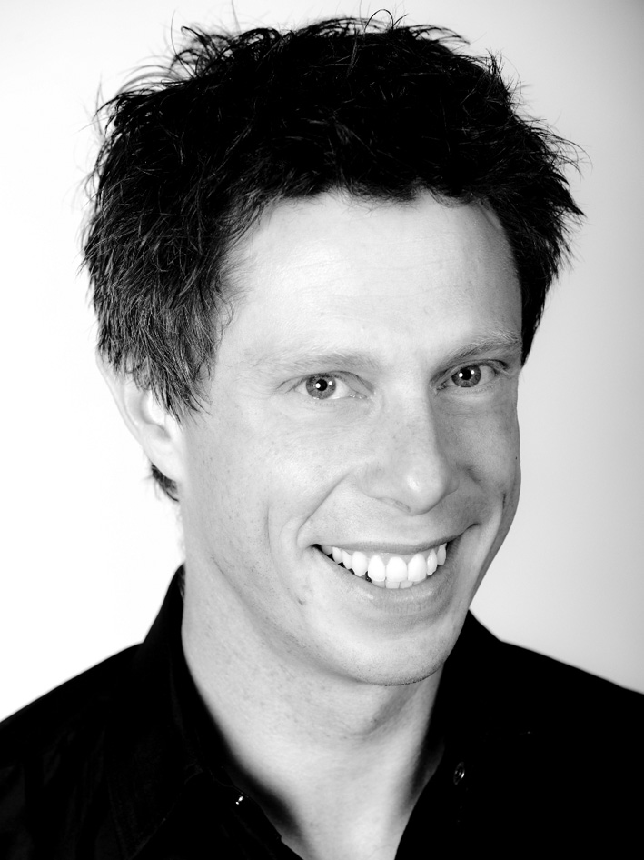
Ryk Goddard is the Breakfast presenter for 936 ABC Hobart and creates TV shows and online comedy series including Sneaking Off To My Shed and Ryk Goddard Is Nearly Middle Aged. He also wrote, directed and voiced Blogdaddy a 20-episode comedy parenting series for Radio National. Having worked mainly in theatre, much of which was improvised full-length shows, Ryk's Spartan TV credits include being eaten as a convict, being a road accident victim and being the nice guy in a pad ad.

Ryk trained in acting at VCA and in cross media with AFTRS. He has most recently toured Australia with Terrapin Theatre including the Sydney Opera House and Victorian Arts Centre with Helena and the Journey of the Hello by Finegin Kruckemeyer. Ryk has also performed for the Tasmanian Theatre Company and the gruelling Botanical Gardens annual panto for Big Monkey.

Ryk was an artistic associate for the Bell Shakespeare Company's Actors At Work program and has performed Stand-Up comedy around the country as middle-aged Hip Hop artist Cecil Brown who was featured on Triple J's Unearthed. He was also a Raw Comedy national finalist some time ago.

For seven years Ryk was Artistic Director of Tasmania's premier theatre company ‘Is Theatre’ where he created critically acclaimed cross media theatre shows and installations. He was awarded a Churchill Fellowship in 2005.

THE FIRST FAGIN is his first major role in a film.

Carrie McLean
ANN SOLOMON
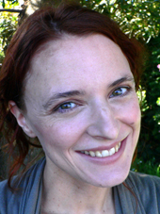
Carrie McLean is a freelance actor, writer, director and mother of four based in Launceston, Tasmania. Since completing a Bachelor of Performing Arts (Theatre) from UTAS in 1997, Carrie has performed with many Tasmanian theatre companies. The roles include Lady Jane Franklin in the Australian premiere of Stella Kent’s Conviction, Batcha in Tobsha Learner’s Witchplay, Edie in Joanna Murray Smith’s Redemption, Alcibiades in Shakespeare’s Timon of Athens, and Mary in Clare McIntyre’s Low Level Panic.
In 2005, Carrie co-founded Mudlark Theatre, an independent theatre company producing new and gutsy theatre for its regional audience. For Mudlark, Carrie has written the plays Beautiful: A Ghost Story (2011); Strange Fruit as part of Dancing Back Home (2010), an epic continent-wide collaboration with JUTE Theatre in Cairns; Mind the Gap (2011), The Fools of Fire (2008) and Danger #31 (2006) for the One Day Projects; and Cafe, which toured Tasmanian schools and colleges in 2007. She has also written and directed the short film New Skin, awarded a WiFT Award for Emerging Artist, and her short film script Die Die Die My Darling, Beneath the Blanket of Stars recently won the Familial Horror Award at the Stranger With My Face Film Festival. Most recently, she wrote Chasing a Sound Like Rain, a collaborative youth theatre project for SSYT which was performed as part of the Ten Days on the Island Festival in Tasmania, and the Gros Morne Theatre Festival in Canada.

Playing Ann Solomon in THE FIRST FAGIN is Carrie McLean's screen debut in a feature role.

Miriam Margoyles
NARRATOR

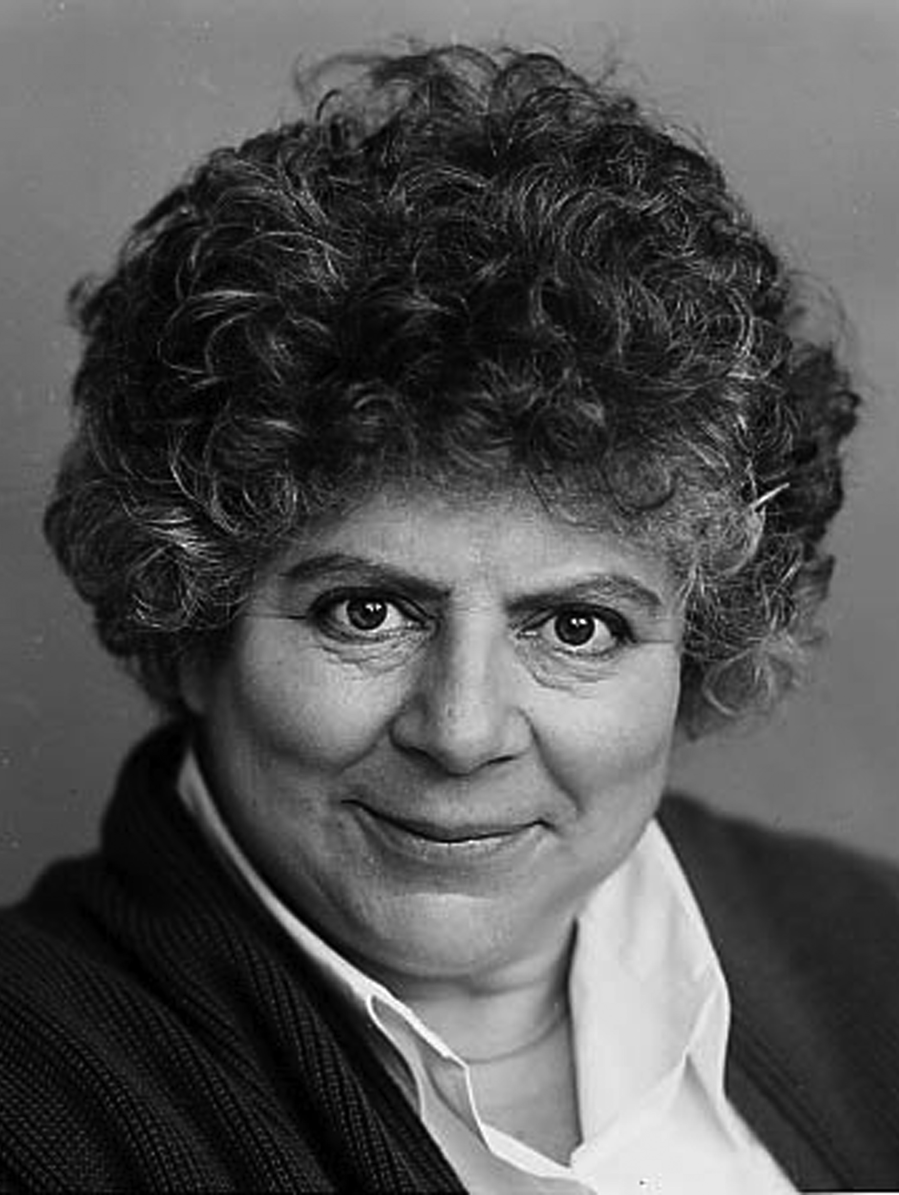
Award-winning actress Miriam Margoyles has worked on stage and screen internationally for more than thirty years. She was appointed an Officer of the Order of the British Empire (OBE) for services to Drama in 2001.

Miriam is internationally recognised for her work in film, winning the BAFTA in 1993 for Best Supporting Actress for her performance in Martin Scorcese’s The Age of Innocence. The film was nominated for four Academy Awards, Five Golden Globe Awards and Three BAFTAs. She is well known and well loved for her performance as Professor Sprout in the hugely successful Harry Potter franchise which was a global box office hit. She also appeared memorably as Juliet’s Nurse in Baz Luhrmann’s 1995 remake of Romeo + Juliet alongside Leonardo Dicaprio and Claire Danes. Other film credits include James and the Giant Peach, Legend of the Guardians: The Owls of G’ahoole, Babe and How to Lose Friends and Alienate People.

For television, she is well known for her character roles including the hugely popular British television comedy Blackadder, opposite Rowan Atkinson and Hugh Laurie where she played Spanish Infanta, Lady Whiteadder, and Queen Victoria. She played a major supporting role in the BBC drama, The Life and Loves of a She-Devil. Recently Miriam performed in the Australia production Miss Fisher’s Murder Series as Aunt Prudence. Other television credits include, Miss Marple, Fall of the House of Windsor and Frannie’s Turn.

Miriam’s has work in theatre in Britain, America and Australia. She most recently toured Australia and New Zealand with Dicken’s Women, written by her and writing partner, Sonia Fraser. The monologue unfolds with her playing an impressive 23 different characters based on the novels of Charles Dickens. The show was first developed for the Edinburgh Festival and was so well received critically it has since played at the Duke of York and Hampstead Theatre’s in London as well as worldwide. For her performance she was awarded the 1991 Olivier Award for Best Entertainment.

In 2009 Miriam performed in Samuel Beckett’s Endgame at the Duchess Theatre in London’s West End. She was also one of the original cast of the London production of the hugely successful musical, Wicked, playing Madame Morrible alongside Idina Menzel.

In 2008 she reprised this role in New York on Broadway. Other theatre credits include The Importance of Being Earnest, The Way of the World, The Vagina Monologues, Romeo and Juliet at Ahmanson Theatre, Los Angeles, Realism with the Melbourne Theatre Company and Gertrude Stein and Companion which toured internationally.

CAST

Narrated by MIRIAM MARGOLYES
Ikey Solomon RYK GODDARD
Ann Solomon CARRIE MCLEAN
David (17 years old) THOMAS BYERS
David (10 years old) HARRY DUB
David (18 months old) EDDIE HARDING
Nancy (15 & 20 years old) GEORGIA BLIZZARD
Nancy (8 years old) ELLIE WARMBRUNN
John (20 & 21 years old) MAT BURTON
John (10 years old) COOPER WARMBRUNN
Moses (18 years old) AMERY JACKSON
Moses (9 years old) JOE BIRD
Baby Moses KASIA POPRAWSKI
Sarah (11 years old) NATALIE GARTLAN
Sarah (5 years old) AMBER ZOOEF
Mark (9 years old) LIAM NORRIS
John & Mark (18 months old) EMILIANA POPRAWSKI
Henry Solomon ROGAN BROWN
Moses Julian CHRIS CORNISH
Ben Solomon JOHN MENEZIES
Mr Newman JAMES CASEY
Mrs Newman MEL KING

Governor Arthur GUY HOOPER
Gellibrand IVANO DEL PIO
Chief Justice Pedder JASON DIMBYLOW
Joel the Pickpocket AIDAN FURST
Forster GAVIN BASKERVILLE
Fortune ROWAN HARRIS
Mary Browning JUDITH CORNISH
Madden LES WINSPEAR
Charles Strachan BRIAN ANDREWS
John Wilson SAM MITCHELL
Sarah Knightsbridge LARA ROSS MCGLYNN
Ikey's Mother LEIGH TESCH
Ann's Mother SARAH PHILLIPS
Solicitor General ANDREW CASEY
Crown Prosecutor NATHAN SPENCER
Rabbi KEVIN COLLIDGE
Speechmaker STEVEN JONES
Prison Chaplain JOHN ANDREWS
Turnkey 1 CONNOR CARTHY
Turnkey 2 STUART PEARCE
Reader 1 RICK ROGERS
Reader 2 SAM DE ZOETE
Drinker DAVID BLOOMFIELD
Seamstress ROSE KOKKORIS
Young Crook CAMPBELL MCKENZIE
Newgate Guard ALFIE LEE
Plain Clothes Cop 1 NICK FALK
Plain Clothes Cop 2 DAMIAN BROCKIE
Man 1 ELI HALLIWELL
Man 2 DAVID BANNISTER
Old Bailey Judge SEAN MONRO
Old Bailey Prison Guard TIM HARRIS
Jury Foreman ANDREW COLRAIN
Barn Policeman 1 ZANE PINNER
Barn Policeman 2 KRISTIAN BYRNE
Guard ANTHONY ARCHER
Convict 1 CHRISTOPHER WRIGHT
Convict 2 JOHN RILEY
Convict 3 JESSE LYNCH
Condemned Man IAIN LANG
Court Reporter BEN PAINE
Servant Girl MADDY DOBSON
Ikey's Jury 1 DARYL PEEBLES
Ikey's Jury 2 DAVID MOORE
Ikey's Jury 3 LINDSAY ARNOLD
Ikey's Jury 4 BOB BUCHANAN
Nancy's Rabbi MICK LOWENSTEIN
Ikey's Friend KEVIN O'FLAHERTY
Watch Policeman 1 STUART MCDONALD
Watch Policeman 2 CRAIG WELLINGTON
Scribe BEN WINCKLE
Bow Street Runner 1 BARRY GRIFFIN
Bow Street Runner 2 AARON WELLS
Oliver Twist Reader ALAN ROSENTHAL
Woman in Court TIRTZA ROSENTHAL
Experts DR ALISON ALEXANDER
DR TRUDY COWLEY
DR PETE HAY
PROFESSOR JANET McCALMAN

DEVELOPED WITH THE ASSISTANCE OF



THE PRODUCTION HAS BEEN REALISED WITH ZDF IN CO-OPERATION WITH ARTE



EDITOR: PETER ALLENBACHER

DEVELOPED & PRODUCED WITH THE ASSISTANCE OF
SCREEN QUEENSLAND



PRODUCED WITH THE FINANCIAL ASSISTANCE OF
MELBOURNE INTERNATIONAL FILM FESTIVAL (MIFF) PREMIERE FUND

EXECUTIVE PRODUCER: MARK WOODS

An initiative of the State Government of Victoria, Australia

DEVELOPED & PRODUCED IN ASSOCIATION WITH
SCREEN TASMANIA





© 2012 The Crown in Right of Tasmania, Melbourne International Film Festival, Screen Queensland Pty Limited, Wild Fury Pty Limited & Alan Rosenthal

ISAN 0000-0003-11EE-0000-1-0000-0000-Y

