Sydney at War Press Kit

Synopsis

Midnight, 31st May 1942, three Japanese midget submarines slip into Sydney Harbour and launch a surprise attack on the city’s defences. In the confusion that followed, 21 Australian and 6 Japanese lost their lives. Now part of Australian folk lore - it’s doubtful that you’ll have heard from the voices of the survivors, witnesses, or relatives of those who died – Australian and Japanese. No film in the last 80 years has filmed or presented the Japanese perspective of this infamous attack. Moving back and forth in time, using old and new footage, interviews past and present, Sydney at War tracks the events of the night and aftermath that still resonates to this day.

* Nominated for Best Documentary film – IF AWARDS 2004
* Voted Audience Favourite – Best Documentary - Sydney Film Festival 2005.

Background

Director Claude Gonzalez had always been interested in Sydney folklore and this story from Sydney's recent past had never, he believed, been fully explored. ‘Over the years I'd seen a lot of news reports about the incident, but it wasn't until I actually met one of the survivors from the Kuttabul, that my interest was sparked.’

Sydney at War interviews remaining survivors of the mission – both Australian and Japanese – as well as family members of the Japanese submariners. The film also uses archival footage to recall the events of that night.

In Japan the subject of the Second World War remains a sensitive subject, and even 80 years after attack on Sydney Harbour and its aftermath the subject remains un-mentionable. Rarely are documentary films able to present the conflict from those on the ‘other side’.

The film draws out stories from those involved in the tragic night’s events, and how it has shaped their lives and their perspective on those they once called the ‘enemy’. Gonzalez: ‘They had all taken part in an event that at the time was quickly swept under the carpet, but they were left with strong feelings that have never been resolved.’

One of the little-known incidents that occurred after the attack was the funeral of the dead Japanese submariners on Tuesday 9 June 1941. The Australian military at the time wanted to create an act of goodwill that would possibly give Australian POWs some leniency with their captors in Changi and Burma. Today, some of the Japanese servicemen regard Australia as a very compassionate nation that showed great respect to their war dead at a time when that sort of act was unthinkable.

Sydney at War. Running time: 52 mins.
Directed & Written: Claude Gonzalez.
Producers: Claude Gonzalez Tamara Popper
Cinematography: Grant Jordon
Editor: Frans Vandenburg
Sound & Composer: Sam Petty
PRESS

The Independent
REVEALED: The Day the War Came to Sydney – article by Kathy Marks
13TH June 2004

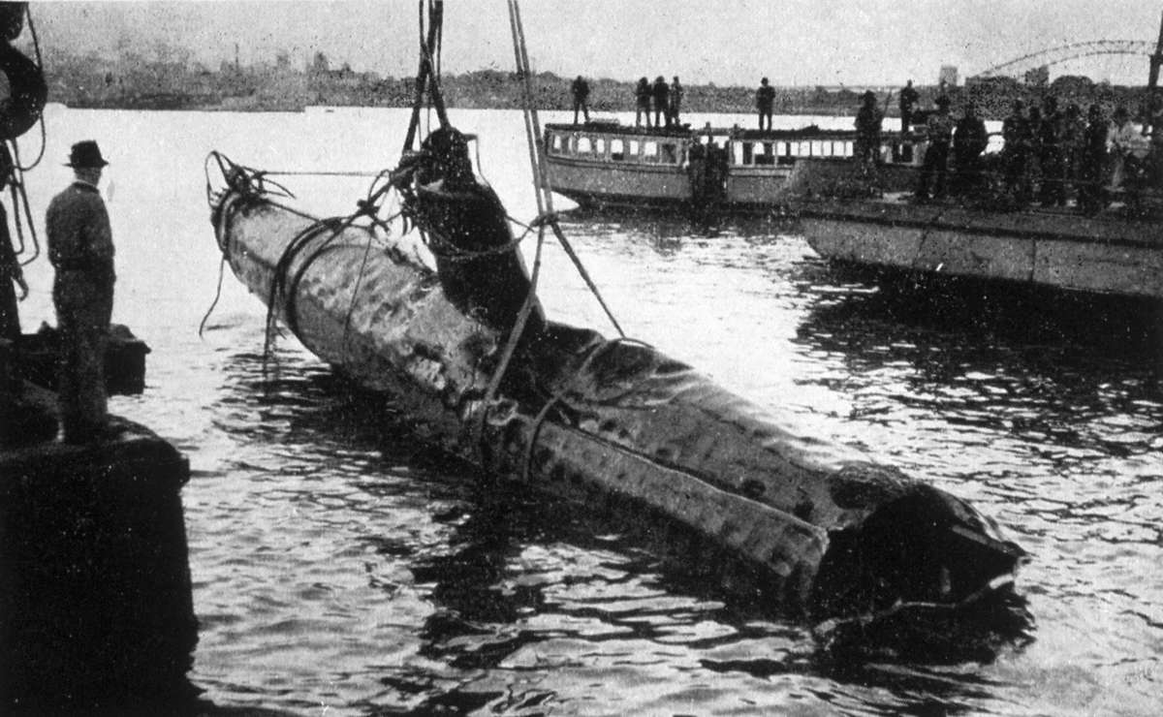

In 1942 the world was at war but Sydney, despite the fall of Singapore and the bombing of Darwin, felt immune. That complacency was shattered on 31 May when three Japanese midget submarines sneaked into Sydney Harbour and sank a ferry, killing 21 sailors.

The daring assault sparked fears of a Japanese invasion, and many residents sold up and fled to the Blue Mountains. But while the incident marked a turning-point for Australia, the events of that night have always been clouded by myth and rumour.

A documentary to be shown at the Sydney Film Festival this month attempts to set the record straight. Sydney at War - The Untold Story interweaves old footage with interviews with survivors, casting new light on an incident that shook the city out of its apathy.
The mission was an unsuccessful bid to divert Allied naval power from the decisive battle fought near Midway, in the Pacific, a week later. The submarines, part of a taskforce assembled to attack ships in enemy ports, were launched from a "mother" submarine 35 miles east of Sydney Heads.

Warrant Flying Officer Susumu Ito, who conducted a reconnaissance flight, told the film's director, Claude Gonzalez: "We knew little about Australia, except a few things, like it had a White Australia policy that did not allow migrants of coloured races ... the land was populated only on the east coast, the rest was virtually a desert."

As his seaplane flew low over the harbour, he observed that fully lit merchant ships were moving around, and lights were on at the airport. "It was clear that Sydney was not on alert," he said. "It was a carefree atmosphere."

At midnight the next day, the midget subs were dispatched, each crewed by two young men. All six knew they were heading for certain death. "The last day of my life arrived belatedly today," Petty Officer Masao Tsuzuku wrote to his two sisters before setting off. As Mr Ito said: "It was heart-rending for those of us who sent them. We knew it was for the sake of our country, but we wished they would somehow manage to come back alive."

After entering the harbour, the mini subs were trapped in torpedo nets. Bombarded by depth charges, Tsuzuku and his commanding officer, Lieutenant Keiu Matsuo, shot themselves. The occupants of a second sub were also found dead.

In the third were Petty Officer Mamoru Ashibe and Sub-Lieutenant Katsushisa Ban. Under attack from the USS Chicago, the sub fired two torpedoes. One failed to go off; the other passed in front of the Chicago and under the Kuttabul, exploding against the wall of Garden Island naval base and demolishing the ferry.

Seaman Neil Roberts had just finished sentry duty on the Kuttabul and his relief watch offered him his bunk on the top deck. "That saved my life," Mr Roberts said. The casualties were all on the main deck, where he usually slept. In the pandemonium, the survivors swam to the island, thrashing through the debris and the bodies of their comrades.

Many were convinced an air raid had taken place. The last thing anyone expected was a submarine attack. Arriving at the scene, Admiral Gerard Muirhead-Gould barked at his underlings: "What are you lot doing, running up and down the harbour dropping depth charges and talking about enemy submarines?"

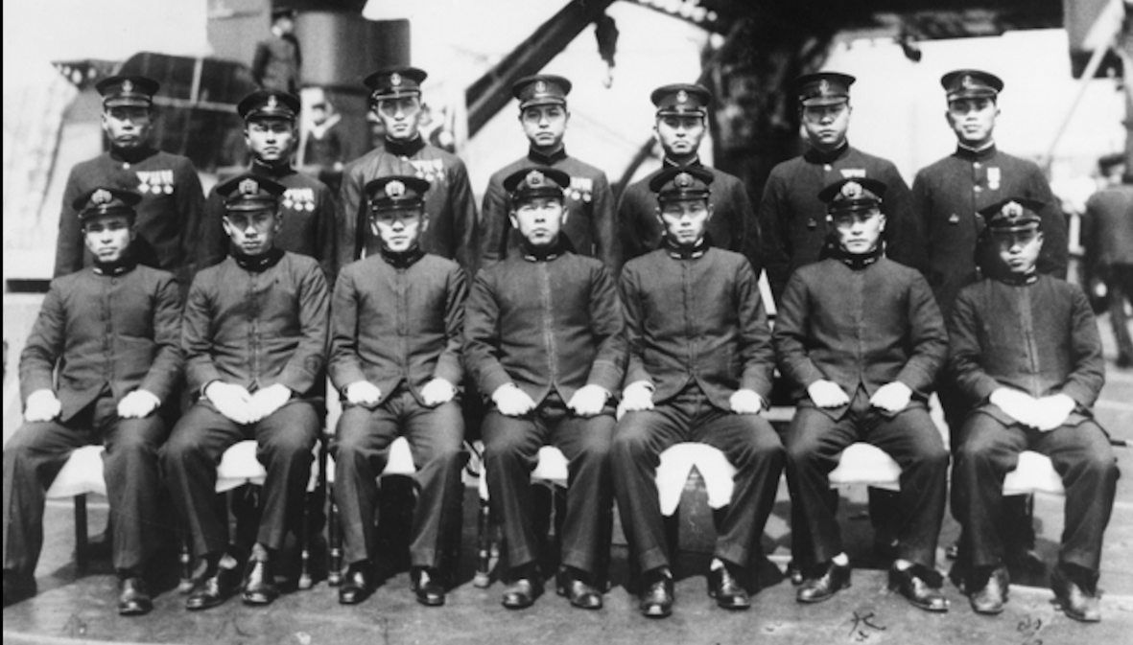

The following week, submarines shelled Sydney, reinforcing the realisation that - as one naval commander put it - "our isolation did not protect us from the horrors of war".
Mr Gonzalez said the film had been cathartic for the Japanese survivors, who had never talked about their experiences before. The war remains, to some extent, a taboo subject in Japan. Among those interviewed was Mr Ashibe's brother, Itsuo, still in deep grief 62 years on. The sub containing his brother was never found. "I longed for a memento, a glove if nothing else," he said. "I kept thinking he might turn up at home one day."

Sydney Morning Herald
Sydney Film Festival – Review by Garry Maddox - August 2, 2005

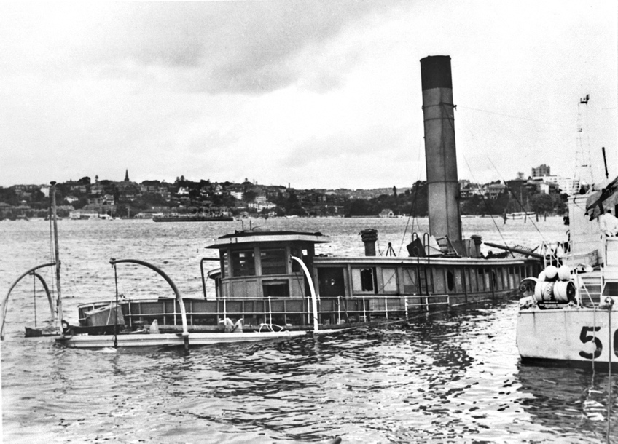

There are Sydney Harbour tours that can give you many of the historical details in this documentary, but for most Australians much of the information here will be new. On May 31, 1942, six Japanese infiltrated Sydney Harbour in three midget submarines. While they all died in the attack, some of their comrades and family are interviewed here, as are harbour patrol officers and survivors of the HMAS Kuttabul, which was sunk after a torpedo missed a nearby US warship.

It's clear that Sydney was completely unprepared and very fortunate that the results were not worse. The night before the attack a Japanese seaplane flew over the harbour and it is chilling to hear the pilot recall seeing no blackout, all lights on at the airport and a seemingly carefree attitude prevailing below.

Thankfully, the film isn't at all flag-waving or nationalistic. The path chosen by the director, Claude Gonzalez, is that of quiet, thoughtful remembrance, respectful to both sides and filled with the sorrow that such events naturally cause. Most moving is the comment from a Japanese man about the deep impression left on him when he heard our government had given his countrymen a naval funeral and sent their ashes home to Japan. Good viewing.

ACMI – Melbourne
Sydney at War. Written, directed, and produced by Claude Gonzalez.
Intriguing documentary about a midget submarine attack on Sydney Harbour by the Japanese during World War II. On the evening of 1st June 1942, a surprise offensive left twenty-one allied and six Japanese dead. Survivors, witnesses, and relatives, from both Australia and Japan, recount their memories of the event and how it still affects their lives today. A moving portrait of a singular incident that brought the realisation that the war was not an event happening overseas - how prepared was Australia for invasion? Using a mixture of archival, contemporary footage and interviews (and with a moving musical score composed by Sam Petty) this poignant documentary recalls in a personal way the lives and losses of those caught up in the perils of war.

