PRESS KIT

AUDREY NAPANANGKA IS A CHILI FILMS/BRINDLE FILMS PRODUCTION. PRINCIPAL PRODUCTION FUNDING FROM SCREEN AUSTRALIA, IN ASSOCIATION WITH NATIONAL INDIGENOUS TELEVISION FINANCED WITH SUPPORT FROM SCREEN TERRITORY

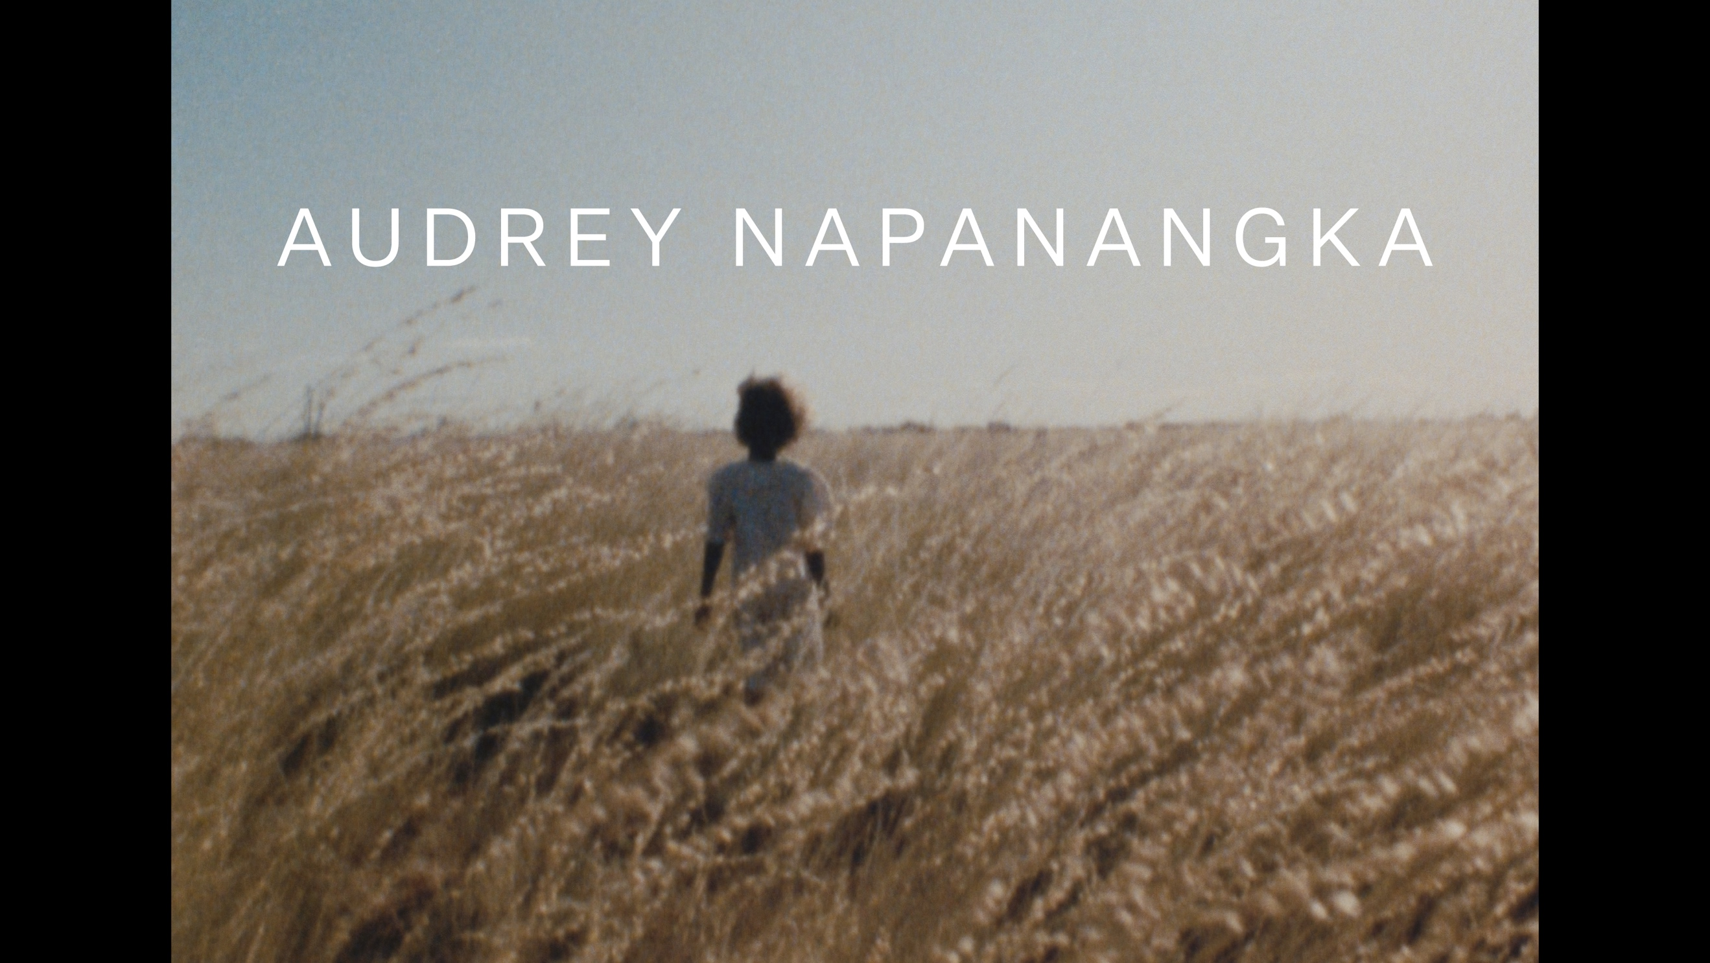

DIRECTOR PENELOPE MCDONALD IN COLLABORATION WITH AUDREY NAPANANGKA MARTIN
WRITERS PENELOPE MCDONALD AND DYLAN RIVER
PRODUCERS PENELOPE MCDONALD, TRISHA MORTON-THOMAS, RACHEL CLEMENTS



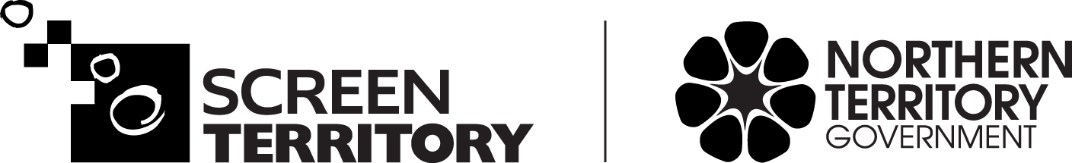

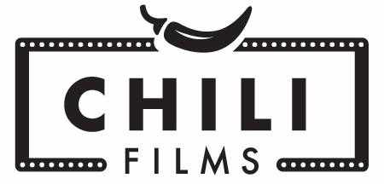

Chili Films +61 410 695 272 penelope@chilifilms.com.au
Brindle Films +61 414 484 472 rachel@brindlefilms.com.au
© 2022

AUDREY NAPANANGKA

SYNOPSIS

The story of a Warlpiri woman, Audrey, and her Sicilian partner Santo as they navigate through colonial systems to keep the children they care for together.

Audrey Napanangka was born at a time when the world was changing for the people in the Central Australian Desert. Settler colonisation was permeating the desert and forced changes and the fusion of two worlds shifted Audrey’s life forever. Today, Audrey raises young people to walk in many worlds, by centering culture, language, and Law in their lives alongside mainstream education. The intimate footage filmed over 10 years in Mparntwe (Alice Springs), Yuendumu and Audrey’s Warlpiri country Mount Theo, showcases a heartwarming story about the power of kinship and family in what is known as Australia.

ONE PAGE SYNOPSIS

Audrey Napanangka tells the story of Warlpiri matriarch Audrey, who was born at a time when the world was changing forever for people of the central Australian desert. Colonial settlements, relocation, displacement, and the forced removal of children as two worlds fused, ended in tragedy for Audrey and her young family. Despite this, she had a happy childhood which gave her the resilience to be the woman she is today.

With her Sicilian partner, Santo, Audrey uses her deep cultural knowledge to enrich the lives of others, and particularly her foster children, as she also gives them the skills for navigating the complex modern world.

Audrey lives in Alice Springs in the centre of Australia, hundreds of kilometres from her Country, the land of her forbears for thousands of years, where she was born and she grew up, south of the Tanami Desert.

She keeps a precarious balance between two worlds, the ancient desert law of the Warlpiri nation, and the modern-day town of Alice Springs. She has been with Santo for over 30 years and together they have provided a safe home for many Warlpiri children who have needed one.

In her 70s now, Audrey is an elder with a big extended Warlpiri family, who live between Alice Springs and small townships and communities hundreds of kilometres from Alice Springs. She looks after her family and has many obligations to fulfil. As one of the few family members with a house in Alice Springs she and Santo are called upon for support when family need to visit town for shopping, hospitals, or court.

Audrey has had a lifelong journey of raising children which has had its highs and lows.
As a grandmother and great grandmother, together with Santo, she still has teenagers in her care. To Audrey it is important that the children can navigate and thrive in two worlds, that of mainstream Australia, and that they know the language, laws and cultures of their forbears, and their connection to the land and skies of the central desert that is their birth right.

Life is not always easy, and we journey with Audrey and her family through the obstacles that they must overcome, as well as the good times.

In the end, family and love are everything.

DIRECTOR’s STATEMENT

Audrey Napanangka is Audrey’s story.

I have known Audrey for most of my adult life, for 40 years. I first met Audrey in the early 1980s, when we both lived in the small remote community of Lajamanu, at the top of the Tanami Desert. We both live in Mparntwe (Alice Springs).

It is more than 10 years ago when I was first drawn to making a film about Audrey. Her resilience and sense of wicked humour is the basis of our friendship and became the underpinning of the story that I began to document. Audrey is no stranger to film, having acted in small roles many films from Samson & Delilah, to Nulla Nulla to Rabbit Proof Fence. I first cast her in a community film in 1992. She was comfortable having me around her with a camera in hand. We have journeyed together through the past decade to create a story that portrays a small segment of this amazing Warlpiri woman’s life.

Audrey has been a true collaborator throughout the process, deciding what we could film and when, and then being involved in looking at the various edits. In telling Audrey’s story, we centre some of her family – her partner Santo, and some of the many children that she has raised.

The process involved observing and filming what was happening in Audrey’s life and that of her family. I did some of the filming myself, and at other times worked with different cinematographers, all of whom knew the family, and the family were easily comfortable with them. The story kept evolving because of what was happening in their worlds, and there was a need to be open to change.

The story thread that became clear as the filming progressed, and as events evolved in Audrey’s life, was the importance of generations of children to Audrey. Now she is raising two grandchildren with Santo and overcomes challenges as she enriches their lives with her deep cultural knowledge, at the same time as ensuring they gain strength to thrive in a colonised world. I saw Audrey fighting to keep her grandchildren while also remembering the children that she loved and lost in her youth. I wanted to honour and capture the memory of those children. I chose to use Super 8 as it gives a feel of the distant past, of echoes of memory.

This is Audrey’s film, not mine. I am embedded in the film, but this is a film for Audrey and her family, and I thank them immensely for sharing their story.

KEY CREDITS

SCREEN AUSTRALIA PRESENTS IN ASSOCIATION WITH NATIONAL INDIGENOUS TELEVISION WITH SUPPORT FROM SCREEN TERRITORY A CHILI FILMS AND BRINDLE FILMS PRODUCTION

FEATURING AUDREY NAPANANGKA, SANTO GIARDINA, MIRIAM WILLIAMS, LEANORAH WILLIAMS AND TYRESE JOHNSON

MUSIC FOR FILM BY DAVID BRIDIE
SOUND DESIGN BY LIAM EGAN
EDITED BY JAMES BRADLEY, JANE ST VINCENT WELCH AND KARRYN DE CINQUE
CINEMATOGRAPHY BY DYLAN RIVER, JUSTINE KERRIGAN ACS, SHANE MULCAHY, ANNA CADDEN, BONNY SCOTT, MIRIAM WILLIAMS AND PENELOPE MCDONALD
PRODUCED BY PENELOPE MCDONALD, TRISHA MORTON-THOMAS AND RACHEL CLEMENTS
DIRECTED BY PENELOPE MCDONALD IN COLLABORATION WITH AUDREY NAPANANGKA MARTIN
WRITTEN BY PENELOPE MCDONALD AND DYLAN RIVER

MADE ON THE LANDS OF THE ARRERNTE PEOPLE OF MPARNTWE AND THE WARLPIRI PEOPLE OF MOUNT THEO AND ON THE LANDS OF THE ANMATYERR PEOPLE.

FILMMAKERS BIOS

Penny McDonald – Writer Director Producer

Penny McDonald is an award-winning producer (Buckskin, SFF 2013, My Mother India, SFF 2002, My Bed Your Bed SFF 1992, Night Cries Cannes 1990,) and director (Too Many Captain Cooks SFF 1989). She has worked in the industry for over 35 years.

A directing and producing graduate of the Australian Film Television and Radio School, Penelope has directed documentaries including Too Many Captain Cooks, Travelling Warlpiris and Kamira: Pina Yanirlipa Ngurrarkurra, and the short dramas Life on Earth as I Know It and for television Safe Home.

As a creative producer, she has been integrally involved with the story of each production she has been involved with. In 2019 she produced First Nations Bedtime Stories, which aired on NITV. She produced Dylan River’s first documentary, Buckskin, which won the Sydney Film Festival Foxtel Award. She produced Safina Uberoi’s My Mother India, which also won the equivalent award, as well as many others nationally and internationally.

Other documentary producing credits include Mike Rubbo’s Much Ado About Something and Warwick Thornton’s Photographic Memory. Drama credits include many Indigenous short films, including Warwick Thornton’s first dramatic short Payback, Erica Glynn’s My Bed Your Bed and My Mother My Son, and Tracey Moffatt’s Night Cries: A Rural Tragedy.

She stepped out of direct filmmaking from 2004 to 2016, to be the inaugural director of the Northern Territory Government’s agency Screen Territory.

She has a diverse slate of feature films, documentaries, and web series in development.

Her productions can be found at:

www.chilifilms.com.au

Trisha Morton-Thomas – Co-Producer
Trisha Morton-Thomas is a First Nations Anmatyerr woman from Central Australia. She is a writer, producer, director, journalist, and actor who has an outstanding career in radio, film and television for over 30 years.
In her early career, Trisha worked for CAAMA making documentaries for Imparja TV, ABC and NITV including Destiny in Alice, Ridin’ Time, Bungalung and Finding Place. Later, she joined the newly established NITV eventually becoming Senior Commissioning Editor.
In 2021, Trisha wrote, directed, produced, and presented History Bites Back for NITV/SBS, a follow up and companion documentary to Occupation: Native, which won the Screen Producers of Australia Award for Best Documentary, an ATOM Award, and a Capricornia Award (DIFF).
Trisha is also a renowned Indigenous actor, supporting Debra Mailman as Jan Irving in the powerful ABC drama, Total Control. She plays Lola in 8MMM Aboriginal Radio (2015) – Australia’s first Aboriginal narrative comedy series which Trisha also wrote and produced. Trish also appears in the award-winning Redfern Now series 1 and 2 and played lead as May in Rachel Perkin’s directing debut – Radiance.

Rachel Clements – Co-Producer

Rachel Clements is co-founder of Brindle Films, with Trisha Morton-Thomas, a prominent screen production company in the Northern Territory and the recipient of the 2015 Screen Producers of Australia (SPA) Breakthrough Business Award.

Recent productions include MaveriX (children’s television drama series for ABC and Netflix, created by Rachel), and feature documentaries Finke: There and Back (Madman, Stan) and The Song Keepers (MIFF Premiere Fund). Rachel has produced drama projects including 8MMM Aboriginal Radio, the first Aboriginal comedy narrative series (ABC, co-created by Rachel), and Double Trouble, the first Indigenous children’s drama series for network television (Channel 9, Disney Australasia). Documentaries include Occupation: Native, Big Name No Blanket, Blown Away and Ochre and Ink.

Rachel’s productions have won AACTA and AWGIE awards and have screened at festivals including Sundance and Berlin.

AUDREY NAPANANGKA MARTIN – STORYTELLER

Audrey Napanangka Martin is a well-respected senior First Nations Warlpiri woman, an artist, and actor from Yuendumu Community, Central Australia.
She met Director Penelope McDonald in 1983 in the community of Lajamanu, Northern Territory. Audrey was working with the Council, operating the remote telephone services, and fostering a small girl. Penelope McDonald was a teacher and aspiring filmmaker. They struck up a friendship based on mutual respect, sharing and love of drama.
Audrey and Penelope worked together on a few short local productions. Audrey then acted in one of the early short dramas Penelope produced My Bed Your Bed (1997). This led to many small roles in acclaimed productions such as in Kings in Grass Castles (1998), Rabbit Proof Fence (2002), Monsters We Met (2003), Green Bush (2004), Sampson & Delilah (2009), Doors (2010), Nulla Nulla (2016), and Robbie Hood (2019).
Audrey has a strong visual arts career in painting since the mid 1980s having mentored by Netta Williams Napanangka (a well-known Warlpiri artist). For Audrey arts is a cultural practise, and she has been surrounded by painters since she was a small child. Both her parents were artists. Audrey often paints bush tucker (food) dreaming, water dreaming and ceremonial body painting images. Some of Audrey’s artworks and designs have been transferred onto fabrics.
Audrey uses her skill and the deep spiritual meanings behind Aboriginal art as well as understanding of the modern art world to nurture the next generation of Aboriginal artists including Miriam and Leanorah Williams.
Audrey’s mentoring and fostering of children while having an amazing professional artistic career inspired Penelope McDonald to want to document Audrey’s unique life. After 10 years of filming Audrey Napanangka had its world premiere at Sydney Film Festival in June 2022.

FESTIVALS

WORLD PREMIER SCREENING
Sydney Film Festival Finalist Documentary Australia Award June 2022

AWARDS
Finalist, Best Documentary, Sydney Film Festival 2022
Finalist, Best Direction Documentary Feature, Australian Directors’ Guild 2022
Best Social Documentary at the Beyond Borders International Film Festival, Greece 2023
Best Direction at Cyprus Archaeological Ethnographic & Historical Film Festival 2024

FESTIVALS
Melbourne International Film Festival August 2022
CinefestOZ August 2022
Darwin International Film Festival September 2022
Adelaide Film Festival October 2022
Brisbane International Film Festival November 2022

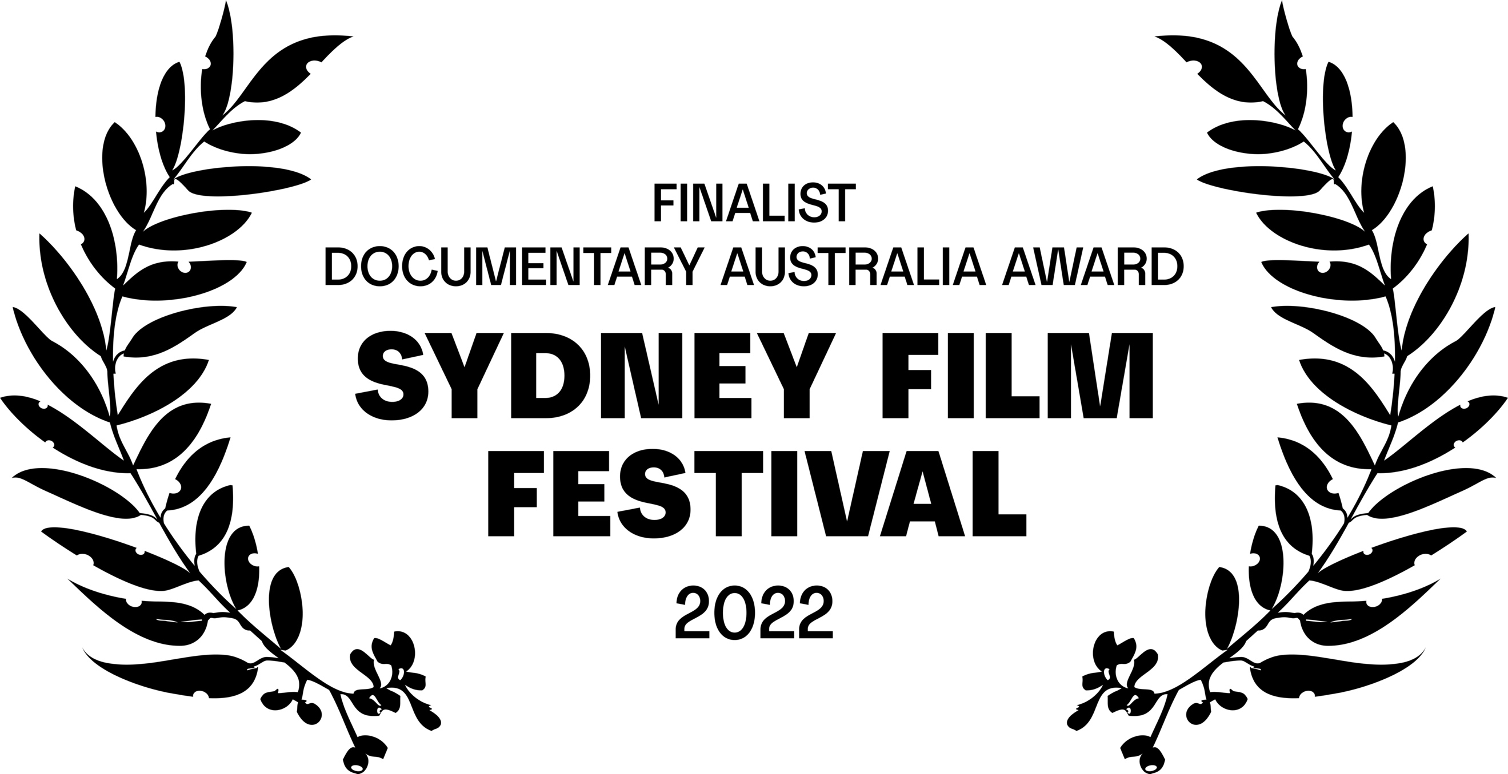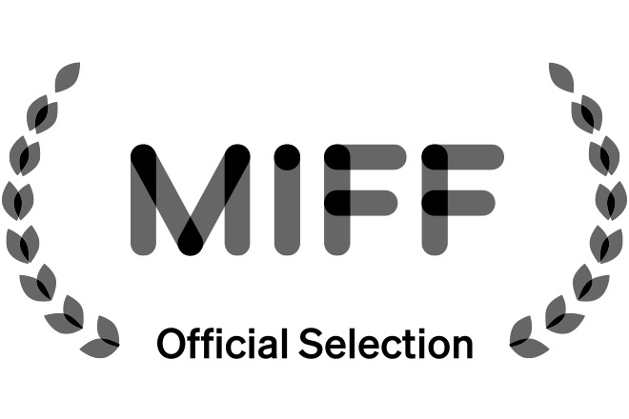

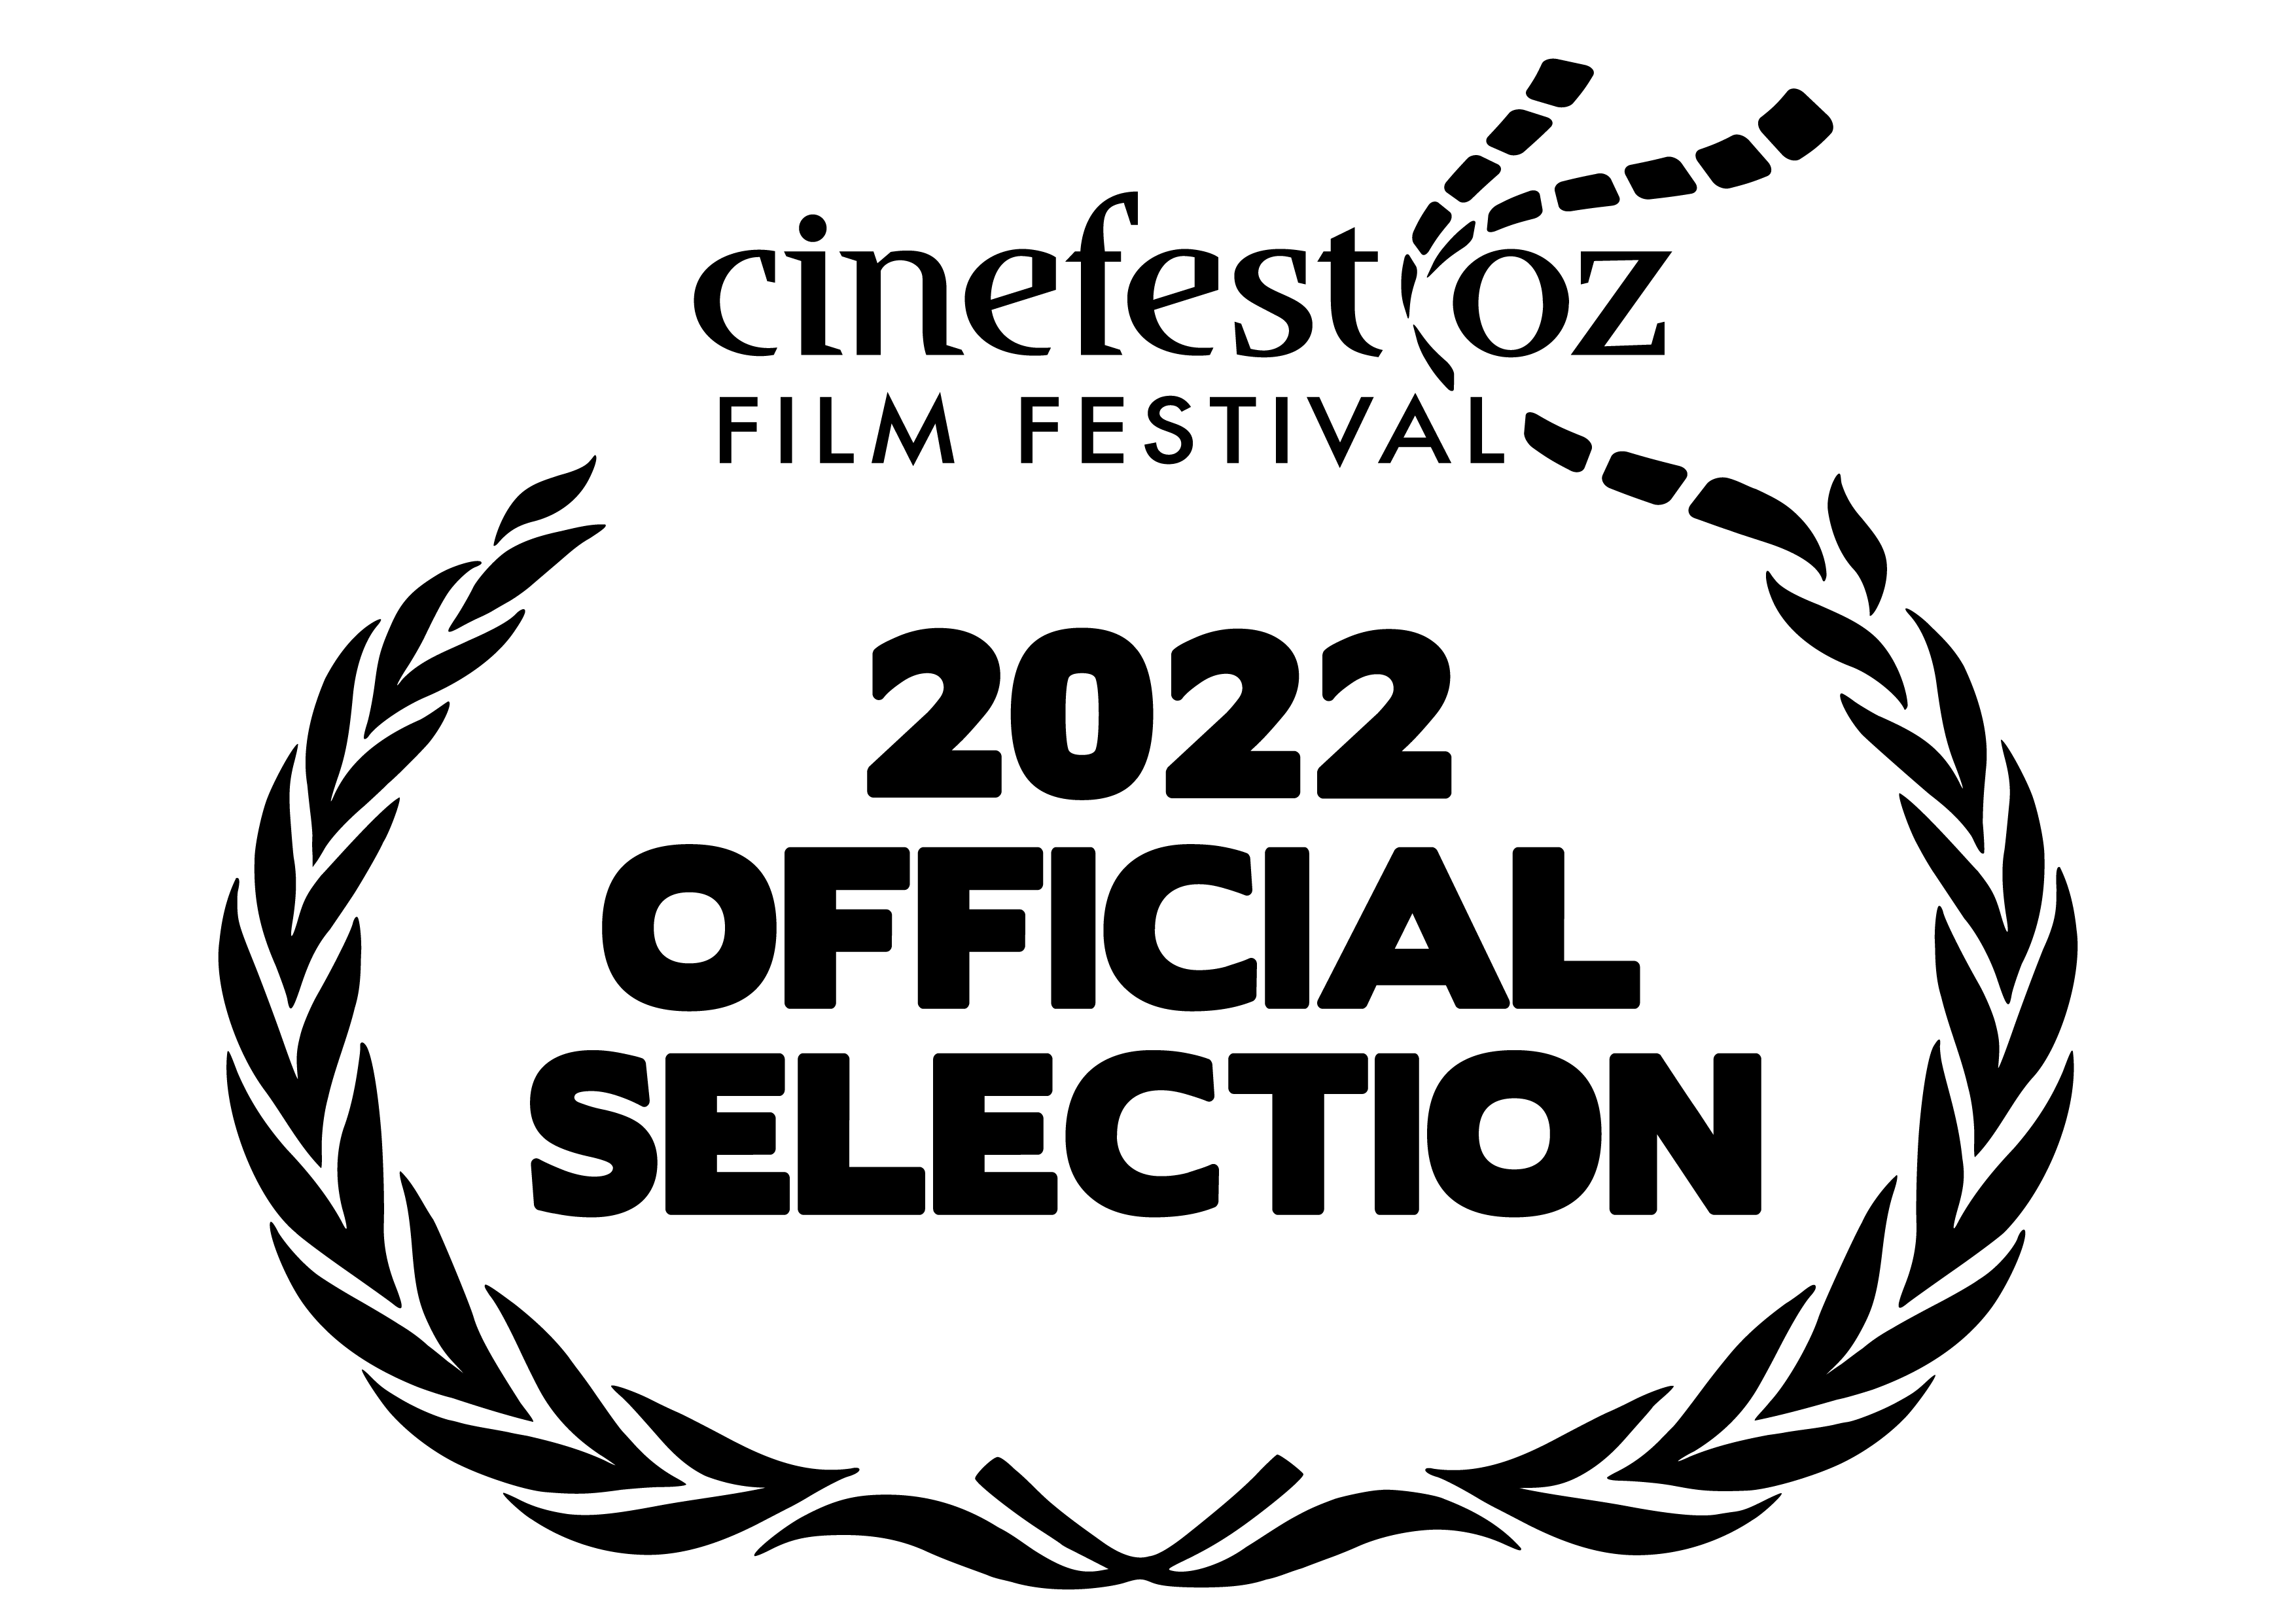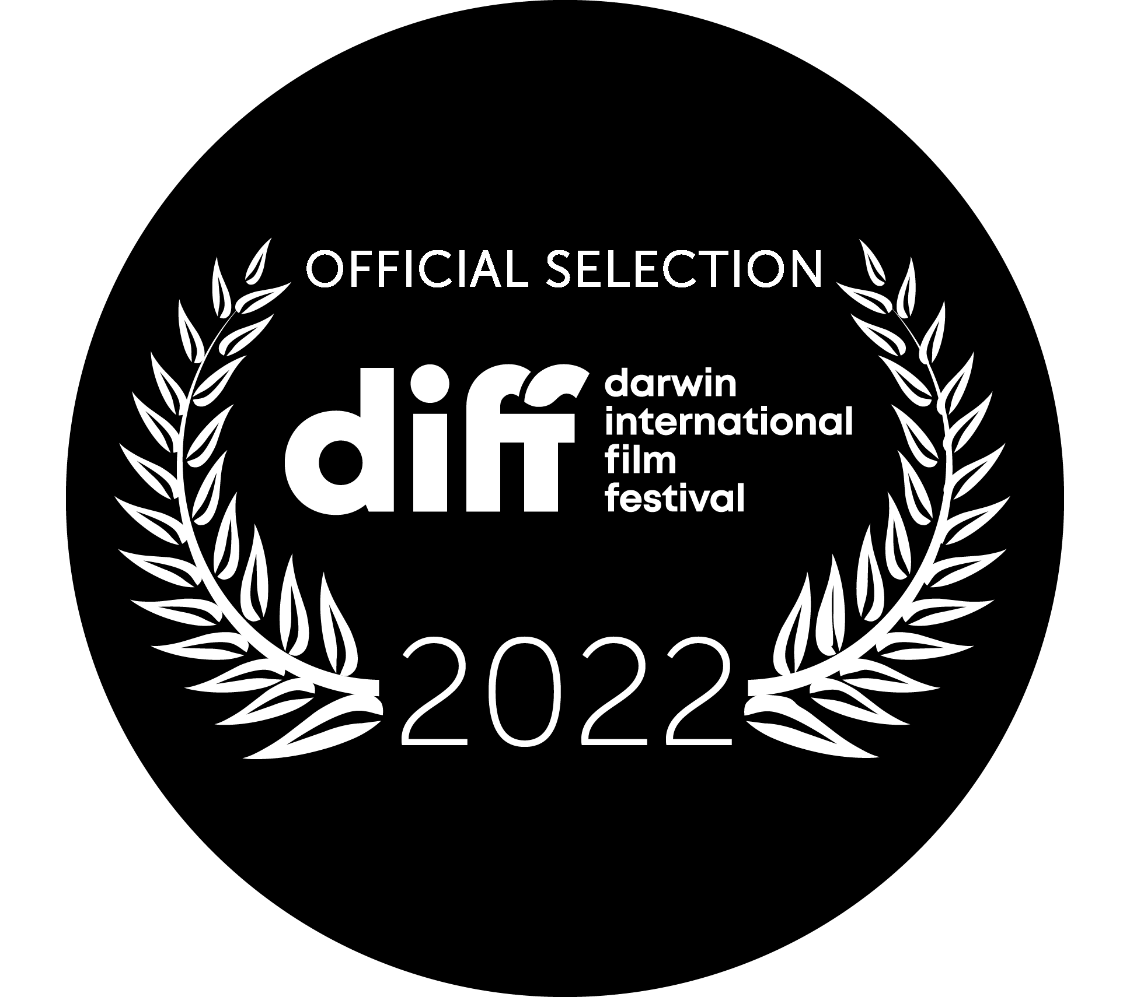

SBS On Demand
Available for private viewing on SBS on Demand

WEBSITE
Film Website www.audreynapanangka.film

SOCIAL MEDIA

Facebook @audreynapanangkafilm
Instagram @audreynapanangkafilm
TikTok

