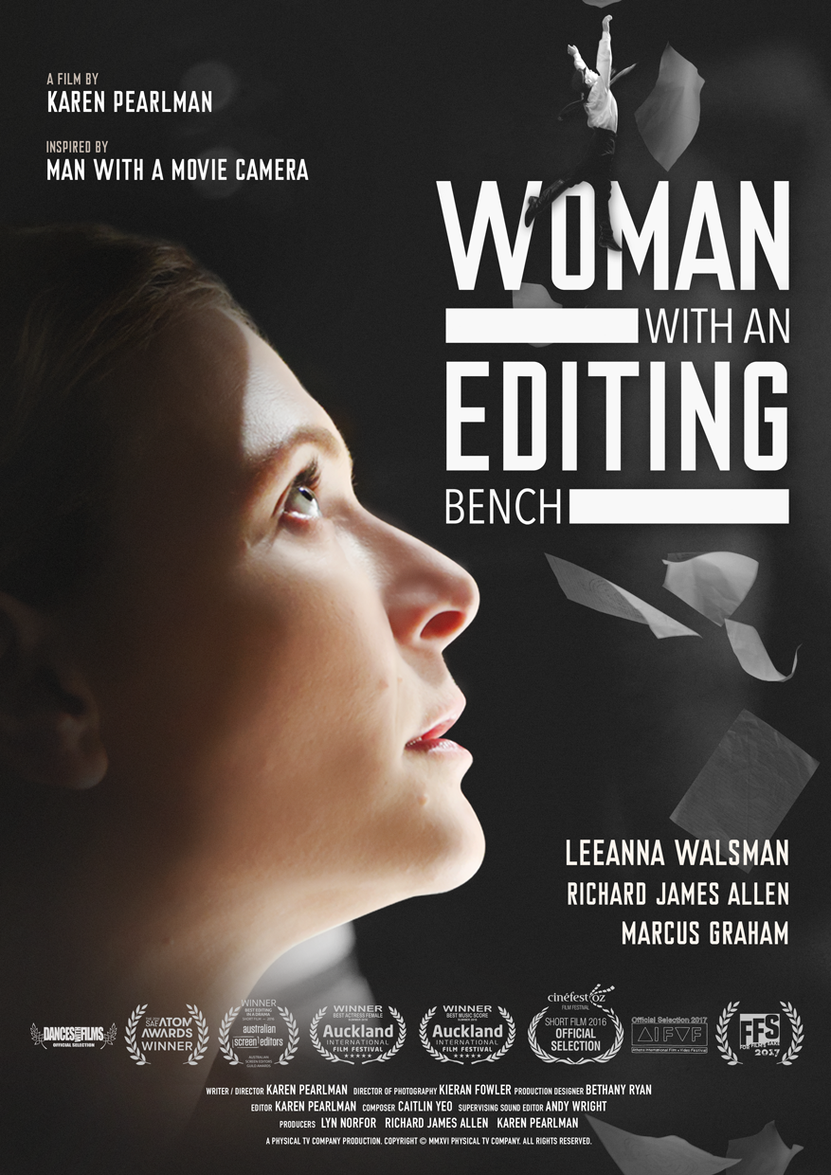

**IMDB**

[**https://www.imdb.com/title/tt5870326/reference**](https://www.imdb.com/title/tt5870326/reference)

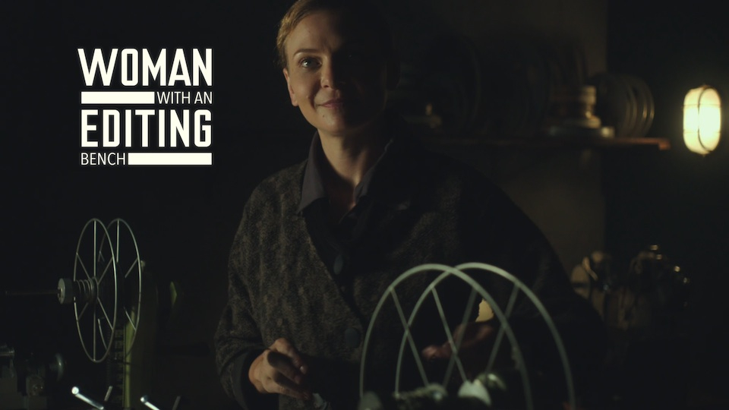

**WOMAN WITH AN EDITING BENCH**

**MEDIA KIT (English)**

**~ Awards – Winners & Nominations**

**~ Reviews**

**~ Screenings – Film Festivals**

**~ Logline**

**~ 30 Word Synopsis**

**~ 45 Word Synopsis**

**~ 100 Word Synopsis**

**~ 200 Word Synopsis**

**~ Director’s Statement**

**~ Director’s Approach**

**~ Producers’ Statement**

**~ Key Credits**

**~ Technical Specifications**

**~ Brief Biographies**

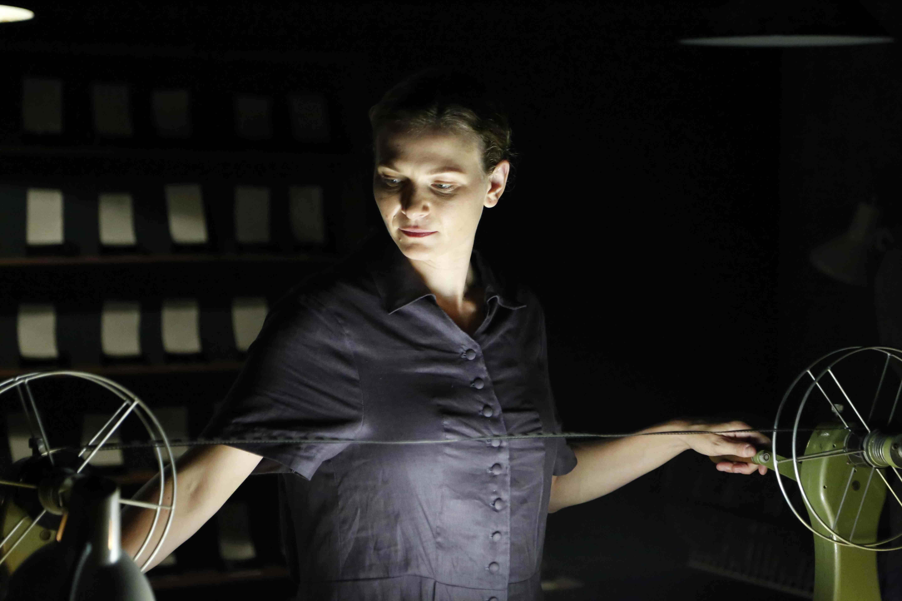

**WOMAN WITH AN EDITING BENCH**

**AWARDS - Winners**

SAE ATOM AWARDS 2016:

[Winner](http://atomawards.org/2016-tertiary-industry-category/best-short-fiction-50-minutes-or-less/), Best Short Fiction (50 Minutes Or Less)

AUSTRALIAN SCREEN EDITORS GUILD

ASE ELLIE AWARDS 2016:

[Winner](http://www.screeneditors.com.au/2016-ellie-award-nominees/), Best Editing in a Drama – Short Film

AUCKLAND INTERNATIONAL FILM FESTIVAL

Summer 2016:

Winner, Best Actress Female

AUCKLAND INTERNATIONAL FILM FESTIVAL

Summer 2016:

Winner, Best Music Score

WORLDFEST HOUSTON INTERNATIONAL FILM FESTIVAL 2017:

Historical Short Productions

Winner, Silver Remi Award

REEL SYDNEY FESTIVAL OF WORLD CINEMA 2017:

Best Short Film:

Special Jury Award

DANCES WITH FILMS 2017:

Winner, Grand Jury Awards: Best Short, Honorable Mention

SCRUFFY CITY FILM & MUSIC FESTIVAL 2017:

Winner, Best Editing

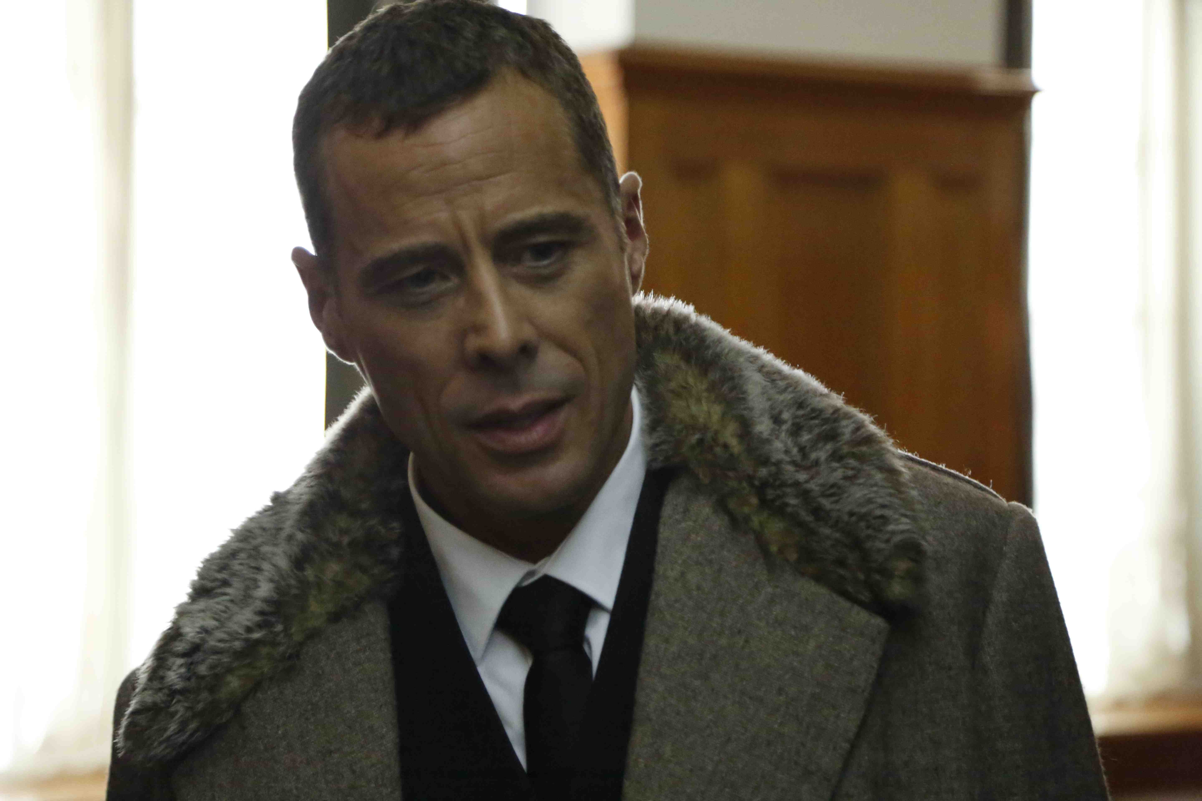

**WOMAN WITH AN EDITING BENCH**

**AWARDS - Nominations**

WOLLONGONG FILM FESTIVAL 2017:

Finalist, Best Short Film

BLOW-UP CHICAGO INTERNATIONAL ARTHOUSE FILM FEST 2017:

Finalist, Vittorio De Sica Award, Best Narrative Short (International)

SAE ATOM Awards 2016:

[Finalist](http://atomawards.org/2016-tertiary-industry-entry/woman-with-an-editing-bench/), Best Docudrama

AUSTRALIAN SCREEN SOUND GUILD

ASSG Awards 2016:   
[Nominee](http://assg.org.au/assg-awards-2016-nominations/), Best Sound for a Short Fiction Film

HEART OF GOLD INTERNATIONAL FILM FESTIVAL 2018:   
Nominee, Finalist Best Sound Design

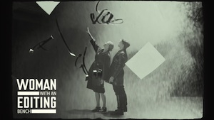

**WOMAN WITH AN EDITING BENCH**

**REVIEWS**

“A great standard-bearer for the art of cinema.”

**Dominic Case, author, *Film Technology in Post Production***

“In *Woman with an Editing Bench* we follow Svilova and her husband Dziga Vertov grappling with a hostile bureacracy, being denied resources, raided and obstructed, discussing the aesthetics of a way to proceed, and trying to salvage their project. I relished the physicality of the film making that was depicted, the editing room filled with cuts, the editing and viewing machinery, the flick and pull of the film stock, Svilova searching the film to find exactly the right shot, sharing them with Vertov, all under pressure of time, other work, and the suspicion of their art by the authorities. All those ideas, thoughts, possibilities, on the editing bench, the passion of their endeavour, and the tension around the threats to them, is compelling.

‘The editing room is where documentary is made,’ says Vertov. We experience this in watching the drama of editing, and in the editing of *Woman with an Editing Bench* itself. Svilova’s flashes of thoughts and emotions are revealed in montage (the mind of the editor) in a poetic and exhilerating characterisation and point of view. This is a story inspired by Svilova and Vertov’s work together, and makes central the role that Svilova played, with her skill, her savvy, and determination. Later, she ensured Vertov’s legacy by smuggling his archives out of Russia, allowing their work to continue to inspire the rest of the world. Pearlman is repositioning Svilova’s vision (and her female colleagues) as central to the revolutionary film movement. Leanna Walshman and Richard James Allen play the lead roles and their energies depict a convincing creative, working, and intimate partnership. Marcus Graham is suitably noirish and gnarly as the evil bureaucrat.”

**Sarah St Vincent-Welsh**, “Reclaiming women’s position in film making history”, *Rochford Street Review*, June 09, 2020

<https://rochfordstreetreview.com/2020/06/09/flashes-of-thoughts-and-emotions-sarah-st-vincent-welch-reviews-three-films-by-karen-pearlman/>

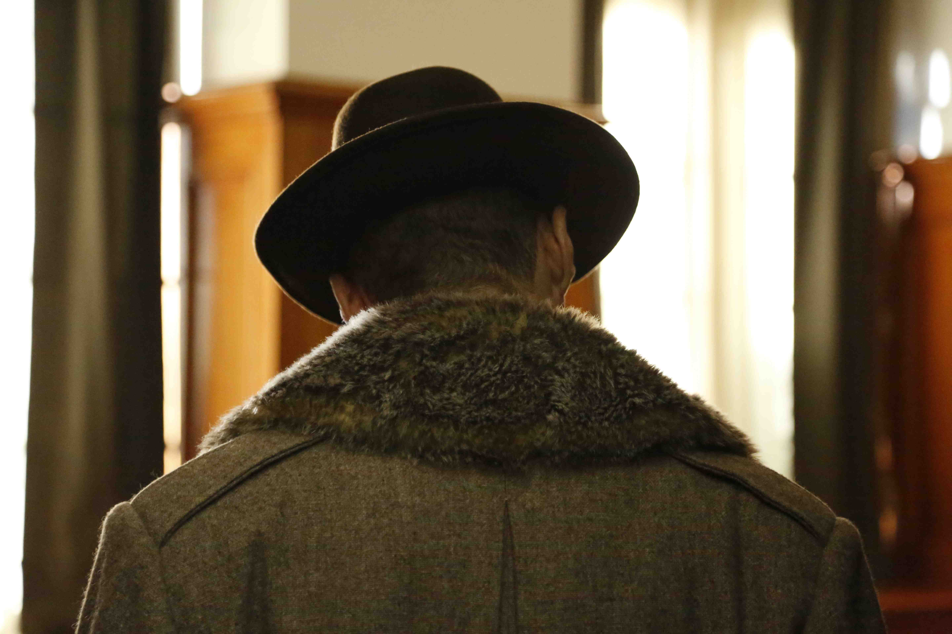

**WOMAN WITH AN EDITING BENCH**

**REVIEWS *(cont’d)***

“The title of the first film in the series, “Woman with an Editing Bench” (2016), is a play on director Dziga Vertov’s film “Man with a Movie Camera”, and focuses on Vertov’s wife Elizaveta Svilova, whose editing of Vertov’s famous film was pivotal to the film’s success. Her role in Vertov’s work is explored here, but also the nature of creativity, inspiration, oppression and perseverance. The creative relationship between Svilova and Vertov is a story of its own, subtly and powerfully depicted through facial expressions and body language. What really stands out though is the cinematography, which mirrors Svilova’s innovative editing techniques, applying subjective and often abstract visualisations, repetition, and surreal sequences such as synopses papers flying out of the window, Vertov falling, film reels unspooling, Svilova and Vertov dancing amidst a shower of flour, or Svilova holding Vertov in her arms. These sequences presented from Svilova’s point of view gives the film a poetic quality.

**Magdalena Ball**, **“A review of Karen Pearlman’s Woman with an Editing Bench, After the Facts, and I want to make a film about women”, *Compulsive Reader****,* August 9, 2020: <http://www.compulsivereader.com/2020/08/09/a-review-of-karen-pearlmans-woman-with-an-editing-bench-after-the-facts-and-i-want-to-make-a-film-about-women/>

“Thank you for submitting *Woman with an Editing Bench*to the Washington Jewish Film Festival. It was a beautifully realized portrait of an artist—and a whole branch of filmmaking—that is too often overlooked. The production quality, acting and script all sung in harmony, and your short is truly a wonderful work of art. Quite fitting as it takes on one of my favorite films of all time! I’m sure DC audiences will be captivated.” **Ilya Tovbis, Director, Washington Jewish Film Festival**

"One of the highlights [of [CinefestOz](http://tix.cinefestoz.com/session_cine.asp?sn=Woman+with+an+Editing+Bench&s=213)] was the premiere screening of [Karen Pearlman](http://www.screeneditors.com.au/membership-details-2/?authorId=1805)’s short film “Woman With An Editing Bench” … a beautifully realised and brilliant homage to Svilova and a celebration of the art of film editing. Karen has not only captured the spirit of the time but she’s recreated the look and feel of Vertov’s and Svilova’s work.  Indeed some shots I could have sworn were taken directly from their original films.  Every editor will identify with the themes she’s exploring. And there are some notable scenes in the film that made me want to punch the air and shout Yes!  Watch out for it when it screens and read Karen’s book [[*Cutting Rhythms: Intuitive Film Editing*](https://www.routledge.com/Cutting-Rhythms-Intuitive-Film-Editing-2nd-Edition/Pearlman/p/book/9781138856516) (Focal Press)].

**Lawrie Silverstrin, *Australian Screen Editors Guild (ASE) e-News*​**

“Woman with an Editing Bench does more than reclaim a piece of cinema’s founding story: it aims to understand editors’ broader role in the process of co-writing and producing films. … Where (the film) differs from most other new short films is that it also qualifies as an original contribution to scholarly thought, having been produced through Macquarie University’s Creative Ecologies Lab, a haven within the academy for around 20 artist-scholars working in dance, performance, music, creative non-fiction and film.”

**Lauren Carroll Harris, *RealTime***

[**www.realtime.org.au/woman-with-an-editing-bench-how-do-film-editors-think/**](http://www.realtime.org.au/woman-with-an-editing-bench-how-do-film-editors-think/)

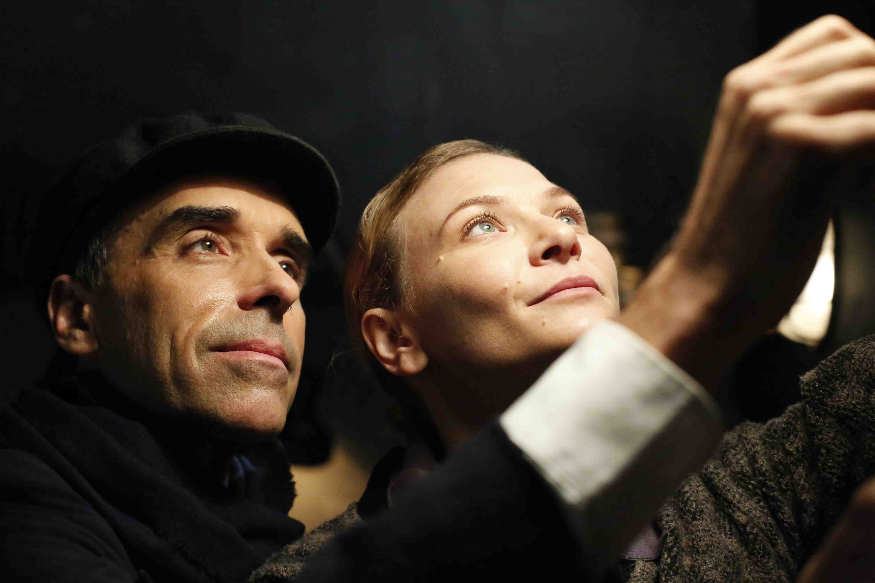

**WOMAN WITH AN EDITING BENCH**

**SCREENINGS – Film Festivals**

CinéfestOZ, WA, Australia, 2016

Athens International Film + Video Festival, OH, USA, 2017

For Film’s Sake, Sydney, NSW, Australia, 2017

Reel Sydney Festival of World Cinema, NSW, Australia, 2017

Dances with Films, Los Angeles, CA, USA, 2017

Queensland International Film Festival, Brisbane, QLD, Australia, 2017

Revelation Perth International Film Festival, WA, Australia, 2017

Brisbane International Film Festival, QLD, Australia, 2017

Film Score and Scruffy City Film & Music Festival, Knoxville, TN, USA, 2017

HollyShorts Film Festival, Los Angeles, CA, USA, 2017

Women Media Arts and Film Festival, Sydney, Australia, 2017

SCAD Savannah Film Festival, Georgia, USA, 2017

Noosa International Film Festival, QLD, Australia, 2017

Wollongong Film Festival, NSW, Australia, 2017

Russian Film Festival, Moscow, Russia, 2017

Manchester Film Festival, UK, 2018

Chicago Feminist Film Festival, USA, 2018

Washington Jewish Film Festival, USA, 2018

Oneata Film Festival, Decorah, Iowa, USA, 2018

Washington Jewish Film Festival, USA, 2018

Dance on Camera , New York USA, 2018

Female Eye Film Festival, Toronto, Canada, 2018

Heart of Gold International Film Festival, Gympie, QLD, Australia, 2018

Cosmic Visions: Visionary Russian Cinema, Art Gallery of NSW, Sydney, Australia, 2018

Bondi Cinema Club, Sydney, Australia, 2019

Kyiv Film Festival, Kyiv, Ukraine, 2019

Pacific Meridian International Film Festival, Vladivostok, Russia, 201

IF Maitland Indie Festival, Maitland, Australia (trilogy screening), 2021

Short Screens, Brussels, Belgium, 2021

SELECTED SCREENINGS – Educational

ASPERA Conference, Canberra, ACT, Australia, 2016

Centre for Media History, Media Histories Conference, Macquarie University, 2016

Faculty Research Showcase, CAPA International Education, Sydney, 2016

The Faculty of Arts Themed Workshop, Macquarie University, Sydney, 2016

Society for Cognitive Studies of the Moving Image (SCSMI), Aalto University, Helsinki, Finland, 2017

Swedish Film Editors Guild, Stockholm, Sweden, 2017

Visual Arts, the Senses and the Brain Symposium, University of Sydney, 2017

The Faculty of Arts Creative Research Seminar Series, Macquarie University, 2017

MeCCSA annual conference at Southbank University, London, 2018

Zurich International Documentary Conference, Switzerland, 2018

St Petersburg Cultural Forum, St Petersburg, Russia, 2020

Women in Film and Television (WIFT), Perth WA, 2020

Australian Screen Editors and the Australian Directors’ Guild trilogy screening

at Griffith University, Brisbane, Australia, 2021

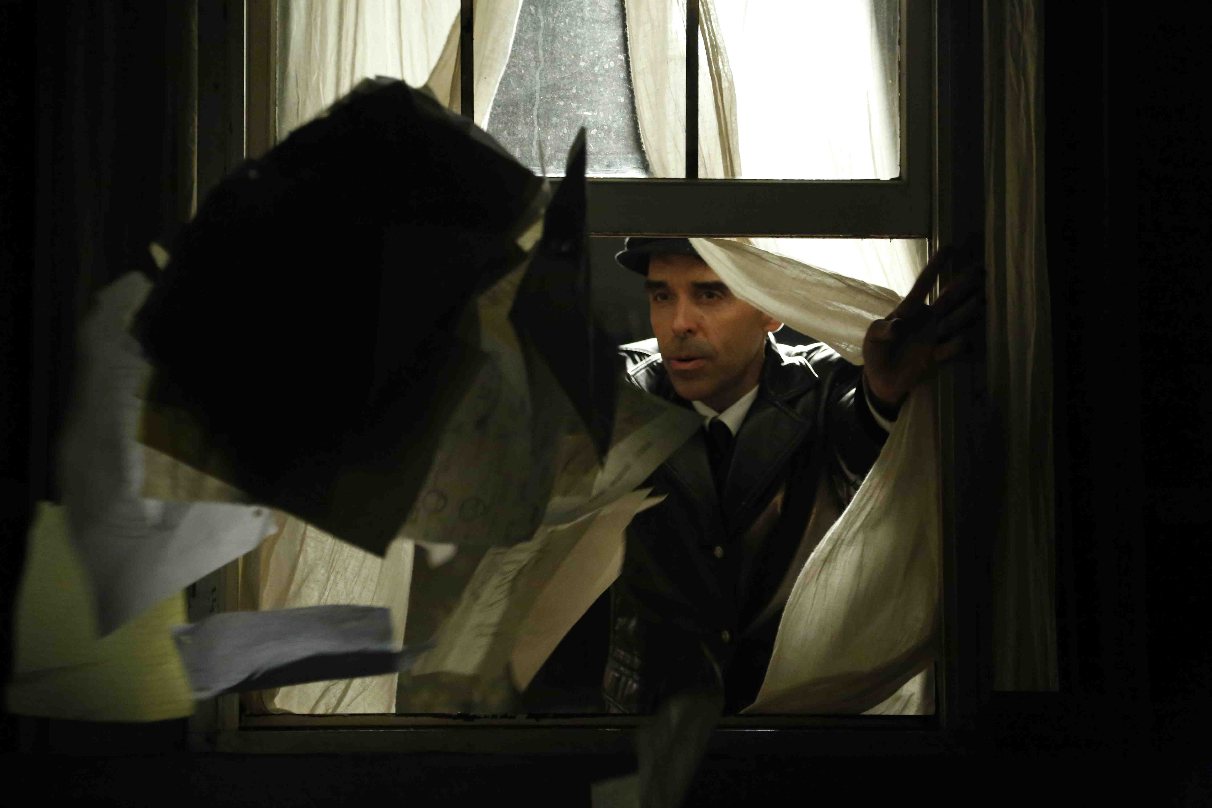

**WOMAN WITH AN EDITING BENCH**

**LOGLINE**

Soviet Union, 1930s: An editor has to save her film and save her husband from Stalin's suppression.

**32 WORD SYNOPSIS**

Inspired by the editor of “Man with a Movie Camera” (1929). In Stalinist Russia, a woman navigates politics, bureaucracy and the impetuous outbursts of collaborators to create something extraordinary despite the odds.

**45 WORD SYNOPSIS**

Inspired by the woman who edited Man with a Movie Camera (1929), Woman with an Editing Bench reveals the personal impact of Stalin’s censorship of cinema on a woman navigating politics, bureaucracy and the impetuous outbursts of collaborators to create something beautiful despite the odds.

**100 WORD SYNOPSIS**

**Inspired by a true story, "Woman with an Editing Bench" celebrates Elizaveta Svilova, the editor of Dziga Vertov’s 1929 masterpiece "Man with a Movie Camera" (#1 on the "Sight and Sound" list of Best Documentaries of all time). By referencing Svilova’s own kinetically exhilarating montage style, “Woman with an Editing Bench” reveals her fierce tenacity and fleet thinking as she dodges the bureaucracy and sustains revolutionary filmmaking in spite of Stalin’s oppression. "Woman with an Editing Bench" is “a beautifully realised and brilliant homage to Svilova and a celebration of the art of film editing”, Lawrie Silverstrin, ASE, Australian Screen Editors Guild Newsletter, September 2016.**

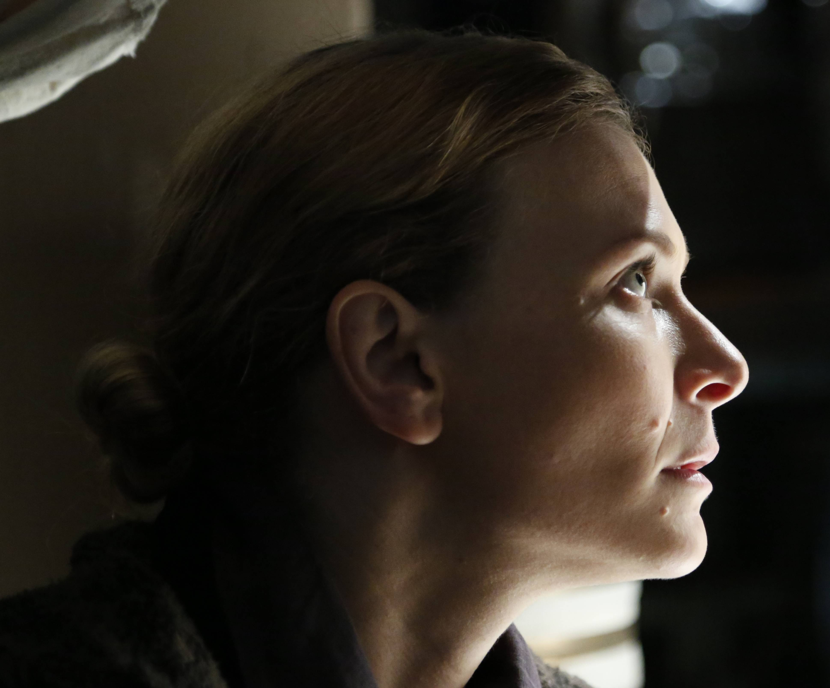

**WOMAN WITH AN EDITING BENCH**

**200 WORD SYNOPSIS**

**Inspired by a true story, "Woman with an Editing Bench" pays homage to the creativity of Elizaveta Svilova – the unsung editor behind Dziga Vertov’s 1929 documentary masterpiece "Man with a Movie Camera" (No 1 on the "Sight and Sound" list of Best Documentaries of all time). It uses her revolutionary editing techniques to reveal her thoughts and recuperate her legacy in the history of cinema.**

**"Woman with an Editing Bench” is about sustaining creativity and fighting repression. In 1930s Russia, Dziga Vertov and Elizaveta Svilova make radical, groundbreaking films. Stalin, threatened by their innovations, wants his henchmen to suppress them. Vertov, unhappy and artistically constrained, is inept at working with the bureaucracy. Svilova knows how to work the system laterally and from behind the scenes – as all great editors do. She is also adept at working with Vertov’s mind, understanding what he wants to say and how he wants to say it. Svilova’s editing makes Vertov’s genius possible. Vertov’s eccentricity makes Svilova’s editing genius indispensable.**

**"Woman with an Editing Bench" is “a beautifully realised and brilliant homage to Svilova and a celebration of the art of film editing” ~ Lawrie Silverstrin, ASE, “Australian Screen Editors Guild Newsletter”, September 2016.**

.

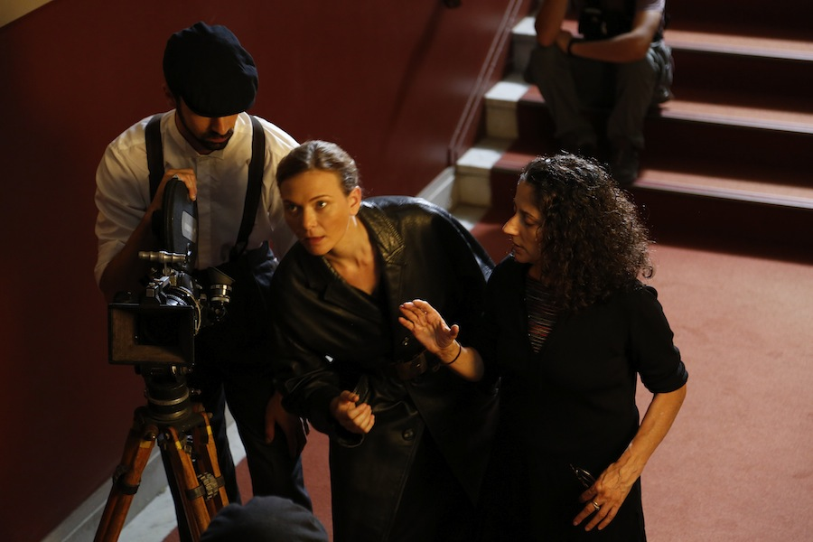

**WOMAN WITH AN EDITING BENCH**

**DIRECTOR’S STATEMENT**

**by Karen Pearlman**

*Man with a Movie Camera* is # 1 on the *Sight and Sound* Critics list of Best Documentaries ever made, and # 8 of the 10 Best Films ever made. Its greatness lies in its spectacular, inventive and kinetically daring editing. But the woman who actually cut the film, Elizaveta Svilova, is virtually invisible to history. By telling a story from her point of view and using the editing techniques that she devised, *Woman with an Editing Bench* explores the perspective and contributions of editors and women, celebrating the creative art of editing and a true cinema pioneer.

*Woman with an Editing Bench* is about the fight for creativity in the face of repression. In the 1930s Soviet Union Stalin has personal approval over all films and film scripts. Director Dziga Vertov and editor Elizaveta Svilova make radical and groundbreaking documentaries. Stalin is threatened by their formal innovations, he wants his henchmen to shut down their creativity. Vertov, unhappy and artistically constrained, is inept at understanding how to work within the bureaucracy. Svilova is savvy and knows how to work the system laterally and from behind the scenes – as all great editors do. She is also adept at working with Vertov’s mind, understanding what he wants to say and how he wants to say it. Svilova’s editing makes Vertov’s genius possible. Vertov’s eccentricity makes Svilova’s editing genius indispensible.

When Svilova finally wrangles approval to shoot in a bakery, the two of them are seen in their element, shooting the vibrant montage that justifies their struggle to create. They work together and think together, they become part of the film they are making, and imagine it vividly as it will be when edited. But when the shoot is finished and they review the footage, they find some of it is missing. The bureaucrat in charge reveals that the footage isn’t missing, it has been withheld. Vertov’s clumsy attempt to challenge the bureaucrat gets his project cancelled. Vertov seems to give up and to be dying a metaphorical death. But Svilova saves the key footage and pushes on, attempting thereby to save Vertov through the completion of their film.

**r**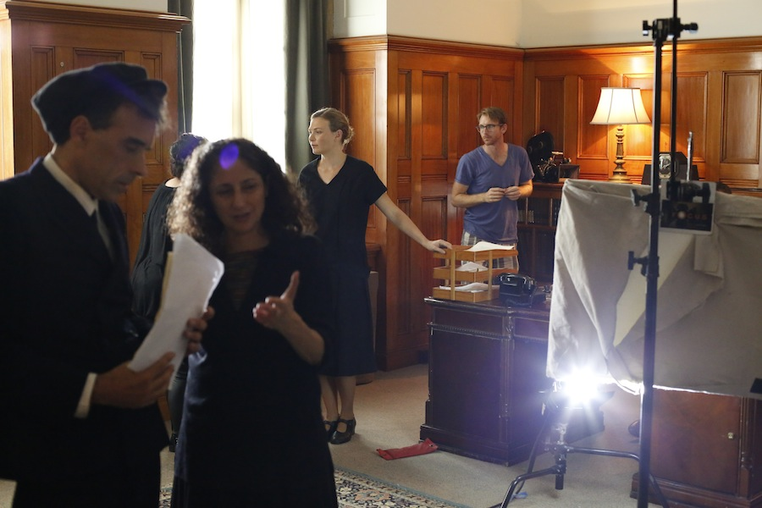

**WOMAN WITH AN EDITING BENCH**

**DIRECTOR’S APPROACH**

**by Karen Pearlman**

Svilova’s own work is the key reference for this project. The story unfolds from her point of view and, as it does so, we see flashes of her subjective perspective. These subjective sequences are shot in a highly expressionist style, referencing the exaggerated performances, angles and high contrast black and white imagery of early Soviet Cinema. We also, in the course of the story, see sequences that reference those that Svilova might have worked on herself, such as the women smiling, the bean factory, and the final montage sequence. These are shot and edited to maximise the patterning of movement and emulate her percussive and kinesthetically energised style.

I envision this short film as proof of concept for a much longer film, inspired by the life and work of this great editor and telling the whole story of how Svilova’s creative thinking saved projects and maybe even Vertov’s life on more than one occasion.

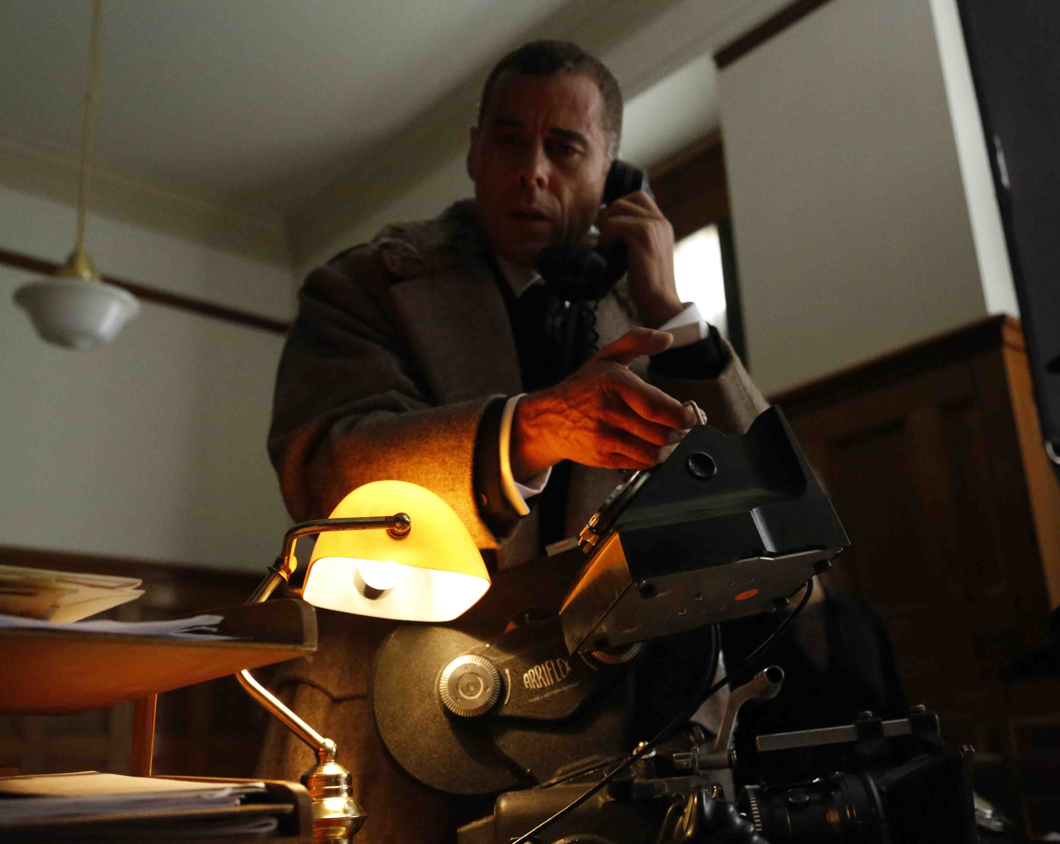

**WOMAN WITH AN EDITING BENCH**

**PRODUCERS’ STATEMENT**

WOMAN WITH AN EDITING BENCH is a unique fictional interpretation of the extraordinary Soviet creative team of Vertov and Svilova who created MAN WITH A MOVIE CAMERA – one of the greatest documentaries of all time. The director, Vertov, is well known and his legacy is studied in most film schools around the world but his creative and life partner, Svilova, is less well known. Svilova worked as an editor on all of their films together as well as many other Russian documentaries.

Karen Pearlman, the director of WOMAN WITH AN EDITING BENCH, herself an editor, has passionately and beautifully realised her vision of Svilova, her work and relationship with Vertov. Using archival material, diaries, black and white footage shot on film and dramatic re-enactments, Karen has woven together a magical short film that transports the audience into Svilova’s world in 1940’s Soviet Russia.

In the current social and media conversation about gender equality and gender balance, particularly in the arts, Karen has elevated Svilova to her rightful place beside Vertov and recognised their jointly-achieved genius. WOMAN WITH AN EDITING BENCH is a timely and contemporary film that will resonate with audiences and film lovers around the world.

We had a wonderful team and many supporters we worked with to produce WOMAN WITH AN EDITING BENCH and we thank them all for their commitment and support.

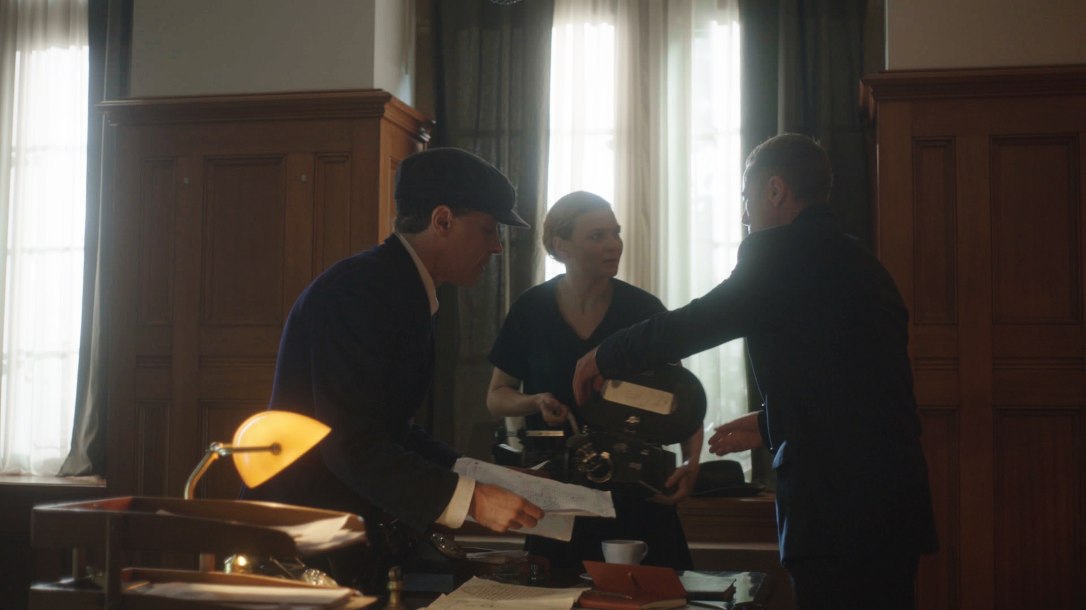

**WOMAN WITH AN EDITING BENCH**

**KEY CREDITS**

LEEANNA WALSMAN as Elizaveta Svilova

RICHARD JAMES ALLEN as Dziga Vertov

MARCUS GRAHAM as Boris Shumyatsky

Writer & Director

Karen Pearlman

Producers

Lyn Norfor

Richard James Allen

Karen Pearlman

Director of Photography

Kieran Fowler

Production Designer

Bethany Ryan

Costume Designer

Anna Cahill

Editor

Karen Pearlman

Music

Caitlin Yeo

Supervising Sound Editor

Andy Wright

A Physical TV Company Production

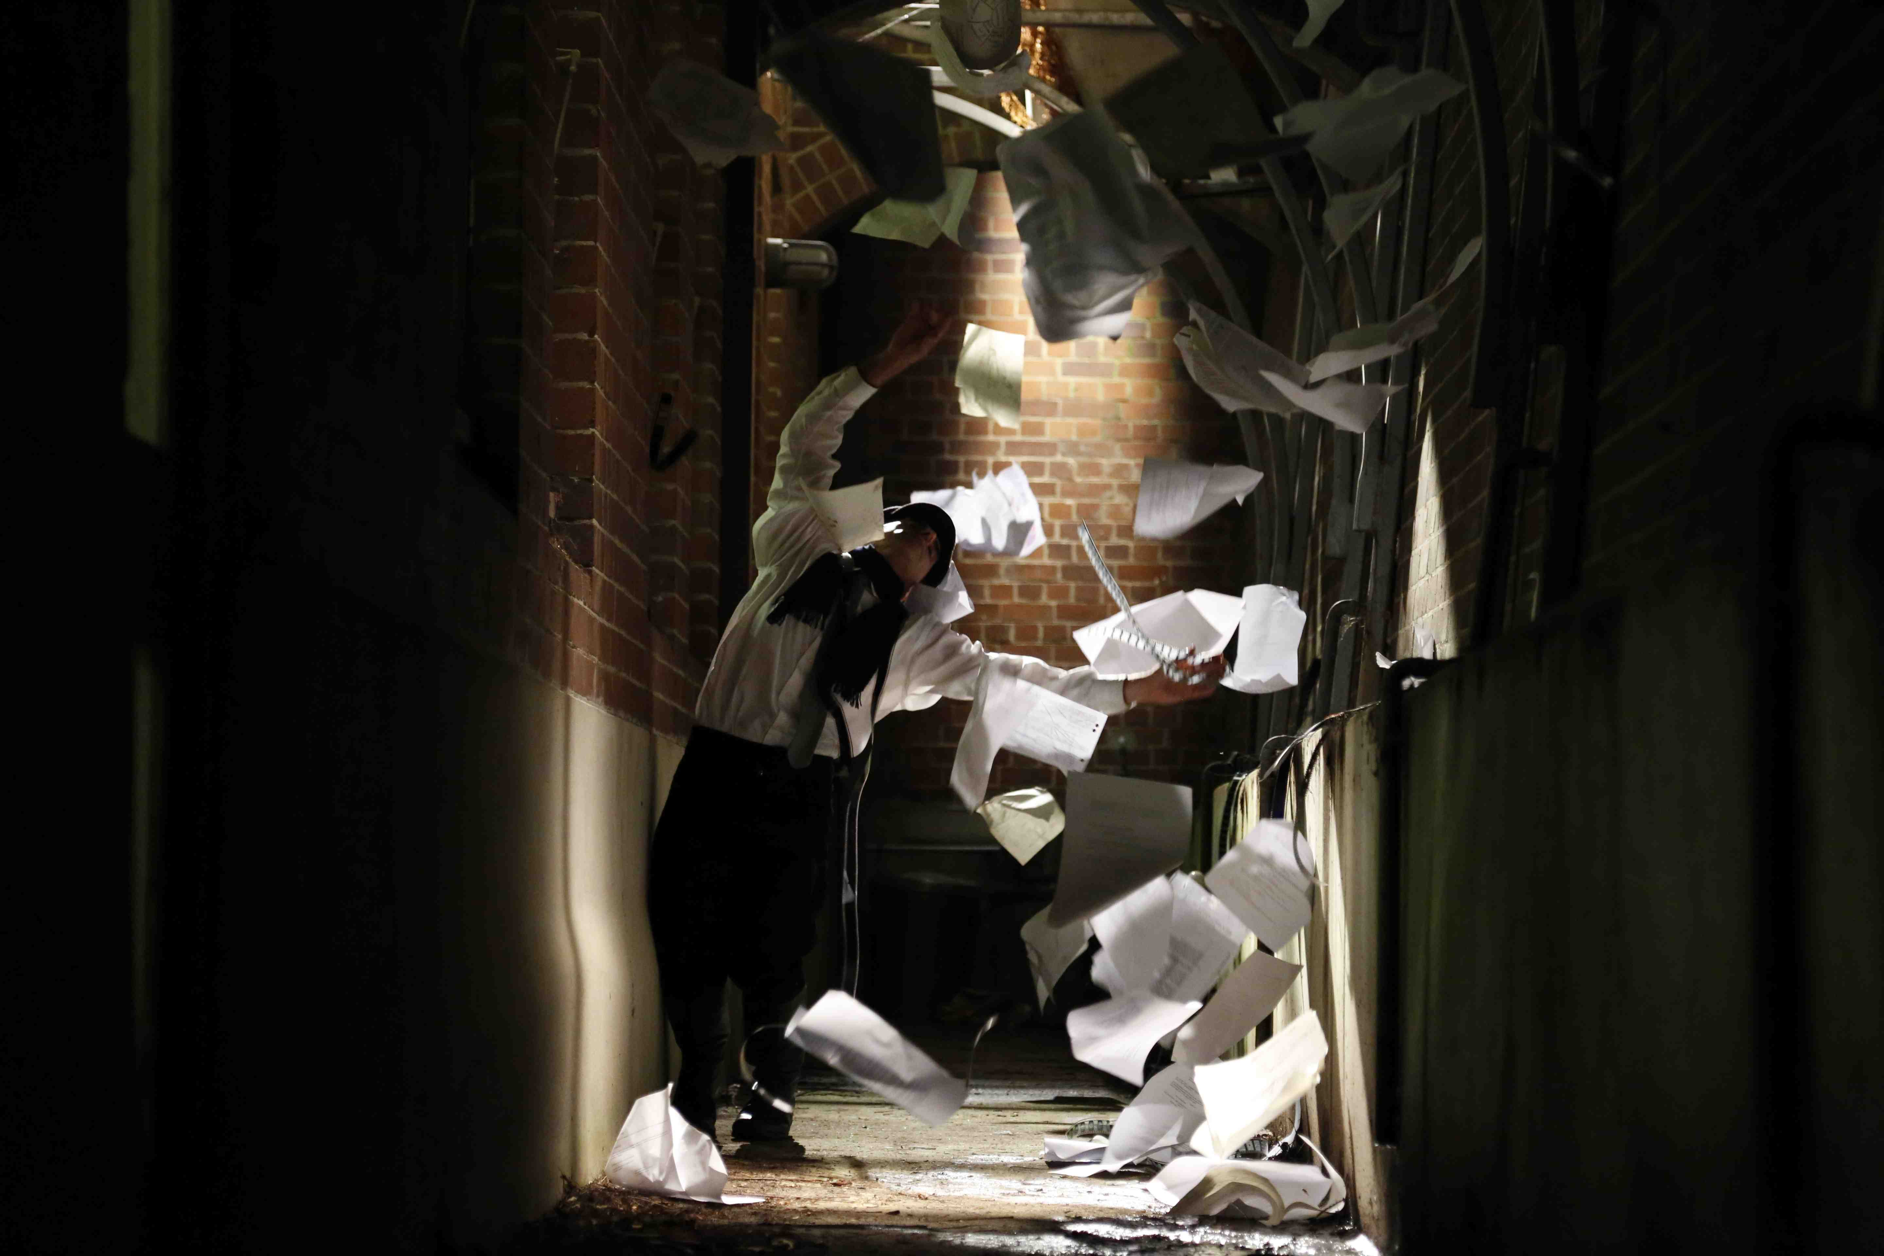

**WOMAN WITH AN EDITING BENCH**

**TECHNICAL SPECIFICATIONS**

***Available for screening on:***

**~ DCP, 35mm, ProRes 4444, HDCAM,**

**Digital Betacam, BluRay, DVD**

***Technical details:***

**~ Duration: 16mins (35mm Film Print), 15mins (DCP)**

**~ Sound: Dolby Digital (35mm Film Print), 5.1 (DCP)**

**~ Aspect Ratio: 1.85: (35mm Film Print), 16:9 (DCP)**

**~ Speed: 24fps (35mm Film Print), 25fps (DCP)**

**~ Colour and Black & White**

***Webpage:***

**~** <http://physicaltv.com.au/woman-with-an-editing-bench/>

**WOMAN WITH AN EDITING BENCH**

**BRIEF BIOGRAPHIES**

Karen Pearlman – Director, Writer, Producer, Editor:

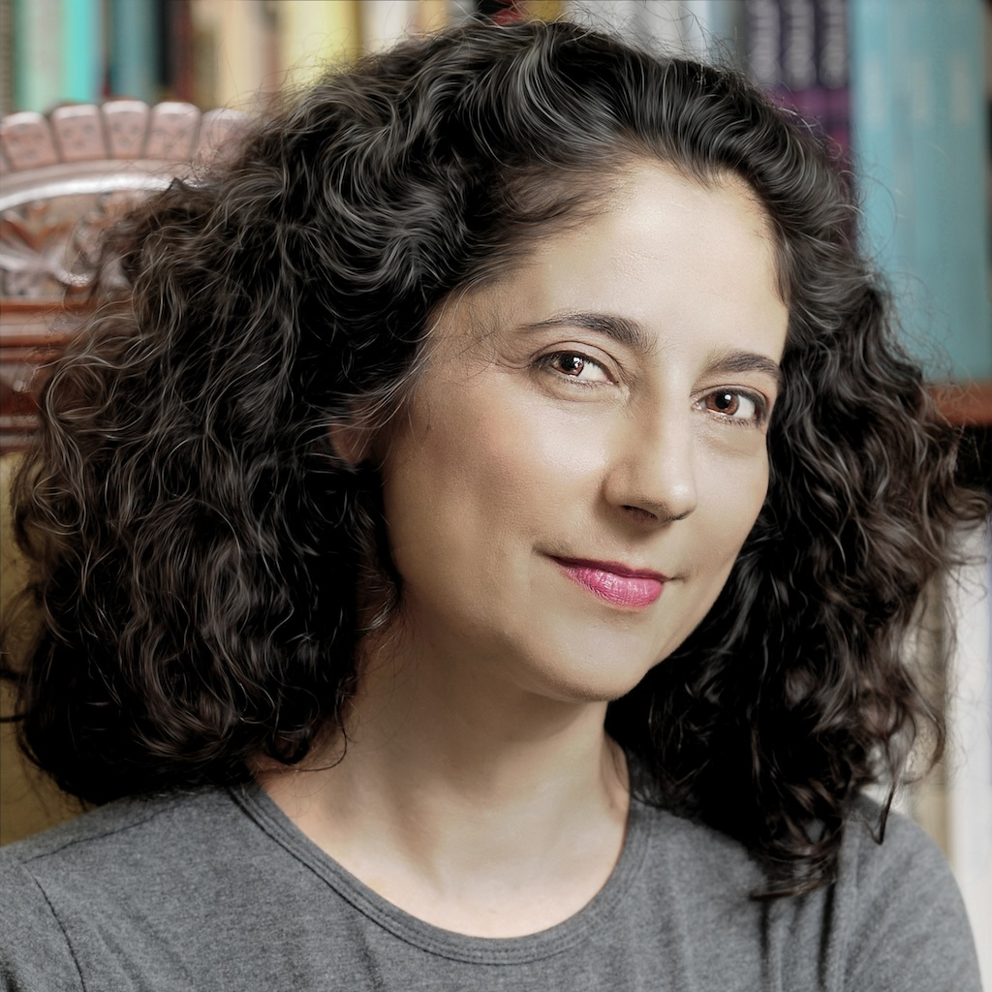

Karen Pearlman – Director, Writer, Producer, Editor:

Karen Pearlman writes, directs and edits screen productions and she writes about screen culture and creative processes. Karen is a director of the multi-award-winning Physical TV Company, through which she has developed, produced, directed or edited numerous highly acclaimed short films, online and mobile productions, and produced and edited the ATOM Award winning short feature “Thursday's Fictions”, recently acquired by OzFlix. Her period drama short, “Woman with an Editing Bench”, won eight awards including the 2016 ATOM Award for Best Short Fiction Film as well as Best Editing in a Drama – Short Film at the Australian Screen Editors Guild Awards. Her earlier documentary “...the dancer from the dance” was a finalist for an Australian Dance Award for Outstanding Achievement in Dance on Screen, and also a finalist for an ATOM Award for Best Arts Documentary.

Karen is a lecturer in Screen Production at Macquarie University, and she held the post of Head of Screen Studies at AFTRS for 6 years. She is the author of “Cutting Rhythms, Intuitive Film Editing” (Focal Press, 2016). Karen previously edited "Performing the Unnameable: An Anthology of Australian Performance Texts" (Currency Press/RealTime) and has published academic essays and articles in the "International Journal of Screendance", "Participations Journal of Audience Research", “The Journal of Performance Studies" and other anthologies and journals. Before taking up filmmaking, editing and film studies, Karen had a distinguished career as a professional dancer - performing on the Opera House stages of the world and directing two dance companies. She holds a Doctorate of Creative Arts from UTS, two Masters degrees, and a BFA in Dance from NYU Tisch School of the Arts.

**WOMAN WITH AN EDITING BENCH**

**BRIEF BIOGRAPHIES**

Karen Pearlman – Director, Writer, Producer, Editor:

Selected Filmography

1996 What is Video Dance?

11.25 minutes

**Director, Writer, Editor**

1996 Sam in a Pram

18 minutes

**Director**

1997 Three Documentaries on Dance

5-6 minutes each

**Director, Writer, Editor**

1997 13 Acts of Unfulfilled Love

19:05 minutes

**Director**

1997 The Hope Machine

23:13 minutes

**Co-Director**

2000 A Dancer Drops Out Of The Sky

2 minutes

**Director, Editor**

2001 Rubberman Accepts the Nobel Prize

6 minutes

**Director, Co-Writer**

2002 What I Did On My Nervous Breakdown

1.55 minutes

**Director, Editor**

2003 Down Time Jaz

12 minutes

**Director, Editor**

2006 Thursday's Fictions

54 minutes Short Feature - Drama

**Producer, Editor**

**WOMAN WITH AN EDITING BENCH**

**BRIEF BIOGRAPHIES**

Karen Pearlman – Director, Writer, Producer, Editor:

Selected Filmography *(cont’d)*

2009 Entanglement Theory

10 minutes

Producer, Writer, Editor

2011 Monk, Reloaded

3:30 minutes

**Producer, Editor**

2014 "...the dancer from the dance"

Half-hour Documentary

**Director, Co-Producer, Editor**

2016 Woman with an Editing Bench

15 minute Period Drama

**Director, Writer, Producer, Editor**

2017 Digital Afterlives

5 minutes

**Producer, Editor**

2018 After the Facts

5 minute Documentary

**Director, Writer, Producer, Editor**

2019 Text Messages from the Universe

62 minute Drama Feature

**Editor**

**WOMAN WITH AN EDITING BENCH**

**BRIEF BIOGRAPHIES**

Lyn Norfor – Producer:

Lyn is one of the three founding partners of Emerald Productions. She currently has a feature film, UNDERTOW (writer/director Miranda Nation), in postproduction and three others in development, including BEREFT (writers Andy Cox and Ranald Allan) funded through Screen Australia. Emerald Productions has developed their COBALT slate for debut female directors with a diverse and bold range of projects and Lyn is one of the head producers of COBALT.

Lyn's credits as a producer encompass drama and documentary film and television productions. Her commercial work includes TVCs, digital content and corporate projects. Her films, including ON THE LOOSE (: Jane Oehr), have won numerous awards and screened at the Sydney Film Festival and the Sundance Film Festival.

Lyn has produced over a dozen short films that have screened in many domestic and international festivals and garnered numerous accolades.

Lyn was selected for Screen Australia’s Springboard program (2011-12) for debut features with writer/director Miranda Nation for their psychological thriller UNDERTOW. Lyn and Miranda’s Springboard-funded short film, PERCEPTION, which won Best Short Film in the Dendy Awards, Sydney Film Festival 2013, was nominated for Best Short Film in the AACTA Awards 2014 and selected for screening in the prestigious Clermont-Ferrand Film Festival 2014.

Richard James Allen – Producer:

Director and Creative Producer of The Physical TV Company for 20 years, Richard James Allen has guided dozens of film projects from conception to completion.  A three-time ATOM Award winning director and producer, his work has been commissioned and purchased for multiple broadcasts by ABC and SBS-TV, and picked up for broadcast in China, Europe and on cable TV in the USA.  Richard’s multi-award winning productions with Physical TV have travelled to over 250 film festivals or public screenings on five continents, including all of the most selective and prestigious dancefilm festivals in the world.  These productions have garnered more than 60 nominations or awards and many of them have attracted grant funding or support through government or philanthropic arts funding bodies.  In addition to his work as a director, producer, writer, actor and dancer for the screen, Richard has an extensive track record in creating work for the stage, has written nine published books of poetry and edited a national anthology of writing for performance. Richard won Chancellor’s Award for Most Outstanding PhD Thesis for his doctorate at the University of Technology, Sydney, and graduated with First Class Honours for his B.A. at Sydney University. For more information, see the website of The Physical TV Company, which he co-directs with Dr Karen Pearlman: [www.physicaltv.com.au](http://www.physicaltv.com.au)

**WOMAN WITH AN EDITING BENCH**

**BRIEF BIOGRAPHIES**

Leeanna Walsman – Lead Actor

Leeanna Walsman is one of Australia’s most accomplished actors and has enjoyed an extensive career in film, theatre and television. She has had nominations for numerous awards such as AFI, If, FCCA and a Silver Logie.

Leeanna is most renowned for her role in George Lucas’ *Star Wars: Episode ll Attack of the Clones* as the bounty hunter ‘Zam Wesell’. Other film credits include *Caught Inside, Bitter and Twisted, One Perfect Day, $9.99* and *Looking for Alibrandi.* Her most recent feature is the romantic comedy *Manny Lewis* in the lead role of ‘Maria’ alongside Carl Barron, as well as the drama *Touch* as the lead ‘Dawn’. Leanna has recently completed work on the features *Don’t Tell* and *A Single Rider*.

Her numerous television credits include *Underbelly: Badness*, *The Pacific*, NBC’s *The Starter Wife,* the telemovie *Jessica* as the lead, *Hercules*, *Beastmaster*, as well as dramas *All Saints, White Collar Blue,* *The Informant, Wildside, Murder Call, Love is a Four Letter Word* and *Heartbreak High.* Leeanna’s most recent television appearances include Foxtel’s extraordinarily successful *Wentworth* in the role of Erica Davidson and in the second instalment of the legal drama *Janet King* for the ABC. She will soon be seen in the highly anticipated *Cleverman,* screening on the ABC in Australia and Sundance TV in the US.

She has been prolific on stage with her most recent roles in *Anaconda* for Tamarama Rock Surfers and returning to the State Theatre Company of South Australia for *Speaking in Tongues* after previously starring in their production of *Closer*. Leanna has also appeared in over a dozen roles in Sydney Theatre Company productions including *Stockholm, Saturn’s Return, The Shape of Things, Old* *Masters*, *The Recruit* directed by Robyn Nevin as well as the critically acclaimed *La Dispute* directed by Benedict Andrews, ‘Desdemona’ in the Bell Shakespeare Company’s *Othello* and ‘Stella’ in *A* *Streetcar Named Desire* for the Queensland Theatre Company.

She won Best Actress Female at the Auckland International Film Festival, Summer 2016, for her portray of Elizaveta Svilova in *Woman with an Editing Bench.*

**WOMAN WITH AN EDITING BENCH**

**BRIEF BIOGRAPHIES**

Richard James Allen – Lead Actor

Born in Australia, **Richard James Allen** has been performing professionally around the world as an actor, dancer and poet for more than 30 years. Trained as an actor in the methods of Constantin Stanislavski, Michael Chekhov, Jerzy Grotowski, Peter Brooke and Pina Bausch, he has a wide dramatic, physical and vocal range. A writer himself, he has a profound respect for language and a rich understanding of the underlying dramatic shape of a scene. An experienced performer for stage and screen, he is creative and at ease with improvisation, fluid and generous in collaboration. A teacher of directing actors at [Sydney Film School](http://www.sydneyfilmschool.com/school/our-staff/teachers/dr-richard-james-allen.aspx), he understands the nuances of different styles of acting, and has a precisely honed ability to respond to direction. Once described as being “Australia’s most successful performance poet” (Nyk Sykes, Secretary, Poets Union Inc), he has a developed skill at holding an audience and a finely tuned sense of comic timing. Richard also has unique physical capabilities. An advanced yoga teacher and practitioner, with an additional track record as an acclaimed choreographer, he can easily pick up most physical skills, and unites a surprising flexibility and strength, speed and grace in his actions with trained dancer’s ability to take physical direction and understand precise shape and movement sequencing in a short time. He also has a beautiful singing voice and rich understanding of musicality and rhythm having studied violin and piano and sung in the Sydney Opera House as a child.

Artistic Director of the internationally acclaimed Physical TV Company in Sydney, and before that of Tasdance in Launceston, and That Was Fast in New York City, Richard has played many roles on film and on stage, including a soldier, a monk, a madman, a filmmaker, a murderer, a loyal son and a terrified father, and two very different kinds of angels. These productions have received critical acclaim in *The New York Times* and other leading publications, multiple awards and nominations, and been broadcast, screened and performed in 30 countries around the world. His performances have been describes as “extraordinary” (*ArtsHub*), “terrifying” (*The Village Voice*), “ferociously watchable” (*The Glasgow Herald*). He has also performed in films, plays, web series, TVCs, performance pieces, site specific works, dances and street theatre with numerous other international artists and companies.

**WOMAN WITH AN EDITING BENCH**

**BRIEF BIOGRAPHIES**

Marcus Graham – Lead Actor

AFI award winning and Logie nominated actor Marcus Graham, first gained wide acclaim while starring in the Australian TV soap *E Street* as 'Wheels'. He has been a professional actor for twenty – eight years and has performed in over eighty productions in theatre, film and television. Marcus has gone on to receive prestigious acclaim landing roles in several projects including *David Lynch* directed Mulholland Drive, *The Rocky Horror Picture Show*, *The Blue Room*, *Angels in America* and *Noises Off*. His extensive television credits include *Hiding*, *Underbelly 1*, *Crownies*, *Janet* *King*, *City* *Homicide*, *Good Guys Bad Guys* for which he was nominated for an AFI best actor award, *Home and Away* and *Blue* *Heelers* which won him the AFI. Most recently Marcus has appeared in the Australian film *Holding the Man* and has completed work on the upcoming television series; *Secret City* and *Jack Irish*. Marcus will next be seen in the highly anticipated ABC drama series *Cleverman* which was picked up by Sundance TV and is due for release in Australia in the latter half of 2016.

Kieran Fowler – Director of Photography

New Zealand born Kieran Fowler attended International Film School Sydney where he trained under Denson Baker, ASC. A rising star in cinematography, Kieran has shot two feature films and numerous shorts, ads and music videos around the world.

Bethany Ryan – Production Designer

Bethany Ryan first developed her skills as a Designer at RMIT in Melbourne, completing her Honours in Interior Design. A string of awards including a travelling scholarship led her overseas before studying Production Design at AFTRS in Sydney. Before the year closed, Bethany Art Directed her first feature Film *Nerve,* which premiered at the Sydney Film Festival. Bethany has since Art Directed feature films: *The Darkside* (Warwick Thornton) and *The Turning: Long Clear View* (Mia Wasikowska). Most recently, she was Production Designer on *The Pretend One* (Tony Prescott), currently in post-production. Bethany’s short film credits include *Baby Baby* (MIFF), *All God’s Creatures* (SFF) and Shane Danielsen’s directing debut, *The Guests* (Official Selection Festival de Cannes).

**WOMAN WITH AN EDITING BENCH**

**BRIEF BIOGRAPHIES**

Anna Cahill – Costume Designer

Graduating from a Fashion Design degree at the University of Technology, Sydney, Anna then went to London’s Central Saint Martin’s School of Design to focus her studies on costume design. Anna has worked as Costume Designer for a range of short films that have gained international recognition and film festival awards, including *BINO*, directed by Billie Pleffer (Winner Best film, International Jury at Berlinale 2011), period dramas *NGURRUMBANG* directed by Alex Ryan (2012), *The Fence* directed by Lucy Gaffy (2012)*, Foal* directed by Vanessa Gazy (2014)and *The Guests* directed by Shane Danielson and officially selected for Cannes 2015*,* as well as for music video clips including an ARIA nominated *Geronimo* for Sheppard (2014). Anna has costume designed two features to date, including *The Pretend One* directed by Tony Prescott and *Safe Neighbourhood,* a joint Australian/American production directed by Chris Peckover. She is currently working on the period drama, *A Place to Call Home*, as costume extras coordinator, further enhancing her skills with period costume design.

Caitlin Yeo – Composer

Australian screen composer Caitlin Yeo’s style has always been unique. Since graduating from Screen Composition at AFTRS in 2003, Caitlin has receive a swathe of accolades including the 2013 APRA screen music award Feature Score of the Year for **The Rocket**, and 2007 Best Music for a documentary for **Bomb Harvest**, 2014 AACTA nomination, and the 2014 Film Critics Circle Award to name afew.

Yeo has scored no less than seven feature films, 25 documentaries, and five TV series, includingcritically acclaimed feature film **The Rocket**, prime time channel 7 Telemovie **The Killing Field,** and the theme song for kids television series, **Tashi**, and weekly news documentary program **Compass** (ABC).-

In 2011, Caitlin was also awarded the APRA Professional Development Award, which garnered her a spot at the prestigious ASCAP Film and TV Scoring Workshop in Los Angeles.

Caitlin's musical style comes from a fascination with music from different cultures, 20th century composition and a deep love of telling stories with- music. This multi instrumentalist is also a proud board member of the Australian Guild of Screen composers, and a lecturer of film music, composition and production at the Australian Institute of Music.

She won Best Music Score at the Auckland International Film Festival, Summer 2016, for her work on *Woman with an Editing Bench.*

**WOMAN WITH AN EDITING BENCH**

**BRIEF BIOGRAPHIES**

**Andy Wright - Sound Supervisor & Re-recording Mixer**

Andy has worked at Soundfirm in Sydney since 2000 and has been the in-house Re-recording Mixer since 2006 and Sound Supervisor since 2011. His time there has seen him experience every facet of sound post production for feature film and television, from sound mixing on Kriv Stenders "Red Dog", ADR recording on "The Lord of the Rings" trilogy, Foley recording on Zhang Yimou's "Flowers of War" and sound editing on James Cameron's "Deep Sea Challenge". Andy is currently working on Mel Gibson's "Hacksaw Ridge". His outstanding work has been consistently acknowledged by his peers with AACTA and MPSE award nominations and a handful of ASSG awards.

Andy and his team were nominated for Best Sound for a Short Fiction Film, 2016 Australian Screen Sound Guild Awards for their work on *Woman with an Editing Bench*.

When he's not filling his ears in the mix room, Andy enjoys spending time with his young family in the inner west suburbs of Sydney.

