*Copyright © 2018 The Physical TV Company*

*PO Box 522, Surry Hills, NSW 2010, Australia*

*Mobile: +61 402 630 325*

*Email:* [*PhysicalTV@gmail.com*](mailto:PhysicalTV@gmail.com)

*Website:* [*www.physicaltv.com.au*](http://www.physicaltv.com.au)

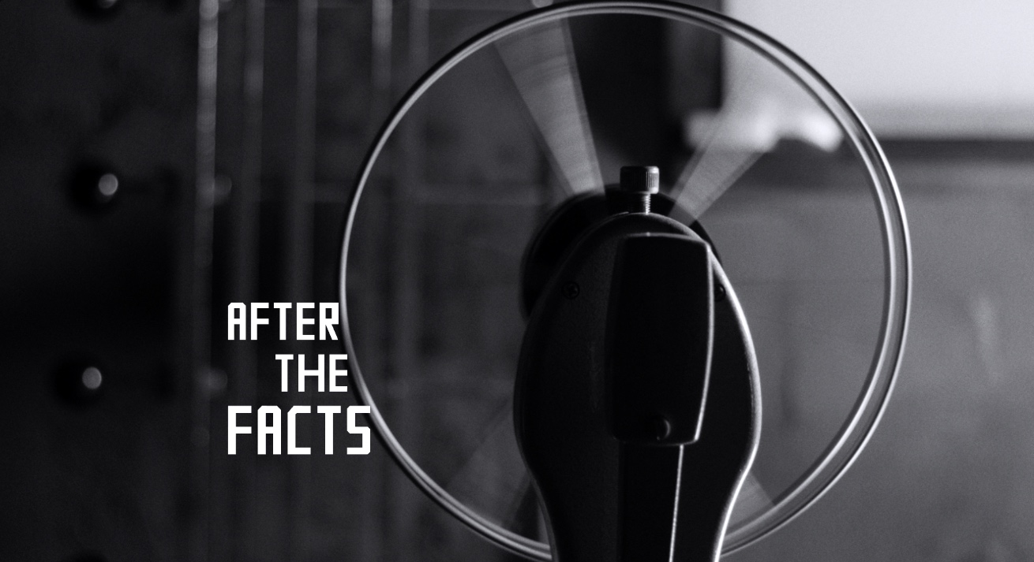

***MEDIA KIT***

***After The Facts***

***(Director: Karen Pearlman, 2018, 5 minutes)***

*Logline (4 words)*

*Logline (13 words)*

*Logline (23 words)*

*Synopsis (31 words)*

*Synopsis (41 words)*

*Synopsis (46 words)*

*Synopsis (79 words)*

*Synopsis (91 words)*

*Synopsis (150 words)*

*IMDb*

*Awards*

*Screenings*

*Key Credits*

*Karen Pearlman – Director Biography*

*Richard James Allen – Producer Biography*

*Copyright © 2018 The Physical TV Company*

*PO Box 522, Surry Hills, NSW 2010, Australia*

*Mobile: +61 402 630 325*

*Email:* [*PhysicalTV@gmail.com*](mailto:PhysicalTV@gmail.com)

*Website:* [*www.physicaltv.com.au*](http://www.physicaltv.com.au)

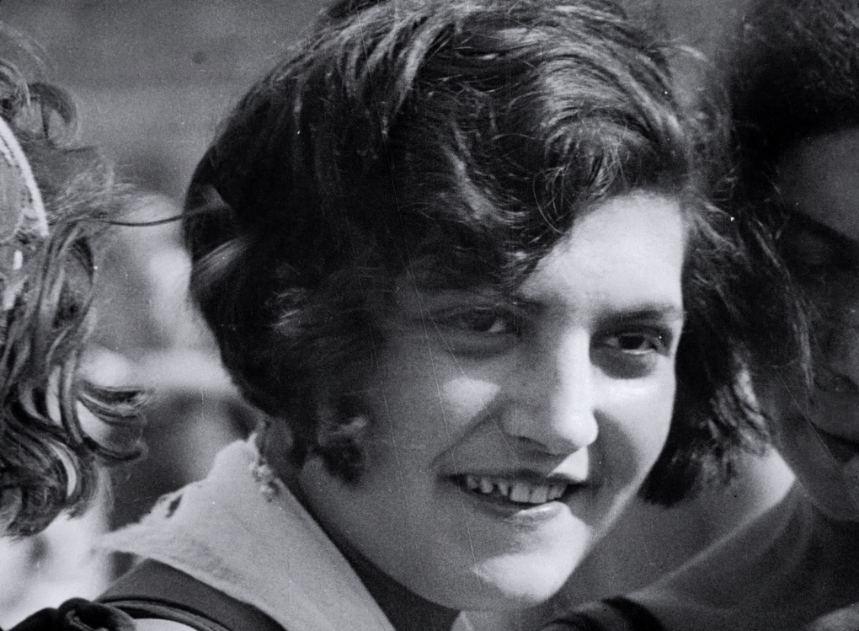

***After The Facts***

***(Director: Karen Pearlman, 2018, 5 minutes)***

***Logline (4 words)***

*Women. Editing. Power. Invisibility.*

***Logline (13 words)***

*After the Facts* is a short essay documentary about turning facts into thoughts.

***Logline (23 words)***

*After The Facts* is a documentary about the power of editing to shape what we think we see and therefore what we think.

***Synopsis (26 words)***

In the early years of cinema, editors were usually women. This short documentary looks at how they wielded power, and how their work was made invisible.

***Synopsis (31 words)***

Editors are powerful. They are also usually invisible. Most editors in early film were women. This short documentary looks at how they wielded power and how their work was made invisible.

*Copyright © 2018 The Physical TV Company*

*PO Box 522, Surry Hills, NSW 2010, Australia*

*Mobile: +61 402 630 325 Email:* [*PhysicalTV@gmail.com*](mailto:PhysicalTV@gmail.com)

*Website:* [*www.physicaltv.com.au*](http://www.physicaltv.com.au)

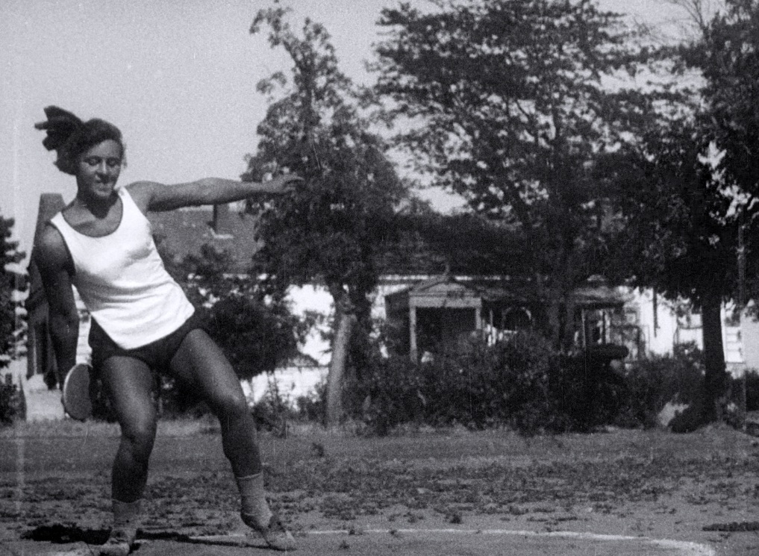

***After The Facts***

***(Director: Karen Pearlman, 2018, 5 minutes)***

***Synopsis (41 words)***

Most editors in early film were women. This short documentary, focusing on the work of Esfir Shub (1894-1959), shows how the groundbreaking work of women editors profoundly influenced some of the masterpieces of cinema and how their work was made invisible.

***Synopsis (46 words)***

Editors are powerful. They are also usually invisible. Most editors in early film were women. This short documentary looks at Esfir Shub (1894-1959), credited with inventing the remix film, and shows the groundbreaking work of women editors who profoundly influenced some of the masterpieces of cinema.

***Synopsis (79 words)***

*After the Facts* is a documentary about turning facts into thoughts. It looks at film editing techniques that revolutionized thinking and understanding of stories and asks: what happened to the stories of the women who did the editing? *After the* Facts uses the pioneering techniques of one such invisible woman and editor, Esfir Shub (1894-1959), credited with inventing the remix film. It reveals how many different ways a story can be told depending on how the archive is mixed.

***Synopsis (91 words)***

*After The Facts* is a documentary about the power of editing to shape what we think we see and therefore what we think. It looks at film editing techniques that revolutionized thinking and understanding of stories and asks: what happened to the stories of the women who did the editing? *After the* Facts uses the pioneering techniques of one such invisible woman and editor, Esfir Shub (1894-1959), credited with inventing the remix film. It reveals how many different ways a story can be told depending on how the archive is mixed.

*Copyright © 2018 The Physical TV Company*

*PO Box 522, Surry Hills, NSW 2010, Australia*

*Mobile: +61 402 630 325*

*Email:* [*PhysicalTV@gmail.com*](mailto:PhysicalTV@gmail.com)

*Website:* [*www.physicaltv.com.au*](http://www.physicaltv.com.au)

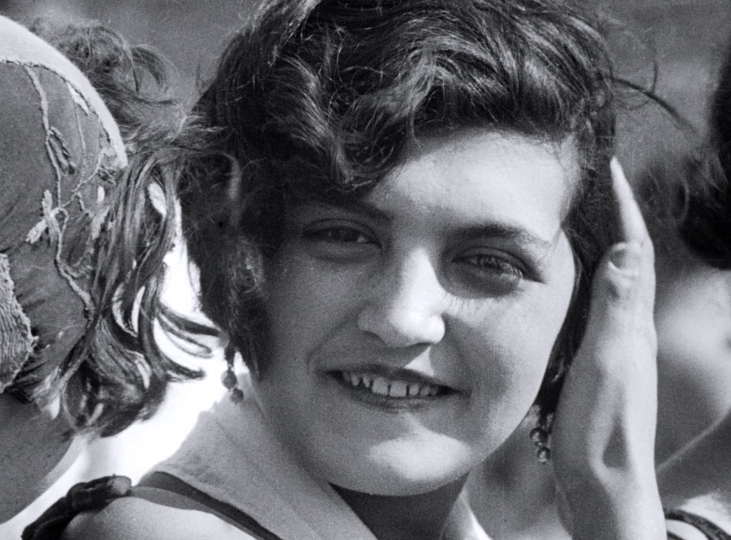

***After The Facts***

***(Director: Karen Pearlman, 2018, 5 minutes)***

***Synopsis (150 words)***

*After the Facts* is about the power of film editing and the women in early film who revolutionized it. *After the Facts* playfully reveals how juxtaposition of different films ‘facts’ (documentary images) can shape the viewer’s thoughts and understandings differently. It demonstrates the kinds of juxtapositions are often called ‘the Kuleshov’ effect, because Lev Kuleshov, Soviet film teacher in the 1920s, conducted experiments that showed how they work. But *After the Facts* asks: why is something that lots of women and editors were already doing named after one man who observed them doing it? In *After the Facts,* Pearlman reclaims and re-names this innovation that is so central to how screen stories work. She calls it The Editor’s Effect.

This short documentary is part of Dr Karen Pearlman’s ongoing research, which is interrogating the standard film histories and bringing to light the significant and overlooked contributions made by women editors.

***IBDb***

<https://www.imdb.com/title/tt8070500/reference>

***Awards***

Winner, Best Editing, Open Content, 2018 Australian Screen Editors (ASE) Guild Awards

Winner, Best Female Editor, 2021 Toronto International Women Film Festival

*Copyright © 2018 The Physical TV Company*

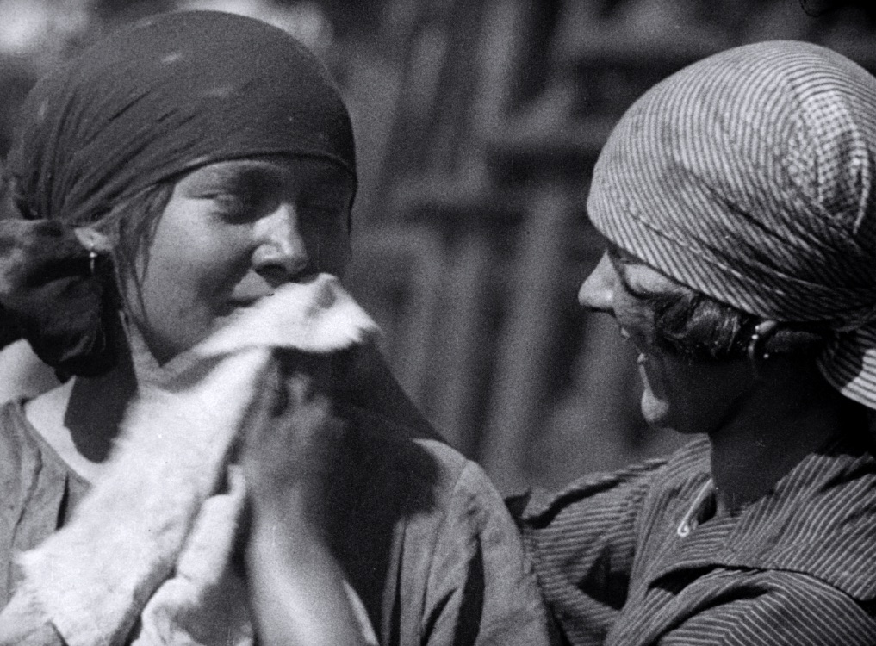

***After The Facts***

***(Director: Karen Pearlman, 2018, 5 minutes)***

***Screenings***

Sydney Film Festival, NSW, Australia

Revelation Perth International Film Festival, Western Australia

CinefestOZ Film Festival, Western Australia, Australia

Sydney Underground Film Festival, NSW, Australia

Heart of Gold International Film Festival, QLD, Australia

Antenna Film Festival, Australian Shorts Competition, NSW, Australia

Adelaide Film Festival, South Australia

Ficsur Festival Internacional de Cine

(International Festival of the Countries of the South of the World), Buenos Aires

Pera Museuam and Pera Film Events, Istanbul, Turkey

On Art Film, Poland

Zurich Documentary Conference, Zurich, Switzerland

Eisenstein in the 20th Century, Bologna, Italy

Women Over 50 Film Festival, UK

International Kids Film Festival, India

Meraki Film Festival, Berlin and Madrid, Germany and Spain

Master of Art Film Festival, Sofia, Plovdiv and Varna, Bulgaria

Pacific Meridian International Film Festival, Vladivostok, Russia

***After The Facts***

***(Director: Karen Pearlman, 2018, 5 minutes)***

***Screenings (cont’d)***

Toronto International Women Film Festival

Women in Film and Television (WIFT), Perth WA, 2020

Australian Screen Editors and the Australian Directors’ Guild host screening of the Karen Pearlman’s Trilogy at Griffith University, Brisbane, Australia, 2021

IF Maitland Indie Festival, Maitland, Australia (also trilogy screening), 2021

Los Angeles Women in Film Festival, Los Angeles, California, USA, 2021

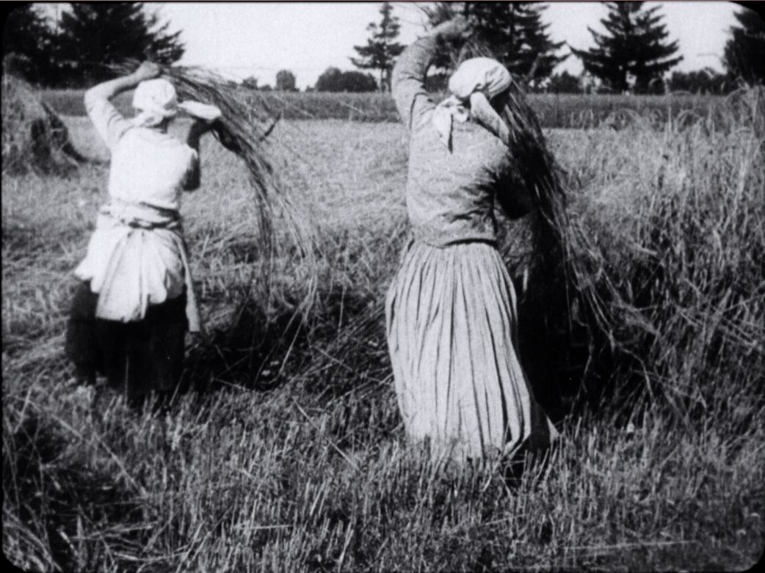

***After The Facts***

***(Director: Karen Pearlman, 2018, 5 minutes)***

***Reviews***

In *After the Facts* we have what feminist film theory never achieved in the 1970s—a theory of women’s editing practice. …*After the Facts*stimulates the field, challenges it to return women to the top, taking as its premise that to start with “women in the early industry” is to transform motion picture filmmaking as a historical field. If we start with the women who worked, especially in the Soviet revolutionary society, surprise, surprise—*everything* looks different…What we have here is “theoretical research” on the historical film text. *After the Facts* demonstrates nothing more nor less than a *new theory and practice of historical research*—no traditional “fact-finding.”

**Jane M. Gaines**, review at Women Film Pioneers Project, 2020: <https://wfpp.columbia.edu/2020/03/16/after-the-facts/>

*After the Facts* at first adopts a familiar documentary style to discuss Esfir Shub’s work and aspirations. She wanted to make a film about women, and a film capturing the rhythm of work, and though she worked on and made many films, Shub’s aspirations (and those of her colleagues Svilova and Vertov) were unable to continue to be realised under Stalin’s regime, we can only imagine and reflect on what she left behind in her archive that infers what else might have been, in different circumstances. Pearlman helps us do that. Pearlman’s reflexive and daring handling of her own thoughts, editing thoughts, rendered in montage and compilation, are an ecstatic conclusion to her observations and arguments throughout the film. It firmly reclaims women’s position in film making history. It is a sweet nugget of a film.

**Sarah St Vincent-Welsh**, “Reclaiming women’s position in film making history”, *Rochford Street Review*, June 09, 2020:

<https://rochfordstreetreview.com/2020/06/09/flashes-of-thoughts-and-emotions-sarah-st-vincent-welch-reviews-three-films-by-karen-pearlman/>

“After the Facts” is the shortest of the trio at only five minutes. The film is, in some ways, a commentary on the other two [films in the trilogy]—exploring the importance of editing, not just in film but in how it can impact the way we perceive reality. The film demonstrates its thesis artistically: the camera panning from *a woman looking* to what*she sees,*and finally, to *what she thinks.* This is done by utilising Esfir Schub’s archive of “facts” to create a “remix” that that moves between historical image, modern story, and an engaging lecture on the power and importance of editing.

**Magdalena Ball**, “A review of Karen Pearlman’s Woman with an Editing Bench, After the Facts, and I want to make a film about women”, *Compulsive Reader,* August 9, 2020: <http://www.compulsivereader.com/2020/08/09/a-review-of-karen-pearlmans-woman-with-an-editing-bench-after-the-facts-and-i-want-to-make-a-film-about-women/>

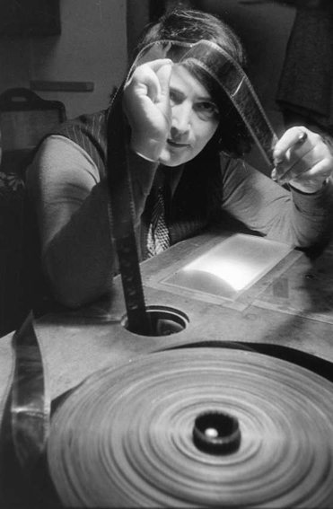

***After The Facts***

***(Director: Karen Pearlman, 2018, 5 minutes)***

***Key Credits***

Directed, Written and Edited by Karen Pearlman

Screen Dramaturge: Kathryn Millard

Music: Caitlin Yeo

Music Editor: Andrew Scott

Musicians: Véronique Serret, Ben Walsh, Caitlin Yeo

Titles Designer: Gail Pearce

Sound Designer & Re-recording Mixer: Diego Ruiz

Russian Voices Loop Group: Victoria Carwin, Mark Lebedev, Alexandra Ponomareva, Vladimir Shvedov, Viktoria Vlasova

Colourist: Jamie Hediger

Online Editor & Post-production Supervisor: Marcus Eckermann

Facilities: Macquarie University

Legals: Michael Frankel, Frankel Lawyers

Production Company: The Physical TV Company

Producers: Karen Pearlman and Richard James Allen

Series Producers: Kathryn Millard & Tom Murray



***Karen Pearlman – Director Biography***

Dr Karen Pearlman writes, directs and edits screen productions and she researches and writes about screen culture and creative processes.

Karen and her partner Richard James Allen direct the multi-award winning Physical TV Company, through which they have developed, produced, directed or edited numerous highly acclaimed short films, online productions and the feature films 'Thursday's Fictions', 'Text Messages from the Universe', and ‘Bloodshot Heart’.

Karen’s 2016 film, 'Woman with an Editing Bench', won the national ATOM Award for Best Short Fiction, the Australian Screen Editors' Guild (ASE) Award for Best Editing in a Short and 6 other film festival awards. Her 2018 documentary, ‘After the Facts’, was also honoured with an ASE Award for Best Editing, after its screenings at the Sydney International Film Festival, the Adelaide International Film Festival, the Perth Revelation Film Festival, CinefestOz and the Antenna Documentary Film Festival. The third in her trilogy of films bringing back into light under-recognised Soviet women artists, ‘I want to make a film about women’, has gone on to win 15 awards and screen at dozens of festivals.

Karen is a lecturer in Screen Production and Practice at Macquarie University. Before joining Macquarie, Karen held the post of Head of Screen Studies at AFTRS for 6 years. She is the author of 'Cutting Rhythms, Intuitive Film Editing' (now in its 2nd edition with Focal Press). Before taking up filmmaking, editing and film studies, Karen had a distinguished career as a professional dancer - performing on the Opera House stages of the world and directing two dance companies.

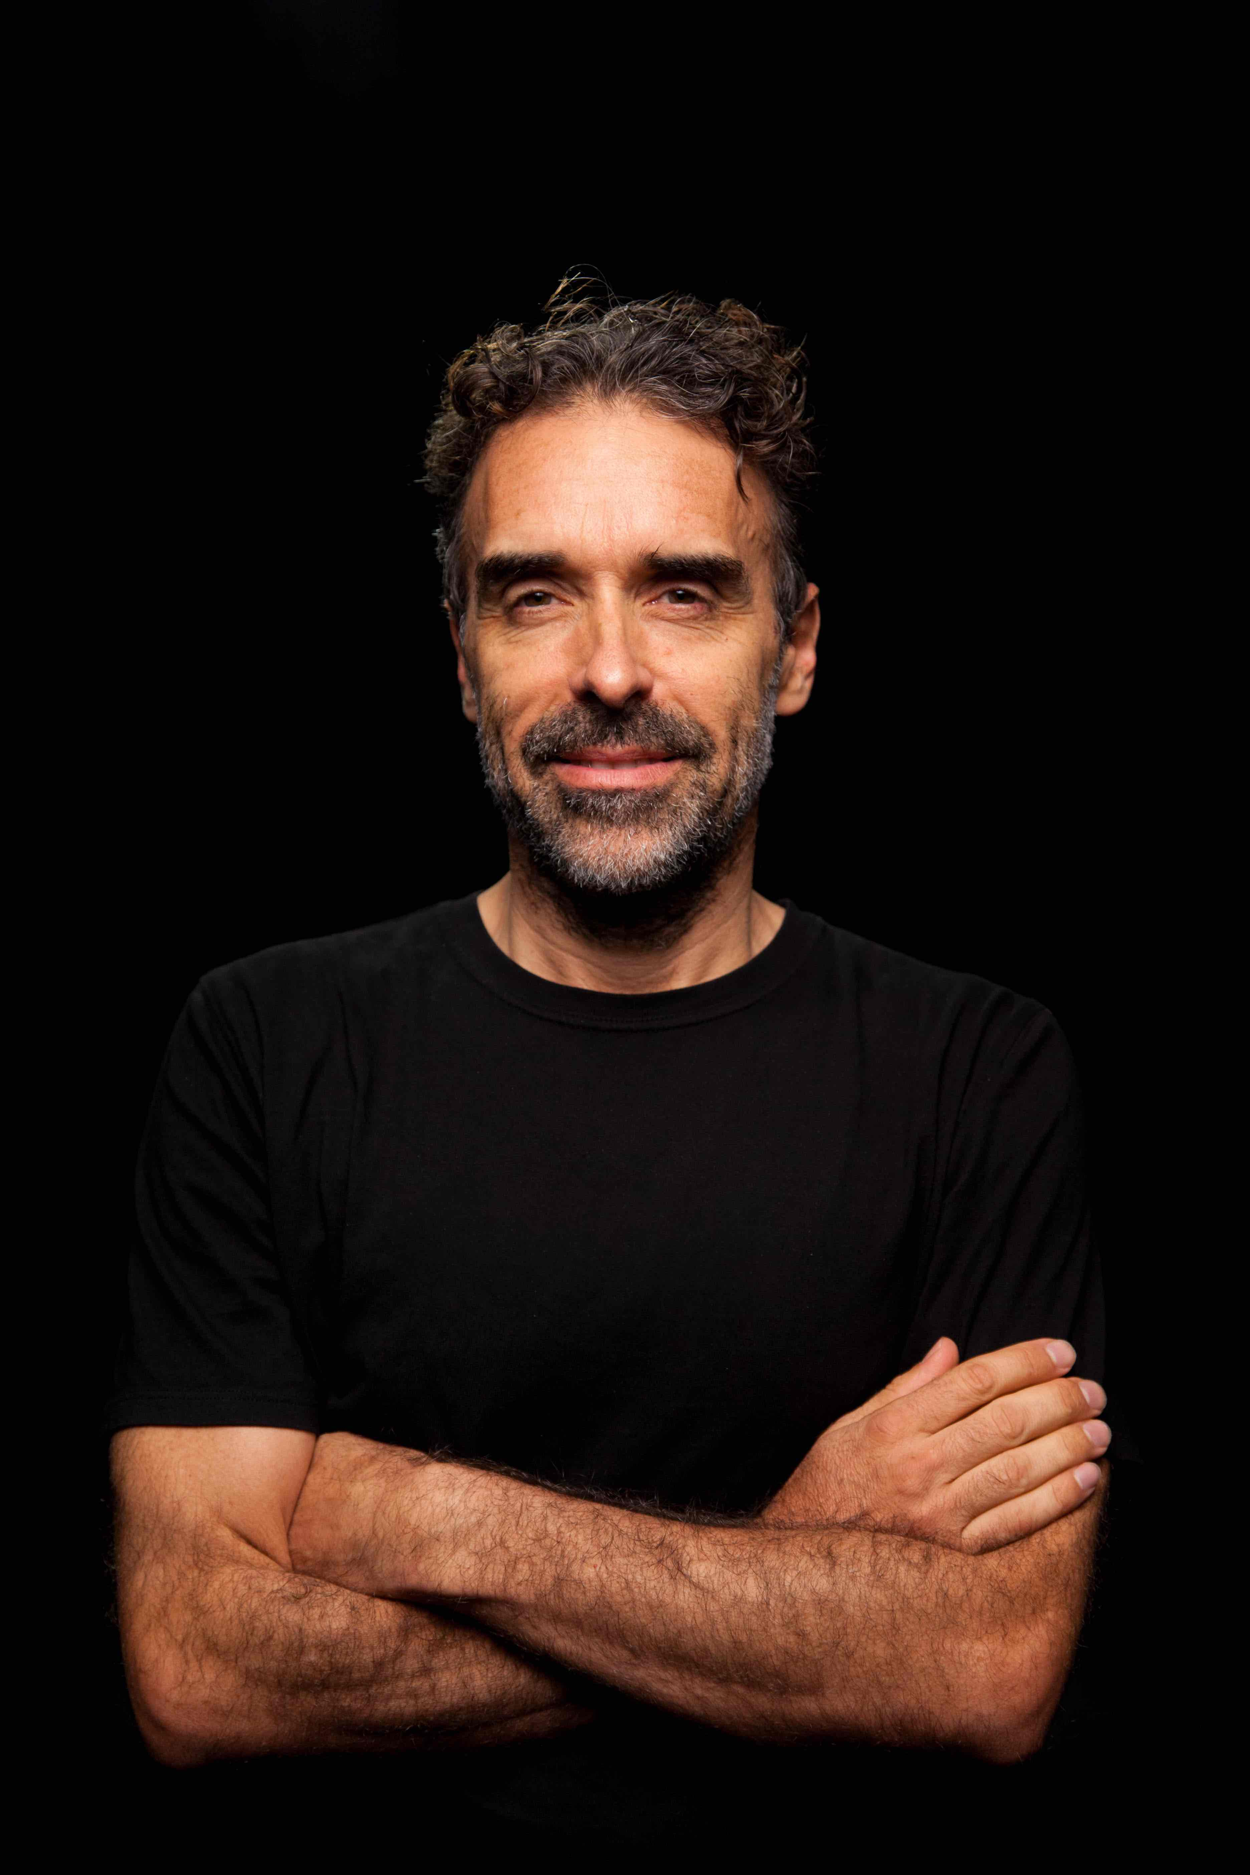

***Richard James Allen – Producer Biography***

Richard James Allen is a director, with Karen Pearlman, of the critically acclaimed Physical TV Company (http://physicaltv.com.au).  An AACTA nominated, Dendy, St Kilda, Brisbane and ATOM Award winning producer, Richard’s films have been commissioned or purchased for multiple broadcasts by ABC and SBS-TV, and picked up for broadcast in China, Europe and on cable TV in the USA.  His productions have travelled to over 300 film festivals or public screenings on five continents. They have garnered around 100 awards or nominations, and many have attracted grant funding or support through government or philanthropic arts funding bodies.  As well as producing Karen Pearlman’s trilogy of films about under-recognised Soviet women filmmakers, Richard recently produced two lower-budget long-form productions, ‘Text Messages from the Universe’ and ‘Bloodshot Heart’, both nominated for Best Fiction Feature Film at the ATOM Awards. In addition to his creativity as a producer, director, writer, actor and dancer for the screen, Richard is an acclaimed Australian poet.  His latest book of poetry, 'The short story of you and I', was published by UWA Publishing in 2019, and his novel, ‘More Lies’, appeared with Interactive Press in 2021.  He also has an extensive track record of creating critically lauded works for the stage and edited a landmark national anthology of writing for performance.