***MEDIA KIT***

*Awards and Screenings*

*Reviews*

*Synopses*

*Key Credits*

*Director’s Statement*

*Director’s Biography – 75 words*

*Director’s Biography – 100 words*

*Director’s Filmography*

*Director’s Biography – 500 words*

*Producer’s Biography*

*Copyright © 2019-2021 The Physical TV Company. All rights reserved.*

*PO Box 522, Surry Hills, NSW 2010, Australia*

*Mobile: +61 (0) 402 630 325 Email:* [*PhysicalTV@gmail.com*](mailto:PhysicalTV@gmail.com)

*Website:* [*http://physicaltv.com.au*](http://physicaltv.com.au)

***I want to make a film about women***

**Screenings and Awards**

* JEWISH INTERNATIONAL FILM FESTIVAL, Melbourne and Sydney, 2019

WINNER: Production Grant, 2019 JIFF Short Film Fund

* SYDNEY FILM FESTIVAL, Sydney, Australia, 2020

Section: Dendy Awards for Australian Shorts

WINNER: Special Mention, 2020 Dendy Award for Live Action Australian Short

Judges comment: "We want to highly commend Karen Pearlman for her ambitious and masterful mix of forms, combining animation, graphics, dance, documentary and drama, to craft - 'I want to make a film about women'". (Dr George Miller, Sophie Hyde, Byran Brown)

Finalist: Best Live Action Short

Finalist: Best Direction in a Short Film

* ST KILDA FILM FESTIVAL, Melbourne, Australia, 2020

WINNER: Best Documentary (making the film eligible for an Academy Award)

Festival Director’s Comment: “For a film that is both experimental and dramatized to win Best Documentary at St Kilda is both a tribute to the film but also to the subject – Esther (Esfir) Schub – who in herself totally blurred the boundaries.” (Richard Sowada)

Finalist: Best Short Film

Finalist: Craft Award

Finalist: Best Original Score

* CINEFESTOZ FILM FESTIVAL, Western Australia, 2020

Section: Inaugural CinefestOz Short Film Awards

WINNER: Best Director

***I want to make a film about women***

**Screenings and Awards *(cont’d)***

* BRISBANE INTERNATIONAL FILM FESTIVAL, Brisbane, Australia, 2020

Section: Short Film Awards (and online editing workshop)

WINNER: Creative Achievement Award

* AUSTRALIAN DIRECTORS' GUILD AWARDS, Sydney, Australia, 2020

WINNER: Best Direction of a Documentary Short Subject

* AUSTRALIAN CINEMATOGRAPHERS SOCIETY, NSW Branch, 2020

WINNER: Silver Medal, Short Film (for Meg White)

* APRA AMCOS Screen Music Awards, Sydney, Australia, 2020

Finalist: Best Music in a Short Film (for Caitlin Yeo)

* AUSTRALIAN FILM INSTITUTE (AFI) | AUSTRALIAN ACADEMY OF CINEMA AND TELEVISION ARTS (AACTA) 2020, Sydney, Australia

Finalist: Best Short Film

* ATOM AWARDS, Melbourne, Australia, 2020

WINNER: Best Documentary - History

WINNER: Best Docudrama

Finalist: Best Documentary - Short Form (30 minutes or less)

Finalist: Best Documentary - Biography

* SCAD SAVANNAH FESTIVAL, Savannah, Georgia, USA, 2020

Section: Shorts Spotlight (and online editing workshop)

WINNER: Best Short: Pride Parade

* VANCOUVER INTERNATIONAL FILM FESTIVAL, British Columbia, Canada, 2020

Official Selection (and online editing workshop)

***I want to make a film about women***

**Screenings and Awards *(cont’d)***

* Sydney Women’s International Film Festival, Sydney, Australia, 2020

WINNER: Best Doco Short

Finalist: Best Director

Finalist: Best Australian Film

Finalist: Best Actress

* IZMIR INTERNATIONAL SHORT FILM FESTIVAL, Izmir, Turkey, 2020

'International Panorama

* The BUDDHA INTERNATIONAL SHORT FILM FESTIVAL, Pune, India, 2020
* REVELATION PERTH INTERNATIONAL FILM FESTIVAL, Western Australia 2020
* HOLLYWOOD WOMEN’S FILM INSTITUTE:

HOLLYWOOD WOMEN’S FILM FESTIVAL, 2020

WINNER: Best LGBTQ Short Holiday Documentary

* CINEFESTOZ FILM FESTIVAL, Bunbury, Western Australia, 2021

‘Best Shorts of 2020’ at Bunbury Fringe

* THROUGH WOMEN'S EYES INTERNATIONAL FILM FESTIVAL, Florida, USA, 2021
* CALIFORNIA WOMEN’S FILM FESTIVAL, TARZANA, California, USA 2021
* THOMAS EDISON BLACK MARIA FILM FESTIVAL, 2021

WINNER: Jury’s Citation Award

* WIFT V-FEST Online Women’s Film Festival, Brisbane, Australia 2021

WINNER: Best Director

Finalist: Best Documentary

Finalist: Best Editor

***I want to make a film about women***

**Screenings and Awards *(cont’d)***

* MIAMI JEWISH FILM FESTIVAL, Florida, USA 2021
* MASTER OF ART FILM FESTIVAL, Sofia, Plovdiv, Varna, Bulgaria, 2021
* SEBASTOPOL DOCUMENTARY FILM FESTIVAL, California, USA 2021

WINNER: Special Jury Mention – Short

Judge’s comment: “The film *I Want to Make a Film About Women* is stunning in every way. Every element from the subtle brilliance of lead actor Victoria Haralabidou to the design of set and use of archival film—all work innovatively together to ignite the importance of suppressed filmmaker Esfir Shub and her colleagues in the Soviet Union. It’s a film of innovative brilliance, celebrating the inexhaustible, essential tenacity of suppressed artists everywhere.”

* Australian Screen Editors (ASE) and the Australian Directors’ Guild (ADG) host

screening of the Karen Pearlman’s Trilogy at Griffith University, Brisbane, Australia, 2021

* IF MAITLAND INDIE FESTIVAL, Maitland, Australia

screening of the Karen Pearlman’s Trilogy, 2021

* BEIRUT INTERNATIONAL FILM FESTIVAL, Lebanon, 2021
* INTERNATIONAL DOCUMENTARY FESTIVAL OF IERAPETRA AND AWARDS, Ierapetra, Crete, Greece, 2021
* DURBAN INTERNATIONAL FILM FESTIVAL, KwaZulu, South Africa, 2021
* JXJ FESTIVAL (WASHINGTON JEWISH FILM FESTIVAL), USA, 2021
* SAN FRANCISCO DOCUMENTARY FILM FESTIVAL, USA, 2021
* EXPERIMENTAL FILM FORUM, Los Angeles, California, USA, 2021

WINNER: Honorable Mention

* CINEFESTOZ Film FESTIVAL online schools and community program CineOnline, 2021

***I want to make a film about women***

**Screenings and Awards *(cont’d)***

* THE IMPACT DOC AWARDS, La Jolla, California, USA, 2021

WINNER: Award of Excellence: Special Mention ~ Documentary Short

Citation: “Highly creative and deftly directed – a queer, speculative, love letter to Russian

constructivist women. A kitchen turns into a workshop, a stage set, a film, while juggling

noisy men and history. Skillful mix of animation, graphics, dance, documentary, drama and

narration. Soundtrack by AACTA nominee Caitlin Yeo. Stars Victoria Haralabidou.”

* AUSTRALIAN PRODUCTION DESIGN GUILD AWARDS (APDG Awards)

Finalist, Best Production for a Short Film (Valentina Iastrebova)

Finalist, Best Costume Design for a Short Film or Music Video (Valentina Serebrennikova)

* DANCE/LENS, DANCEHOUSE, Melbourne, Australia, 2021
* DALLAS VIDEOFEST, USA, 2021
* MIMESIS DOCUMENTARY FILM FESTIVAL, Boulder, Colarado, USA 2021
* MULTICULTURAL FILM FESTIVAL, Melbourne Australia, 2021

WINNER: Best Short Non-Fiction Film Award

The Hon. Ros Spence MP Minister for Multicultural Affairs: “On behalf of the Andrews Labor Government, I congratulate you on winning the Short Nonfiction Film section of the Victorian Multicultural Commission’s Multicultural Film Festival… *I Want To Make A Film About Women* is a beautifully told story of Esfir Shub’s quiet revolution within a revolution, expressed with dignity and humour. I commend you on this well-deserved recognition and wish you both well with your future film endeavours.”

* DOCUTAH INTERNATIONAL DOCUMENTARY FILM FESTIVAL, St George, Utah, USA, 2021
* UK JEWISH FILM FESTIVAL, London and other cities, United Kingdom, 2021
* TOPAZ FILM FESTIVAL BY WOMEN IN FILM DALLAS, Dallas, Texas, USA, 2021
* NEWPORT BEACH FILM FESTIVAL, Newport Beach, California, USA 2021
* AUSTIN JEWISH FILM FESTIVAL, Austin, Texas, USA, 2021

***I want to make a film about women***

**Reviews**

“Karen Pearlman, whose artistic career has spanned everything from dance to an indispensable textbook on film editing (*Cutting Rhythms*), completes an ambitious, lively trilogy on Russian women in the “Soviet montage” period with *I want to make a film about women* (in the Dendy Awards section). It recreates, in a suitably stylised way, the close-knit circle of creative women including montage master Esfir Shub – “cultural workers” who literally turned their kitchens into laboratories for inspiring, revolutionary art. Where [Allison] Chhorn [*Plastic House*] likes to linger and explore, Pearlman packs everything in tightly, kinetically; their films make an exceptional study in contrasting styles.”

**Adrian Martin**, “Sydney Film Festival 2020: Women On Top”, *screenhub*, June 2020

<https://www.screenhub.com.au/news-article/news/film/adrian-martin/women-on-top-sydney-film-festival-highlights-260527>

This is a well-researched, intelligent and playful imagining of creative workers, how their ideas and practice might have inspired each other, and it works to diffuse history’s favoured story of the dominant male author… *I want to make a film about women* ‘is not just about what happened, but the what ifs. What if this potential was not supressed by the politics of the time? It relocates the ‘less visible’ work of women revolutionary artists (which strangely enough is highly visible if we only observe and acknowledge it), to a place it deserves. It is research in action, and a film that brings to life ground-breaking filmmakers. It is also wonderful entertainment.

**Sarah St Vincent-Welsh**, “Reclaiming women’s position in film making history”, *Rochford Street Review*, June 09, 2020

<https://rochfordstreetreview.com/2020/06/09/flashes-of-thoughts-and-emotions-sarah-st-vincent-welch-reviews-three-films-by-karen-pearlman/>

*Copyright © 2019-2021 The Physical TV Company. All rights reserved.*

***I want to make a film about women***

**Reviews *(cont’d)***

“Karen Pearlman’s queer, documentary ‘love letter’ to Russian women constructivists of the new Soviet Union in the 1920s is…an activity of speculation that reveals afresh what has been previously ‘invisible’ or hidden by both choice and neglect of those who exercise the power to determine who’s histories are privileged.

*“I want to make a film about women* richly rewards the spectator with its stylised interplay of dance and everyday physicality, dramatized enactments and playful animations, glowing filaments and documentary reflections…[a] delightfully innovative docu-dramatisation…

“What is most invaluable in this short film is that it also functions like a set of Russian Babushka (or Matryoshka) dolls - there is a narrative, within a narrative, within a narrative….It is this rhythmic playfulness that repeatedly and cumulatively rewards the viewer throughout the journey of the documentary.”

**Mark Seton** (excerpt from a forthcoming review)

“Karen Pearlman’s trio of films rediscovering the work of Soviet women filmmakers are a joy to watch. Each of them is evocative and taut—illuminating and imagining the lives of the amazing women who have had such a (relatively unknown) impact on film, but also providing insight into the creative process and into the critical importance of women’s work through the Stalin era and beyond.

“Collectively, the films present a compelling story of quiet tenacity, talent, and artistic determination. The films are all exquisite, featuring a distinctive blend of narration by Pearlman overlaying an Expressionist montage of documentary images, storytelling, and visual imagery to create seamless shifts between past and present, inner life and outer, and the creative process versus the finished film.”

**Magdalena Ball**, “A review of Karen Pearlman’s Woman with an Editing Bench, After the Facts, and I want to make a film about women”, *Compulsive Reader,* August 9, 2020: <http://www.compulsivereader.com/2020/08/09/a-review-of-karen-pearlmans-woman-with-an-editing-bench-after-the-facts-and-i-want-to-make-a-film-about-women/>

***I want to make a film about women***

**Synopses**

1 – line synopsis:

*‘I want to make a film about women’* is a queer, speculative, documentary love letter to Russian constructivist women.

2 – line synopsis:

*‘I want to make a film about women’* is a queer, speculative, documentary love letter to Russian constructivist women.  It asks what the revolutionary women artists of the 1920s said, what they did, and what they might have created had it not been for Stalin's suppression.

1 – paragraph synopsis:

*‘I want to make a film about women’* is a speculative documentary love letter to Russian constructivist women. The new Soviet Union of the 1920s championed equality for women and great innovation in the creative arts. Until it didn't. Looking back at that time, history remembers the men who were celebrated and then shut down. But women were there, too, and they were influential, powerful and brilliant.*‘I want to make a film about women’* gazes in to a creative communal kitchen and watches these women transform it into a workshop, then a stage set, then a film, all the while juggling noisy men and the wolves of history. It imagines what the revolutionary women artists of the 1920s said, what they did, and what they might have created had it not been for Stalin's suppression.

*Copyright © 2019-2021 The Physical TV Company. All rights reserved.*

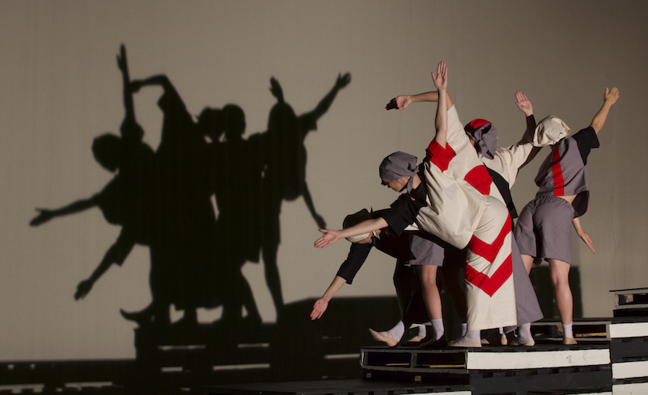

***I want to make a film about women***

**Key Credits**

Written, directed & edited by Karen Pearlman

Produced by Richard James Allen and Karen Pearlman

Starring: Victoria Haralabidou

Featuring: Liliya May, Inga Romantsova, Violette Ayad, Ever Sliter, Nadia Zwecker,

Tug Dumbly and Richard James Allen

Dancers: Jay Bailey, Clémence Dugué, Clarissa Harrison, Olivia Kingston, Billie Moffat

Cinematography by Meg White

Production Design by Valentina Iastrebova

Costume Design by Valentina Serebrennikova

Visual effects by Pavel Trotsenko

Sound Editors: Leah Katz, Andy Wright

Music by Caitlin Yeo

A Physical TV Company Production

***I want to make a film about women***

**Director’s Statement**

*‘I want to make a film about women’* is about constructivist women in the Soviet Union in the 1920s and a conversation they never had in a kitchen where potato peels become film strips and men get put in cupboards.

It is a speculative documentary. It had to be speculative, because it is about hidden forces. The women constructivists of the new Soviet Union in the 1920s were one such force. Hidden by more famous husbands and louder men, these women created from the world around them. Their work often started in domestic contexts. But what did they say to each other? How did they think? There are hints in the works they left behind, and I have, in this film, picked up on the thoughts that are embedded in their work and brought them to life as processes. In ‘*I want to make a film about women’* we see women’s hidden creativity, their creative thinking with hands, with tools, with available materials and with each other.

The creative processes of the central character, Esfir Shub (1894-1959), inspired me first. She was a great innovator in documentary filmmaking, but her innovations often go uncredited. She innovated with many techniques of remix filmmaking. She taught Eisenstein to edit. She invented the character-driven documentary. She recorded the first ever sync-sound interview in a documentary. And she wrote a script for a film about women that she never got to make. Her 1933 article, entitled ‘I want to make a film about women’, cries out for an opportunity to work, to realise her visions for constructivist documentaries even in Stalin’s freeze on innovation. I’ve used this short manifesto as a springboard for my speculations. Esfir Shub wanted to make a film about women, and I want to make a film about her, because if I don’t speculate on what she and her brilliant constructivist friends might have done or felt or thought, their stories will remain hidden.

*Copyright © 2019-2021 The Physical TV Company. All rights reserved.*

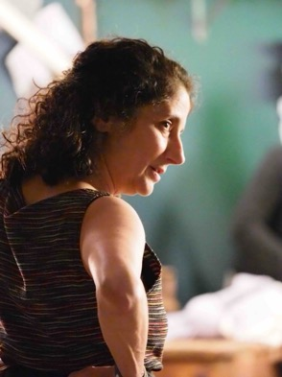

***I want to make a film about women***

**Director’s Biography – 75 words**

Karen Pearlman is a writer, director and editor and a two-time Australian Screen Editors Guild award winner. ‘I want to make a film about women’ is the third in her trilogy of films about women filmmakers which have, between them, won twenty-seven awards and screened at dozens of festivals. Karen is the author of ‘Cutting Rhythms: Intuitive Film Editing’ and teaches filmmaking at Macquarie University. She and Richard James Allen direct The Physical TV Company.

**Director’s Biography – 100 words**

Karen Pearlman is a writer, director and editor and a two-time Australian Screen Editors Guild award winner. ‘I want to make a film about women’ is the third in her trilogy of films about women filmmakers which have, between them, won twenty-seven awards and screened at dozens of festivals. Karen is the author of ‘Cutting Rhythms: Intuitive Film Editing’ and teaches filmmaking at Macquarie University. She and Richard James Allen direct The Physical TV Company, where they create dramas, documentaries and dance films informed by scholarly research into the history and future potential of the cinematic medium.

**Director’s Filmography**

I want to make a film about women (2020),

After the Facts (2018),

Woman with an Editing Bench (2016),

"...the dancer from the dance”(2014),

Down Time Jaz (2003),

What I Did On My Nervous Breakdown (2002),

Rubberman Accepts the Nobel Prize (2001),

A Dancer Drops Out Of The Sky (2000),

13 Acts of Unfulfilled Love (1997).

*Copyright © 2019-2021 The Physical TV Company. All rights reserved.*

***I want to make a film about women***

**Director’s Biography – 250 words**

Karen Pearlman writes, directs and edits screen productions. Her 2020 film [*I want to make a film about women*](https://vimeo.com/370015980)*,*won the Sebastopol Documentary Film Festival Special Jury Prize (06/2021) for: "a film of innovative brilliance, celebrating the inexhaustible, essential tenacity of suppressed artists everywhere". It garnered three best directing awards, including one from the Australian Directors Guild, three best documentary awards including the Academy Award qualifying award from the St Kilda Film Festival; two ATOM awards; more than half a dozen film festival awards and jury prizes, and an AACTA nomination.

*I want to make a film about women*is the third in Karen’s trilogy of films about Soviet women filmmakers. The 2nd one, the 2018 documentary [*After the Facts*](https://wfpp.columbia.edu/2020/03/16/after-the-facts/), was honoured with an ASE Award for Best Editing, as was the first, [*Woman with an Editing Bench*](https://vimeo.com/ondemand/womanwithaneditingbench)(2016), which also won the ATOM Award for Best Short Fiction, and six other film festival awards.

Karen is a former President of the Australian Screen Editors Guild and enjoys her ongoing association with the guild as a full member and frequent public speaker. A 5-time Best Editing Award nominee, Karen is a leading theorist, speaker and writer on the art of film editing, she is the author of [*Cutting Rhythms, Intuitive Film Editing*](http://www.karenpearlman.net/karenpearlmannet/cutting-rhythms-the-book)(now in its 2nd edition with Focal Press) and well-known around the world for her YouTube series [*The Science of Editing*](https://www.youtube.com/watch?v=02JF19lJ29M&feature=youtu.be)created with *This Guy Edits*.

*Copyright © 2019-2021 The Physical TV Company. All rights reserved.*

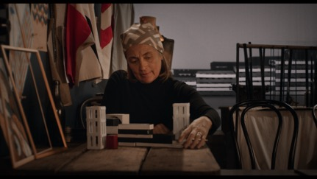

***I want to make a film about women***

**Director’s Biography – 600 words**

Dr Karen Pearlman is a director, with Dr Richard James Allen, of the critically acclaimed Physical TV Company (<http://physicaltv.com.au>), based in Sydney, Australia. They create dramas, documentaries and dance films informed by scholarly research into the history and future potential of the cinematic medium. Their works have been commissioned or purchased for multiple broadcasts by ABC and SBS-TV in Australia, and picked up for broadcast in China, Europe and on cable TV in the USA. Their screen productions have travelled to over 300 film festivals or public screenings on five continents, including the most selective and prestigious dance film festivals in the world.  They have garnered over 100 nominations or awards and many have attracted grant funding or support through government or philanthropic arts funding bodies.

Dr Karen Pearlman writes, directs and edits screen productions and she researches and writes about screen culture and creative processes.

Her 2020 film, ‘[*I want to make a film about women*](https://www.youtube.com/watch?v=gIUyOpWBwjU)*’*won Best Documentary at the St Kilda Film Festival, placing it on the international long list for an Academy Award. Karen was awarded Best Director in a Short Documentary at the 2020 Australian Screen Directors Guild Awards, Best Director at the inaugural CinefestOz Short Film Awards (2020), the Award for Creative Achievement at the Brisbane International Film Festival and Special Mention at the 2020 Sydney Film Festival’s Dendy Awards for the film's ‘ambitious and masterful mix of forms.’ Karen’s 2018 documentary, ‘[*After the Facts*](https://wfpp.columbia.edu/2020/03/16/after-the-facts/)*’*, was honoured with an ASE Award for Best Editing, after its screenings at the Sydney International Film Festival, the Adelaide International Film Festival, the Perth Revelation Film Festival and the Antenna Documentary Film Festival. Her 2016 film, ‘[*Woman with an Editing Bench*](https://vimeo.com/ondemand/womanwithaneditingbench)*’*, won the Australian Teachers of Media ATOM Award for Best Short Fiction, the Australian Screen Editors' Guild (ASE) Award for Best Editing in a Short and six other film festival awards. *‘...the dancer from the dance’*,a 2014 documentary made with the Sydney dance community, and directed and edited by Karen, won two Audience Choice Awards at the World of Women (WOW) Film Festival, and was a finalist at the Australian Dance Awards for Outstanding Achievement for Dance on Screen and the Atom Awards for Best Documentary.

Karen is a senior lecturer in Screen Production and Practice at [Macquarie University](https://www.mq.edu.au/study/find-a-course/media-communications-and-performing-arts/film), the 2020 *Australian* Research leader in Film. She and her colleague Dr Iqbal Barkat won the 2019 Australian Award for University Teaching Citation, and Karen is proud to [supervise](https://www.mq.edu.au/research/phd-and-research-degrees) up and coming researchers in creative practice. Before joining Macquarie, Karen held the post of Head of Screen Studies at AFTRS for 6 years. A leading theorist, speaker and writer on the art of film editing, she is the author of [‘*Cutting Rhythms, Intuitive Film Editing’*](https://www.amazon.com/Cutting-Rhythms-Intuitive-Pearlman-2015-12-16/dp/B01FIY4KB2)(now in its 2nd edition with Focal Press) and well-known around the world for her YouTube series ‘*The Science of Editing’*created with This Guy Edits (over 1 million views).

Before taking up filmmaking, Karen had a distinguished career as a professional dancer - performing on the Opera House stages of the world with Bill T. Jones/Arnie Zane Company and other leading New York dance companies, as well as co-directing, with Richard James Allen, two other critically acclaimed dance companies, That Was Fast and Tasdance. She holds a Doctorate of Creative Arts from UTS, MAs in filmmaking from AFTRS and UTS, and a BFA in Dance from NYC’s Tisch School of the Arts.

Many of Karen’s research publications can be accessed here: [https://mq.academia.edu/KarenPearlman.](https://mq.academia.edu/KarenPearlman)

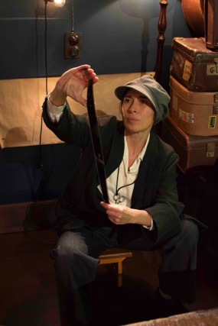

***I want to make a film about women***

**Producer’s Biography**

Richard James Allen is a director, with Karen Pearlman, of the critically acclaimed Physical TV Company. Based in Sydney, Australia, they create documentary, drama and dance films informed by research into the history and the future potential of the cinematic medium. An AACTA nominated and five-time ATOM Award winning, producer and director, Richard’s films have been commissioned or purchased for multiple broadcasts by ABC and SBS-TV, and picked up for broadcast in China, Europe and on cable TV in the USA. His productions have travelled to over 300 film festivals or public screenings on five continents, including all of the most selective and prestigious dance film festivals in the world. They have garnered over 100 awards or nominations and many have attracted grant funding or support through government or philanthropic arts funding bodies.

As well as producing Karen Pearlman’s multi-award-winning trilogy of short films about women, Richard recently completed two long-form works, both nominated for Best Fiction Feature Film at the ATOM Awards: *Text Messages from the Universe*, which he wrote and directed, and *Bloodshot Heart*, which he produced and stars in.

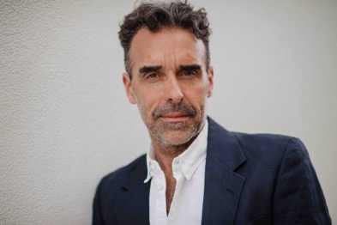In addition to his creativity as a director, producer, writer, actor and dancer for the screen, Richard is an acclaimed Australian poet. His latest book of poetry, 'The short story of you and I', was published by UWA Publishing in 2019, and his novel, ‘More Lies’, appeared with Interactive Press in 2021.  He also has an extensive track record of creating critically lauded works for the stage and edited a landmark national anthology of writing for performance. Richard won Chancellor’s Award for Most Outstanding PhD Thesis for his doctorate at the University of Technology, Sydney, and graduated with First Class Honours for his B.A. at Sydney University. For more information, see the website of The Physical TV Company: <http://physicaltv.com.au>