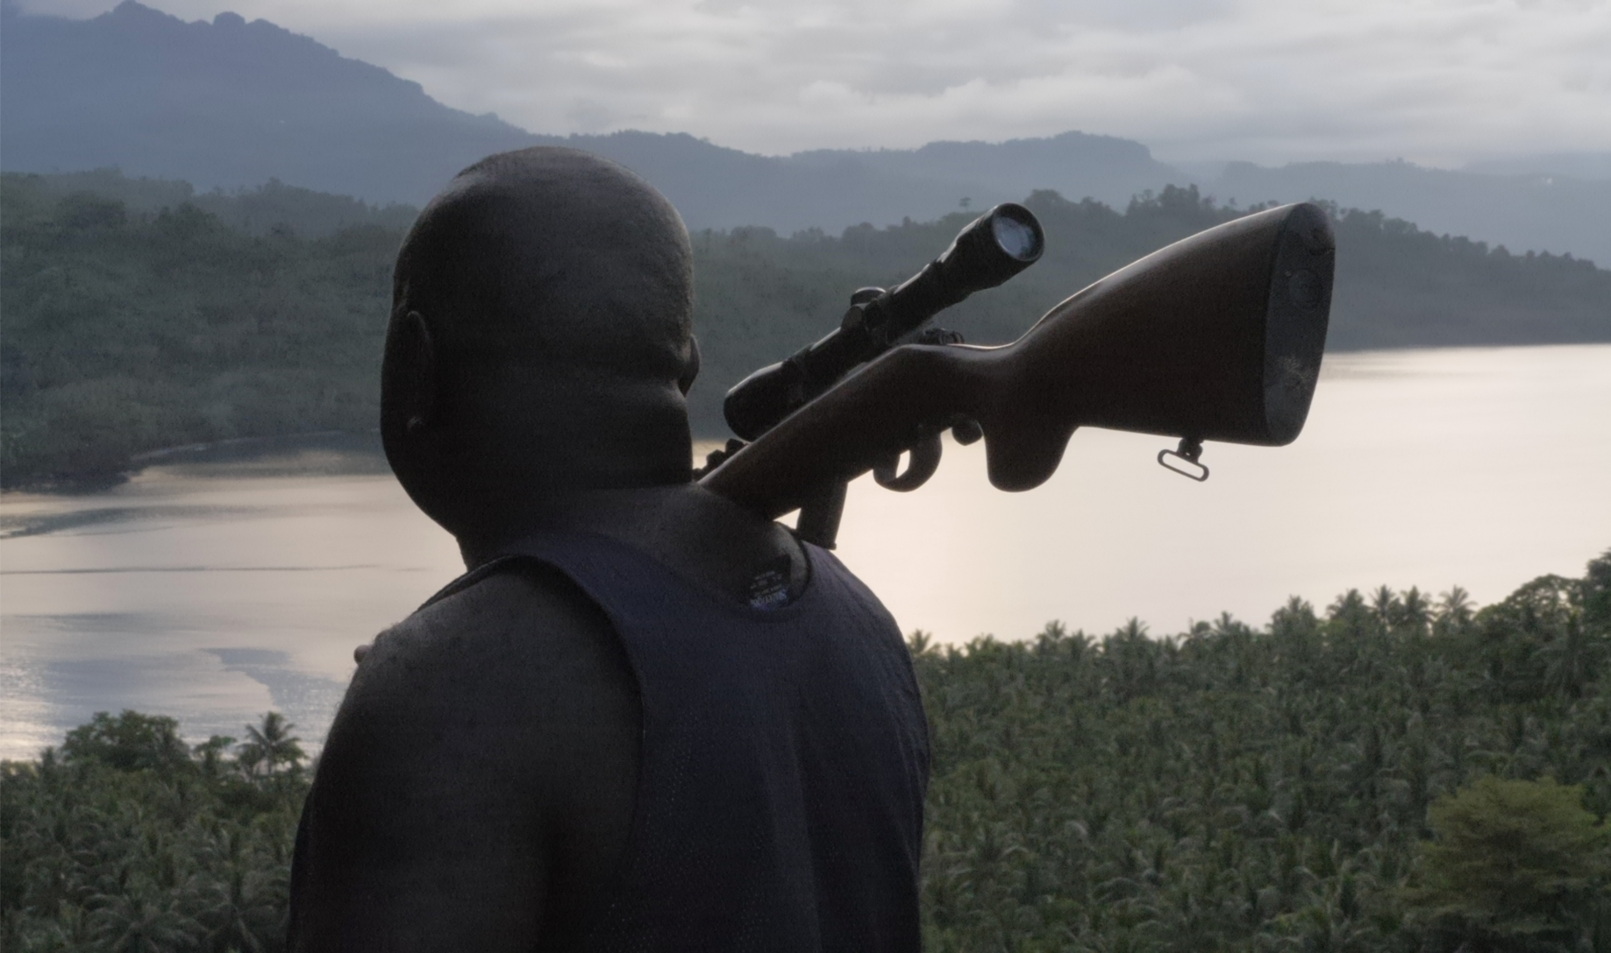

Ophir
(2020, 97’, France/UK)

Short Synopsis
A poetic yet dramatic ode to the indelible thirst of a peoples for freedom, culture and sovereignty, Ophir documents the visible and invisible chains of colonisation, as well as its enduring cycles of physical and psychological warfare.

Synopsis
Ophir tells the story of an extraordinary indigenous revolution for life, land and culture, leading up to the potential creation of the world’s newest nation in Bougainville, Papua New Guinea. A poetic yet dramatic ode to the indelible thirst for freedom, culture and sovereignty; the film sheds light on the biggest conflict of the Pacific since WWII, revealing the visible and invisible chains of colonisation and its enduring cycles of physical and psychological warfare.

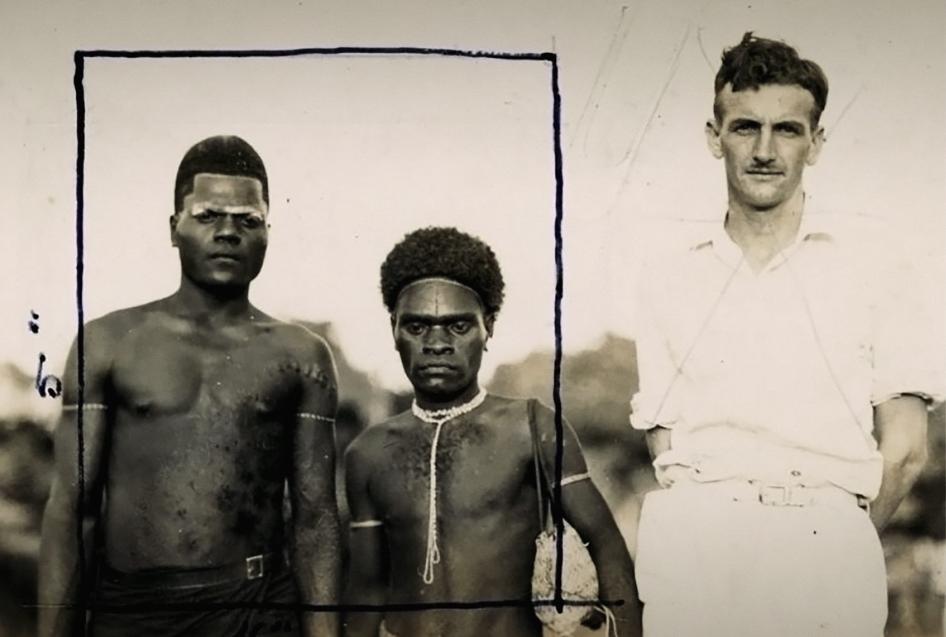

Key Credits

Directors: Alexandre Berman & Olivier Pollet
Assistant Director: Nathan Matbob
Writers: Alexandre Berman & Olivier Pollet
Cinematography & Sound: Alexandre Berman & Olivier Pollet
Producers: Ilann Girard (Arsam International), Olivier Pollet (Fourth World Films) and Kristian Lasslett (Ulster University)
Editors: Alexandre Berman, Marie Estelle Dieterlé
Research: Theonila Roka-Matbob
Additional Research: Clive Porabou
Composer : Xavier Thiry
Sound Mix : Thomas Musso
Colorist : Jean-Christophe Savelli
Communications: Aditi Bhonagiri

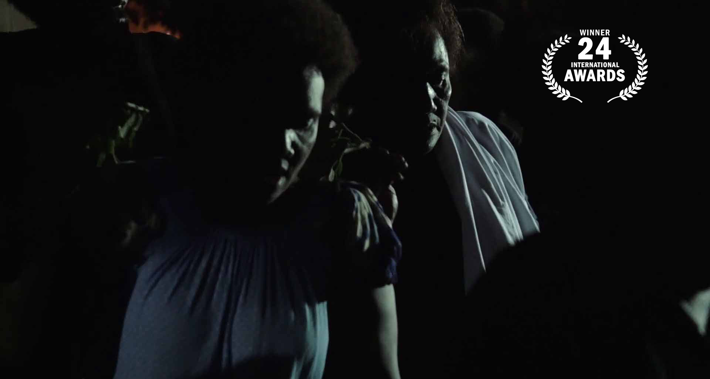
Festivals & Awards (as of March 2021)

FIFO International Documentary Film Festival of Oceania – World Premiere
 WINNER Grand Jury Prize (February 2020)

Doc Edge Festival, New Zealand – Australasia Premiere (June 2020)

Asinabka Film & Media Arts Festival – Canada - North American Premiere (September 2020)

Wildscreen Festival – European Premiere (October 2020)

Dharamshala International Film Festival – Asian Premiere (November 2020)

Suncine Environmental Film Festival – Spanish Premiere – (November 2020)
WINNER Grand Jury Prize + Festival Opening Film

Guam International Film Festival – Guam - US Premiere
WINNER Grand Jury Prize Best Documentary (November 2020)

Red Nation International Film Festival & Awards – United States (November 2020)

Escales Documentaires – La Rochelle, France – French Premiere (November 2020)

PNG Human Rights Film Festival – Papua New Guinea (November 2020)

Traces de Vies – France (November/December 2020)

Présence Autochtone Montreal First Peoples Film Festival – Canada (Dec/April 2021)
WINNER Grand Jury Prize (Rigoberta Menchú)

Karama Human Rights Film Festival – Jordan – Middle East Premiere (December 2020)

Garifuna International Film Festival – United States (December 2020)

Wild & Scenic Film Festival – United States (January 2021)

Ficwallmapu – Chile – South American Premiere (January 2021)

Toronto Black Film Festival – Canada (February 2021)

Human International Documentary Film Festival – Norway - Scandinavian Premiere (March)

RAI Film Festival – UK (March 2021) – Nominee RAI & Basil Wright Film Prize

Environmental Film Festival at Yale – United States (March 2021)

Liberation DocFest – Bangladeshi Premiere (April 2021 - postponed)

London Mining Network – Special Screening (April 2021)

Princeton Environmental Film Festival – United States (April 2021)

Censurados Film Festival – Peruvian Premiere (April 2021)

Seattle Black Film Festival – Seattle, United States (April 2021)

Human Rights Arts & Film Festival – Melbourne, Australian Premiere (April 2021)

Special Screening with Q&A – Sydney, Australia – Organised by Jubilee Australia (April 2021)

One World Media Award – Best reporting on Global South - United Kingdom
Nominee (longlisted)

Muestra de Cine Internacional Memoria Justicia Verdad – Central American Premiere – Guatemala (April 2021)

Northwest Fest International Documentary Festival – Edmonton, Canada (May 2021)

Millenium International Documentary FF – Brussels, Belgium Premiere (May 2021)
WINNER Silver Award – Best Film on Sustainable Development Award

Front – Mostra Internacional de Cinema de Conflicte i Pau
Festival Closing Film

Cinema e Ambiente Avezzano – Avvezzano, Italy – Italian Premiere
WINNER Grand Prix – Best Feature Film

Wairoa Maori Film Festival – New Zealand (June 2021)

Martinique International Documentary Film Festival Les Révoltés du Monde – Martinique – Caribbean Premiere (June 2021)
WINNER Special Jury Prize

Peloponnesus International Documentary Festival – Greek Premiere (July 2021)

Weengushk International Film Festival – Canada (July 2021)

NaturVision Film Festival – Ludwigsburg, Germany – German Premiere (July 2021)

Durban International Film Festival – Durban, South Africa – African Premiere (July 2021)

Aegean Film Festival – Paros, Greece (July/Aug 2021)

Noma International Human Rights Film Festival – Azores, Portugal – Portuguese Premiere
WINNER Audience Award
WINNER Jury Special Mention

Green Montenegro International Film Festival – Montenegro - Balkan Premiere
WINNER 1st Special Jury Prize

FINCALI - Santander, Colombia – Colombian Premiere (August 2021)

Doqumenta International Film Festival – Mexico – Mexican Premiere (August 2021)

Islantilla Cinéforum Bajo La Luna Film Festival – Huelva, Spain (August 2021)

Ujan International Documentary Film Festival – Ujan, Armenia (August 2021)

Smaragdani Eco Film Festival – Croatia (August 2021)

AricaDoc – Arica, Chile (August/September 2021)

PukaNawi International Human Rights Film Festival of Sucre – Sucre, Bolivia – Bolivian Premiere (September 2021)
WINNER Grand Prix – Best International Feature

Human Rights Film Festival of Panama Bannabafest – Panamean Premiere (Sept 2021)

International Nature Film Festival Godollo – Budapest, Hungarian Premiere
WINNER 2nd Jury Prize – International Documentaries

Festival de Cine Verde de Barichara Festiver – Colombia (September 2021)
WINNER Grand Prix – Best Feature Film

IndieCork Film Festival – Irish Premiere (Sept/Oct 2021)

Human Rights Film Festival Berlin – Berlin, Germany (September 2021)

Montreal International Black Film Festival – Montreal (September 2021)

Los Angeles Asian Pacific Film Festival – Los Angeles, United States (September 2021)

Life After Oil International Film Festival – Italy (September 2021)

Taiwan International Ethnographic Film Festival – Taiwan – East Asian Premiere (Oct 2021)

AegeanDocs International Film Festival – Greek Islands (October 2021)
WINNER Grand Prix – Best Foreign Film Award

Dili International Film Festival – Timor Leste Premiere (October 2021)
WINNER Best International Documentary Feature Award

All Living Things Environmental Film Festival – Panchgani, India (October 2021)
WINNER Grand Prix – Best International Feature Film

Terra di Tutti Film Festival – Bologna, Italy (October 2021)
WINNER Grand Prix – Benedetto Senni Award

CineEco – Serra de Estrella International Environmental Film Festival – Portugal (October 2021)
WINNER Best International Film – Youth Jury

Festival Internacional de Cine Invisible Film Sozialak de Bilbao – Spain (October 2021)

Native Spirit Film Festival - London, UK (Oct/Nov 2021)

Edinburgh Green Film Festival – Edinburgh, Scotland – (October 2021)

Jakarta Independent Film Festival – Indonesian Premiere (October 2021)

Bogota Film Festival Bogocine – Colombia (Oct 2021)
WINNER Best Environmental Film Award

Royal Anthropological Institute/ RAI Film Festival Anthropology and Conservation Conference- UK/Global (October 2021)

Arica Nativa Film Festival – Arica, Chile (Oct/Nov 2021)
WINNER Best Feature Film Award

Anuu-ru Aboro Film Festival – New Caledonia (Oct 2021/ Postponed)

Green Screen Environmental Film Festival – Trinidad & Tobago Premiere (Oct 2021)

Filmambiente Festival – Rio de Janeiro, Brazil – Brazilian Premiere (October 2021)
WINNER Special Jury Prize – Best Script

FICKIN – Festival International de Cinema de Kinshasa – DRC Premiere (November 2021)

Slow Film Festival – Roma, Acquapendente, Antrodoco, Italy (November 2021)

International Green Culture Film Festival ‘Green Fest’ – Belgrade, Serbian Premiere (Nov 2021)
WINNER Best Feature Film Award

Naples Human Rights Film Festival – Naples, Italy (November 2021)

Sunchild International Environmental Film Festival – Yerevan, Armenia (November 2021)

Museum of Tahiti – French Polynesia (November 2021)

Destinazione Sud – Radicondoli, Sienna, Italy (November 2021)

Festival Interférences – Lyon, France (November 2021)

Calgary Justice Film Festival – Canada (November 2021)

Muestra de Antropologia Audiovisual de Madrid – Spain (November 2021)

Pocahontas Reframed Film Festival – United States (November 2021)

Nepal Human Rights Film Festival – Nepali Premiere (November 2021)

Virginia Dares Award on Decolonization – United States (December 2021)

Alter do Chao Film Festival – Brazil (December 2021)

FICA Festival Internacional de Cinema Ambiental – Goias, Brazil (December 2021)
WINNER Film of the Year Award

DOCA – Argentina (December 2021)
Festival Closing Film

Auroville Film Festival – Auroville, India (January 2022)

Papua New Guinea Cinema Release – Port Moresby, PNG (March 2022)

Cine-Clube da Ilha Terceira – Azores, Portugal (March 2022)

Eugene Environmental Film Festival – USA (April 2022)
WINNER Environmental Justice Award

FIFEQ International Ethnographic Film Festival of Quebec – Canada (May 2022)

German International Ethnographic Film Festival – Germany (May 2022)

Ecozine Film Festival – Zaragoza, Spain (May 2022)

Arctic Film Festival – Norway (May 2022, date TBC)

Wildview Taiwan - Taiwan (June 2022 TBC)

International Documentary Festival of Ierapetra – Greece (August 2022)

Ecocine International Cinema Festival for Environmental and Human Rights – Brazil (August 2022)
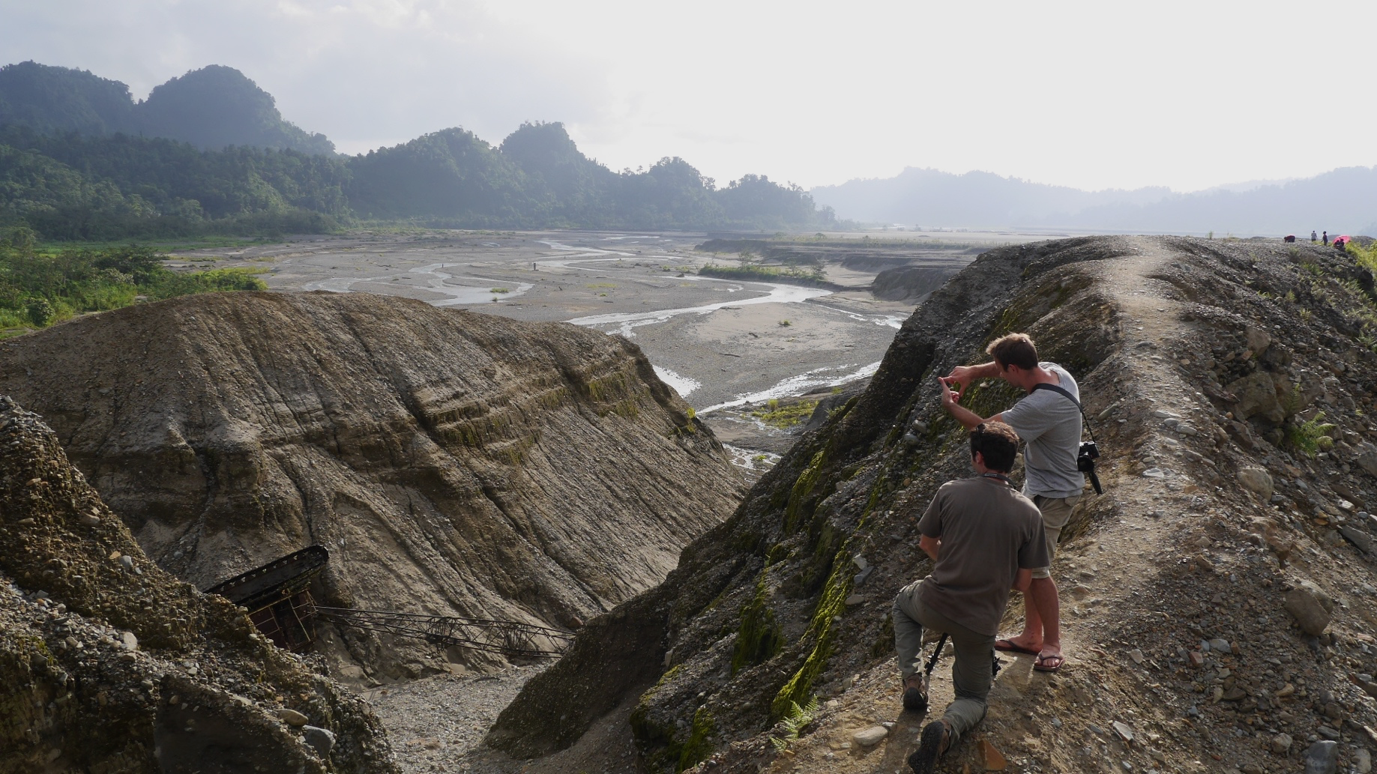
Directors Biographies & Filmographies

Alexandre Berman
Alexandre Berman is a French documentary filmmaker and editor, based in Paris, France. He co-directs the documentary “The Panguna Syndrome” with Olivier Pollet and the film is a finalist for Albert Londres Prize 2017 in France. In 2018, his feature documentary “Norvège: Les Ombres sur la Mer” captures cultural heritage stories in Norway. Part of the relaunch of French “Connaissance du Monde” cinema circuit, it is screened in France and Switzerland for several months across 2018 and 2019.

Credits : Ophir (2020, 97’), Norvège: Les Ombres sur la Mer (2018, 80'), The Panguna Syndrome (2017, 52')

Olivier Pollet
Olivier Pollet is an investigative journalist and award-winning filmmaker, producer and researcher based in the UK. Over the past decade his works have focused on corporate accountability, human rights, environmental issues and colonial legacies, working alongside indigenous communities in the Asia-Pacific region, and especially in Papua New Guinea. His films have been recognized numerous times on the festival scene, including with a nomination for the Albert Londres Prize, the most prestigious journalism award in France. His latest project is the award-winning feature documentary Ophir (2020), alongside its multimedia educational counterpart The Colonial Syndrome (2021).

Credits: The Colonial Syndrome (2021, Multimedia web-series), Ophir (2020, 97’), The Panguna Syndrome (2017, 52'), When We Were Hela (2014, 14'), Canning Paradise (2012, 90')
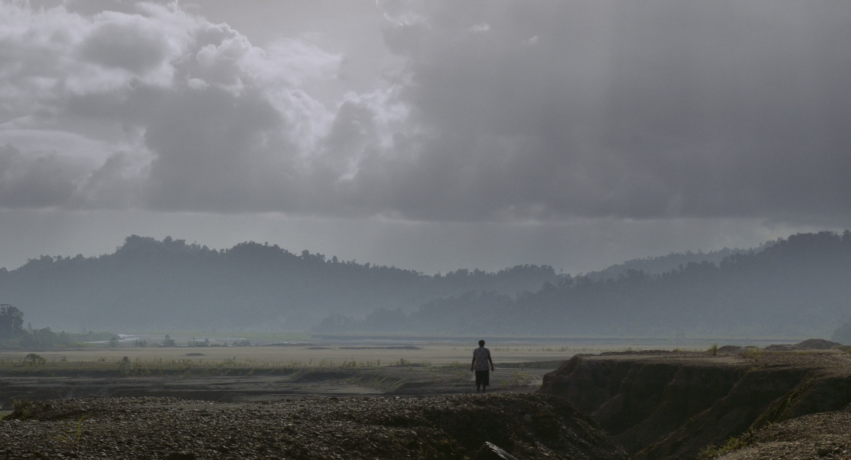

Key Bougainville Team Members Biographies

Nathan Matbob – Assistant Director
Nathan had been living and working in Bougainville since 2013. His primary works are in research, film making and assisting in community development projects and initiatives in the constituency he resides in. Together with his wife Theonila, both manage and run the early childhood and counselling centre in Panguna. One of his major work is the Bougainville Voices report of 2014 by Jubilee Australia, and among other partnerships; Nathan continues to use his networks to send young people out to tertiary institutions throughout the country. Nathan’s broad experience has enabled him to work in different spheres in research, education, community development, politics and journalism. He currently manages the Adult Literacy and Research & Partnership components at the John Roka Learning and Counselling Centre.

Theonila Roka Matbob – Research
Theonila is the current member elect of Ioro Constituency where the Panguna mine is located, and the Minister for Education of the Automomous Bougainville Government. She is a strong advocate for reconciliation, peace and justice for the people and environment. Together with her family, she established and continues to manage an early childhood and counselling centre in her village. Theonila has held several roles in her career with different international partners and NGOs, Peace Building, politics, health, education and gender equality advocacy. She continues to advocate and be vocal on issues that affect her people in Panguna and Bougainville. She is a strong supporter for independence for her island home.

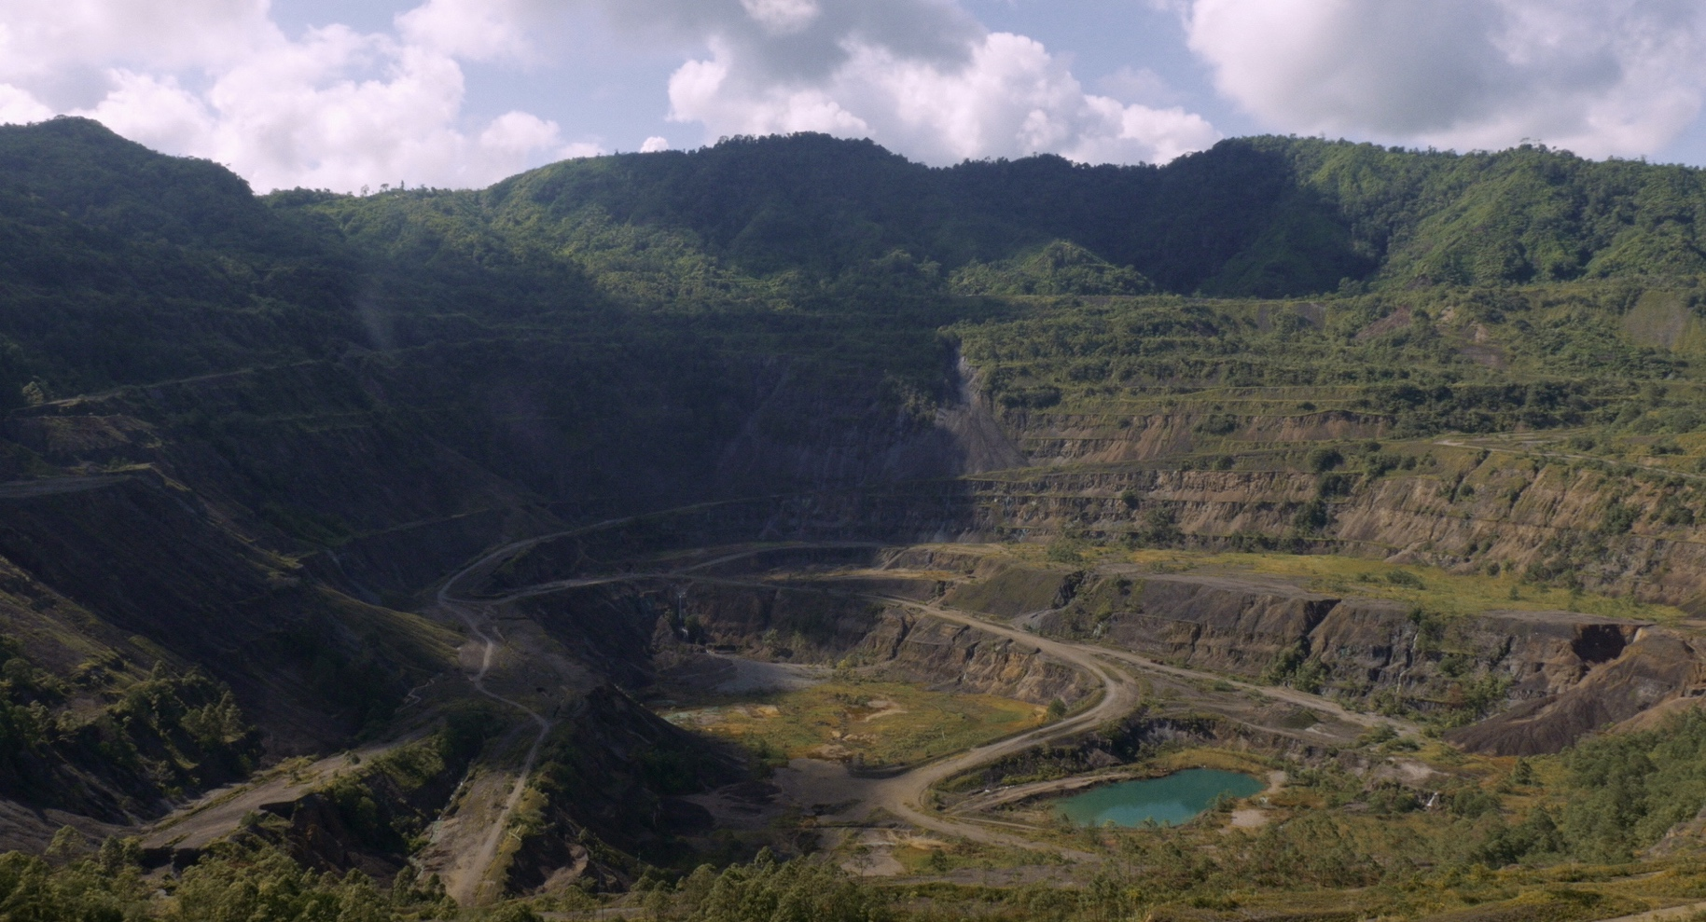
Producers Biographies & Filmographies

Ilann Girard – Arsam International - France
After a 12 years tenure as General Counsel for Pandora Cinema, a leading sales and financing company of the 90’s, Ilann Girard set up Arsam as consultancy and production company for high end documentary and drama features. His credits include Academy award-winning feature documentary “March of the Penguins”, Berlinale Official Competition’s “Goodbye Bafana” by Bille August, “Plastic Planet” by Werner Boote, Venice 2009 Golden Lion “Lebanon” by Samuel Maoz, Stanley Tucci’s “Final Portrait” and Alla Kovgan’s 3D feature dance documentary “Cunningham” which premiered in 2019 at TIFF.

Olivier Pollet – Fourth World Films – United Kingdom
See director’s biography.

Kristian Lasslett – Ulster University – Northern Ireland
Professor Kristian Lasslett is Head of the School of Applied Social and Policy Sciences at the University of Ulster, and sits on the Executive Board of the International State Crime Initiative. He is joint Editor-in-Chief of State Crime, a leading international peer reviewed journal, and Editor of The State Testimony Project, the first online casebook for state crime studies. Kristian’s research focuses on criminogenic intersections of state-corporate power, and the communities of resistance that emerge in opposition. He is the author of State Crime on the Margins of Empire: Rio Tinto, the War on Bougainville and Resistance to Mining.

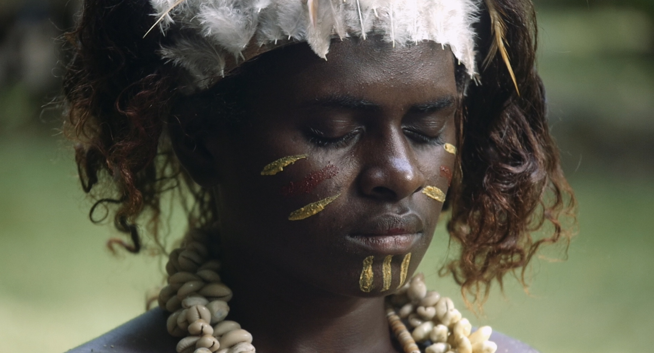
Impact & Educational Outreach

Beyond the Ophir documentary, the project team and communities of Bougainville worked hand in hand to produce an educational platform entitled “the Colonial Syndrome.”
Spearheading the project is Professor Kristian Lasslett from the University of Ulster and Dr Ruth Saovana from the Bougainville Peoples Research Center. Featuring over 40 short-films, it blends story, art and historical artefacts to narrate an existential struggle for survival on the island, that left up to 20,000 of its people dead.

Conceptualized as a seven-part educational documentary series - accessible both online (for a global outreach) as well as offline (to maximize local impact and offer solutions to limited internet access) – the platform allows audiences to delve deeper into the effects of past and present colonialism and understand its dynamics, structures and impacts on indigenous populations and cultures, through the prism of the experience of the people of Bougainville.
Each part in this series is led by village historians, political analysts and philosophers that can be found today across Bougainville and who offer their personal stories. Those are carefully placed in a timeline that takes the viewer through a century of history marked by violence, trauma, resistance and renewal. Punctuating the film, are photographs and records obtained from colonial, academic and legal archives, which document the ideologies and strategies that informed the colonial mission, and subsequent military incursions. Complimenting each part is a detailed historical essay that sets the scene in intricate detail for the more dedicated user.
The platform can be accessed at the following link: https://www.colonialsyndrome.org/

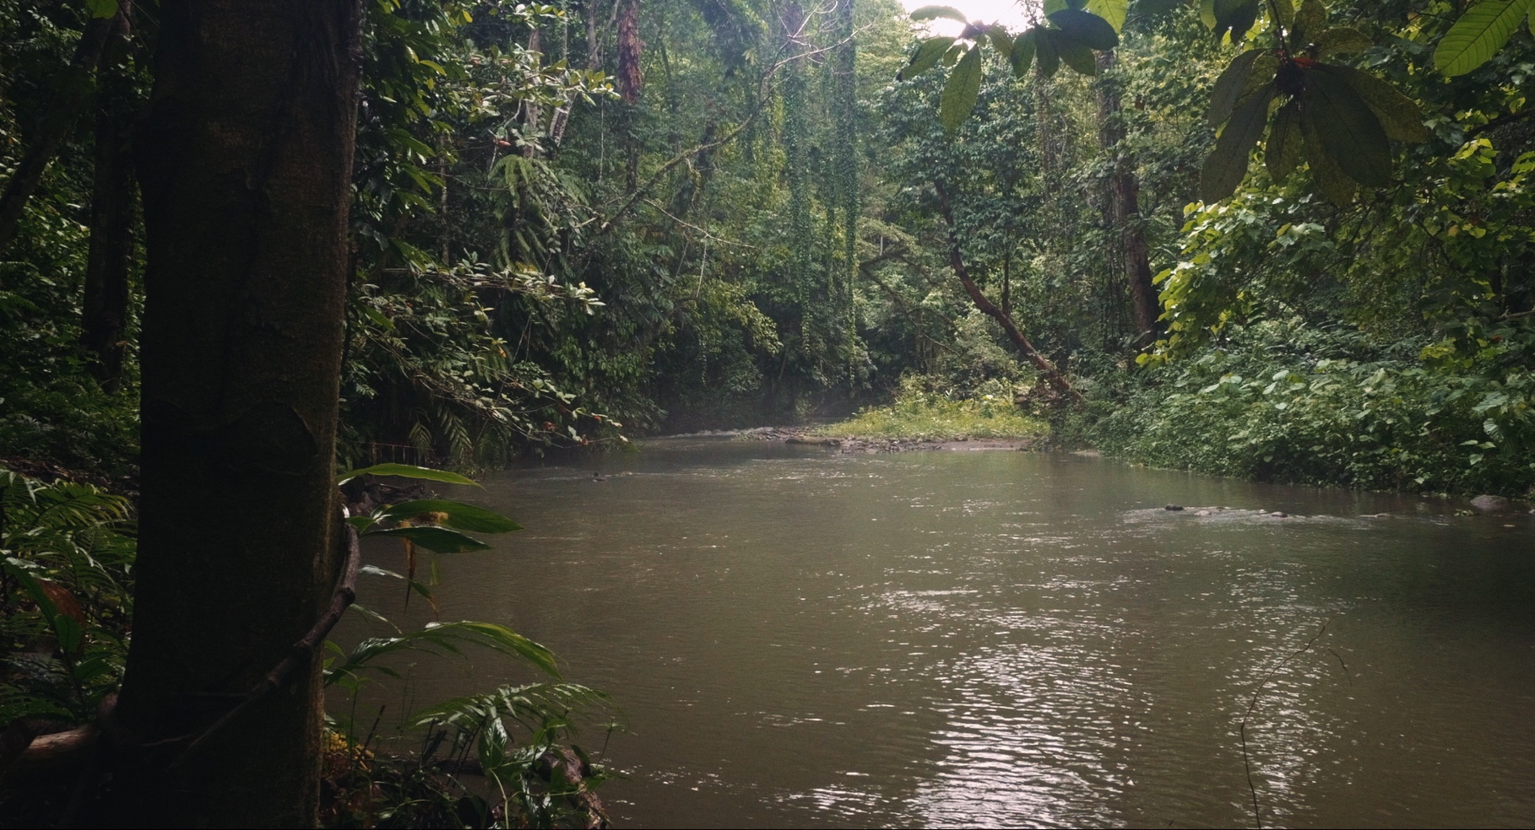
Links

Official Websites
www.ophir-film.com/
www.facebook.com/OphirDocumentary/

Trailer
With English Subtitles: https://youtu.be/fH-NbfOYH3s
With French Subtitles: https://youtu.be/jo7-1QnLP-o
With Spanish Subtitles: https://www.youtube.com/watch?v=g2ihoH9lSW0

Multimedia Educational Platform
https://www.colonialsyndrome.org/
The film is available with English, French, Spanish, Italian, Armenian, Catalan, Greek, Traditional Mandarin (Taiwan), Serbian or Portuguese subtitles.

Contact
Ilann Girard – Arsam International
28 Rue de Turin
75008, Paris
France
Email : ilann.girard@arsam.biz - Phone : + 33 6 14 82 42 65

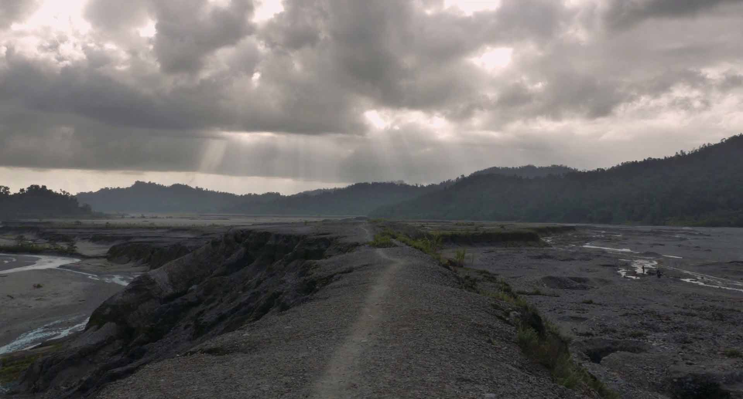
Directors Statement

The Context

Since the turn of the 21st century, areas of conflicts have been multiplying at an unprecedented rate leading to an ever more polarised world. Issues that in the past were seen as isolated from each other are now intertwined in a large and wide-ranging conversation about how we co-exist on earth. Everything is being questioned in a continuous and deafening reverberation; our ability to protect our environment of course, but also our ability to reconcile humans with each other. On the one hand, there is the tremendous hope for the building of peaceful human societies where nature is respected, where we harmoniously progress with solidarity and benevolence. On the other, we are confronted by the brutal reality of the natural world being attacked from all sides, not once but a million time, and of ideals plunged into confusion. Both ways of beings are fast running out of breath at the same time. By suffocating our environment and those who inhabit it, we in turn suffocate the very idea of peace; an increasingly distant dream.

Our world is in Crisis. The Crisis of imagination that privileges outdated growth patterns and band-aid solutions. The Crisis of global warming, of the uninterrupted race for natural resources, of forests burning on every continent, of democracies in loss of certainties, of digital clouds observing our intimacies, of the vacuum of justice in the struggles for equality and equal opportunity. The Crisis that mobilises people to join the collective cries of #metoo, #FridaysForFuture, #blacklivesmatter, and of indigenous peoples and exploited workers around the world.

The Crisis almost always leads us back to our chequered past. Finally, the issues related to the colonial legacies of the “great” Western powers catapult to the forefront. These debates gain ground well before a deadly virus paralyses the world. But this young decade begins with a chaotic bang and our collective narrative is being sought: Who are we? Where are we going? In this context, it is legitimate to harp on the grand questions of the future: the Crisis, what is this phenomenon? How do we move forward? Whose worldview counts? Who do we listen to, who do we believe? Us or them, over here or there? The pro or against? Can we begin to repair as quickly as we have destroyed, and as we continue destroying? It is a vast undertaking to plunge into these profound questions, when a new one seems more urgent than the previous one, when pessimists accuse the optimists of naivety, who themselves accuse the former of defeatism. Meanwhile, the struggles for survival do not wait. Their battlegrounds bear telling signs of the creeping atrophy of human civilisation, while screaming “will you pay attention?”

The Story

Ophir exposes the roots of this integral Crisis, voiced entirely by the indigenous people of the autonomous region of Bougainville in Papua New Guinea. The film deconstructs the mechanisms of exploitation through the colonisation of land and its people, who at the end of the 1980s were left with no choice but to revolt for their right to exist. They defiantly defended the core principles that formed the basis of their society, in the face of absolute destruction of their mental, physical, and spiritual conception of what it means to be human. A conception of existence in which women and men, culture and the environment, form an inseparable whole, a vector of harmony and peace. This may seem utopian. Yet, the people of Bougainville led their revolution in the mountains and jungle and won.

They won against the colonial powers, in a bid to secede from their motherland Papua New Guinea, which was propped up by Australia and one of the biggest mining giants, Rio Tinto. This is better known as the Bougainville Crisis of the 1990s. A decade-long dramatic civil war which killed around 20,000 Bougainvilleans, wiping out approximately 10% of the island’s population. The largest conflict in the Pacific region since the Second World War, where a small group of islanders first armed with bows and arrows fought helicopters and guns. Some say they were guided by nature. That "when nature fights at your side, you cannot lose". While filming Ophir, we heard these words. Not once, but dozens of times. They mark you for life.

Ophir tells a story that is emblematic of the story of the world. It is the story of a land that oversaw a continuous succession of colonial administrations, each one brought markedly different changes to an ancestral society that had been around for millennia. For generations people inhabited the lands, coasts, and mountains that provide them with their livelihood, they created their repositories of knowledge by observing their environment and different landscapes. The era of European colonisation begins with the reshaping of local beliefs by Christian missionaries carrying out God’s work and their Bible; and the immeasurable worth of their land is gradually commodified. In the 1960s explorers discover, in the exact centre of the island – as in its belly – the monumental copper and gold resources of what will later come to be known as the Panguna mine. And in the early 1970s the exploitation of these precious minerals starts despite initial resistance.

Then, for the next two decades, we witness an uncomfortable cohabitation between miners who extract their resources day and night while discovering the pleasures of a certain exoticism; a paradise on earth. The local population is displaced, relocated, stunned, watching their rivers being blocked, their villages being buried, its way of life turned upside down. A problem imported from scratch by a foreign profit-seeking model. Their carefree smiles give way, faces get tense, frustration mounts, stifling the air. Smiling is no longer possible. Suspicions rule the roost. Unable to be held prisoners in their own land, the local people rise up and war breaks out. Perhaps, this is what a revolution is all about: this irrepressible act of refusing a life of lament. Perhaps, therein lies the high ideal of courage. That, in any case, is what the Bougainville Crisis is all about. An uprising for life in its entirety. For the possibility of a life where the environment we now constantly talk about is not just a museum and something to be preserved, but an active, living, joyful company. That is what is at stake, the reminder, the struggle of the people of Bougainville, yesterday and today.

The Film

Told through a local prism, Ophir breaks the chains, setting up a montage of interlaced narratives of the Bougainville Crisis and alternates between the factual, the perceptual, and the personal. One stream of storytelling delves deep into the very idea of Bougainville as recounted by Bougainvilleans themselves. Testimonials and archives offer historical accounts of events that led up to the conflict, as well as ongoing issues: the difficult dressing of deep wounds, the fight against proposals of a dangerous new mining law that criminalises dissent from the local community, but also visualising the long-desired road to independence, centred around a huge dilemma: the price of sovereignty could mean reopening of the Panguna mine which lay at the heart of the Crisis – or at least this is how it is being presented by powerful interests.

The film ties in elements of an exceptional secret report written by the American anthropologist Douglas Oliver in 1968 for the mining company Rio Tinto prior to setting up the Panguna mine, and in which he warns that the mining project is in every way incompatible with local culture. There will be strong resistance, which he anticipates and details in long pages. Then, stupefyingly, the tone starts to gradually change, and Oliver proposes a long list of recommendations to the company in order to get around the resistance, exploring ways to make the ‘natives' switch to consumerism, to monitor them, to educate them according to his model. In a few words, the observations and recommendations systematically and clinically lay out the blueprint for the neo-colonial project. By inviting the audience into the pages of this exceptional document, we intend to take a plunge into the deepest waters of colonialism and its invisible mechanisms and mindsets that still shapes the world and its institutions as we know it.

In this montage where several temporalities respond to and nourish each other, Ophir observes the consequences of the act of inflicting on a society, a culture and a people what we have been inflicting on ourselves for a long time: a reversed polarity, the earth which is no longer a necessary and indispensable space for human survival but an inert body with a quantifiable anatomy. Ophir, the imagined entity, tries to face the consequences of this act of unnatural and unsettling rupture. Through the symbolic story of a small Pacific island and a people with an extraordinary resilience, the film reveals this fracture, this point of no return, when the link between mankind and his environment is broken.

Ophir thus tells the story of Bougainville, but also the much broader filigree story of a difficult attempt to decolonise the mind in the polarised world of the 21st century, which must face the urgency of profound reflections for its future. In a consultative referendum in December 2019, the population of Bougainville voted nearly 98% in favour of independence and could in the near future become the newest nation in the world. But which nation? Bougainville has a rare opportunity to explore a new road.

"When nature fights at your side, you can't lose".

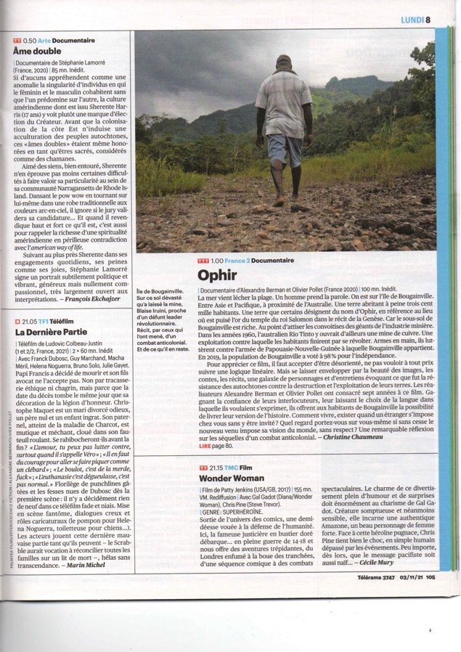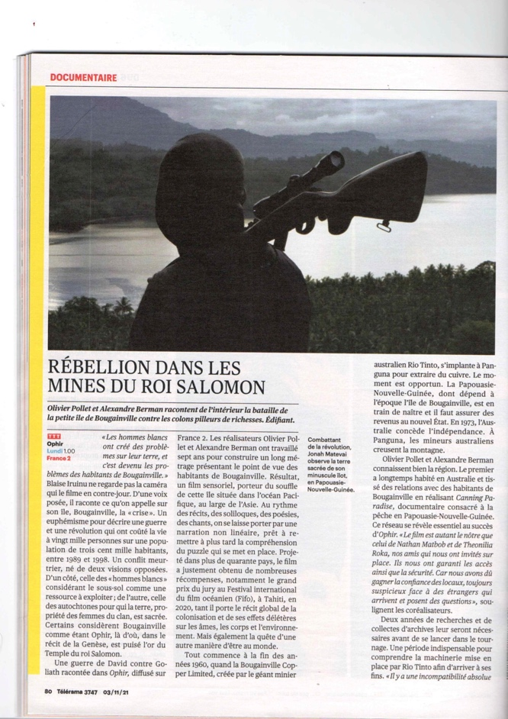

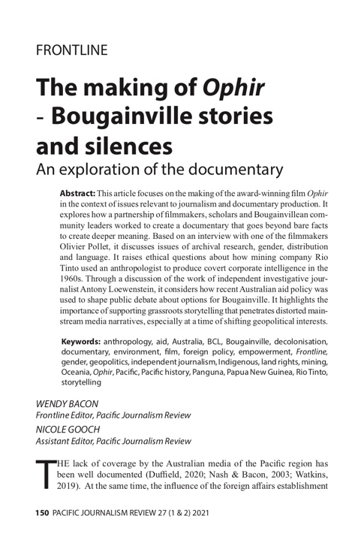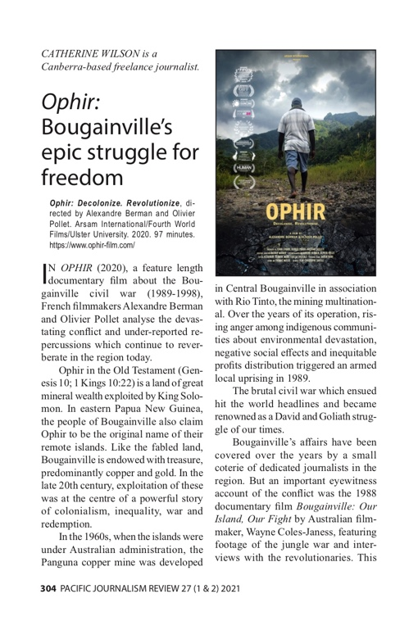
Press / Selection

https://www.fifotahiti.com/2020/02/ophir-des-paroles-fortes-qui-touchent-au-coeur/

https://www.nouvelobs.com/teleobs/20200210.OBS24650/fifo-bougainville-cette-ile-qui-a-fichu-dehors-une-multinationale.html

https://www.rfi.fr/fr/culture/20200207-fifo-2020-ophir-peuple-lutte-bougainville-festival-film-oc%C3%A9anien

https://www.rnz.co.nz/international/pacific-news/409167/film-about-bougainville-wins-top-prize-in-tahiti

https://www.abc.net.au/radio-australia/programs/pacificmornings/ophir-the-story-of-bougainville/11970862

https://www.rnz.co.nz/international/pacific-news/418584/unique-fight-for-fundamentals-captured-in-bougainville-film

https://la1ere.francetvinfo.fr/nouvellecaledonie/ophir-remporte-grand-prix-fifo-france-televisions-2020-798187.html

https://www.tahiti-infos.com/Porter-haut-la-petite-voix-du-Fifo_a188726.html

https://www.fifotahiti.com/2020/02/alexandre-berman-et-olivier-poller-cest-leur-prix/

https://la1ere.francetvinfo.fr/polynesie/rencontre-realisateurs-primes-au-fifo-798853.html

https://actu.fr/loisirs-culture/fifo-2019-ophir-remporte-grand-prix-jury_31379503.html

http://www.hiroa.pf/2020/03/hiroa-n150-loeuvre-du-mois-ophir-la-force-dun-peuple-face-a-la-puissance-des-multinationales/

https://www.tahiti-pacifique.com/Fifo-2020%C2%A0-decolonisation-et-paix_a1541.html

https://www.maisondelaculture.pf/remise-des-prix-itw-des-gagnants/

The Making of Ophir – Bougainville Stories and Silences – An exploration of the documentary - In depth academic article by Wendy Bacon and Nicole Gooch. Pacific Journalism Review – September 2021.

Review: Ophir: Bougainville’s epic struggle for freedom. Pacific Journalism Review – September 2021

Film on Bougainville wins International Awards – ‘Chillingly beautiful’ – PNG Post Courier – January 2022

