**THE WEATHER DIARIES**

Feature Documentary: 91 mins

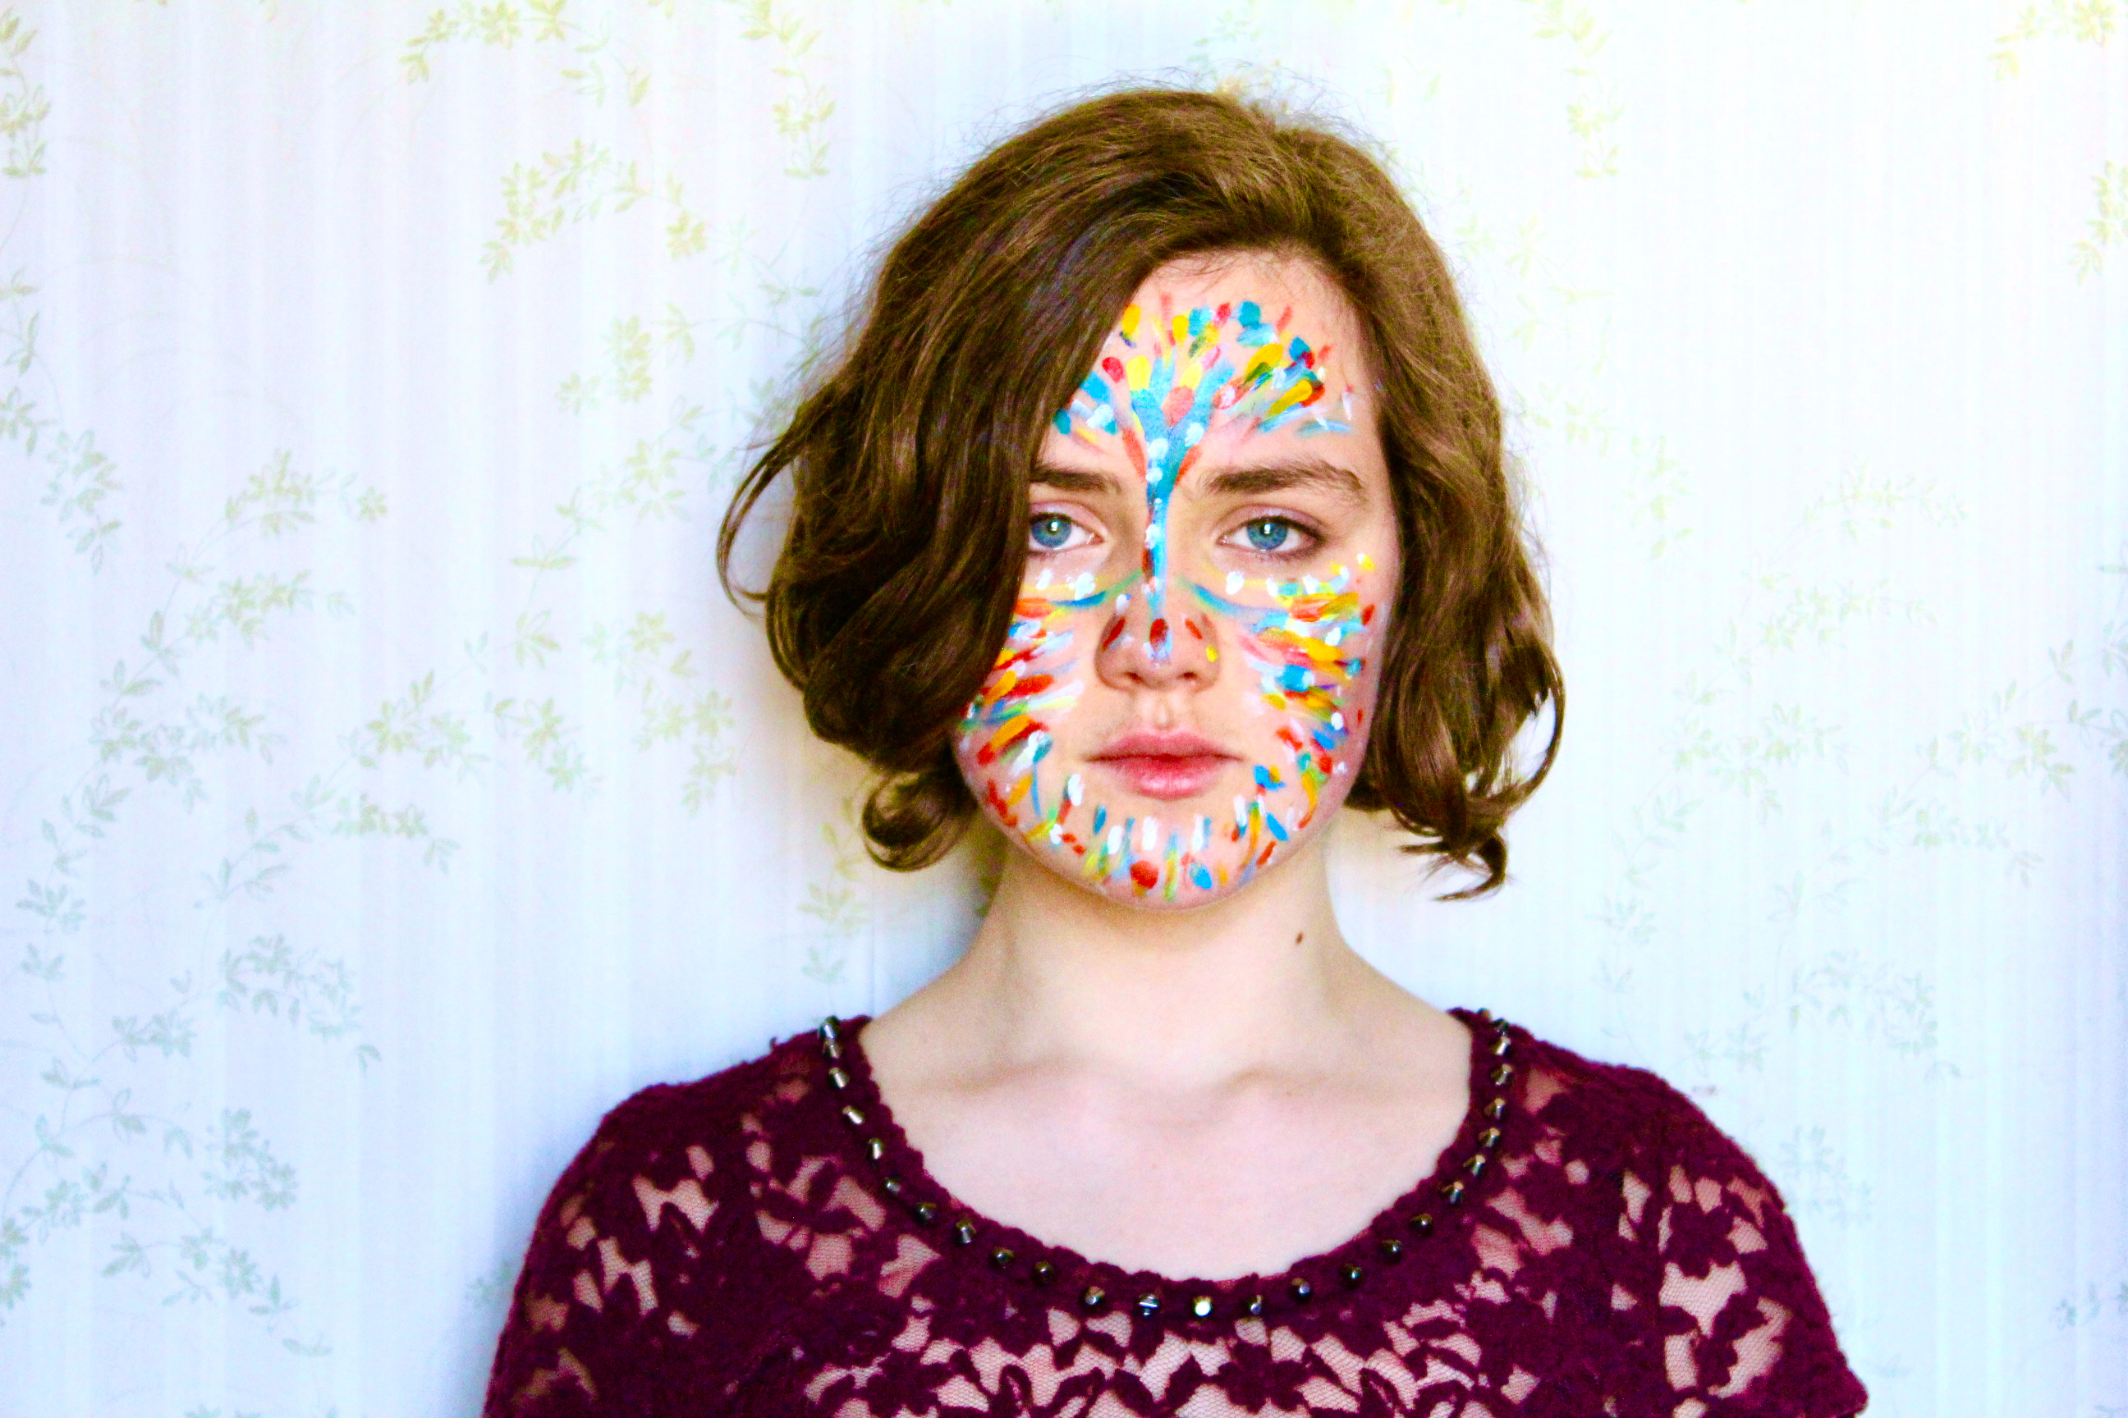

**LOGLINE**

A mother's meditation on the future for her musician daughter as she grows up in the shadow of the twin threats of climate change and mass extinction.

**SYNOPSIS**

The Weather Diaries is an intimate chronicle of two simultaneous histories: on the one hand the darkly cataclysmic impacts of climate change and the extinction crisis on the forest ecosystems around Sydney, and on the other, the development of Drayton’s daughter, Imogen Jones, from child to adult. Filmed over six years, ***The Weather Diaries*** reaches its climax in 2020, as temperatures soar, bushfires rage, and flying fox pups die in record numbers. Drayton ruminates on our failure to value these essential pollinators and the forests they sustain, and reflects on the implications for her daughter Imogen, a girl long inspired by Studio Ghibli’s ***Princess Mononoke****,* who’s emerging from the classical confines of the Conservatorium High School to embark on a career as an electronic pop artist. The film strikes a hard-won balance of optimism and pessimism, fear and hope, melancholia and illumination.

**DIRECTOR’S STATEMENT**

I’ve made this film in the knowledge that documentaries about climate change are seen in the industry as ratings killers, and that to find an audience, they need to offer substantial grounds for hope to their viewers. Tragically, with the rate of greenhouse gas emissions escalating year upon year, and the levels of atmospheric CO2 already higher than they’ve been in the past three million years or more, this is not grounded in reality. We’ve already lost more than one third of the Great Barrier Reef to coral bleaching, and the horrific megafires of 2019 -2020 incinerated half of Australia’s World Heritage areas of ancient Gondwana rainforest, along with billions of animals and the habitat of hundreds of vulnerable and threatened species.

Most climate documentaries are based on the information deficit model of climate communication, based on the assumption that with more information, the public will recognise and support the urgent action on climate change we need to take. After three decades this approach has largely failed, and conversation around the science has become polarised. It suggests that the underpinnings of climate denial and apathy are emotional and irrational. People are filled with a sense of dread and powerlessness in the face of such an overwhelming threat, and prone to distancing themselves from it to focus on the minutiae of their everyday lives. It’s difficult to engage people around such dark themes, but it’s vital that we do.

***The Weather Diaries*** attempts this by working within the traditions of contemplative, poetic and personal documentary to capture something of the hope and anguish suffusing mothering now as we watch our children grow in the knowledge their lives are overshadowed by the spectre of catastrophic climate change and mass extinction. In grounding the story in the lives of my daughter and I, and giving voice to my hopes, fears and sadness around the future she faces, I’m seeking to circumvent some of that resistance to enliven a heightened perception and reflection in the audience about the emotional and physical impacts climate change is already having on their own lives, and will have on the lives of the children they know and love. In forging an emotional intimate connection with the abstraction of climate change, I’m hoping to awaken an audience to its impacts already occurring at a local level, to imagine the possible futures it presents, in order to face the grief and fear it stirs in all of us, so we can move beyond the denial this triggers to focused urgent action.

In its focus on the beauty to be found in everyday life and our connections to the natural world, the power of dreams and stories and music in our lives, and the inspiration to be found in people working directly or indirectly with climate change, ***The Weather Diaries*** supports a modest hope, one that doesn’t shy away from grieving the losses we’re already suffering, but a realistic hope that with creativity, determination, and contributing in our various ways to the protection of the lives we love, we can make a difference. ***The Weather Diaries*** is ultimately a plea for swift, unified and ambitious action on climate change, and a re-engagement with the natural world.

|  |  |
| --- | --- |
|  |  |
|  |  |

|  |  |
| --- | --- |
| **TRAILER (DOWNLOADABLE):**  <https://vimeo.com/424427124> | **WEBSITE**  <https://www.facebook.com/theweatherdiaries> |

**PRESS**

“The film strikes a hard-won balance of optimism and pessimism, fear and hope, melancholia and illumination.” Adrian Martin Screenhub

<https://www.screenhub.com.au/news-article/news/film/adrian-martin/women-on-top-sydney-film-festival-highlights-260527>

“…a poetic and evocative confronting reflection on the psychological stresses of climate change on everyday lives.” Jason di Rosso The Screen Show: ABC Radio National

<https://www.abc.net.au/radionational/programs/the-screen-show/the-screen-show-18-june/12363400>

“If Princess Mononoke is a guiding force for Jones, Jones herself becomes such a force for her mother’s beautifully bleak documentary …”

Jenny Valentish The Guardian

<https://www.theguardian.com/film/2020/jun/09/why-should-i-try-to-have-a-future-at-all-film-captures-hopelessness-amid-climate-crisis>

“…radiant with love, and full of a desperate hope...” Zöe Almeida Goodall Roughcut Film

<https://roughcutfilm.com/2020/06/12/review-the-weather-diaries-speaks-to-parenting-in-an-environmental-crisis/>

**PRODUCER CONTACTS:**

|  |  |
| --- | --- |
| **KATHY DRAYTON**  Independent  [kathy.drayton@gmail.com](mailto:kathy.drayton@gmail.com)  17 Stokes Ave  Asquith  NSW AUSTRALIA 2077  +61 2 424 264 932 | **TOM ZUBRYCKI**  Jotz Productions  [tzub@ozemail.com.au](mailto:tzub@ozemail.com.au)  171 Elswick St  Leichhardt  NSW AUSTRALIA 2040  +61 2 414 683 231 |

**KATHY DRAYTON: Director’s Biography**

Kathy Drayton comes to filmmaking from a background in editing. She wrote, directed and edited two short films in her early career, both of which screened in Australian and international film festivals, and she edited a variety of award-winning short films for her peers. After working as an editor for SBS Television for 15 years, she left to write and direct the documentary ***Girl in a Mirror: A Portrait of Carol Jerrems***, which was highly acclaimed both nationally and internationally. She has made ***The Weather Diaries*** as the major component of a doctorate she’s completing at the University of Technology, Sydney.

**Filmography**

2020 The Weather Diaries Documentary 91 mins

2005 Girl in a Mirror Documentary 55 mins

2001 Beach Story Short Drama 15 mins

1988 Eat Experimental 18 mins

**TOM ZUBRYCKI: Producer’s Biography**

Tom Zubrycki is an award-winning documentary filmmaker renowned for his distinctive observational story-telling style and his ability to get close to his subjects. During the course of a long career spanning 40 years, Tom’s documentaries have focused around a personal response to the issues of the day. Tom has directed 17 documentaries, and produced another 20 with mainly new and emerging directors. Recent films including ***TEACH A MAN TO FISH*** *ab*out a father/son relationship, indigenous identity and fishing, and ***UNDERMINED – TALES FROM THE KIMBERLEY*** (2018, 90 mins) about the Kimberley region and the threat of mining, pastoralism and irrigated agriculture, and what this means for our First People. Tom’s current projects include **ABLAZE**, which follows the journey of Opera singer Tiriki Onus to solve the mystery surrounding a recently discovered old movie believed to be made by his Aboriginal grandfather. Tom is recipient of the Stanley Hawes Award “in recognition of outstanding contribution to documentary filmmaking in Australia”.

**TOM ZUBRYCKI: Filmography**

2017: Hope Road (103 mins. Director/Producer)

2011: The Hungry Tide (83 mins. Director/Producer)[[](https://en.wikipedia.org/wiki/Tom_Zubrycki#cite_note-21)

2007: Temple of Dreams ( 89 mins. Director/Producer)

2005: Vietnam Symphony (52 mins. Director/Producer)

2003: Molly & Mobarak (85 mins, Director/Producer)

2001: The Secret Safari (52 mins, Director)

2000: The Diplomat (84 mins, Director)

1995: Billal (87 mins, Director/Producer)

1993: Homelands (79 mins, Director/Producer)

1991: Bran Nue Dae (55 mins, Director/Producer)

1990: Lord of the Bush (55 mins, Director/Producer)

1990: Amongst Equals (90 mins, Director)

1989: Strangers in Paradise (56 mins, Director/Producer)

1985: Friends & Enemies (90 mins, Director/Producer)

1984: Kemira - Diary of a Strike (62 mins, Director/Producer)

1981: Waterloo (48 mins, Director/Producer)[[](https://en.wikipedia.org/wiki/Tom_Zubrycki#cite_note-34)

1974: We Have To Live With It

1974: Fig Street Fiasco

**SCREENINGS OF THE WEATHER DIARIES**

**Sydney Film Festival** (virtual edition) 2020 June 10th – 18th

**National Film and Sound Archive - Feature** (online) Sept 10th 2020

**Cinema Launch**:

**Event Cinemas George St Sydney** (sold out)

**Indooroopilly Brisbane** Qld Sept 24th 2020

**Bondi Cinema Club** (online) October 20th 2020

**Hornsby Event Cinemas** The Greens (sold out) November 3rd 2020

**Melbourne Women in Film Festival** - sold out Feb 20th 2021

**Waverley Council Summerama** (online) Feb 18th 2021

**Mount Vic Flicks** - sold out Mar 2nd  2021

**Roseville Cinema** for Bradfield Can Do BetterMay 5th 2021

**Lake Mac City’s May Movie Month** May 19th 2021

**Narooma Kinema** for Eurobodalla 350.orgJun 23rd 2021

**Forum 6 Cinema Wagga** for The Greens July 25th 2021

**CREDITS**

The filmmakers acknowledge the traditional custodians of the land where this film was made, and pay their respects to Elders past and present.

**Written & Directed by**

Kathy Drayton

**Producer**

Tom Zubrycki

**Producer, Cinematography & Editing**

Kathy Drayton

**Animation**

Melody Li

**Music**

Imogen Jones

Nathan Moas

Mara Schwerdtfeger

**Sound Post Consultant**

Annie Breslin

**Sound Editor**

Peter Johnson

**Mix**

Andrew Belletty

**Editing Consultant**

Anna Craney

**Script and Story Consultant**

Miro Bilbrough

**Fine Cut Mentoring**

Jackie Wolf aka Farkas

**Online and Grade**

Roen Davis,

Central Business Digital

|  |  |  |  |
| --- | --- | --- | --- |
| **Additional Flying Fox Cinematography**  Fabio Cavadini  James Muller  Joanne Parker  Vivien Jones  **Animation Assistants**  Shelley Wang   * Ada Xu * Florence De Jong * Lenko Wu   **Animation Voices**  Clancy James  Jemima James  Finn Webster | | **Additional Sound**  Mandy King  **Archive**  Peter Duff – NSW Rural Fire Service  Fire and Rescue NSW  Jaala Presland – Singleton Bat Rescue  Triple J Radio  Imogen Jones (‘Infinite Colour’)  ABC Library Sales  Deborah Kelly – Imonoke photograph  **Legals**  Stephen Boyle  Nicholas Cole  **Production Accountant**  Christopher Coote & Co. | |
| **Music**  ***The Infinite Colour***  ***The Secret***  ***Eyes Unclouded***  ***Statues***  ***Numb***  ***Pull Me Under***  ***Comfort in Numbers***  Written and Performed by Imogen Jones as  **Lupa J** | ***Follow***  ***Blood***  ***Ghost***  ***Blue***  ***Why Am I Underwater***  Written and Performed by Mara Schwerdtfeger as  **Mara** | | ***Glacial***  ***Thrived and Undone***  ***Dawn***  Written and Performed by Nathan Moas as  **Land Systems** |
| ***Breathe In***  Written by Gab Strum  Performed by **Japanese Wallpaper**  Featuring **Wafia**  ©Native Tongue & Gaga  ***Sonatina for Violin and Looping Pedal***  Written and Performed by Imogen Jones  © Imogen Jones | ***Requiem in D minor K 626***  Composed by Wolfgang Amadeus Mozart  Performed by  The Conservatorium High School 2011  ***Ceol na Fidlhe***  Composed by Maria Grenfell  Performed by Imogen Jones and Jasper Rasmussen  ©Maria Grenfell | | ***Fantasia no 7 from '12 Fantasia's for Violin Without Bass',***  Composed by Georg Philipp Telemann  Performed by Imogen Jones |

|  |  |  |
| --- | --- | --- |
| **Thanks to**  **Royal Botanic Gardens**  Sydney  Tim Pearson  Storm Stanford  Adrian J Caruana  Deborah Martin  Rhonda Hansen  Meg Churches  Teneale Hayes  Dr Kerryn Parry-Jones  Jessie Grace  Dr Peggy Eby  Dr Billie Roberts | **Hawkesbury Institute for the Environment**  Western Sydney University  Professor Mark Tjoelker  Dr John Drake  Angelica Varhammar  Burhan Amiji  Tamara Weyman  Michael Aspinwall  Dushan Kumarathunge  David Tissue  Craig Barton  Tim Shiel  Declan Byrne | **Conservatorium High School**  Sydney  Jasper Rasmussen  Matthew Castle  Nicki Kim  Jane Anderson  Ian Barker  Mara Schwerdtfeger  Nathan Moas  Alexandre di Francesca (Violin Teacher)  Adrian Jones  Barbara Drayton  Ted Drayton |
| **Thanks also to**  Mel Broe  John Janson-Moore  Tara McLennan  Sydney Screen Studies Network  Kerry Brewster  Ken McLeod  Judith Horvath  Bettina Dalton | Sassy Park  Lisa Nicol  Helen Bowden  Catherine King  Katharine Tebbatt  Antenna Doc-Lab  Tingjia Wang  Rowena Crowe | Karl Schwerdtfeger  Mitzi Goldman Philippa Bateman  Margot Nash  Sue Castrique  Brendan Randles  Anette Bremer  Rowena Lennox |

**Thanks to University of Technology Sydney**

**Project Supervisors**

Dr Andrew Taylor

Dr Jeremy Walker

**Scholarships**

Australian Postgraduate Award – University Technology Sydney

Professor Alison Lee Doctoral Top Up Scholarship

FINANCED WITH THE ASSISTANCE OF

SCREEN AUSTRALIA

|  |
| --- |
|  |

© 2020 JOTZ PRODUCTIONS