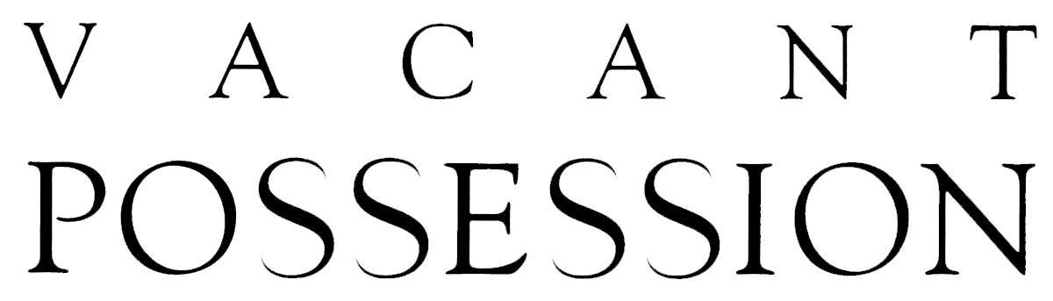
A film by Margot Nash
In 2020, Vacant Possession was restored from original film materials

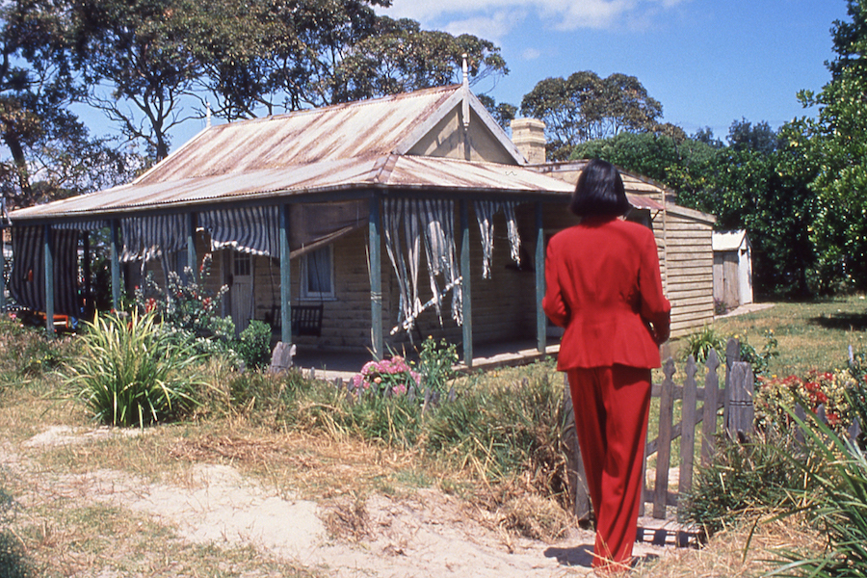

Press Kit
© Wintertime Films & As If Productions
35mm 92 minutes 1994 Australia
Vacant Possession was produced with the assistance of the Australian Film Commission
https://www.margotnash.com/vacant-possession

Distributed by Ronin Films
www.roninfilms.com.au or 02 6248 0851

Synopsis
Following her mother's death, Tessa returns to the old family home, a ramshackle, dilapidated cottage in a coastal town. The visit brings personal memories that still disturb her, and also brings her into contact with a neighbouring Aboriginal family with its own story of dislocation. Her father, too, returns: a former soldier still struggling with demons from his wartime trauma and unable to communicate with his family.
A haunting film about personal and public loss, about white ownership and Aboriginal dispossession and about the difficulty of reconciliation.
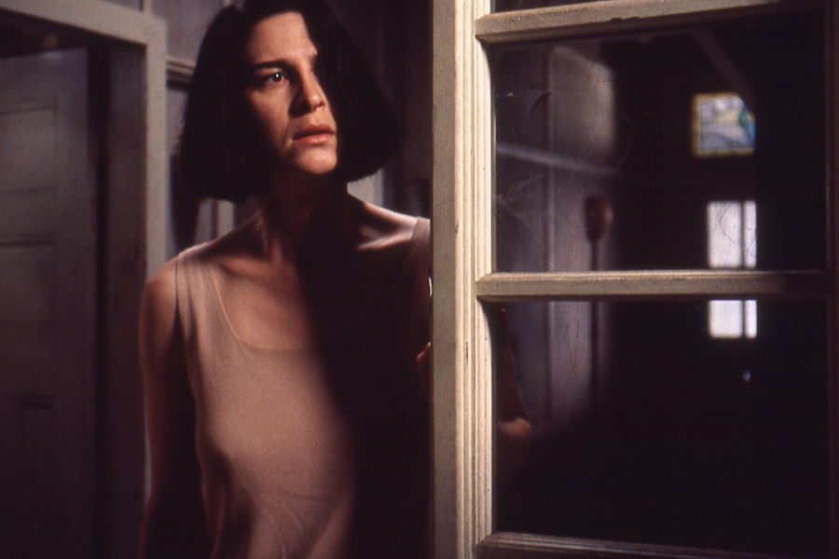

‘Probes the question of Australian identity, intelligently and cinematically’ – David Stratton, Variety
‘A truly exciting piece of cinema’ – Adrian Martin, The Age, Melbourne.
‘Daring and mature ... a landmark Australian film’ - Anna Maria Dell 'Oso, Sydney Morning Herald

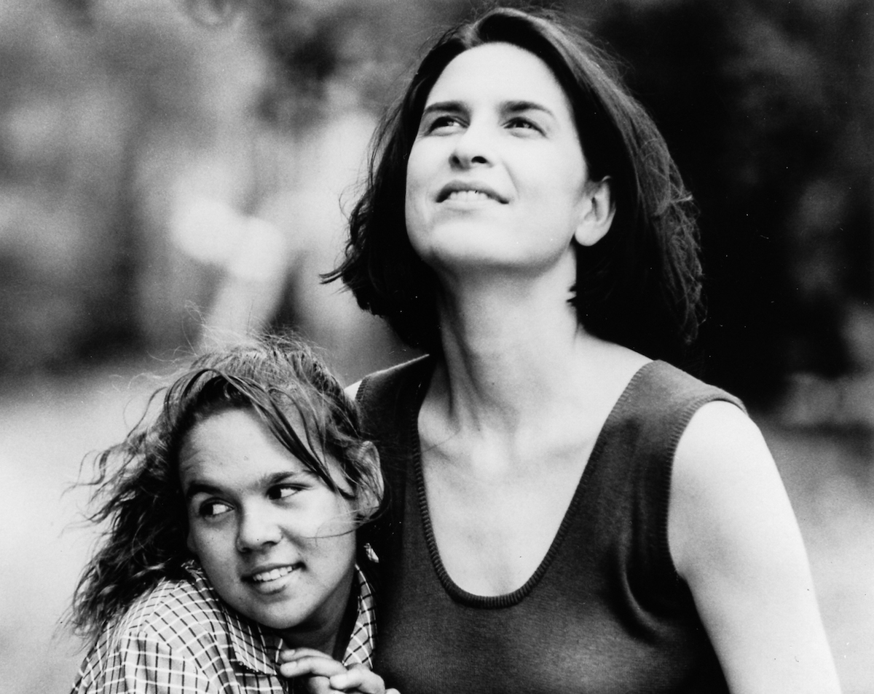

Year Completed 1994
Guage and Stock 35mm Kodak Eastmancolour
Running Time 95 min
Ratio 1:1.85
Sound Dolby A Stero

Filmmaker's Statement

The great white Australian dream is to own a house but for Aboriginal people the dream is to regain ownership of the sacred land. When Captain Cook took possession of Australia in 1788 in the name of the British Crown, the land was deemed 'Terra Nullius' i.e. vacant, uninhabited. This principal was not overturned legally until the historic Mabo decision of 1992.

Vacant Possession is a film about an empty house, an inheritance inhabited by dreams and memories.

Growing up in Australia I never saw much less met Aboriginal people until I was an adult. The history books didn't tell the stories of dispossession and destruction of the land, the stories of injustice and racism. While Aboriginal people live with the devastating consequences of colonisation many of them pity white people because we have no 'place', no dreaming. We don't know where we belong.

I wanted to explore notions of house, home, land, place, family and belonging from a white point of view. I wanted to explore the image of the house as a psychological space that could be possessed and I wanted to tell a story of a dysfunctional white family ripped to shreds by alcohol and the effects of war.

The opening premise of Vacant Possession is the death of the mother. After years of estrangement Tessa returns home when her mother dies leaving her and her sister the family home. A house haunted by emotional memories. I started writing about the mother/daughter relationship, about grief and estrangement and the past. I saw it as a metaphor for the breakdown of relationship to land, country and place. I wanted to engage with contemporary issues such as environmental destruction and family breakdown. I ended up making a film that was also about the father/daughter relationship, about repressed male grief and the complexities of reconciliation in the present.

MARGOT NASH
November 1994

AWARDS
1998 Audience Award: La Mo-Viola Cinema Delle Donna – Torino, Italy.
1996 Speciale Mention du Jury: Films Des Femmes Créteil, France.
AFI Nomination Best Director
AFI Nomination Best Original Screenplay
AFI NominationBest Editing,
AFI NominationBest Sound
1995 Audience Award most popular Australian film Sydney Film Festival.

FESTIVALS and SCREENINGS
202169th Melbourne International Film Festival, Restorations section.
2019 University of Technology Sydney – Margot Nash Retirement conference.
2017 NITV screening in Reconciliation Week plus SBS Video On Demand
2016 Between Past and Present: The films of Margot Nash Melbourne Cinematheque ACMI
2015 The Arc Cinema, National Film and Sound Archive
2002 Buenos Aires 5th International Festival of Independent film. ARGENTINA
1999 Tribute to Australian & NZ Women Filmmakers: Films Des Femmes Créteil, FRANCE
1998 Dreaming Reels – NFSA CANBERRA
Downloading Downunder Australian Film, Video and New Media AMSTERDAM
1997 Femme Totale – Dortmund GERMANY
La Mo-Viola Cinema Delle Donna – Torino ITALY
Ist Women’s Film Festival Seoul – KOREA
Australian Film Festival Johannesburg SOUTH AFRICA.
1996 Portland International Film Festival
Seattle International Film Festival
Films Des Femmes CRÊTEIL
Cannes Film Festival - Tribute to Australian Cinema
ADELAIDE ln Spaces Unsuspected Telstra Film Festival
Strictly OZ USA – UCLA and WASHINGTON (opening night film)
SYD Travelling Film Fest
Australian Day Film Festival Maleny
Dealing With Difference New Australian films KOREA Seoul, Pusan & Kwangju
Australian Identities, history and culture – DUBLIN
Arsenals Film Forum – LATVIA
Cinema Tout Ecran – GENEVA, OLDENBURG.
1995 CHICAGO International Film Festival
HAWAII International Film Festival
ASIA PACIFIC Indonesia
Jump Cut International Film Festival PERTH
BRISBANE International Film Festival
SYDNEY International Film Festival
MELBOURNE International Film Festival

Theatrical release: 1996 Sydney, Melbourne, Perth, London
Cairns, Noosa, Darwin, Adelaide, Hobart
Broadcast: SBS Australia Day 2001; NAIDOC week July 2001, SBS, NITV 2018-2019
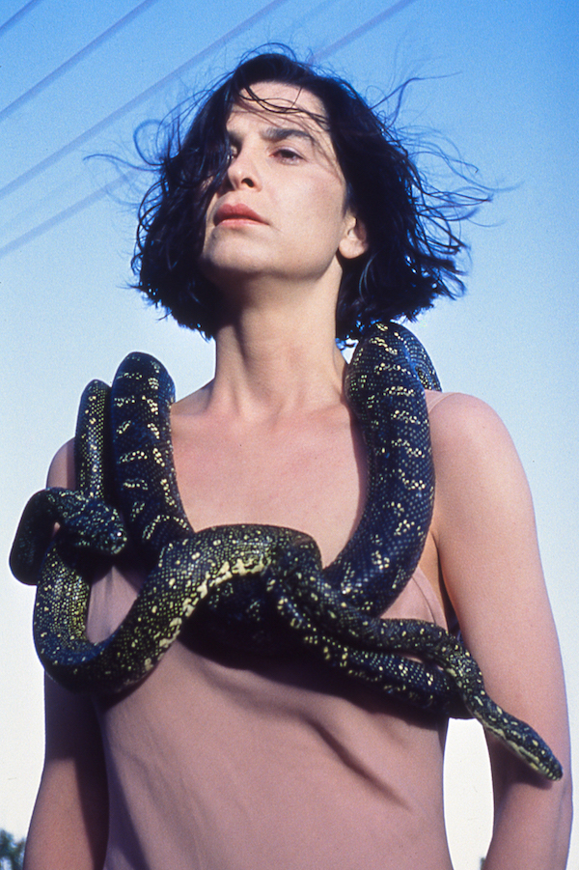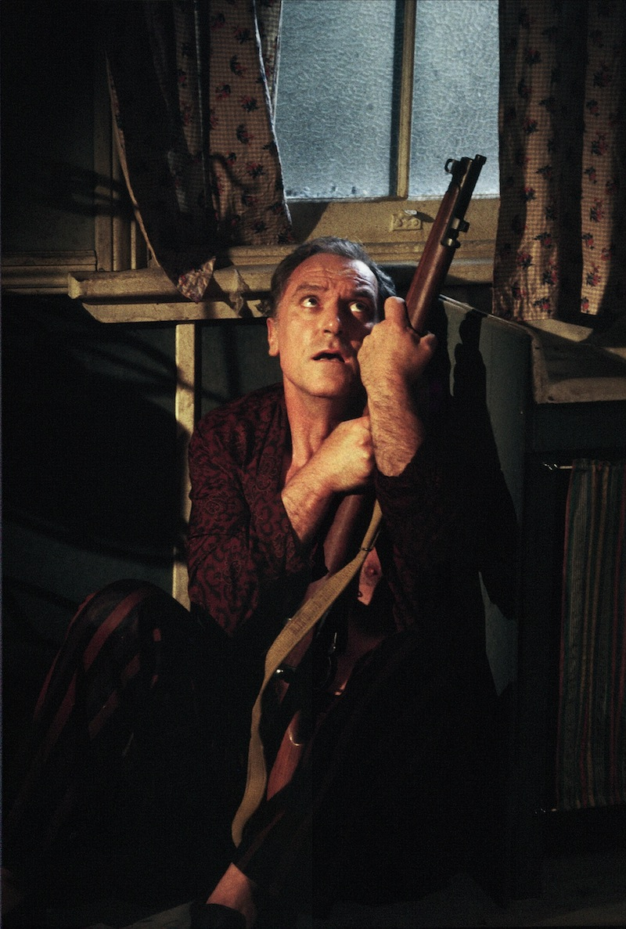

RESOURCES
Vacant Possession is a useful resource for schools, libraries, universities and TAFE. Clips can be viewed on the Australian Screen website. https://aso.gov.au/titles/features/vacant-possession/

MAIN CAST
Tessa Pamela Rabe
Frank John Stanton
Joyce Toni Scanl
Kate Linden Wilkinson
Aunty Beryl Rita Bruce
Millie Olivia Patten
Gracie Barbara Wyndon
Thea Phyllis Baker
Teenage Tessa Simonne Pengelly
Mitch Graham Moore
Young Tessa Melissa lppolito
Billy Tom E. Lewis
Mrs Costas Tessa Mallo
Estate Agent Bill Young

KEY CREW
Director, Writer Margot Nash
Producer John Winter
Director of Photography Dion Beebe
Editor Veronika Jenet
Production Designer Michael Philips
Composer Alistair Jones
Casting Faith Martin
Aboriginal Consulatant Kathy um-Sing
Sound Recordist Bronwyn Murphy
Sound Design Audio Loc
Sound Mix Tony Vaccher & John Dennison
Wardrobe Clarissa Patterson
Stills Corrie Ancone
Production Manager Caroline Bonham
Production Company Wintertime Films

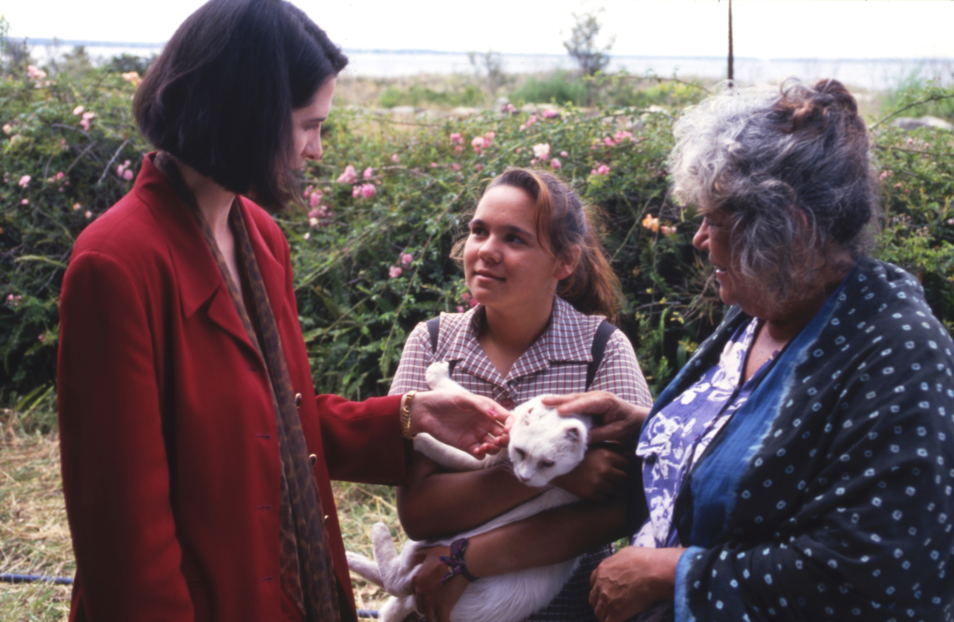

REVIEWS
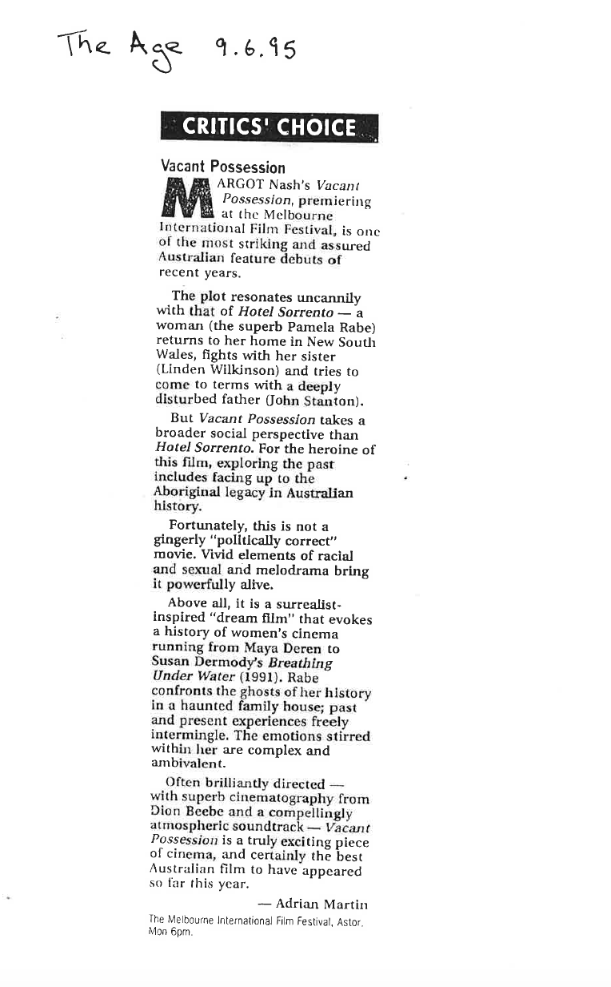
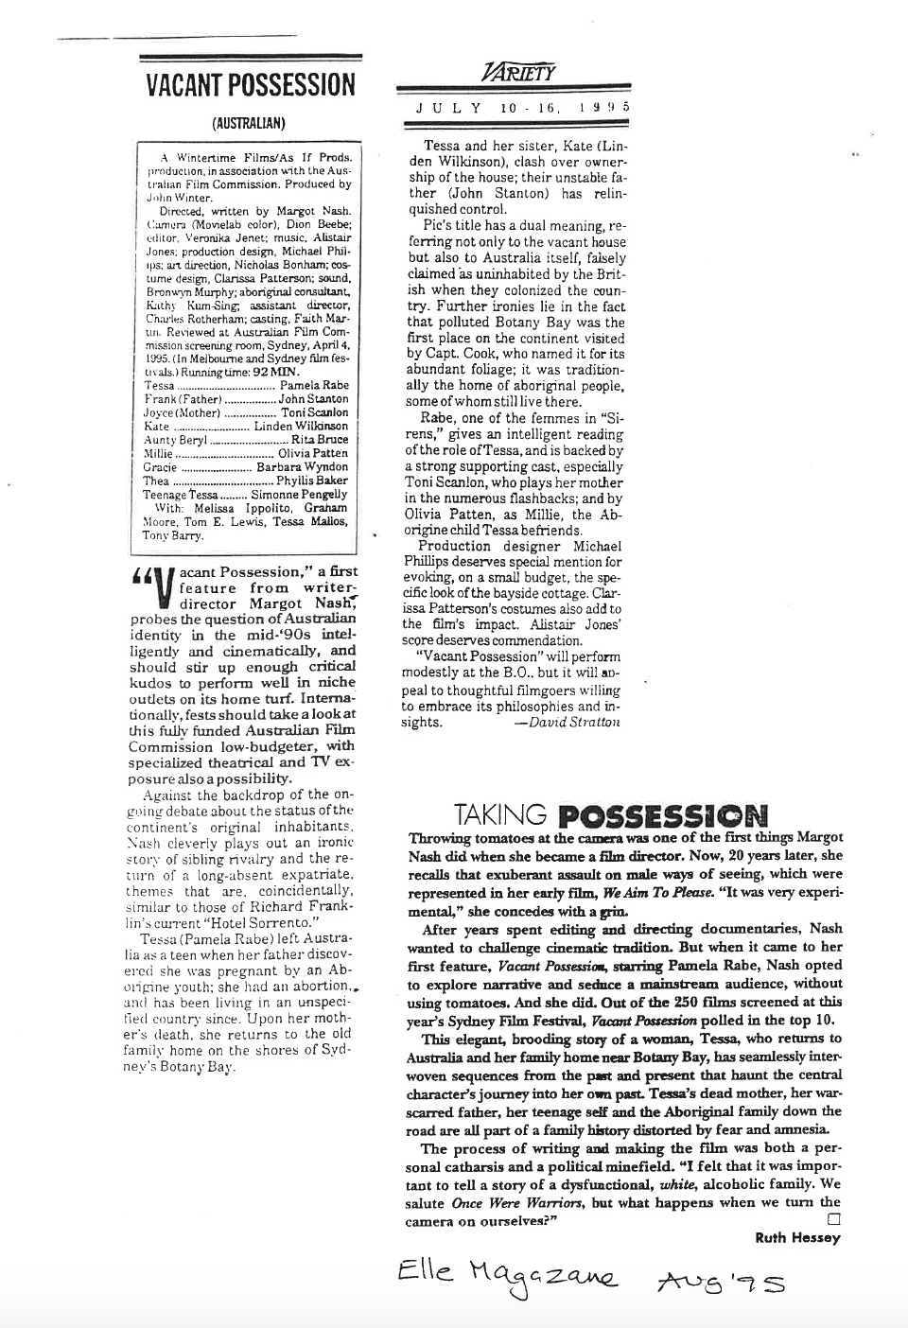
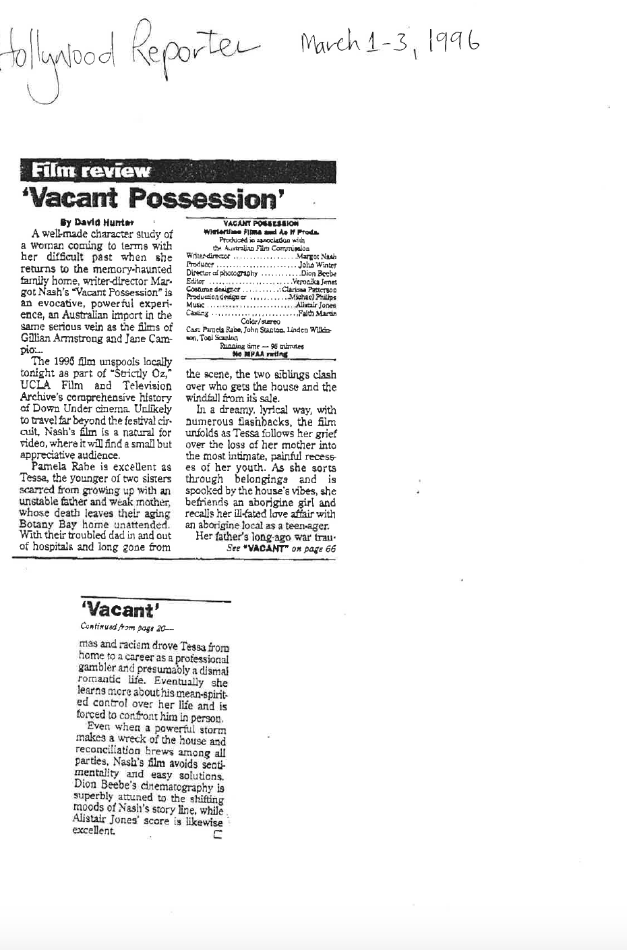
MARGOT NASH Writer/Director - BIOGRAPHY
Margot Nash is a filmmaker, photographer and academic. Her film credits include the award-winning feature dramas Vacant Possession (1994) and Call Me Mum (2005), the experimental shorts Shadow Panic (1989) and We Aim To Please (1976) and the feature documentaries For Love Or Money (1983) and The Silences (2015). She has worked as a consultant and mentor for Australian Indigenous filmmakers and worked in the Pacific running documentary workshops for Pacific Island women producers. Her 2015 personal essay documentary The Silences screened nationally and internationally and in 2016 she won an Australian Writers’ Guild AWGIE Award for the screenplay.
Margot worked as a Senior Lecturer in Communications at the University of Technology Sydney teaching screenwriting from 2000 – 2018. She is currently a Visiting Fellow in Communications at UTS. In 2019 she collaborated with performance artist Victoria Hunt to make the award-winning short film Take and in 2021 she exhibited a series of photographs called Songs for Gaia. See: https://www.margotnash.com

JOHN WINTER Producer - BIOGRAPHY
John’s numerous producing credits include the AFI winning Rabbit-Proof Fence, Paperback Hero (Hugh Jackman), Berlin entrant My Mother Frank (Sinéad Cusack and Sam Neil), Sydney Film Festival opening night film, Doing Time for Patsy Cline, and Script Producer on the first series of the ABC’s high-rating SeaChange.Now writing and directing, John’s short films include Apartment 1911 (Byron International Film Festival) and Mirror Mirror which screened at 27 festivals including Frameline32, the San Francisco International LGBT Film Festival and opened the Melbourne Queer Film Festival. His ATOM award winning feature film, Black & White & Sex screened at the International Film Festival Rotterdam, was in competition in Taipei as well as screening at the Sydney & Brisbane festivals.

