MAKING A MARK
PRESS KIT

World Premiere
Adelaide Film Festival, 11 October 2017

ANZ Distribution
Ronin Films - Australia

Technical Specs
Running time: 56 minutes
Shooting format: HD
Production completed: September 2017

Production Info

Produced by
Southern Light Alliance Pty Ltd
1 Mulberry Drive, Glenside, 5065, Australia

Financed with the assistance of
South Australian Film Corporation, Adelaide Film Festival, Screen Australia

Filmed in
Australia, Italy, Hong Kong

From Director Richard Jasek:

Making a Mark is set in a world where human creativity collides with human realities, and it catches the shards thrown off from these two monumental flywheels. The film follows a selection of finalists in the inaugural $100,000 Ramsay Art Prize, and asks the question: what does it take to survive as an artist in the 21st century?

Finding the core of the story wasn’t simple or easy. First we thought we would be making a film about a brand new art prize, one that’s unique because it accepts works on any subject, in any medium, as long as the artist is under 40. We thought that the drama would come from watching this series of talented, young artists preparing their works and biting their nails, wondering if they could be that lucky person to make their mark, and have their lives and careers transformed overnight.

But the reality of the art world is different. We discovered artists and their careers are certainly helped by art prizes, but those careers aren’t created overnight. And as we came to know the remarkably gifted people in this film, we realised the story isn’t actually about the prize at all. It’s about people who make our lives immeasurably richer even at huge cost to their own; how they survive in one of the most difficult vocations anyone could imagine, and why they have chosen to be there at all. In other words, this isn’t an art film, and in a way it isn’t even a film about the arts. It’s about obsession, human resilience, and a relentless quest to find truth. We wanted our film to reach out to as broad an audience as possible, not just to art enthusiasts.

Making a Mark is a very personal film. Our featured artists opened their lives to us, generously and courageously, revealing their deepest fears and greatest dreams. It’s also very personal in another way: the Ramsay Art Prize was created in honour of my aunt Diana Ramsay shortly before her death. A leading arts philanthropist, she left a bequest that not only supports the prize in perpetuity, but also numerous people and organisations in other walks of life. So Making a Mark is a small thank you to her for a lifetime of giving, and in a larger sense, a celebration of the giving that is the essential nature of the arts and all artists.

MAKING A MARK

TAG LINE
Australia’s top emerging artists seek art / life balance in the lead-up to a $100k prize

SYNOPSIS
Filmed during the inaugural year of the Ramsay Art Prize, Making a Mark is a chronicle of passion and creative trailblazing as a selection of finalists, all aged under 40, vie for the $100,000 prize. In a story that spans the globe from Europe to Outback Australia, we explore one of the most personally challenging and financially tenuous vocations, and find out just what it takes to live a life in the world of visual arts.

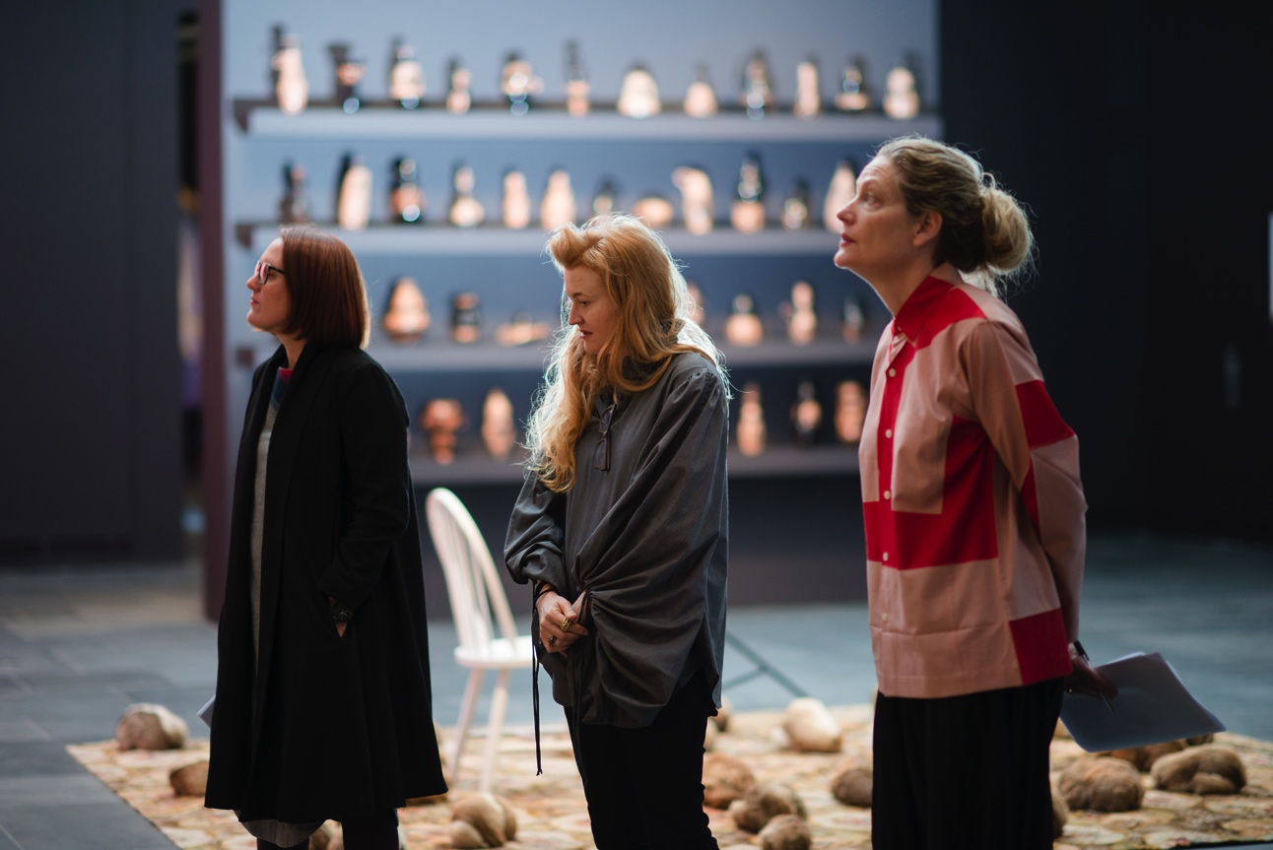
Judges Leigh Robb, Nell and Rhana Devenport judging the 2017 Ramsay Art Prize
Photo Credit: Nat Rogers

Credits

The South Australian Film Corporation
Presents

In association with
The Adelaide Film Festival

a
Southern Light Alliance
Production

Making a Mark

Written and Directed by
Richard Jasek

Produced by
Anna Vincent

Executive producers
Timothy White
and
Richard Jasek

Co-Producer
Bonnie McBride

Editor
David Scarborough

Cinematographer
Maxx Corkindale

Additional Camera
Richard Jasek

Composer
Benjamin Speed

FEATURING
(in order of appearance)

Tracey Moffatt
Natalya Hughes
James Tylor
Justine Varga
Khadim Ali
Baden Pailthorpe
Owen Leong
Tony Albert
Atika Hussain
Peter Johnson
Alexie Glass-Kantor
Rebecca Selleck
Aneshka Mora
Celeste Chandler
Ursula Sullivan
Ralph Hobbs
Patricia Jungfer
Robert Postema
Stephanie Grose
Julian Grose
Vincent Namatjira
Dr Gaye Sculthorpe
Lisa Slade
Jason Phu
Nick Mitzevich
Leigh Robb
Nell
Rhana Devenport
Nicholas Ross
Sarah Contos

PRODUCTION TEAM:

DIRECTOR/WRITER/EXECUTIVE PRODUCER – RICHARD JASEK
Richard Jasek is a director of film, television and documentary whose credits include CITY HOMICIDE, MCLEOD’S DAUGHTERS, NEIGHBOURS, HEARTBREAK HIGH, BLUE HEELERS, HOME & AWAY, SOMETHING IN THE AIR, ALL SAINTS and THE SECRET LIFE OF US.
Richard’s passion for arts and sciences is evident in his documentary work. His Screen Australia and SAFC funded film DRIVEN TO DIFFRACTION is about the Nobel-winning father-son science duo William and Lawrence Bragg.
As a follow-on, Richard’s documentary MICROBES TO MACROBES tells the story of Frank Fenner, esteemed Adelaide-born virologist who was a prime force in the successful campaign to eradicate smallpox.
Richard’s producing work includes 7 Network’s primetime police drama CITY HOMICIDE, and he served as Executive Producer of one of the longest-running serial dramas in the world, Neighbours.
Richard is a graduate of Australian Film Television and Radio School (AFTRS), where he majored in direction, and was one of the youngest students ever to have been selected for the program.
As a lecturer, Richard has taught at numerous universities and film schools including AFTRS, Flinders University, Griffith University, University of Southern Queensland, and Britain’s National Film School.

PRODUCER – ANNA VINCENT
Anna Vincent is a film producer and co-founder of Southern Light Alliance (SLA). Her credits include UK co-production CHASING SATELLITES with director Jim Loach; HIGHLY STRUNG (AFF 2015) with director Scott Hicks; and break-out documentary EMBRACE (SFF 2016), which was released globally and sold to Netflix and Amazon

Anna is currently co-producing Sci-fi thriller I AM MOTHER, which stars Hilary Swank and is in production at the Adelaide Studios. This will be followed by ALMOST FRENCH, from writer director Kate Dennis (THE HANDMAID’s TALE) which is an adaptation of the much-loved travel memoir by Sarah Turnbull.
Anna began her career at Channel Nine Adelaide in the 1980s. She spent the 1990s working in LA on various crew and production roles, including at Icon, whilst developing film and theatre projects as a producer, writer and director. In the 2000s Anna returned to Adelaide and completed a journalism degree at UniSA, with a sub-major in screenwriting. Anna heads up the SLA office from the Adelaide Studios, South Australia. SLA works globally through co-production partnerships.

EXECUTIVE PRODUCER – TIMOTHY WHITE
Timothy White is one of ANZ’s most experienced producers with over 45 feature film credits. He is currently producing sci-fi I AM MOTHER with first time director Grant Sputore, starring Hilary Swank. THE PATRIACH (Berlin 2016), BEAST (TIFF 2015), THE DARK HORSE (Tiff 2014) and SON OF A GUN starring Ewan McGregor which premiered at the London Film Festival (LFF 2014).
His illustrious producing credits include MALCOLM, SPOTSWOOD, COSI, ANGEL BABY, DEATH IN BRUNSWICK, OSCAR & LUCINDA, TWO HANDS.
In the early 2000s Tim headed up Working Title Films’ Australian arm, and was executive producer on NED KELLY and GETTIN’ SQUARE.
Tim then set up Southern Light Films and worked in New Zealand producing NO.2, OUT OF THE BLUE, THE WARRIOR’S WAY, THE MOST FUN YOU CAN HAVE DYING, TWO LITTLE BOYS, MR PIP, THE DARK HORSE, GOODBYE PORK PIE, THE END GAME.
Over the past decade Tim has produced numrous Australian films including Scott Hicks’ THE BOYS ARE BACK, SLEEPING BEAUTY, HIGHLY STRUNG, CHASING SATELLITES, EMBRACE., and he is currently producing sci-fi thriller MOTHER at the Adelaide Studios.

CO-PRODUCER – BONNIE MCBRIDE
Bonnie McBride is Head of Production at SLA, working across the slate of films in development and production, including managing the day-to-day running of the office. Bonnie joined SLA in 2015, assisting the producers on hit feature documentary EMBRACE. She then produced SA Film Corp funded short film WILD, before co-producing documentary MAKING A MARK.
Bonnie is a graduate of the University of South Australia, where she earned double degree in Journalism and Creative Writing with a major in Film & Television. In her spare time, Bonnie works as a freelance writer for food and lifestyle publication Broadsheet.

EDITOR – DAVID SCARBOROUGH
David Scarborough has been working as a film and television editor since 2009. In 2012 he gained his first television broadcast credit as editor of the half-hour documentary MEATWORK, airing on ABC2. He was nominated for an ASE Guild award for editing the three-part series, HANNAH GADSBY’S OZ in 2014 and received a nomination the following year for the 6-part sci-fi web series WASTELANDER PANDA: EXILE. He has also worked as assistant editor on several feature films, most recently BOYS IN TREES (2016), on which he was also the assembly editor.
David enjoys working and editing a diverse range of films but has more recently found his niche in documentary where he enjoys the challenge of first finding, then crafting the story.

COMPOSER – BENJAMIN SPEED
Benjamin Speed is an Australian-born film composer, musician and producer who has scored over 30 films including 52 TUESDAYS which won at Berlin and Sundance, the breakout documentary EMBRACE, the multiple award winning THE CAT PIANO narrated by Australian musician Nick Cave; the Australian Documentary Prize winning THE SNOWMAN, The Australian Film Institute Award winning A NORTHERN TOWN; The MTV 180 Project winning DUNGOONA; the Comic-Con winning STREET ANGEL; three Tropfest Australia finalists, CARNIVORE REFLUX, GLASS and THE MAESTRO; and the acclaimed films TENDER and ANIMA.
Benjamin has been nominated for three APRA Australian Screen Music Awards, winning one. He also won Best Score at the St Kilda Shorts Festival and was nominated for an American MPSE Golden Reel Award for Music Editing. He also holds a Bachelors in Music Technology from The Elder School of Music and a Masters degree in Screen Music from the Australian Television and Radio School.

End.

