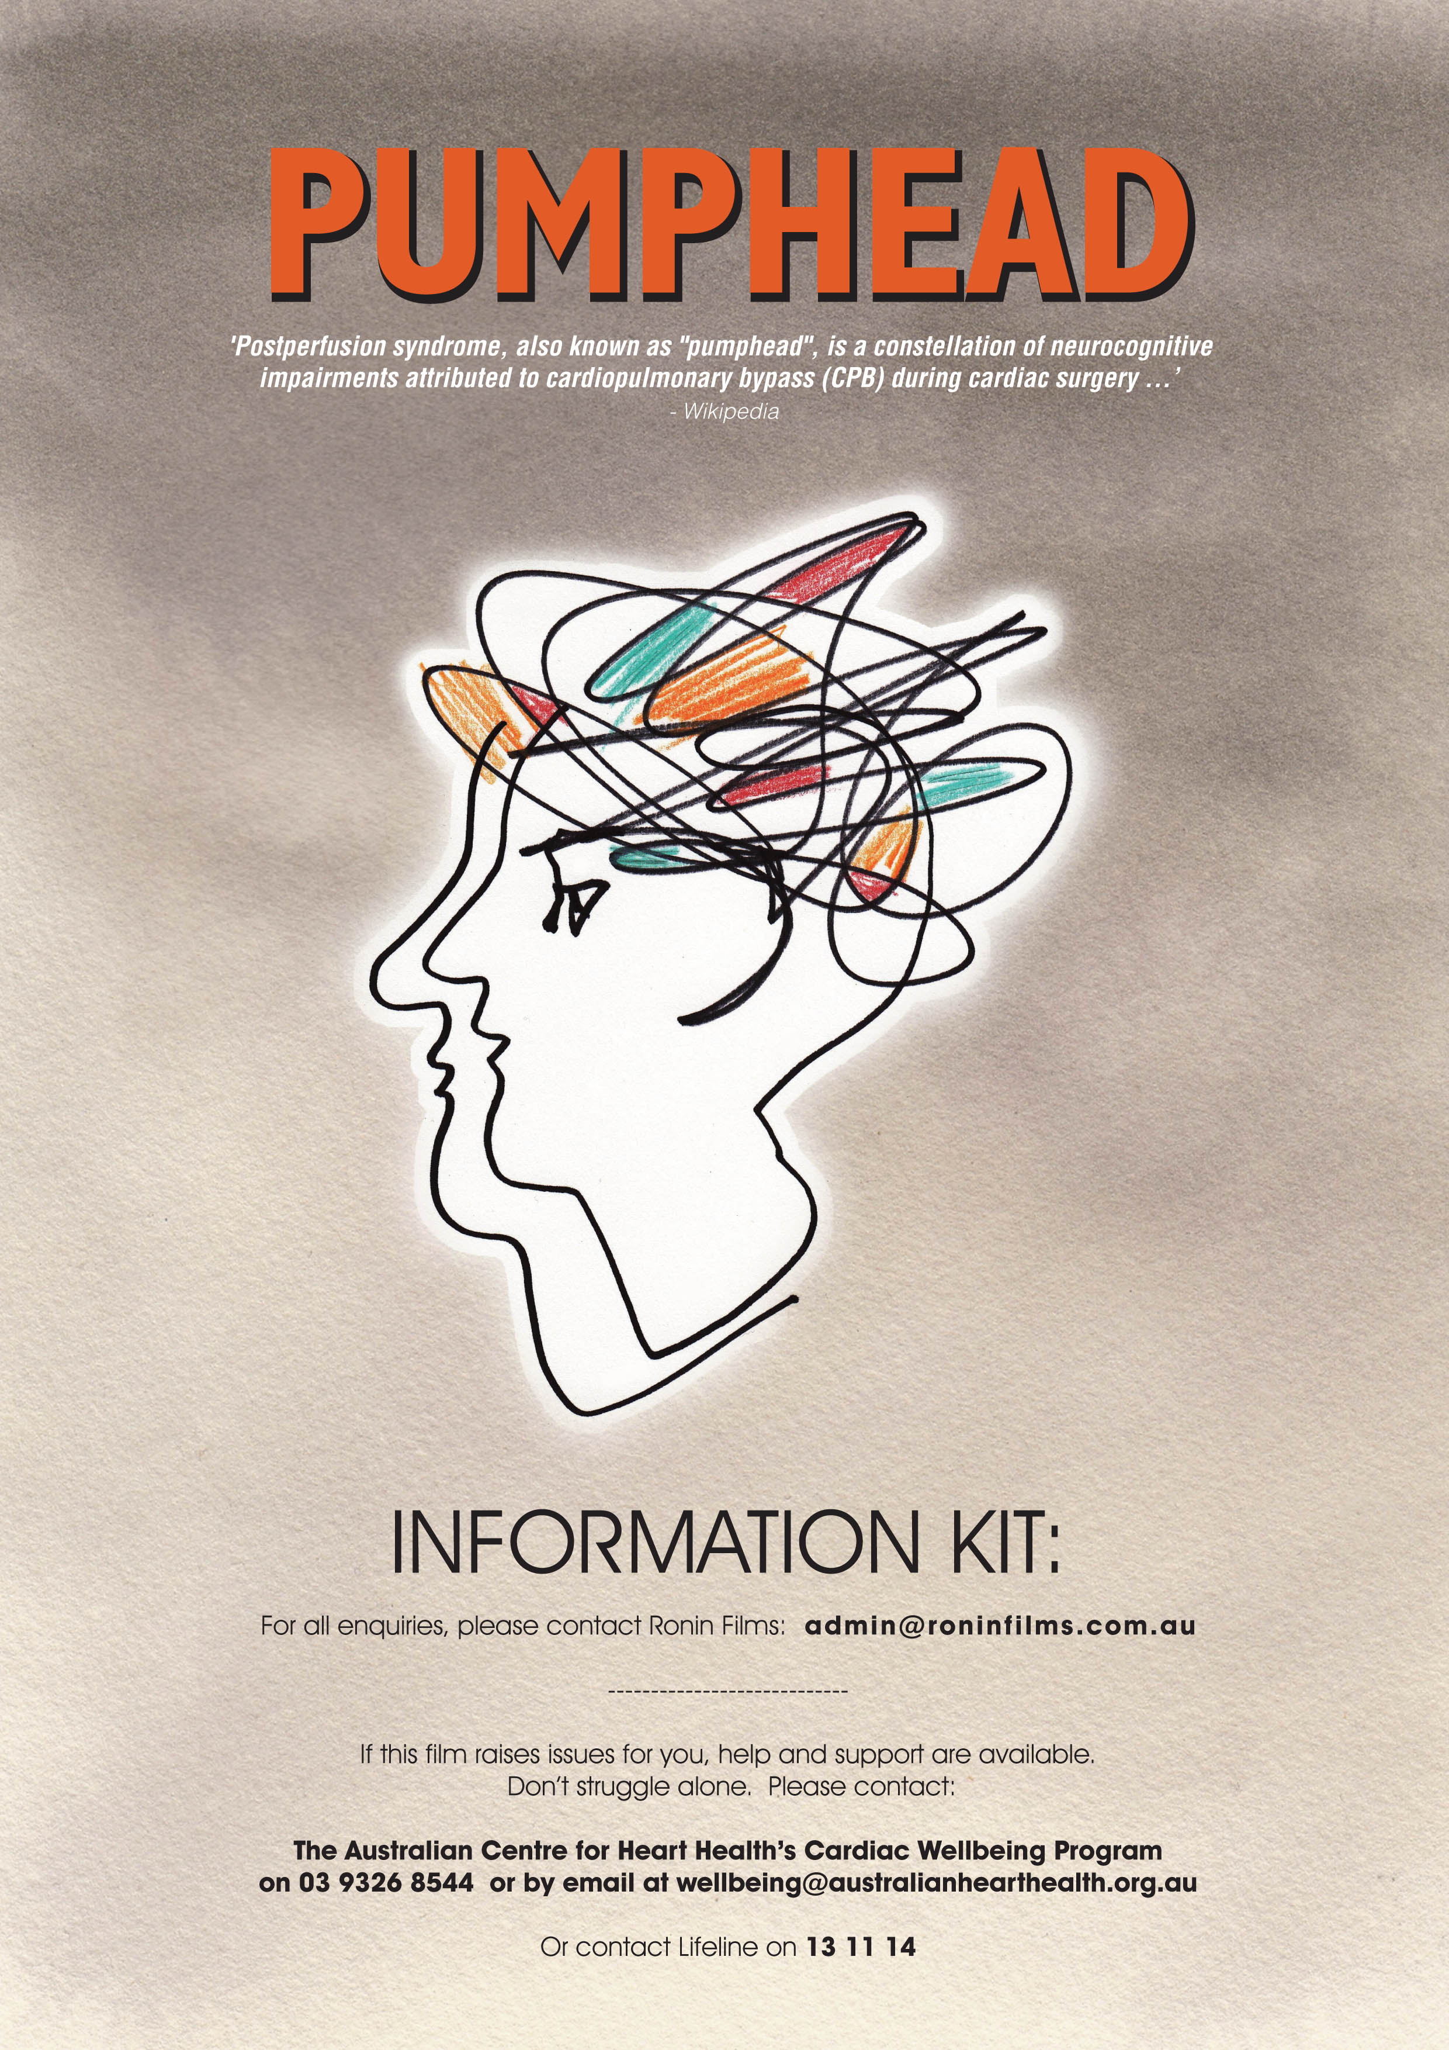

Principal Credits

Directed, produced
and written by Andrew Pike
with Editor James Lane

Cinematographer Zhenshi van der Klooster

Trio Elégiaque no 2,
Opus 9 by Sergei Rachmaninoff
Arranged by Chris Latham
Performed by: Edward Neeman piano
Chris Latham violin
David Pereira cello

Music recordist
and sound mix Tim Duck

Co-producer - Mike Lynskey

Additional photography

Mike Kenneally Timothy Rebbechi

Motion Graphics Michael Gibbs

Legal advisor Shaun Miller

Main Title
and Key Art design Lee Whitmore

Produced with assistance from the ACT Screen Arts Fund
through Screen Canberra and the ACT Government
Produced with the support of Screen Australia through the Producer Equity Program.

Financed with the assistance of Documentary Australia Foundation

76 minutes

© Ronin Films 2020

Synopses

Short synopsis:

Pumphead is a feature-length documentary exploring patient experiences following major heart surgery - how to understand these experiences and how to live with them. A story of existential crises and transformative experiences, told by eight ex-patients including the filmmaker himself.

Longer synopsis:

Pumphead is a documentary feature film exploring patient experiences following major heart surgery - how to understand these experiences and how to live with them.

Through the stories of eight ex-patients, including the filmmaker himself, this documentary indicates the complex diversity of emotional and cognitive changes that often occur after open-heart surgery, simultaneous with physical ecovery. In particular the film focuses on the phenomenon of “post-traumatic growth” which often co-exists with psychological challenges and is triggered by them.

All of the ex-patients in the film reveal aspects of "post-traumatic growth" - marked changes in personal values and priorities, life-style, creativity, and social and family relationships, leading to a life that in many cases is profoundly different from the time before surgery.

Through this composite story of existential crises and transformative experiences, the film also delves into the gulf that can exist between advances in medical science on one hand, and patient experiences on the other. In particular, the film raises the difficulties that the medical establishment often faces in responding to problems that are emotional, intangible and hard to quantify. As one patient contemplates in the film, the "roller-coaster ride” that some patients experience after open-heart surgery is “invisible” to other people. The film is designed to make the “invisible” more apparent and to promote awareness, empathy and under- standing.

The filmmaker, Dr Andrew Pike, is an award-winning documentary filmmaker who had open-heart surgery in 2011.

The participants (in alphabetical order)

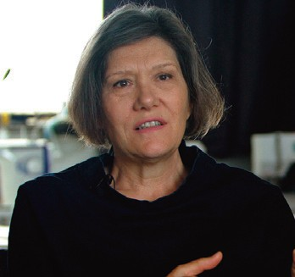
Lisette Breukink
You have to be your own manager of the process, because nobody will do that for you. … I think we are really alone on this road and I would even go further, sometimes lonely.

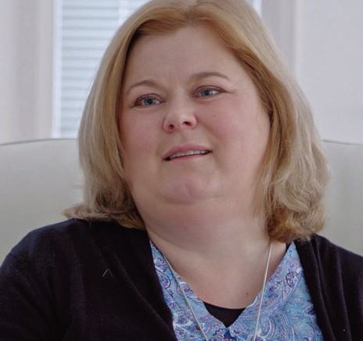
Kerri Cargill
Work provides a lot of structure. It provides a lot of social interaction and opportunities. And it also was for me a very big part of my self-identity. So to have to create something totally different is quite a big process.

Jessica Caudwell
It's very confronting, and I definitely felt like everyone's done so much for me, that I don't want to burden them anymore. And so it took me quite a while to say to them, you know what, I think I need help.

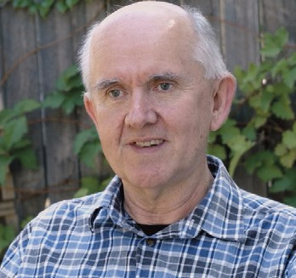
Dr Allan Coop
Society just isn't prepared for the fact that people are going to be living for an extra 20 or 30 years. After having confronted my own mortality, I feel that I have far more to contribute in any situation, and I feel compelled to do that.

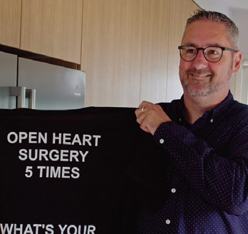
Peter Gallagher
Now we can talk about pumphead, and we're at that tipping point where rather than complaining that we haven't had the discussion, we need to be able to say, let's be leaders and help other people.

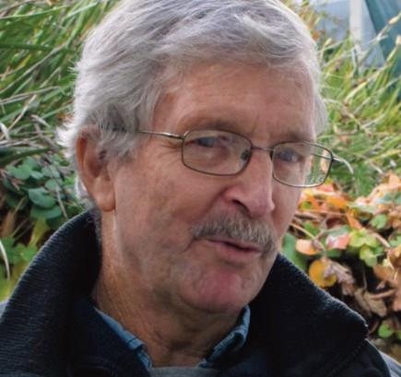
Peter Lynskey
I was dancing at shadows, every tweak to the heart, any sense of pain - where it was insignificant to the doctors, to me it was important. Because I had three children still going through school, you know, what am I going to do?

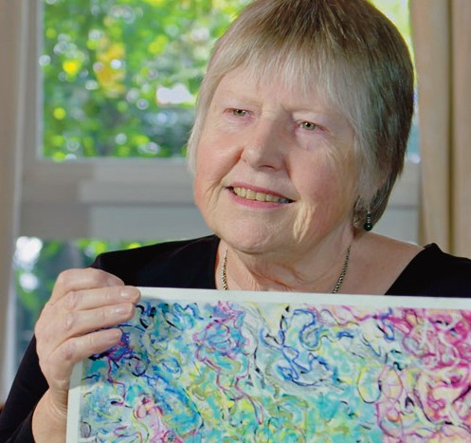
Rosemary Mangiamele
I became very aware that it was important for me as the carer that I had to look after myself too, so that I could always be there for Giorgio. And that's where I found my art was really invaluable.

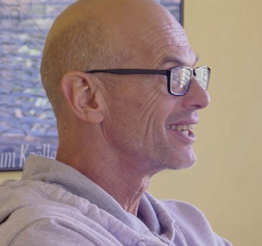
Graeme Sutton
I feel the medical system let me down, but I've slowly come to terms with the fact that that's just how it is sometimes.

The professionals (in alphabetical order)

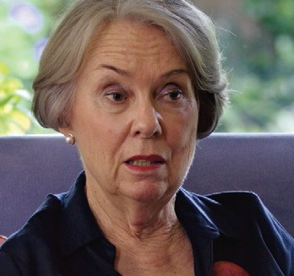
Pamela Cohen
Accredited Mental Health Social Worker
A diagnosis of heart disease can make death anxiety well up like a volcano. So how can I as a social worker help people with death anxiety?

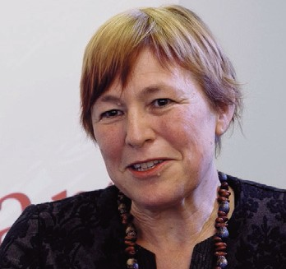
Associate Professor Rosemary Higgins
Health Psychologist, Australian Centre for Heart Health
The psychological outcomes are just as important because that's the reason why we keep patients alive - to live their life, not to just be alive.

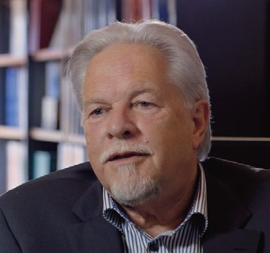
Professor Alun Jackson
Director, Australian Centre for Heart Health
As we live longer, as surgical techniques get better, we're living with the consequences for much longer, and so we have to address them properly.

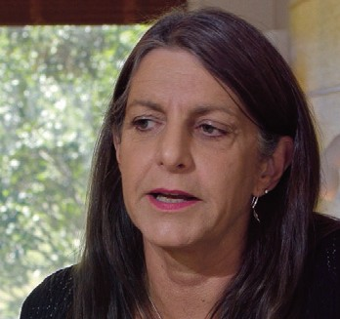
Dr Barbara Murphy
Principal Researcher, Australian Centre for Heart Health
For heart patients, the emotional recovery is huge and it often goes undetected, unrecognised, and not supported. … We've advanced the physical (surgery) and the technology so far, and yet a person can be left broken.

Andrew Pike

The writer-director of PUMPHEAD, Andrew Pike, is a film distributor, film historian and documentary film-maker. He co-authored with Ross Cooper the seminal book, Australian Film 1900-1977 (Oxford University Press). Andrew’s company, Ronin Films, has distributed many Australian films including the feature films STRICTLY BALLROOM and SHINE. Today the company specialises in the distribution of social documentaries.

In 2003, the French government appointed him to the rank of Chevalier dans L’Ordre des Arts et Lettres for his work in the distribution and exhibition of French cinema in Australia.

In 2007, Andrew Pike was awarded an Order of Australia Medal for his services to the film industry, and an honorary doctorate from the University of Canberra.

From 2000 to 2003, Andrew served on the Council of the National Film and Sound Archive, then known as ScreenSound Australia. In 2008 he joined the Board of the newly created independent National Film and Sound Archive, and served until 2012.

In 2009 he began an on-going association with the Asia Pacific Screen Academy, initially as a Jury member in their annual Awards, and subsequently from 2010 to the present as Chair of the MPA APSA Academy Film Fund. This Fund has achieved an unusually high success-rate among the projects it has supported financially in the Asia-Pacific region, most notably Asghar Fahardi’s Oscar-winning A SEPARATION (2011) from Iran.

As a documentary writer-director, his films include ANGELS OF WAR (1982, broadcast by ABC), THE CHIFLEYS OF BUSBY STREET (2008, released in cinemas), EMILY IN JAPAN (2009, broadcast by ABC and NITV), and MESSAGE FROM MUNGO (2014, released in cinemas and broadcast by NITV). His films have won many awards including the Australian Film Institute’s award for Best Documentary fo ANGELS OF WAR, and a United Nations Association Media Award for MESSAGE FROM MUNGO. He has also produced several documentaries for independent filmmakers including Gary Kildea and Chris Owen, and co-produced a feature documentary, ACROSS THE PLATEAU (2007), for Chinese director, Zhang Zeming, filmed in Tibet.

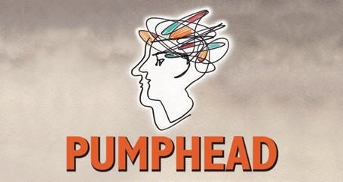
Filmmaker’s statement

I made this film over a period of 6 years to explain, from a patient’s perspective, what it feels like to have the Pumphead syndrome, the lay term for common experiences for many people following cardiac surgery, not only in the immediate post-surgery period, but often long-term.

I used my own experience as a patient, and the film-making skills I’d learned professionally to communicate the “inside” experience - what the pumphead syndrome feels like, day after day, month after month, year after year, relayed through my own story and through the stories of others who knew about it first-hand - patients, carers and cardiac rehabilitation experts.

I wanted the film to help other patients by letting them know they are not alone, and that their experience is common among post-surgical patients.

I wanted the film to communicate with medical professionals, whether cardiac specialists or general practitioners, to help them to be aware, to understand and to be able to respond more appropriately to patients who are experiencing the Pumphead syndrome.

I also wanted to raise a broader issue that affects all of us: medical science is giving humans the potential for longer lives, but we need medical science to pay heed to the quality of these longer lives, to embrace a fuller view of the needs of patients preparing for and recovering from major interventions. In the case of cardiac surgery patients, that means support beyond the realm of short-term hospital-based cardiac rehabilitation programs.

Another theme emerged as the filming progressed. I increasingly became aware of the phenomenon of post-traumatic growth among the patients whose stories I was recording, and the final third of the film came to focus on observations of growth and transformation, in all its myriad forms.

Ultimately, I wanted to see if I could make a film that could serve as a catalyst in promoting a cultural change in the way the health establishment and society in general regard the intangible spiritual and psychological dimensions of life-threatening disease and life-saving interventions.

Going on the road to film conversations with ex-patients was inevitably a therapeutic process for me personally. As the film progressed, I felt a growing sense of value in helping others to communicate with the “outside” world. All of the ex-patients in the film felt they had a lot to say, and were keen to express their feelings for the benefit of others, and that motivation gradually became my motivation too and affected the creative choices I made.

Through the making of the film I found new friends, new creative collaborators, and the process of filming and editing became intensely restorative. I’m immensely grateful to all of those who helped me in the journey, both personally and creatively, and who had faith in my vision for the film.

Andrew Pike, October 2020

The music

The music for Pumphead is drawn from Rachmaninoff’s Trio Elégiaque Trio no 2, Opus 9.

I heard a recording of this music accidentally: Rachmaninoff was a composer I’d always ignored or dismissed as sentimental and cloyingly romantic. But when I first heard his Elegiac Trio no 2 several months after my surgery, at a time when I was struggling, it really spoke to me or for me, like a bolt from the blue. It stayed with me for years and even now it brings a very emotional response. I later found that Rach had begun writing it within hours of the death of his close friend and mentor, Tchaikovsky, and it compounded his sense of loss after the break-up of his family home and the death of his sister. This remarkable piece, long and complex, was composed when Rach was still a raw talent, just 20 years old, and he completed it in an exhausting month of intense creativity. In it, he seems to have expressed the accumulated grief and emotional turmoil of his teenage years. His shock and anguish are all there in the music, and it resonated with me, but what seemed most miraculous for me is its emotional maturity: his distress intermittently resolves into a quiet, calm sadness, expressing grief for what has been lost, but also a sense of acceptance, of things learned and gained. All of my thinking for this film was built around this music. A Jungian psychologist might say that it became a metaphor for my evolving experiences in the years after surgery.

Listening to a good recording of the work (especially David Oistrakh’s heart-felt version), I can hear Rach’s own “post-traumatic growth” in the progress of the music, its intermittent sense of resolution, and it perfectly matched my observations of “growth” among the patients who tell their stories in the film.

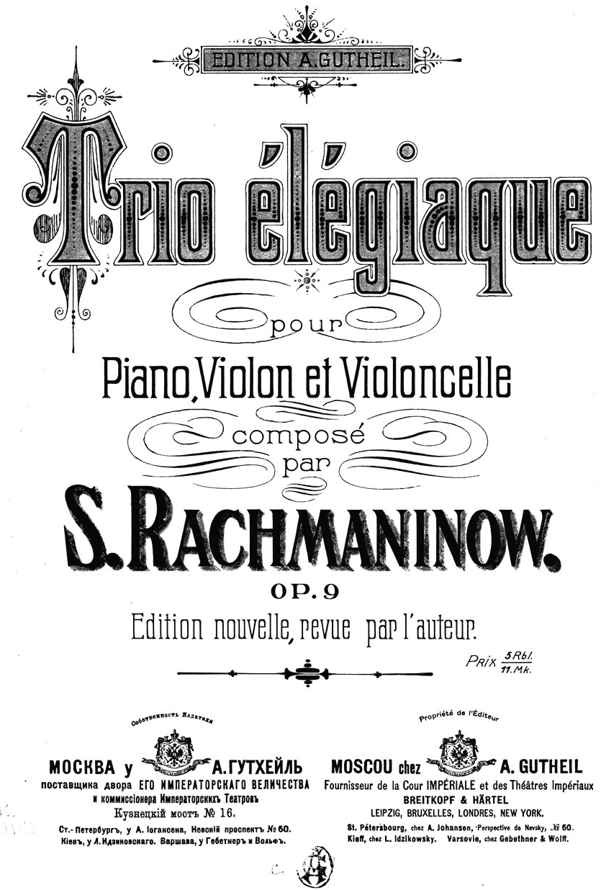
I was very fortunate to find three musicians in Canberra willing to go on the journey with me to adapt and record their response to what Rach had written in 1893. I’m enormously grateful to Chris Latham for his help in arranging the music and playing the violin part, to Edward Neeman on piano, and David Pereira on cello. It is a real honour to have been able to work with these top-ranking musicians – a positive outcome of the pandemic that had left them with the time to spend on the music for the film.

Andrew Pike, Sept 2020

FEEDBACK

“A wonderful work about a particular thing, but all at once universal. I forgot i was watching a film about a condition related to surgery but imagined these people as everyman/woman, as if living in the world was like having your rib cage cracked open to expose your heart... and the species is in a state of abiding trauma that informs our being, making your film a kind of allegory. Thanks Andrew: a lovely film.”

Frank Rijavec, filmmaker

"This personal and absorbing documentary takes us beyond the reassuring world of biomedicine, revealing how the trauma of major heart surgery can have profound and unexpected effects on a person’s thoughts and feelings. Exploring this phenomenon for the first time, the film follows the lives of several patients who have come to terms with it and, in the process, discovered new possibilities in themselves for recovery and personal growth. Although the film deals with complex medical and mental processes, it speaks to a general audience without unnecessary jargon or specialist language."

David and
Judith MacDougall,
filmmakers

"This beautifully crafted investigative documentary observes and explores lesser known aspects of what happens to the psychological, emotional and socia identify of people - young and not so young - who have had their chests opened and their insides adjusted. ... Anyone interested in health and how to live will benefit by gaining improved insight and understanding from this film."

Dr Michael Kindler, educator

"It is a brilliant, supremely useful film. It is really what I always like – the walking 'wounded' helping other fellow 'wounded' – the sufferers, not the doctors, experts. It lives up to your sub-title about it being “patient experiences” and you have accumulated many great fellows on the same journey as yourself. I also really loved the positiveness of the film. The immensity of the human spirit to overcome, recover, accept and become empowered to move on in a new direction. It has obviously been cathartic for you, but the turning of what for many could be a negative experience they never rise from, to a complete change of approach to life, and I am so glad that the film provided that vehicle for your own personal recovery."

Dr Ross Cooper, historian, educator, artist

"A profoundly compassionate film ... An authentic empathy is created throughout, not just in relation to the subject matter but also with those who are interviewed.
… I think there are broad implications throughout the film and not just related to pumphead syndrome. I was particularly intrigued by the many ways that post-traumatic growth was manifested It is such an eye-opener and such an
empowering film – former patients claiming the language and the experience for themselves. I was touched by the imagery throughout, but I think my favourite image was Barbara Murphy’s necklace – that silver anchor. I am sure that you have created an affirming and safe harbour for many with this film, Andrew. I hope that the film reaches many throughout the world."

Dr Adele Chynoweth, OAM, historian and filmmaker

"A beautifully crafted film exploring a much-needed topic. The interview subjects, the evocative outdoor environments, and the judicious use of the beautiful Rachmaninoff music were very moving. It was a revelation to see the creative growth of the people after their traumatic event."

Lucille Carra, filmmaker (New York)

