SHADOW PANIC
A film by Margot Nash
Three women’s worlds collide by chance.
A film about internal and external states of emergency,
resistance and spirit.

In 2020, this feminist classic was restored from the original 16mm film materials.

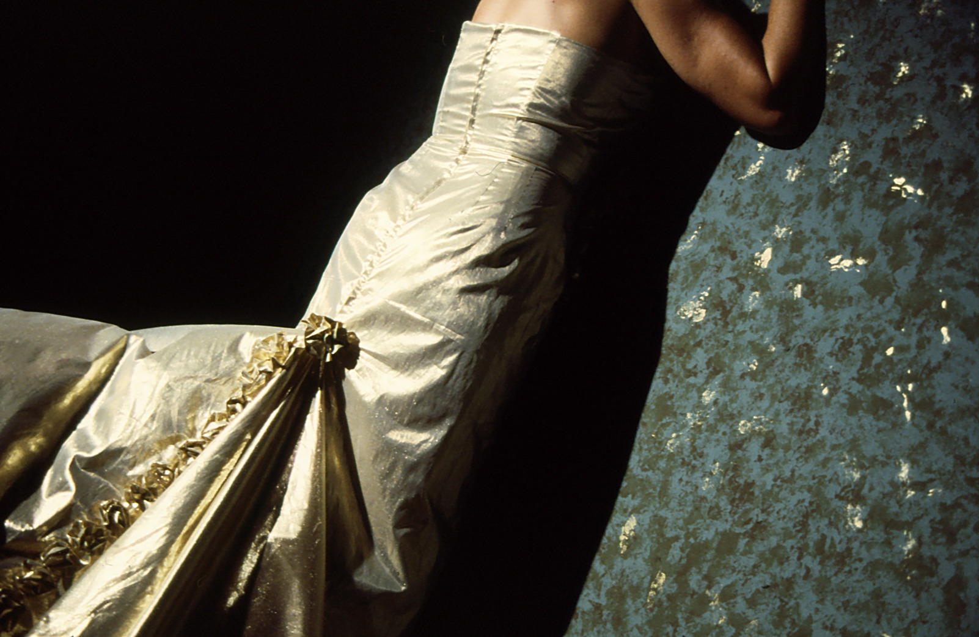

Information Kit
© As If Productions 16mm 25 minutes 1989 Australia
Shadow Panic was produced with the assistance of the Creative Development Fund of the Australian Film Commission, the Women's Film Fund and the Australia Council.
https://www.margotnash.com

Distributed by Ronin Films
www.roninfilms.com.au
orders@roninfilms.com.au or 02 6248 0851

Synopsis

Three women’s worlds collide by chance.

SHADOW PANIC is a short innovative drama about internal and external states of emergency, about personal and collective shadows, about resistance and spirit.

‘I am the dreamer, the redhead, I search for hidden treasure: which fragment would yield the gold, which memory would haunt forever?’

‘I am the investigator, I watch, I record, I collect evidence: little men who get rich quick, this wilful heritage, this aching land.’

‘I am the fool, the hothead, distracted, temporarily unavailable: in love, out of love, searching for love.’

Kaarin Fairfax as The Hothead
Filmmaker's Statement

Made in the late 1980s Shadow Panic was a response to a world beset by greed, natural catastrophe, war and changing weather patterns. It was a
time when many feminist filmmakers like myself were exploring the new
wave of screen theorists and feminist philosophers and wondering
how we might construct images in our films that might smash through the male-dominated hegemony of the visual image. The idea of structuring a
film via the female gaze started to take form.

By working only with fragments connected via the gaze, via chance, by
shaking up narrative expectations, I hoped to create an atmosphere where
the poetic, the fantastic could find expression. I wanted to work with the
unconscious, not with logic, to create images that might resonate later
much as a dream might.’

‘…because poetry involves gaining strength through the unconscious and
…the unconscious, that other limitless country, is the place where the repressed manage to survive.’ (Cixious The Laugh of the Medusa 1976)

Shadow Panic and its earlier counterpart We Aim To Please (Robin Laurie
& Margot Nash, 1979) were inspired by the politics of feminism and the wild uncolonised energy of the anarchists and the surrealists; the threads of resistance that run throughout history. If the spirit of resistance fuels ‘the return of the repressed’ and movement within the unconscious creates new ways of seeing, then surely this is the quest.

Margot Nash
1989/2020

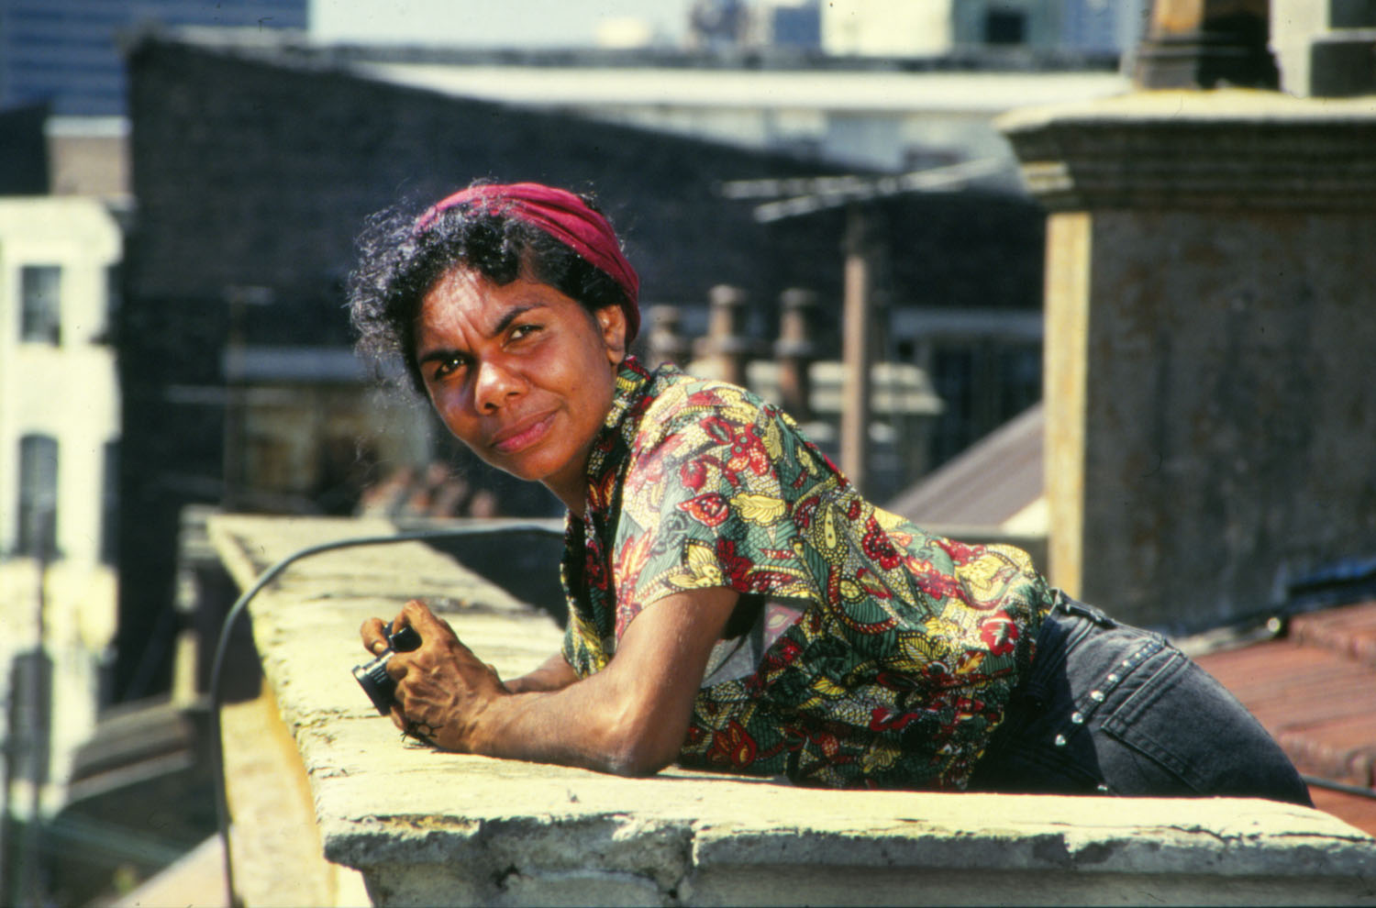

Rose Wanganeen as The Investigator

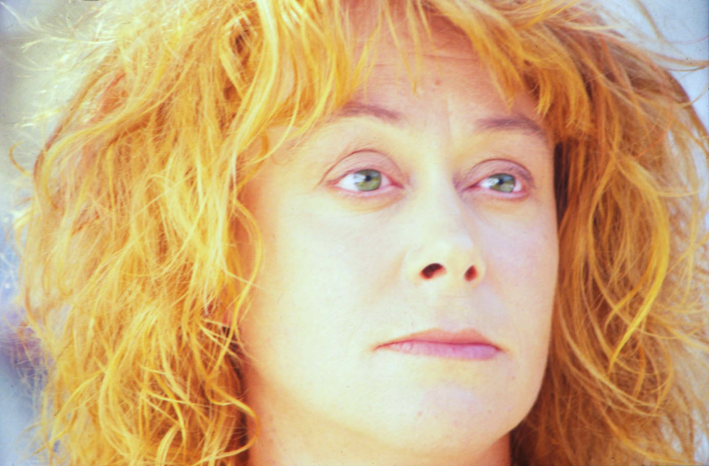
Robin Laurie as The Redhead
AWARDS
1990
Red Ribbon (Film as Art): American Film and Video Festival
Innovative Award ATOM (Australian Teachers of Media) Awards
1989
Best Cinematography AFI Australian Film Institute Awards
Best Experimental Nomination AFI Awards
Certificate of Merit Melbourne Film Festival
Special Commendation for a New Australian Film, Frames Festival Adelaide
Finalist Dendy Awards Sydney Film Festival

FESTIVALS and SCREENINGS
2017 Cinenova, London curated by Alex Martinus-Roe
AGNSW Featured in Alex Martinus-Roe’s exhibition in The National. New Australian Art
2016 Green Screen Institute of Modern Art, Brisbane
Melbourne Cinémathèque Between Past and Present: the films of Margot Nash ACMI
2008 UWA Vision, Memory, Spectacle - Aust Women’s and Gender Studies Conference
1999 Films Des Femmes Créteil France: Tribute to Australian & New Zealand women.
1998 Downloading Downunder: Australian Film and New Media, Amsterdam
1991 Images Festival of Independent Film and Video, Toronto
1990 Films Des Femmes Créteil, France
Clermont Ferrand Short Film Festival France
American Film and Video Festival
Wellington Film Festival
Frames Festival, Adelaide
Insight Women’s Festival, Canada
Flashbacks: Images of Memory and Desire AFI National tour, Australia
BFI British Film Institute Regional tour UK
1989 London International Film Festival
Hawaii International Film Festival
Melbourne International Film Festival
Sydney International Film Festival
Other Pleasures: Feminist Avant Garde Films, MIMA Modern Image Makers Association, Melbourne
WOW Women on Women in Film and Television, Sydney
Recent Australian Films MRC Winter Season Adelaide
Spoletto Fringe Melbourne (Women Feminism and Narrative)

Theatrical release: Australia and UK. Screened in London in 1989 supporting Chantal Akerman’s feature Toute Une Nuit (1982)Broadcast: SBS

RESOURCES
Shadow Panic is a useful resource for schools, libraries, universities and TAFE and
anyone interested in the study of feminism, the short film form, Australian feminist film history, or screen theory. Clips from Shadow Panic can be viewed on the Australian Screen website. https://aso.gov.au/titles/shorts/shadow-panic/.

CAST

The Redhead ROBIN LAURIE
The Investigator ROSE WANGANEEN
The Hothead KAARIN FAIRFAX
The Child ELIZABETH COOK &
SANDRA COOK

CREW

Producer, Director, Writer MARGOT NASH
Director of Photography SALLY BONGERS
Editor DIANA PRIEST
Original Music and Sounds ELIZABETH DRAKE
Sound Recordist / Sound Design LIAM EGAN
Counterpoint Sound
Art Director JAN MACKAY
Wardrobe and Makeup AMANDA HUNT
Production Manager PIP BROWN
Production Company AS IF PRODUCTIONS
POBox120Chippendale
NSW AUSTRALIA2008

Year Completed 1989

Guage and Stock 16mm Eastmancolour

Running Time 25 min 277metres

Ratio 1:1.33

Sound Optical

REVIEWS

Shadow Panic gives us shatteringly sharp
images, poetic voiceovers and head wrenching
sound effects. It pays homage to surrealism
with every shot and director Margot Nash and
cinematogapher Sally Bongers deserve
accolades for the startling beauty of the
pictures.
Nash has said that the film is about internal
and external states of emergency, the nuclear
shadow and the personal shadow, and about
memory and desire. The conscious and the
unconscious. The world of shadows and the
cold light of day. She wanted this film "to
blow the wind out of the codes". How much
codelessness can we stand and still make sense
of things? But this film isn't codeless. It uses
codes and then wickedly turns them on their head.
Three female characters search, not for an
author or a plot, but for the truth below and within
the surfaces. A dreamer - the redhead-
(Robin Laurie); an investigator - the black
woman -Pearl(Rose Wanganeen); and a
hothead - a romantic speed freak - (Kaarin
Fairfax), search for hidden treasure, memories,
love and evidence.
This film provides no answers and gives no
feeling of comfort about the questions either,
but it does provide a kaleidoscopic array of
symbols, of impressions, of visions. People
don't "act" in this film. They play the roles,
the stereotypes. They are pitted against objects
themselves, enemies and their own shadows,
and despite the urgency and haste in this film it
is strangely cool and hard, somehow like the
brittle surfaces it shows and then shatters.

Gillian Leahy
FILMNEWS July 1989

Media Resource Centre’s Winter Season of Recent Australian Films 1989 Adelaide

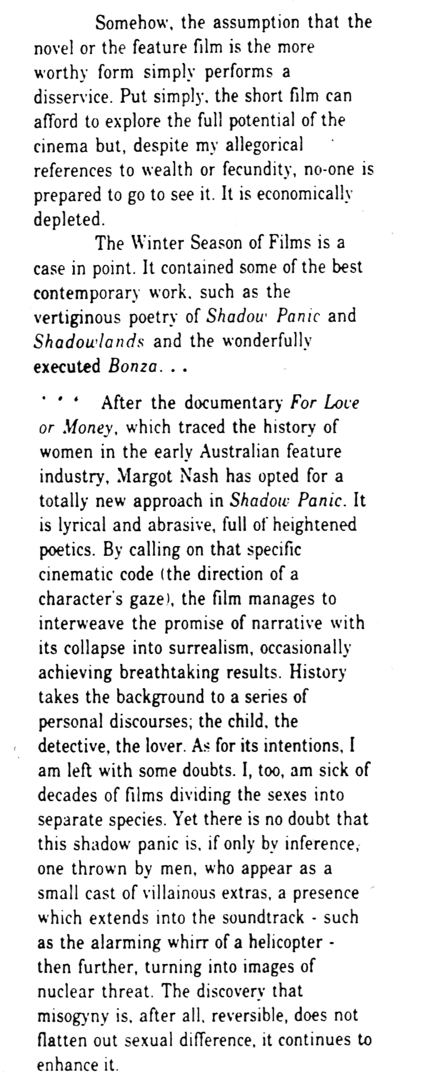

John McConchie Art Link 33 Vol 9 No 3
MARGOT NASH - BIOGRAPHY
Margot Nash began her career as an actor. She started out at the Melbourne Theatre Company and then joined the Australian Performing Group at the Pram Factory in Melbourne in the 1970s where she began videotaping shows and taking stills. After moving to Sydney she joined the Sydney Filmmakers Co-op and began freelancing in the independent film sector.

She has produced, written and directed a number of award-winning films as well as working as a cinematographer and editor. Her first film We Aim To Please (Robin Laurie & Margot Nash 1976) about female sexuality won a Jury Prize at L’Homme Regarde Homme film festival in Paris in 1978. We Aim To Please is represented in Screen Worlds, a permanent exhibition about the history of the moving image in Australia at ACMI in Melbourne. Margot was co filmmaker and editor on the 1982 feature documentary For Love or Money, about the history of women and work in Australia, which screened at Berlin, Toronto and the Tokyo International Women’s Film Festival. For Love or Money received a UN Media Peace prize in 1985. For Love or Money and We Aim To Please were both digitally restored by the National Film and Sound Archive in 2017 and both screened in ‘Personal and Political’ a retrospective of Feminist Films from the 70s and 80s at the 2017 Sydney Film Festival.

Margot’s short documentaryTeno won the Jury Prize for Direction and Best Documentary in the ATOM Awards in 1984. Her 1989 short innovative drama Shadow Panic won an AFI Award for Best Cinematography, an ATOM Award for Best Innovative Film and a Red Ribbon for Film as Art at the American Film and Video Festival. Shadow Panic screened internationally at festivals including London, Hawaii and Clermont Ferrand and screened theatrically at the Phoenix Cinema in London supporting Chantal Ackerman’s feature film Toute une Nuit (1982). In 2017 it screened at Cinenova in London.

In 1994 Margot wrote and directed Vacant Possession, a feature drama about family, racial conflict and the complexities of reconciliation for which she was nominated for Best Directing and Best Original Screenplay in the AFI awards. Vacant Possession screened at international festivals including Chicago, Hawaii and Asia Pacific and in 1996 won a Speciale Mention du Jury at the Films de Femmes festival in Créteil in Paris. For Love Or Money, Shadow Panic and Vacant Possession screened as part of a ‘Tribute to Australian and NZ Women Filmmakers’ at Créteil in 1999. In 2005 Margot directed her second feature Call Me Mum for SBS Independent. Call Me Mum screened at local and international festivals including Sydney, Adelaide and Créteil, won two AFI Awards in the telemovie category and was short-listed for the NSW Premier’s Literary Awards and the AWGIEs.

Margot has worked as a consultant and a mentor for Indigenous filmmakers in Australia and in the Pacific. In 2012 she was the Filmmaker in Residence at Zürich University of the Arts where she developed a personal essay documentary about family secrets called The Silences. The Silences (2015) screened at a number of film festivals including NZIFF, MIFF and Amdocs in Palm Springs. In 2016 Margot won an Australian Writers’ Guild AWGIE Award for the screenplay. Margot worked as a Senior Lecturer in Communications at the University of Technology Sydney teaching screenwriting from 2000 – 2018 and is now an Honorary Associate Teaching and Research UTS. In 2019 she collaborated with performance artist Victoria Hunt to make the award-winning short Take. She is currently developing new work.
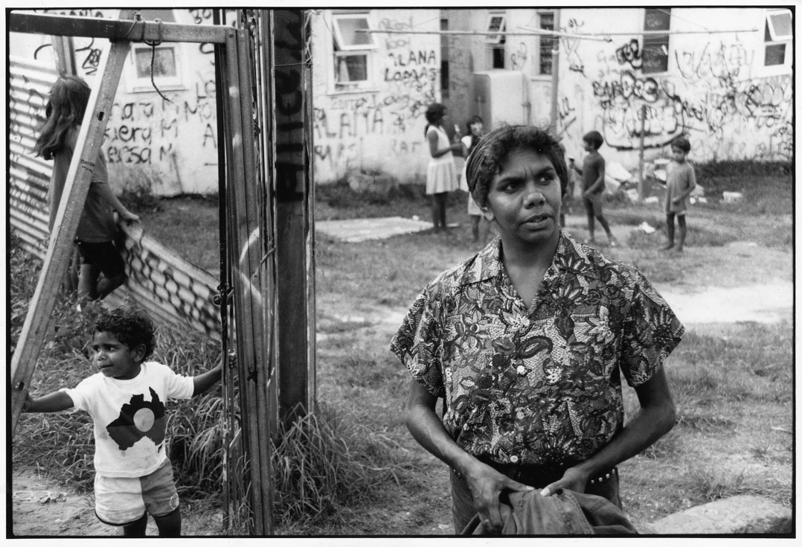
Rose Wanganeen on location the Block Redfern

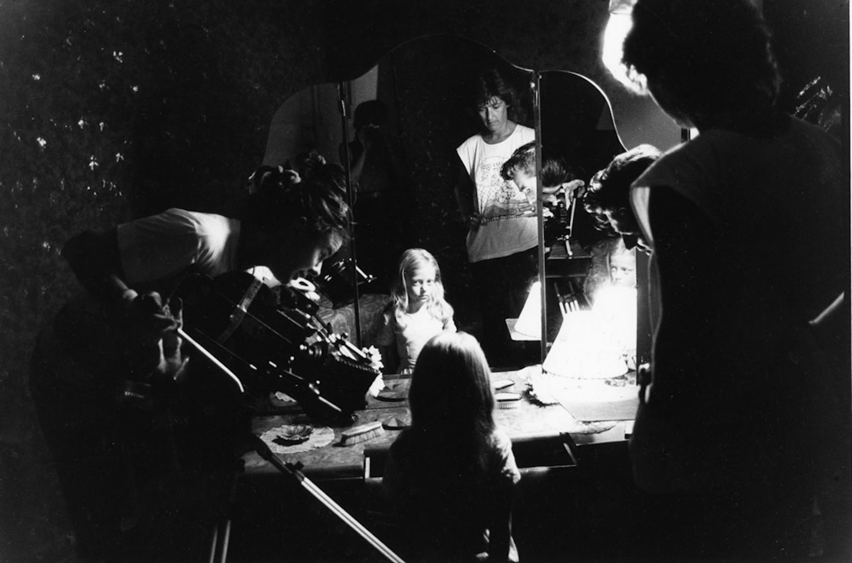

Margot Nash, Cinematographer Sally Bongers and Elizabeth Cook as The Child on set

Photographer: Corrie Ancone

