25th May, 2020

Peter Hegedus
Soul Films

Dear Peter

Many, many thanks for supporting BOFA’s first online film festival with the wonderful Lili, which attracted 771 views! The Conversation with Trevor and you also went really well https://youtu.be/EvYWtkNPPpU

Typical comments from our Top 5 Pix competition about the film were:
- Lili - affecting and well-crafted documentary that sensitively explores the impact of inter-generational trauma on Lili, her daughters and granddaughters. Recreations in documentary are often too literal or stagey, but these were done with more finesse. The editing and structuring of the story was also very successful in keeping you engaged.
- Lili was very disturbing, showing the terrible effects of generational trauma.
- How much heart ache can one woman endure? This film puts your life back into perspective. No time for any self-indulgence after viewing Lili.
- Another difficult film. Trauma and how it can flow to the next generations. So sad! Beautifully done, also the slow revealing of more and more tragedy. It was an excellent film and created compassion for all involved!
- A documentary with twists that had me changing my reaction to the people involved as the story unfolded
- When excavating family history for my Polish passport application Lili voiced the dismissive, yet defensive declaration of my WWII refugee mother. The past is long buried, why bring it all up again now? And just like Lili’s daughter Edie, I kept dredging because both mothers are wrong: past secrets don’t stay buried. They rise like Frankenstein’s Monster and haunt the living’s unconscious decision making. When Lili finally declared why she left her first baby daughter in Hungary, and fled the country to save her 18-year-old self, it hit me like a slap on an ice-cold cheek. An informed viewer can trace the inherited, intergenerational trauma unwittingly experienced by three generations of women in their family line and map the shared trauma milestones. Equally, 9-year-old Lili’s naive evaluation of her father is finally shattered, yet the consequences of his abandonment of her has wreaked havoc in their interlinked lives. Where there’d been estrangement, tentative lines of communication were opened, and it’s through these breadcrumbs, soul deep healing may come.
The festival was a success from our point of view with our viewing and subscriber audience growing by 450%. The new audience comes 50% from mainland Australia and 50% Tasmania. 27% of this new mainland audience comes from regional centres, who are currently probably under-served. Viewers are 66% female. 90+% have one or 2 university qualifications. They typically watched 2-6 films.

Thank you for backing us this year. We will think hard re the format for BOFA 2021 and would welcome your thoughts on the role of online in the screen landscape of the future.

Kind regards
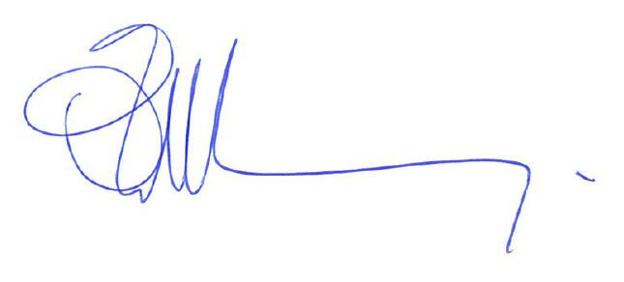
Owen Tilbury, Festival Director

