ROGUE PRODUCTIONS & DONYDJI HOMELAND

presents

HOMELAND STORY
Saving Country

PRESS KIT

Running Time: 86 mins

ROGUE PRODUCTIONS PTY LTD - Contact
David Rapsey - roguedr1@bigpond.com Ph: +61 3 9386 2508 Mob: +61 423 487 628
Glenda Hambly - roguegh1@bigpond.com Ph: +61 3 93867 2508 Mob: +61 457 078 513461

RONIN FILMS - Sales enquiries
PO box 680, Mitchell ACT 2911, Australia
Ph: 02 6248 0851 Fax: 02 6249 1640 orders@roninfilms.com.au

Rogue Productions Pty Ltd
104 Melville Rd, West Brunswick
Victoria 3055
Ph: +61 3 9386 2508
Mob: +61 423 487 628

TABLE OF CONTENTS

Synopses 3
Donydji Homeland History 4-6
About the Production 7-8
Director’s Statement 9
Comments: Damien Guyula, Yolngu Producer… 10
Comments: Robert McGuirk, Rotary Club. 11-12
Comments: Dr Neville White, Anthropologist 13-14
Principal Cast 15-18
Homeland Story Crew 19
About the Filmmakers 20-22

SYNOPSES

ONE LINE SYNOPSIS

An intimate portrait, fifty years in the making, of one small Indigenous community’s struggle to remain on country.

SHORT SYNOPSIS

An intimate portrait of Donydji, a remote, traditional Indigenous Homeland in North- East Arnhem Land in the far north of Australia. The film charts the community’s transition from nomadic life to the digital age, from the 1960’s to the present day.
It documents their struggle to overcome corrosive government policy and mining interests and remain on their ancestral land.

LONG SYNOPSIS

Homeland Story is an intimate portrait of Donydji, a small Indigenous community in North East Arnhem Land in the far north of Australia.

The film charts the Donydji community’s transition from nomadic life to the digital age, from the 1960’s to the present day. One family is featured, across three generations, from the traditional elder, Dhulutarama, who still knew how to make stone tools, to his grand-daughter, Joanne Yindiri Guyula, who teaches at the Donydji school. It is a moving portrait of the family’s struggle to preserve their culture and remain on their Homeland despite the severe obstacles they face: sub- standard education, deplorable service delivery, lack of job opportunities for the youth, inadequate government policy, bureaucratic mismanagement and pressure from mining interests.

The film also tells the remarkable story of cross cultural co-operation over nearly fifty years. In 1974, Neville White, a genetic anthropologist, went to Donydji to research a PhD. In effect he has never left. Spending part of each year on the Homeland, he responded to the community’s request to help them map their clan lands as a way of resisting the threat of mining license claims. When education, housing and employment opportunities became the community’s major concern, he convinced the Rotary Club of Melbourne to fund a major building project that was undertaken by Vietnam Veterans working with the young men of Donydji. Together they built the first school, new houses, and a workshop where the youth could learn trade skills to prepare them for employment. Fifteen years later the partnership between Rotary, the Vets and the young men continues.

DONYDJI HOMELAND HISTORY

The term ‘Homelands’ describes places where small populations of Aboriginal people live in remote areas, on lands to which they have traditional ownership or historical association.

In 2016 there were 630 Homelands in the Northern Territory. Donydji is one of these. It is situated 250 k’s inland from the coastal town of Nhulunbuy in East Arnhem Land.

Arnhem Land lies in the far north of Australia, east of the Kakadu National Park. It has been occupied by Indigenous people for tens of thousands of years and is the location of the oldest-known stone axe. Scholars believe it to be 35,500 years old.

In 1931 the Australian Government declared 96,000 sq km of Arnhem Land an Aboriginal Reserve. Today the Land Trust holds it as Aboriginal freehold land. The traditional owners have the right to refuse access to their land and the right to withhold consent to mining exploration on their land.

Up to the 1960’s the clans of Donydji lived a nomadic life travelling over an area of 5,000 square kilometres following the food supply as the seasons changed. They often camped in Donydji in the late dry season (September - October) where food and water was plentiful. It was also an important religious and ceremonial site.
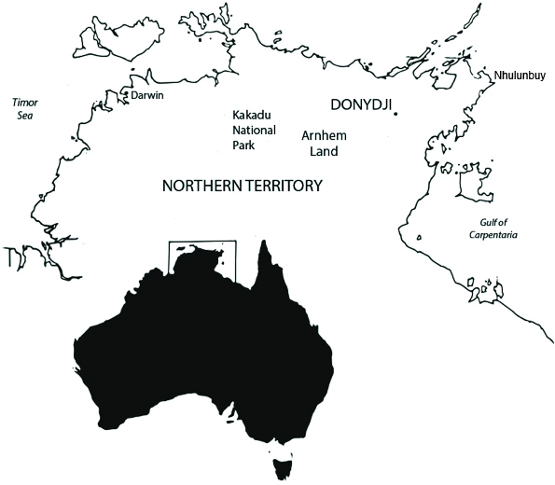

1960’s

Late 1960’s

1974

1970’s - 80’s

1984

1991
BHP conducts survey works and builds a landing strip for their surveyors at Donydji. Some of the Donydji families carry food in for the miners in return for tobacco and sugar.

A BHP survey party drills into a sacred site at Donydji. Dhulutarama and his brother, whose clan is primarily responsible for the sacred site, decide they must stay in Donydji to protect the area.

Neville White, a PhD student in anthropology at La Trobe University, Melbourne, arrives in Donydji. His aim is to study how genetic diversity relates to linguistic diversity. For this he needs to research people who are still
living traditional lives. Donydji consists of nothing more than a collection of traditional bark huts.

Dhulutarama and other senior kinsmen welcome Neville and assist his research. He is incorporated into the Marralarrmirri clan of Wagilak who intermarry with the Ritharrngu clan. In return they enlist his help to resist mining exploration licenses which are being taken out on their land.

Neville completes his PhD and becomes an academic at La Trobe, but each year he returns to Donydji for two to three months to continue his research.

Dhulutarama’s son, Yilarama, teaches Neville Ritharrngu/Wagilak, the language of the clan. Neville teaches Yilarama English in return. They become very close. When Neville marries in 1988, Yilarama is the groomsman at his wedding in Melbourne.

Neville walks all over the clan lands with Yilarama and Yilarama’s brother, Tom Gunaminy, mapping the land to prove that it is ‘taken’, not empty land that the mining companies can claim. Neville is asked to write letters to the mining companies and the government objecting to mining exploration. When that fails to stop the claims, the community asks Neville to record their voices, again objecting to the claims. Neville sends these recordings to the mining company and government, but still the claims continue.

In 1981, Neville’s senior status is acknowledged when Dhulutarama presents him with a bathi (a ceremonial woven bag) which is only given to senior clansmen. It is a sign of respect that ties Neville to the Donydji community and them to him.

Neville makes a documentary You Keep Asking Asking, in which the people demand that mining exploration and licence claims cease.

Dhulutarama dies. Dhulutarama’s son, Tom Gunaminy, takes over as clan leader. Yilarama could have become the next leader but he is spending more time away from the Homeland, working in the towns. Tom is more protective of cultural knowledge than Yilarama. He is reserved about sharing it with Neville, but as they work together he gradually changes his mind and comes to trust Neville as a brother.

1995 - 2000

2002

2003 - 2005

2006 - 2017
Neville and Tom involve all the clans in the Arafura Swamp Catchment Area in a claim to list the area on the Register of the National Estate. The point of the claim is to strengthen the control the clans have over their land and to protect the cultural landscape. The National Heritage Commission accepts the claim but the mining companies see it as a threat and object. Tom uses Neville’s clan maps to press the claim. The Heritage Commission finds on behalf of the clans and the Catchment Area is added to the Register of the National Estate. Next, Neville and Tom set up a Ranger programme to look after the land in the Arafura Swamp Catchment area.

Neville is an Associate Professor at La Trobe when he suffers flashbacks to the Vietnam War where he served as a conscript in the 1960’s. His PTSD is so extreme he has no option but to resign. He decides to concentrate his
efforts on building infrastructure and assisting with community development at Donydji.

Neville devises a scheme whereby the Veterans he served with in Vietnam and the young men of Donydji work together to build the infrastructure needed on the Homeland. People are still living in rough buildings, often open to the elements. Neville takes the proposal to the Rotary Club of Melbourne hoping it will fund the initiative. The Club is immediately interested and supportive.
It forms a committee with La Trobe university and attracts support from philanthropic organizations. Over the next eleven years, $1.6m is raised to build infrastructure and support Vietnam Veterans as they provide vocational training at Donydji.

A school, three houses, ablution blocks and a workshop are built by Vietnam Vets and the young men of Donydji. The workshop is fully equipped to allow practical trade skills in mechanical repairs, carpentry and welding to be taught and applied. Neville and some of the volunteer Veterans assist Joanne Yindiri Guyula in tutoring the children and youths in literacy and numeracy.

Neville and the Vets return each year to work with the young men on new projects; two outdoor kitchens are built, houses are refurbished, a community garden is established, training programs to pass on trade skills are set up.
Furniture built in the workshop is sold to other Homelands. Support is given to Joanne to assist her to become a qualified teacher.

However, despite repeated efforts to secure support from government and the local council for ongoing employment programmes, no long term plan eventuates to use the workshop or employ the Donydji construction team
Instead, the government and council continue to use white contractors to build houses in East Arnhem Land.

ABOUT THE PRODUCTION
Some documentaries have a long gestation. Homeland Story has taken nine years to make because it was fitted in around gaps in the Director, Glenda Hambly’s, other work
- or when money became available to progress the film.

Glenda first approached Dr Neville White about the possibility of making a documentary in 2009. Dr White was reluctant to become involved, however, he put the proposal
to the people of Donydji and the response was positive. They wanted a film made so their voices could be heard; they wanted to tell their story to white audiences. In the light of this, Dr White agreed to help make the film. Thus, from the start, the goal in making Homeland Story was to raise awareness about the importance and value of Homelands.

The project began in an unstructured way. When Glenda made her first trip to Donydji in October 2010 she had no idea what to expect, given it was her first visit to Arnhem Land as well as to a Homeland. She took a cinematographer friend, Moira Moss, with her and together they tracked Neville’s frenetic work pace as he briefed, badgered and pleaded with white government and council officials for better educational and living conditions on the Homeland.

The second filming visit in July 2011 was better planned. There were two objectives; to film the Vietnam Vets and the young men of Donydji working together to build outdoor kitchens funded by the Rotary Club of Melbourne, and to film the people of Donydji going about their daily lives.

In early 2012, Glenda asked a friend of hers, one of Australia’s leading editors, Ken Sallows, for his opinion of the forty hours of footage that had been gathered so far. Did he think there was a film in it? His response was ‘yes’, so the Director pushed on. SBS and the ABC were approached for production support but both refused the project. A small amount of funding from Screen Australia helped pay for the third filming trip in late 2012, which recorded clan leader, Tom Guniminy’s ten day long funeral in Donydji.

It wasn’t until early 2013 that Glenda became aware that Dr White had a vast audio- visual collection. He had been recording Donydji life from 1974 when he made his first trip to the Homeland. Given he returned every year thereafter for the next forty plus years taking photographs, film, video and taping songs and stories, the archive was a treasure trove and of great value in expanding the scope of the documentary. The project became much more than a contemporary story of a remote, traditional
Homeland. Dr White’s archive provided the opportunity to track the evolution of Donydji over forty years, virtually from its foundation. It became a unique historical record of a community’s transition from nomadic practices to the digital age.

The three years of production filming in Donydji was done for ‘no money’ with everyone donating their time. Finishing the film however, the post-production stage, required funding. Film funding agencies, the ABC and SBS were again approached, but again
they refused.

In early 2014, Glenda went to Rotary Club of Melbourne to ask whether it might partner her in approaching other philanthropic organizations to raise money to complete
the film. (The Melbourne club had been heavily involved in supporting infrastructure development at Donydji since the early 2000’s. In addition, it had lobbied successive governments to convince Ministers of the value of Homelands.) Rotary agreed to support the film believing it would be an effective tool in promoting the value of Homelands. Rotary not only partnered Glenda in approaching twenty-six philanthropic organizations in 2014-15, they also funded the cataloguing of Dr White’s archival collection so it could be accessed and used in the film. An archival assistant spent four months digitizing and cataloguing 140 hours of audio-visual recordings and 20,000 stills.

Rotary’s help was crucial in obtaining donations from two of the twenty-six philanthropic organizations and individuals who were approached. This philanthropic money augmented by donations from a small group of private donors meant post production could begin. One hundred and seventy-five hours of archival and contemporary footage was reduced to a three hour cut of the film and then to a feature length film.

Producer, Damien Guyula, the community’s representative on the film, translated the Yolngu languages used in the film, supervised the sub-titling and became the film’s narrator.

The last stage of post-production had to be postponed until more money was raised, again through the Rotary Club of Melbourne and the Baker Foundation. The film was finally completed in January 2019.

DIRECTOR’S STATEMENT

The film was a challenge to structure because of its diverse elements. I was told on a number of occasions as I sought funding that I should simplify the story and focus it on one or two characters. That was counter-intuitive to me because the point of the film was to tell a wide-ranging story that took place over forty years. The film therefore needed
to be complex and episodic. It had to track Dhulutarama’s family from the 1960’s to the current day, the special friendship the family has with Dr White, and describe the enormous problems the community faces in maintaining the Homeland in the contemporary political setting.

Finding the best way to bind the episodic aspects of the narrative into a coherent whole was difficult. The choice of narrator was crucial to this. Dr White provided the narration in the first version of the film. In the second, my co-producer Damien Guyula and Dr White shared the narration and in the third and final version, Damien told the story on his own.

Filmmaking is a collaborative effort and the making of this documentary has been more collaborative than most. Without the enormous amount of goodwill, generosity of spirit and support from so many people, the film could not have been made.

Two of Australia’s outstanding editors helped make Homeland Story. The vision editor, Ken Sallows, worked on a cut of the film for months for no fee. The sound designer, Craig Carter, travelled to Arnhem Land to record the narrator as well as sound effects and atmosphere for no fee. (Sadly, Craig died before completing his work on the film.)

The cinematographers, Moira Moss and Brian McKenzie, who filmed around seventy hours of footage in Donydji between 2010-2012, also worked for no fee. Everyone gave their time because they believed it was a story that should be told.

The tireless effort of two members of the Donydji sub-committee of Rotary, Peter Duncan and Robert McGuirk, ensured enough money was raised to finish the film.

My experience in the film industry is in drama, not documentaries, which meant I did not have the credits to apply for funding from Screen Australia, the federal funding agency, Three highly experienced Victorian producers, Brian McKenzie, Lisa Horler and Andrew Wiseman, teamed up with me on three different occasions, so that I could at least apply for funding. We were unsuccessful each time, but all three provided invaluable support and advice. Another documentary producer, John Moore acted as my mentor from the earliest stages of the project, linking me up with people, guiding me on a path that was very unfamiliar.

The Donydji community gave us full access to film in the Homeland and were always generous in hosting our visits. Dr White was indefatigable in his support of the film. In effect the film is a collaboration. Dr White facilitated the visits to Donydji, provided free access to his archival collection, and was an ever reliable source of information and guidance.

COMMENTS: YOLNGU* PRODUCER, DAMIEN GUYULA

It’s a privilege for me as a descendent of (the) Ritharrngu (clan) to be part of the film. I’m so happy and proud that being part of it means sharing the stories of our people; sharing our culture with the world.

Some people say Yolngu are not capable of doing things themselves, but the film shows we can take on any challenge. Some Australians think we are not capable of doing anything, that we can only rely on the government for money, but the documentary shows the opposite.

I’d like the film to encourage people to come together and work together. This film shows how the two sides (Yolngu and European) can help each other. Also, I hope it helps motivate Yolngu people to be strong in both the traditional and modern world we’re living in today.

I hope this documentary helps the government understand that Homelands are the best place for Yolngu to raise our children, because it’s the only place where we can be close to them. When children move into the bigger communities there are possible bad influences. A few years ago the government wanted to stop funding Homelands and move everyone to the Hubs (towns), but most Hub communities have problems with housing, there’s over-crowding, kids don’t go to bed early, they skip school. In the Homelands they go to bed early. They know what time to go to school. I strongly
believe that the Homelands have more power to control young men and young women and culturally they can teach the young people to take on leadership. In the Hubs there’s freedom; the kids don’t go to bed, they don’t learn, they start to disrespect the elders and leaders. That disables the elders to pass on the knowledge. In the Hubs there are many elders passing on and taking the knowledge with them, without passing it on to the younger generation.

The families of Donydji, the descendents of the Ritharrngu clans, are happy that the documentary has been made. It preserves the images and footage of our ancestors but it tells the contemporary story of Donydji as well. I’m sure the women who speak in the film will cry at first when they see their father and brothers that have passed on, but at the end of the day it will be a blessing because they’ll enjoy it. They’ll be happy that they spoke about their land and were so strong in speaking about it. It will encourage them to be strong. It will also encourage the young men and women of Donydji and others from around Arnhem Land who are Ritharrngu descendents. My goal for the
film is for these young people to watch the film and then stand up and be strong for our land.

*Yolngu is the name used for all Aboriginal people living in North-East Arnhem Land.

COMMENTS: ROBERT McGUIRK, ROTARY CLUB OF MELBOURNE
Indigenous Programs Committee
Rotary became involved in the Donydji project to support the community in their goal to be self-sustaining on their own Homeland and to build a future for their children.
That’s what Neville White asked us to do. The Donydji people didn’t want to move into larger settlements where traditional customs lapsed and there was dysfunctional behaviour. They told us they needed educational and training facilities, and secure
accommodation on their own land. A Rotary committee was formed, in conjunction with La Trobe University, to begin a program that responded to this request.

Rotary had been involved in Indigenous programs in Homelands before, but this is probably the longest and most significant engagement in terms of financial and other support. We’ve been involved in Donydji for fifteen years and that’s what’s needed in working with an Indigenous community. You can’t just walk in for a year and say we’re going to fix this and then walk out. It doesn’t work like that. What’s needed is long term, sustained commitment to deliver what the community decides it needs.

Rotary decided to support the production of the Homeland Story documentary for a number of reasons. One was to record the history of what Neville has done for posterity. Another was to document how Rotary and its connections and resources
had been harnessed to deliver on the community’s requests. Supporting the film was a way of ensuring a permanent record of what Rotary had done in Donydji. Rotary gave
$30,000 to the film to ensure Neville’s archival collection was properly documented and protected by having it digitized so that it could be used in the production of the film. The collection is now held in the State Library of Victoria.

There was a third important reason for supporting the film. The public hears many horrible things about Homelands. We wanted to be able to say to the State and Federal governments, look, here’s a success story about a community that is doing well with the right sort of support. Don’t shut Homeland’s down. Here’s proof they can work.
Try to learn the lessons of what we’ve learnt and apply them and we might be able to keep more people in their own communities which is so critical to their personal development. Rotary is a non-political organization, but that was the message we wanted to get across. Homelands can work with a bit of effort, not just money. Rotary funded the Vietnam Vets to go up and work with the people to build the houses and to assist with the education of the children. It required the right sort of people and
engagement. Sometimes throwing millions of dollars at such problems can just create a disaster. Financial support is important, but human support counts more.

The message we need to give government is that there are different approaches. The one we’ve taken isn’t perfect but it’s a lot better than some others. You can’t think like we urban based people do and provide our solutions to remote Homeland issues. You have to be immersed in their culture and understand them and work with them to come up with solutions. You see Neville sitting there talking with them, discussing for months and years on end, asking: ’What do you want’? That’s how you build relationships. You can’t just say, we’ve got a new program, it’s got to be done in the next six months, we’re going to sign you up to some deal and it’ll all be fine. It takes a lot of time and effort.

Aboriginal culture is thousands of years old. Governments are short term. They want quick results, but that doesn’t work in these communities.

The film is important because it records a really significant story. Neville’s story; forty- five years of continuous engagement with an Indigenous community. It is unique. When he first went there the community hadn’t had much contact with Europeans, and that, in itself is an amazing story. He became part of their culture, leant their language and was accepted. He understood their way of thinking, worked with them, became an elder and attended many of their ceremonies. He has supported them to maintain their cultural connections and at the same time to become more integrated into wider Australian society. I think that’s a brilliant story.

COMMENTS: DR NEVILLE WHITE, ANTHROPOLOGIST

I started my research in anthropological genetics, particularly the relationship between linguistic diversity and genetic diversity and population structure, in Arnhem Land in 1971. The study soon widened to include many areas of biological anthropology and Yolngu culture. My work with the Yolngu of North-East Arnhem Land began in coastal communities, including Yirrkala. My mentor was an elderly lady named Bakali who had a vast knowledge of the landscape. I was introduced into her family as her brother, which is in the social category or malk of balang. In Yolngu society, social categories (called subsections by anthropologists) are applied to individuals, and these are more general than actual kin relationships. So, for example, in the film Damien (the narrator) says that Rayguyun is his “sister”, based on her malk, but in genealogical terms she is his grandmother. Biological links matter most, but when there is some distance between actual biological relationships, a person’s malk defines a social category which includes actual kin. The basic reason for this malk category is the regulation of social behaviour, particularly marriage. This enables individuals without any known kin to be incorporated into the society. Such is the case with many Europeans who become accepted by the Yolngu.

When I first went to Donydji in 1974, I came with the subsection of balang (given to me at Yirrkala) which placed me into a social relationship with Dhulutarama, who was the leader of the Birdingal clan of Ritharrngu-speaking Yolngu at Donydji. He stood
to me as father-in-law. The leaders of an intermarrying clan called Marralarrmirri, of the Wagilak-speaking people, then incorporated me into their clan, with the personal name of Lamburr. In 1981 I was given a bathi (a ceremonial bag), which was a way of recognizing my increased status within the group. Through these relationships I
later became close to Burrukala, who is Damien Guyula’s father, and also the father of Joanne Yindiri Guyula and Sonia Gurrpulan Guyula. Because Burrukala stood to me as my brother, I relate as father to Damien, Joanne and Sonia.

From the time I first arrived in Donydji, the people were very accepting and kind to me. There were no other white people around so it was necessary for me to interact strongly with the families. At night the young men in particular would sit with me at my fire, even though I couldn’t speak or understand their language. I developed a
particularly close bond with Yilarama, who stood as a son to Dhulutarama. He wanted to learn from me as much as I wanted to learn from him – but he was a faster learner than I was! It took me three or years or so before I became moderately fluent in Wagilak/Ritharrngu. Yilarama called me his dhuway, and I called him galay, which is a brothers-in-law relationship.

When I decided to apply my anthropological research and concentrate on helping the people of Donydji, it was the Rotary Club of Melbourne that made it possible. The original chairperson of their Donydji Committee, John Mitchell, now deceased, was totally committed to providing a pathway for the young people to achieve a healthier engagement with other Australians from the security and cultural understanding of their own country. Furthermore, John and his colleagues strongly supported my aim of involving Vietnam Veterans (who I had served with in Vietnam) in a community

development programme. Like me, Rotary saw it as a chance to help two marginalised groups in Australian society. John and other members of the Committee, and other philanthropic organisations who contributed considerable funds to the Donydji project, were thrilled when the Veterans began working with the Donydji community.

I think the most disappointing thing for all of us is what has happened to the Donydji school and to Joanne Yindiri. It’s been her dream to become a qualified teacher and I’ve focused on helping her achieve that so she can assume a key role in the school in Donydji. The failure of the Education Department to support her has been extremely disappointing for everyone. The Department terminated her university studies and
has broken every agreement it made to help her. Education is still an ongoing battle. We’ve now involved Plan International, to help resurrect the school and workshop programmes, as well as other pathways for the Yolngu youth.

There has been incompetence and a lack of commitment in the federal and state government’s response to Aboriginal people across the Northern Territory, as well as a glaring mediocrity among local administrators and contractors. Donydji suffers
particularly because it is the most remote Homeland from the Laynhapuy Homelands Aboriginal Corporation, Donydji’s nominated resource provider, which is based in Yirrkala, 270 km away over rough roads. For Donydji, it seems to be a case of out of sight, out of mind. It is often argued that it would be better for people in the Homelands to move into Hub centres like Gapuwiyak and Yirrkala as it would be easier to provide services, such as police, health, education and so on. The attitude has developed that if people in Donydji want a service they should go and get it, i.e. drive the hundreds of kilometres – if there is a roadworthy vehicle – to the Hub towns rather than the service being provided to them on the Homeland.

The people themselves demand the right to achieve a solution to the chronic problem of Homelands being under-resourced and too often ignored. People choose to live in the Homelands because it is a safer and healthier environment and they can continue their traditional life, passing on its values to the young people, as well as protecting their cultural and natural landscapes.

The simplest things can be difficult in a Homeland. There are few spare parts and tools to repair old second-hand vehicles needed for transport to the Hub centres. Apart from the houses built by the Vietnam Veterans and the Rotary Club of Melbourne, which have solar units installed, the Government houses still rely on a diesel generator, which often breaks down and/or has no diesel fuel available. A few years ago when the generator that provides electricity broke down it took eleven months to be repaired.
People in those houses had no lights or fans during the hot season, for all that time. Attempts were made to run power lines from solar units in the houses we built, which damaged a number of the units. Rubbish disposal is another intractable problem. The tip is about one kilometre from the Donydji village but there is often no transport to take the rubbish to the tip. If there is no fuel or spare parts for the tractor (which was initially provided by philanthropy), it is very difficult to protect the amenity of the community despite the best efforts of the residents.

HOMELAND STORY PRINCIPAL CAST

DR NEVILLE WHITE AM
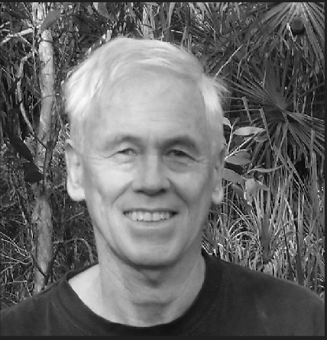
Neville grew up in Geelong, Victoria. His father was ‘Kid Young’, an Australian featherweight boxing champion who trained Aboriginal boxers in his backyard gymnasium. Neville studied to become a textile chemist before being conscripted to fight in Vietnam in 1966. He was opposed to the war, but refused to claim exemption because he did not claim to be a pacifist. Serving in Vietnam had a profound effect on him. He decided he wanted to re-train as an anthropologist to better understand different cultures and how disadvantage and misunderstanding could lead to conflict and war. He was the first one in his family to graduate from University. Neville taught at La Trobe University in Melbourne from 1973-2002. He was forced to resign because of combat related PTSD and since then has dedicated himself to working with the Donydji community, assisting however he can to help them stay on their Homeland and protect their clan lands. Neville is an Emeritus Scholar at La Trobe and was awarded an Order of Australia (AM) in 1998.

DAMIEN GUYULA
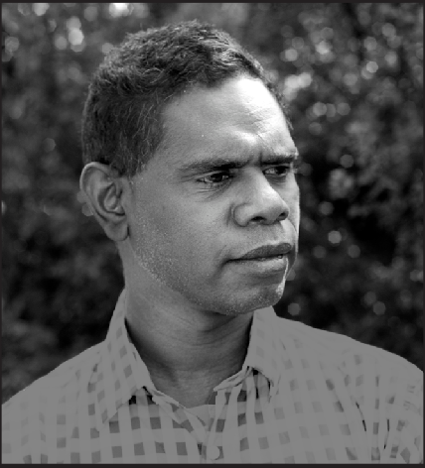
Damien is a member of the Djambarrpuyngu Liya-Dhalinymirr clan. He speaks Djambarrpuyngu, Ritharrngu, Ganalbingu and English. He grew up on the Mirringadja Homeland (pop. 30) on the Arafura Swamp and lived there until he was twelve. (Mirringadja and Donydji are closely associated. They belong to the same family groupings.) Damien’s father is a senior clansman and trained Damien in tribal lore. Damien has worked for the Gapuwiyak Community Council and at the Gapuwiyak High School as a Tutor, Cultural Advisor and School Attendance Supervisor. He has been an Interpreter for Aboriginal Interpreter Services N.T and a Liaison Officer for the Northern Territory Police. He is currently a Police Constable in Yarralin, 400k’s south of Katherine in the Northern Territory.

DHULUTARAMA
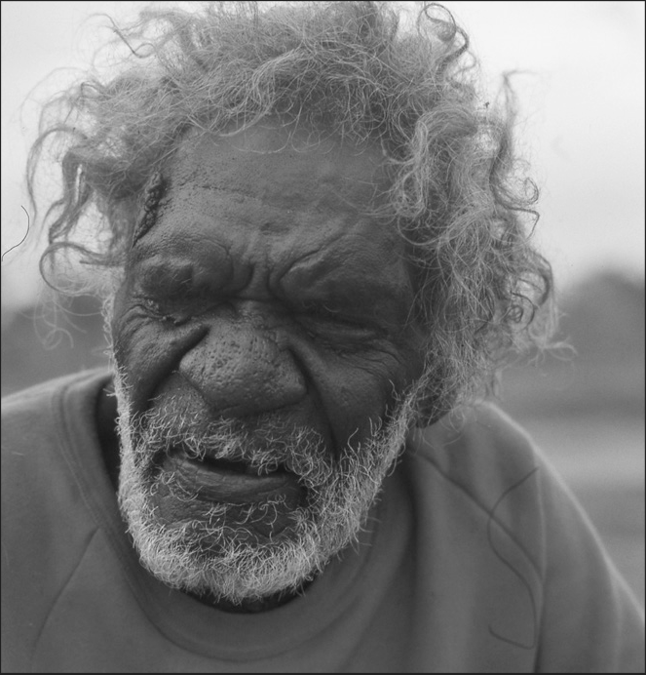
(circa 1916-1991) was a senior Birdingal-Ritharrngu clansman. Renowned as a great fighter, he took pride in the injuries he had received in battle. By the 1960’s many of the clans of East Arnhem Land had moved to missions or government settlements, enticed by the promise of regular food and medical supplies. Dhulutarama, by contrast, refused to give up his country and leave his ancestral land. He had three wives and when his brother Bayram died, his brother’s five wives became his as well. Outgoing, good-humoured, fiery and feisty, Dhulutarama welcomed Neville to Donydji in 1974. He was supportive of Neville’s research and grateful for his help in negotiating the difficult issue of mining exploration. In 1981, expressing his gratitude, he and Wagilak elders confered senior clan status on Neville and invited him to live with them permanently. Dhulutarama had lived a completely traditional life as a nomad and knew all the stone age practices such as making stone tools,a tradition that was at least four thousand years old.

ROGER YILARAMA
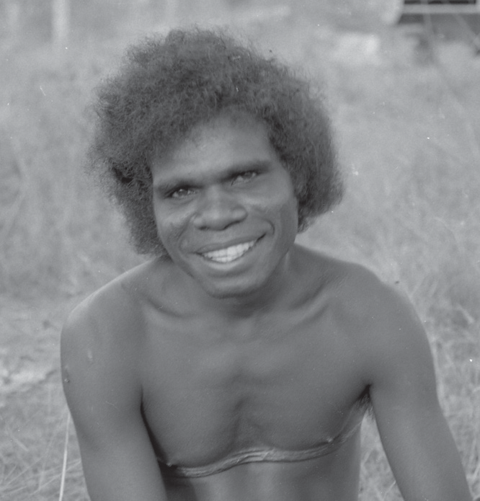
(1961-2002) was one of Dhulutarama’s sons. In the 1970’s he grew close to Neville, as they taught each other their languages. Yilarama walked the clan lands with Neville, recording the location of the clan’s camping and religious sites. This information was used to rebuff mining exploration on land that was deemed ‘empty’ on Western topographical maps. Because he spoke English, Yilarama was able to get work in the towns with the councils and the government. Neville encouraged him to take up these positions, but it rebounded on Yilarama. He found the responsibility stressful and turned to alcohol. In 2002, aged 41, he was killed in a helicopter crash. He was working for the Northern Lands Council clearing a route for a proposed gas pipeline when the accident occurred. The elders tried to stop him taking the flight, because he hadn’t visited the country he was travelling over for years and they feared the spirits wouldn’t recognize his smell. They asked Neville to help as well, but Yilarama couldn’t be reached in time.

TOM GUNAMINY
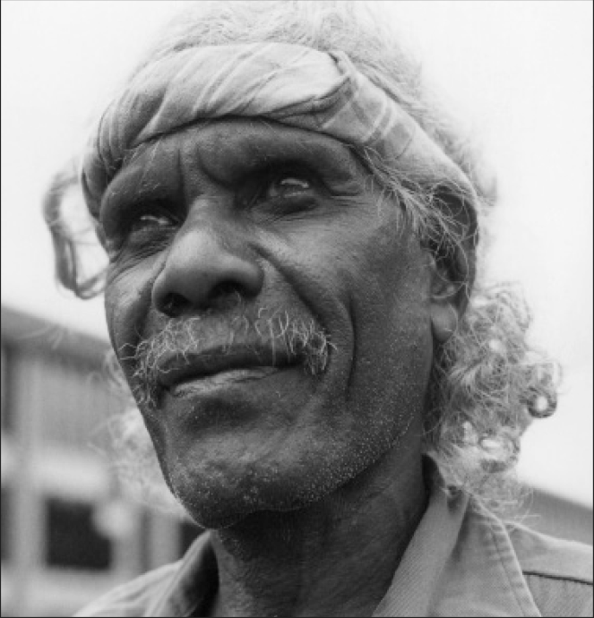
(circa 1943-2012) another of Dhulutarama’s sons, took over as leader after Dhulutarama died. Initially Tom was tough on Neville, taciturn and reserved about sharing tribal lore with an outsider. Slowly however, trust and respect grew into a strong friendship between the two men. Tom knew absolutely everything about the bush from travelling with his family as a young man, living as a nomad. He was fiercely protective of his culture and passionate about passing on the knowledge to the younger generation. However, he came to accept that the children needed to be educated ‘both ways’ and so he pushed for a school to be built in Donydji in 2003. He wanted the children to learn about the outside world in the protected environment of Donydji; Western schooling while learning about their own culture and language on their own land in their own community. When he died in 2012, he was such a respected leader, one hundred and fifty people from all over East Arnhem Land attended his funeral which took ten days.

JOANNE YINDIRI GUYULA
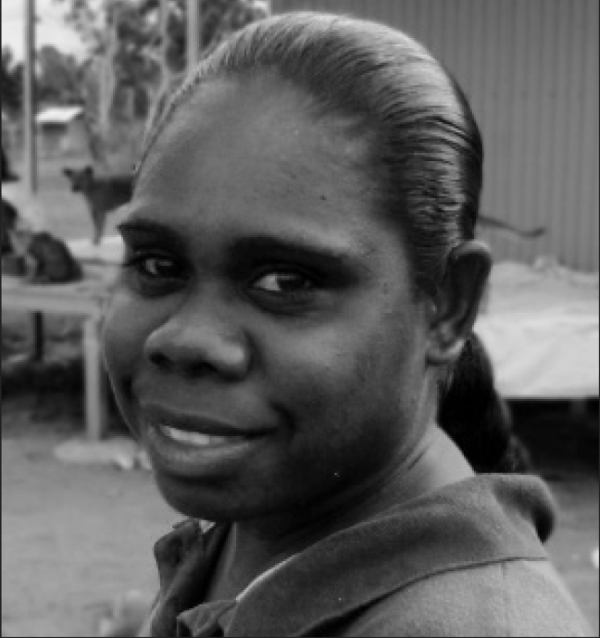
Dhulutarama’s grand-daughter only began to speak fluent English when she moved from the Mirringadja Homeland to Donydji when she was twelve. She was keen to learn and helped out at the school after she graduated from primary school. With ambitions to be a teacher, she trained as an Assistant Teacher and worked at the Donydji school for six years. In 2012 she recieved a government bursary to begin teacher training at Charles Darwin University. Attending University proved difficult because she was not given enough support. She struggled with Year 12 Maths that she was required to pass. When she lost her university accommodation during the holidays, she struggled to find a place to live in Darwin. After one and a half years of study she gave up and returned to Donydji where she continues to work as an Assistant Teacher. Joanne is a skilled weaver and is setting up a co-operative to sell woven artifacts via the Internet. She has not lost her ambition to complete her teaching degree.

DAVID GLYDE
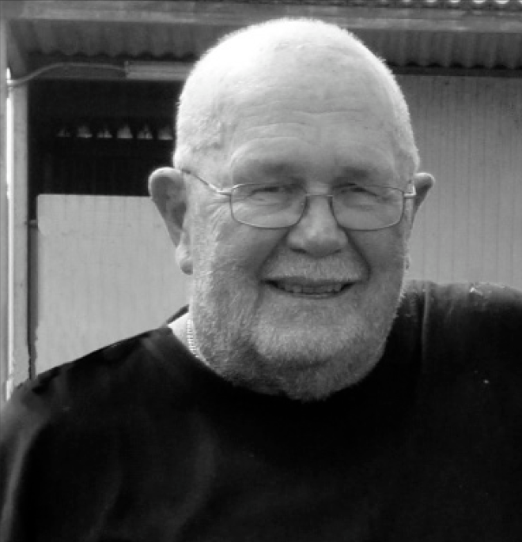
grew up in northern NSW, went to school in Brisbane, then worked in a bank. He first met Neville in 1966 at the Enoggera Barracks after they were conscripted to fight in Vietnam. They became close friends serving together on the front line in Nui Dat. After Vietnam, David returned to banking and then worked in insurance for more than twenty years. His love of rugby drove him to become a coach, first at the Brisbane State School and then at the Queensland University Rugby Club where he trained fifteen hundred young men over twenty-three years. Some have gone on to play for Australia, England and Ireland. David made his first trip to Donydji to help with community work in 2004. He returned virtually every year until 2018 when he decided his body was telling him to call it quits. He says of himself: “I’m not a born again black fellow but Donydji has been a great thing to happen to me. To be with Nev and the other blokes has been a dream come true.”

HOMELAND STORY CREW

Writer, Director Glenda Hambly

Executive Producers Rotary Club Of Melbourne Inc.

The Baker Foundation

Producers Glenda Hambly, Damien Guyula, Ken Sallows, David Rapsey

Cinematographers Moira Moss, Brian McKenzie, Dr Neville White AM, Glenda Hambly

Sound Recordist Craig Carter

Composer David Bridie

Sound Editor Livia Ruzic

Audio Mixer Neil McGrath

Colourist Charlie Ellis

Translators Damien Guyula, Dr Neville White AM

Script Consultant Anna Grieve

ABOUT THE FILMMAKERS

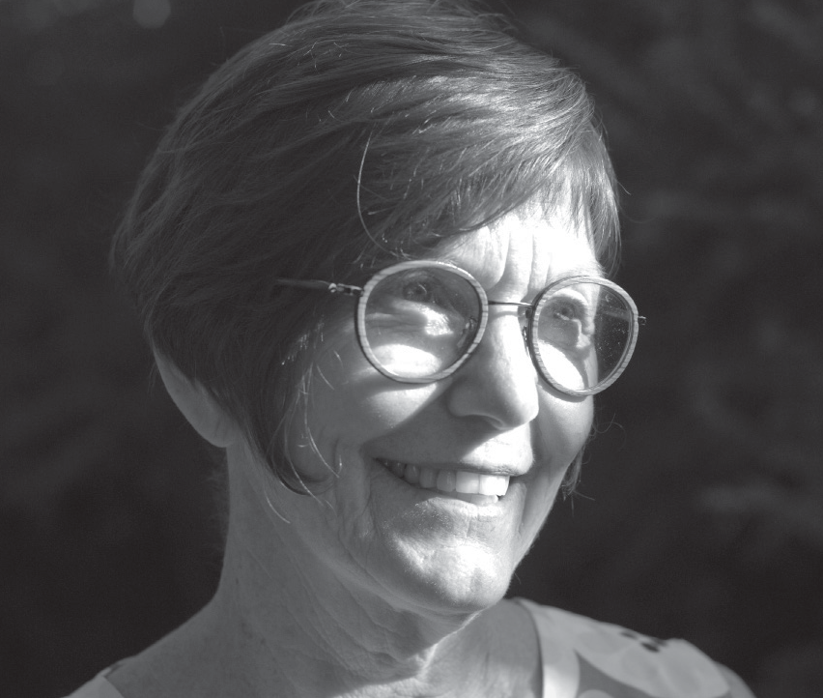
GLENDA HAMBLY - WRITER/DIRECTOR/ PRODUCER
Glenda has written and directed two features, Fran and Waiting at the Royal, winning awards for both and produced two others, The Legend Maker, which premiered at the Melbourne International Festival in 2014 and Homeland Story. She has developed, written and edited for fifteen television series, directed a children’s series and worked as a development executive for the Australian Film Commission and Screen West. She lectures in screenwriting and has a PhD in Screen Studies.

DAMIEN GUYULA - PRODUCER
Damien is Donydji’s representative on the film and therefore responsible for approving it on behalf of the community. In 2016 he travelled to Melbourne to translate the Yolngu languages used in the film and supervise the English sub-title translations. In 2017 he recorded the narration in Gapuwiyak and Darwin and in 2018 returned to Melbourne to record the opening and closing sequences of the film where he appears on screen in the State Library of Victoria. Damien has worked as a School Attendance Supervisor,
a High School Tutor and Cultural Advisor, an Interpreter and a Police Liaison Officer. He is currently a Police Constable in Yarallin, 400k’s south of Katherine in the Northern Territory.

KEN SALLOWS ASE - PRODUCER and EDITOR
During a career, spanning forty years, Ken has edited films in America and France as well as Australia. He has edited numerous documentaries (Gurrumul, From Under the Rubble, Ben Lee: Catch My Disease), television series (Seven Types of Ambiguity, 8MMM Aboriginal Radio) and some thirty plus feature films. He has been nominated for eleven AFI/AACTA Awards, as a producer, sound editor and picture editor. His feature credits and awards include Malcolm, Proof, Chopper, Gettin’ Square and The Combination. In 2000 as a tribute to his work and contribution to the film industry, Ken was presented with an Honorary Life Membership from the Australian Screen Editors Guild.

DAVID RAPSEY - PRODUCER
David has worked in film and television as a producer, writer and director in both Canada and Australia for over forty five years. He produced three award winning features Blackfellas, Fran and Lake Mungo, originated, produced and story edited TV series including Ship to Shore and Haydaze and story produced numerous TV series and mini-series. As Head of Development at Barron Entertainment for five years he was responsible for the development of multiple features, mini-series and telemovies. David has taught screenwriting at VCA, AFTRS and RMIT where he held the post of Adjunct

Professor from 2003-2006. He has worked as a development executive at Film Victoria and a development consultant to the New Zealand Film Commission.

BRIAN McKENZIE - CINEMATOGRAPHER
Since the 1980s, Brian’s documentary and drama work has screened in cinemas, on ABC, SBS and European television and at many international festivals. He specializes in a pure observational style and the drama of ordinary life. As an executive producer at the ABC between 1996 and 2004, Brian oversaw more than 60 hours of broadcast television in various documentary formats including breakthrough programs such as The Bush Mechanics series, Wedding in Ramallah and Stranger Than Fiction. In 2008 McKenzie won the Australian Directors Guild Award for Love’s Harvest, a 4-part series about organic farmers.

MOIRA MOSS - CINEMATOGRAPHER
Moira Moss is a film director with qualifications as a cinematographer and lawyer. Moira’s prime time drama directing credits include two episodes of the 13 hour series RAW FM for the ABC and the four hour mini-series Queen Cat Carmel and St Jude, also for the ABC. Her children’s series directing credits include numerous episodes on the AFI award winning children’s series Eugenie Sandler and Shortcuts for the ABC and Channel 7. Moira has worked as a DOP for Robert Connelly (Mr Ikegami) Rowan Woods (Tran The Man) and Daniel Nettheim (Beat Manifesto). Moira is the director of Go Girl Films Pty which is involved in the development of children’s drama for TV and cinema.

CRAIG CARTER - SOUND RECORDIST
Craig was one Australia’s leading sound designers, editors and recordists. He worked on more than a hundred productions in a career spanning thirty five years and he received many awards for his work both in Australia and overseas. Recent TV projects included Glitch, Barracuda, The Slap and Cloudstreet. Killer Elite, Rabbit Proof Fence, Kenny, Rogue, Homesong Stories and Forbidden Lies were among his many features. He also lectured to undergraduate and post graduate film students. Craig died suddenly in June 2018 and was widely mourned by the film community.

DAVID BRIDIE - COMPOSER
Across six studio albums with Not Drowning, Waving, seven more with beloved group My Friend the Chocolate Cake, innumerable film and television soundtracks as well as five solo albums, the ARIA award winning artist David Bridie has staked a claim as one of Australia’s most prolific and respected songwriters and composers. He has scored over 100 films, television series and documentaries, including The Man Who Sued God, Putuparri and the Rainmakers, Satellite Boy and Wolves. He was awarded the AFI award for Best Original Music Score for In A Savage Land.

