BLOWN AWAY
Feature documentary

PRESS KIT

A Brindle Films
and
Nirvana Films
Production
2014

CONTENTS

Synopsis (Short) ............................................................. | 3
Synopsis (Long) .............................................................. | 3
EPG Program Description ............................................... | 4
Background Information & ‘Making Of’ Notes .................. | 5
Director’s Statement ........................................................  Animator’s Statement ………………………………………  Controversial Elements …………………………………… | 7  8  10
Biographies – Talent ....................................................... | 12
Biographies – Crew ......................................................... | 23
Key Bibliographic References ......................................... | 28
Historical Notes ............................................................... | 29
Indigenous Cultural Protocol ........................................... | 37
Credit Lines ..................................................................... | 37
Logos ………………………………………………………..  Contact Details …………................................................. | 38  39

SYNOPSIS (ONE LINE)
Cyclone Tracy 40 years on, exploring the myths and revealing new perspectives on one of the worst natural disasters in Australia's history.

SYNOPSIS (PARAGRAPH)
Cyclone Tracy was one of the worst natural disasters in Australia's history, virtually wiping the city of Darwin from the map. Now 40 years later, previously untold stories reveal compelling new perspectives on the devastating storm, the controversial mass evacuation and the troubled reconstruction, investigating the socio-political effects on Darwin and its residents. Extraordinary archival footage, immersive animation and in-depth interviews tell a powerful story revealing the legacy and myths of Cyclone Tracy including the coming of age of Darwin, the heroism of Darwinians, and the politicisation of the rebuild. The failure of most official records of the disaster to mention Indigenous people is addressed with stories from Aboriginal people who lived through the storm, and accounts of traditional Aboriginal beliefs that explain the Cyclone and resulting devastation from a cultural standpoint.

SYPNOSIS (ONE PAGE)

On Christmas Eve 1974, Cyclone Tracy devastated Darwin. Tracy is one of the worst natural disasters to strike Australia, and the subsequent evacuation of most of the cities population was an extraordinary and highly contentious military-style operation that is unparalleled in our history.
Now, 40 years later, many of the myths about the disaster and its aftermath can be examined, and stories that have gone untold, including those of Aboriginal people, can be revealed. Is it true that many traditional Aboriginal people left Darwin before the cyclone hit or was this just a convenient rumour that saw authorities dodge their duty of care to Aboriginal people?

Were lax building standards responsible for the city’s destruction? Was pre-cyclone Darwin a real city or just ‘an outpost of Empire at the end of the road’? Did the Mayor really sleep through it all? And at dawn did he really don his pith helmet, pick up his rifle and traverse the ruined city shooting dogs? Did General Alan Stretton really ban New Years Eve? And why has Cyclone Tracy become so ingrained in the Australian national identity?

With flamboyant and legendary characters instrumental to the events, including Aunty Kathy Mills, Dr. Ella Stack, General Alan Stretton, Mayor Tiger Brennan and Prime Minister Gough Whitlam, Blown Away is a story full of drama and tragedy, heroism and bloody-minded stupidity, told by the people who were there.

The post-cyclone rebuilding of Darwin is a story full of conflict and controversy, but despite the bungling, Darwin was eventually reborn as a vibrant multi-cultural city that today is a warts-and-all icon of Australian identity.

Blown Away is based on in-depth eyewitness interviews, immersive animation, and extensive archival material including extraordinary newsreel and stunning photographs, intensified by an evocative musical score.

EPG PROGRAM DESCRIPTION
Cyclone Tracy 40 years on, exploring the myths and revealing new perspectives on one of the worst natural disasters in Australia's history.

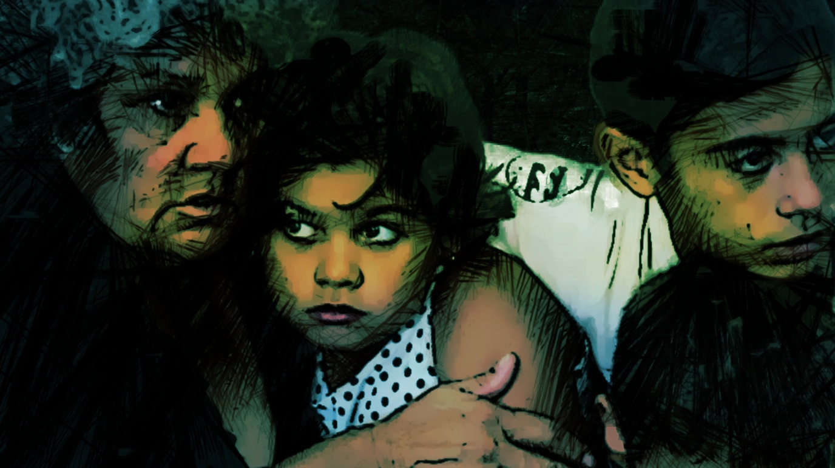

BACKGROUND INFORMATION & ‘MAKING OF’ NOTES

MEMORY, RUMOURS AND THE ‘TRUTH’.
“People have an annoying habit of remembering things they shouldn't.”
― Christopher Paolini, Eragon

BLOWN AWAY tells the story of Cyclone Tracy through the voices of people who were there in Darwin on Christmas Eve 1974 – those who lived through it or arrived soon after.

BLOWN AWAY investigates the role of memory in history and is composed of diverse stories told from different points of view, which build a rich and complex mosaic portraying the terrifying onslaught of Cyclone Tracy and the tragedy, drama and heroism, as well as the some of the difficult decisions that followed.

The documentary explores many often-conflicting narratives including myths, rumours and conspiracy theories about Cyclone Tracy, and does not attempt to present a single ‘expert’ version of the facts. BLOWN AWAY leaves it to the audience to make up their own minds about the contentious and sometimes provocative aspects of the stories that are told and the evidence that is presented.

The ‘Making of’ BLOWN AWAY

The story of Cyclone Tracy is an anthemic Australian narrative. It is part of Australia’s core history and mythology, and provides a modern example of survival and heroism that is so engrained in Australian culture. But if you strip back the national pride that the story gives us, Cyclone Tracy is, above all else, a Northern Territory story. Like the bombing of Darwin, Peter Falconio and Azaria Chamberlin, Tracy is one of ours, and it is time that Australia reflects back on a monumental incident of Australian history with new eyes.

James Bradley and Rachel Clements started talking about making a documentary for the 40th anniversary of Cyclone Tracy in early 2013. In research and development, it became clear that there are untold stories, myths and legends of the storm, the evacuation, the rebuild and the changing socio/political face of Darwin after the event. Rachel and James became excited about the potential of a documentary that looks back on the cyclone after 40 years and challenges the history books.

In March 2013, we approached Danielle MacLean, a leading Aboriginal filmmaker based in Darwin, and she quickly agreed to come on board as writer/director. Coming from an Aboriginal ‘Top-End’ family, Danielle grew up hearing the stories from the survivors in her family. She brought the access to Darwin and it’s residents that was vital for the film. We were delighted to have Danielle on the team. For the first time, NT key-creatives have told the story of Tracy from an NT perspective. We did have a blow-in (James Bradley) but he has spent much of his career editing NT stories (Dhakiyarr vs the King, 5 Seasons, Mr Patterns, etc).
As a team, we were committed to celebrating the courage and resilience of the forgotten champions, and to create a program that would shine a light on the remote frontier town of Darwin in the early 1970s, before self-government. Indeed, many people believe that the rebuilding of Darwin after Tracy was the catalyst for the Territory to finally attain freedom from Canberra. There are generations of Australians who are unaware of the heroes from the tragedy. Everyone knows there was a cyclone; very few people know any of the personal stories of Darwinians who lived through the devastation.
We entered formal development with a Time Critical Development grant from Screen Australia in early September 2013. We travelled to Darwin, country Victoria and NSW, and Canberra to film interviews with some of the leading players in our story.
Their stories, experience and memories were strong and we knew we had found characters who could put add human element to the natural disaster.

We entered official production in May 2014, and we interviewed 35 people during the course of principal photography. There are many people who want to tell their story about Tracy, particularly those who were adults at the time and are now in their 60’/70’s, and we wanted to ensure that we had a diverse range of engaging characters.

We had to work with a large canvas – there are countless stories that could have been included, and numerous elements of the disaster and aftermath to contain. It was tricky and painful to choose the people who appear in the final film, and we carefully debated about which stories to include.

There are teams of fabulous filmmakers who have worked on Tracy’s story over the years, and we were lucky to have access to their archival footage. The now defunct Film Australia sent people to Darwin immediately after the storm, and ABC and other news channels were active in Darwin as soon as first light came up on Xmas Day 1974. We worked with wonderful researchers at the NFSA and ABC who have extensive collections from these filmmakers who provided a treasure trove of past work for us to delve into.
Through research, we were also able to source a collection of still images from a wide range of sources – from professional photographs in large collections, to photographers living in Darwin at the time of Tracy, and from private, family collections of survivors. Many of the photographs from Darwin based-based photographers and stills from personal/family collections have never been deposited in official archives, and we look forward to be able to lodge these in the National Film and Sound Archives as a means of preserving valuable heritage material in relation to Cyclone Tracy.
As there is no visual material available of the storm itself, we needed to find a device for telling that crucial part of Tracy’s story. The Cyclone hit at night and we had to look for ways to use the cover of darkness to hint at the scope and savagery of the storm. The stunning and emotive animation created by Darwin-based animator Melissa Huni Bolliger was a blessing. We were able to illustrate the incredible stories being told by our participants, including accounts of fridges and other whitegoods flying through the sky, and the beautiful images of birds leaving Darwin. We hope that Huni’s work on BLOWN AWAY will bring recognition to a small but passionate sector within the NT film and television community.

DIRECTOR’S STATEMENT
by Danielle MacLean
When I commenced work on Blown Away I was well aware that Cyclone Tracy was part of the fabric of Darwin; growing up I heard many frightening stories about its fury, but it was never real to me because I was fortunate enough to be away on Christmas holidays when it struck. The devastation that lay in Tracy’s wake kept my family away for two years.
On returning to Darwin we lived like many other families at the time under one of the so-called ‘dance floors’. Our house consisted of a concrete slab, an open air lounge room and a makeshift kitchen. At one end of the slab was one small room where we all slept. “Elton John”, the stray cat who was born under the fridge, would become a childhood pet and, looking back, a symbol of life returning to Darwin.
As a first step to make this film we needed to record first hand accounts of what it was like to experience Cyclone Tracy. We filmed over forty interviews with people who made up the town’s population - including police officers, doctors, lawyers and the lord mayor. It was just as important to record the voices of Larrakia people, the traditional owners of the Darwin area, and other Indigenous people whose stories had mainly gone untold. We also interviewed people who were children during Tracy as we were interested to see how this ordeal had shaped their lives.
It was these stories plus archival photographs and footage that was shot in the subsequent hours and days following the destruction that became the skeleton of the film.
But it was apparent that this material could not fully illustrate the night that Cyclone Tracy hit, as there are no film or video recordings of the actual cyclone. Therefore we brought local animator Huni Bolliger onto the team to help re-imagine what it was like during those long hours when Cyclone Tracy mauled at the city of Darwin like a ferocious beast wreaking havoc on anything that stood in her way.
The idea was that these animations would place the audience with our characters in the cyclone and give insight into what it was like to be in Darwin on that fateful night of December 24th 1974.
We worked with film composer Caitlin Yeo who wrote a haunting musical soundscape echoing the life of Cyclone Tracy and heightening the drama that unfolded that night and in the days the followed.
Cyclone Tracy changed Darwin, some may argue for the better, while others long for the Darwin of old. The landscape changed, people were evacuated, some never returned and new people came to town. Larrakia people remained here on their traditional lands and continue to fight to for the right to speak for their country.
Blown Away is as much a story about Darwin as a place and the people who make it that way as it is about Cyclone Tracy. It highlights how the natural environment is much more powerful and in control than humans like to believe.
As author Sophie Cunningham so eloquently puts it, Cyclone Tracy wasn’t a bitch, she was a warning, and we should listen.
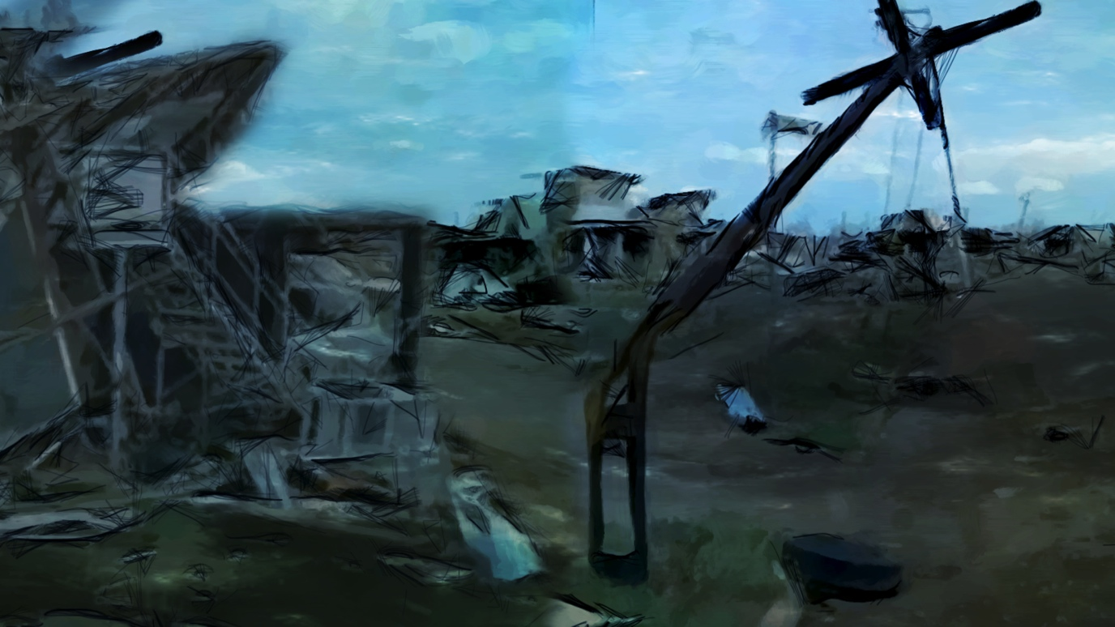

ANIMATOR STATEMENT
by Melissa Huni Bolliger
As a Darwin based animator I was thrilled to have the opportunity to work on a documentary that explored the history of the town that I love so much. I’d always been interested in Cyclone Tracy, knowing that it’s such an important part of Darwin identity.
It’s not very often that you see the genres of animation and documentary mixed together but I think that they can be highly complimentary. Blown Away posed many challenges and unique opportunities in this way.
One of the most interesting challenges for me was exploring the intersection between historical fact, memory, and imagination. Memories, and especially traumatic memories, are often extremely vivid in the minds of those who have experienced the event. In designing the animations, I wanted to create a dreamlike, surreal and sometimes nightmarish mood to reflect this idea. The challenge lay in treading the fine line between representing historical facts and at the same time, creatively re-imagining them within an artistic framework. If the team ever questioned whether I had gone too far in the artistic direction I would usually point towards the artistic license hanging above my computer. Often this just induced raised eyebrows but sometimes it would help me get my own way.
In terms of my process, I generally approach animation as an artist rather than a technician, perhaps this is because of my art teaching background. I look at the works of classical artists for inspiration, studying the colour and texture palettes that I think will suit the stories. I create mood boards and experiment with different looks and feels until I find a style that feels right. I often work with real paint, pencils, inks and collage to create a set of visual tools that I then interpret into digital form.
Rhythm and movement are a very important part of animation so I looked at a lot of contemporary video footage of cyclones and hurricanes to try and get a sense of how objects and nature are moved by such high-powered winds. I was surprised to find that although the winds are quite violent, the flying objects inside them often take on a lyrical rhythm and look like they have a life of their own. Using these movements helped add to the dream like quality of my style. My process also included detailed study of archival photographs of Darwin in the aftermath in order to achieve a realistic sense of the devastation that the storm caused.
Working with an amazing team of award winning filmmakers has been a great experience for me and the whole process has given me the chance to stretch myself in new creative directions.

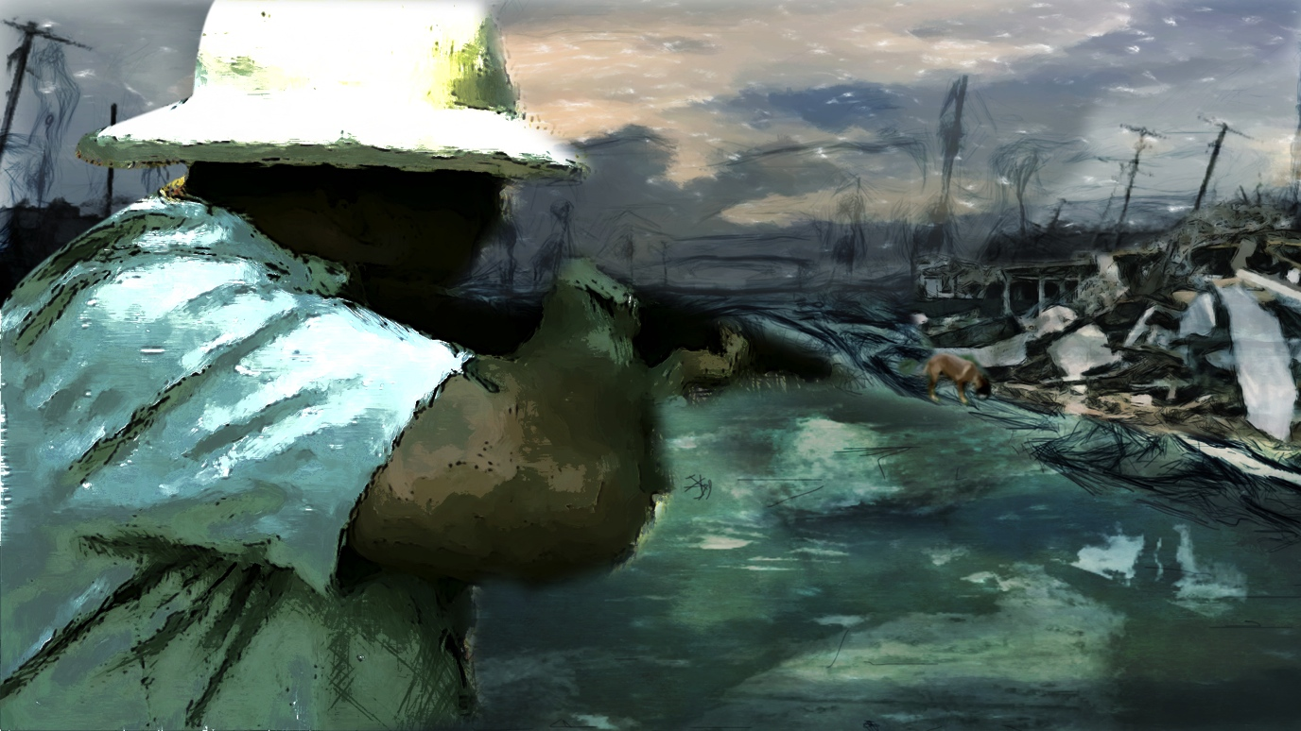
CONTROVERSIAL?
What are the controversial elements in BLOWN AWAY?
1. Did Nungalinya (Old Man Rock) cause Cyclone Tracy to hit Darwin?
Larrakia participants in Blown Away express the belief that Cyclone Tracy was deliberately caused by Nungalinya (Old Man Rock) because Larrakia claims to Land Rights were being ignored (and sacred sites were being used as targets for bombing practise).
Many non-Aboriginal people who survived Cyclone Tracy may find the implications of blame for a natural weather event at best unhelpful and possibly even offensive, particularly if they lost loved ones in the Cyclone.
2. Outpost of Empire?
Early in Blown Away, Tony Powell makes the provocative statement that Darwin was ‘an outpost of Empire and it really had no reason for its existence other than it was an important defense facility because of the airport’. Many pre Cyclone Tracy residents of Darwin would strongly disagree with this statement, as they believe Darwin was already an important regional city in 1974, serving the vast rural and pastoral industries of the Northern Territory.
3. Tiger Shoots Dogs – doesn’t he?
Whether Mayor Tiger Brennan ‘grabbed his rifle and a pistol, and went around Darwin, shooting dogs’ is a question raised in Blown Away, with Kevin Mulcahy and Dr. Ella Stack having different opinions. Several newspaper articles of the time do refer to Tiger Brennan shooting dogs, including an article headlined ‘A Tiger for punishment’ published in The Age on December 31 1974. – ‘Tiger Brennan, mayor of Darwin, had finished shooting dogs this day…’ and ‘Today, still thinking of tomorrow, Tiger Brennan is probably out again combing every wreck and shooting dogs.’
4. Shoddy buildings?
Several people state that many of the houses in Darwin were shoddily built. Bill Wilson says ‘It was alleged that a lot of them hadn't been finished properly. Things like straps that should have been on, were supposedly not on, and nails were missing’.
Most of the ‘upstairs’ buildings that were severely damaged had been built under Government contracts, and Kevin Mulcahy believes that the Government had not enforced building standards and so this was ‘a classic case for a class action of people against the government’.
The Death Toll?
Statements by Sean Kennedy and Kevin Mulcahy questioning the official death toll of 71 and suggesting that there may have been bodies collected in the rubble and dumped at Lee Point Swamp, may cause offense to some viewers. Mention of mass graves and numbers of people missing or unaccounted for after Tracy may also be controversial, as it may reinforce conspiracy theories of an official cover-up of the actual death toll.

4. Was Darwin an ‘open slate’ for planners from Canberra?
Discussion of the Reconstruction and the battle of wills between the ‘blow-ins’ from Canberra and the staunch locals may be controversial, depending on which side of the argument viewers support. Tony Powell makes the quite provocative statement that when he arrived to take control of the Reconstruction Commission, Darwin didn’t really exist – “There was nothing there!”
5. Did Traditional Aboriginal people leave town before the cyclone?
There seems to be a belief among many non-Aboriginal people that all the traditional Aboriginal people knew via certain signs in nature that a cyclone was coming and therefore left Darwin and walked inland to escape. This is not supported by the evidence, and author Sophie Cunningham controversially suggests this was a convenient rumour at the time because it was used as an excuse by the authorities to avoid their duty of care for traditional Aboriginal people.
7. Should Aboriginal land in Darwin be developed?
Cyclone Tracy put a temporary halt to Larrakia land rights claims over parts of Darwin including One Mile Dam, Kulaluk and Knuckey Lagoon and raised questions about the future of the Bagot Reserve, but in the late 70s these areas were granted to Aboriginal people as places they would be able to ‘stay permanently, without fear of eviction’ (Minister Marshall Perron 1979).
Today these areas are targeted for development by the incorporated bodies who have title over them, much to the consternation of other Larrakia groups in Darwin. The debate over the future of these substantial parcels of land within Darwin is referred to by Bill Day and Eric Fejo towards the end of Blown Away.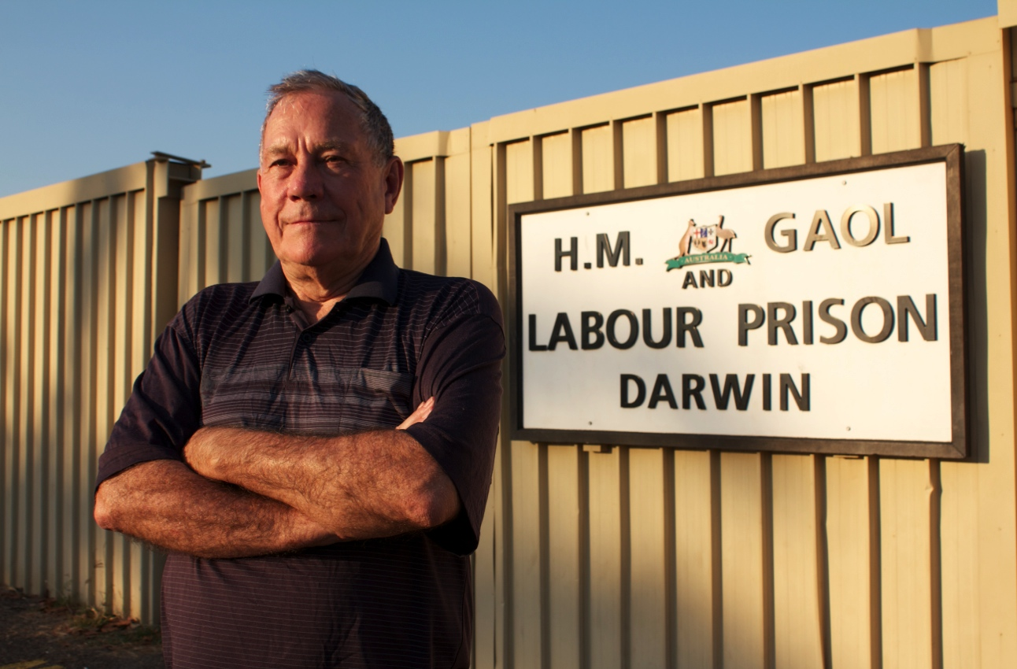

Bill Day at the old Fannie Bay Gaol
BIOGRAPHIES – TALENT (in order of appearance)

INTERVIEWEES INCLUDED IN THE FILM
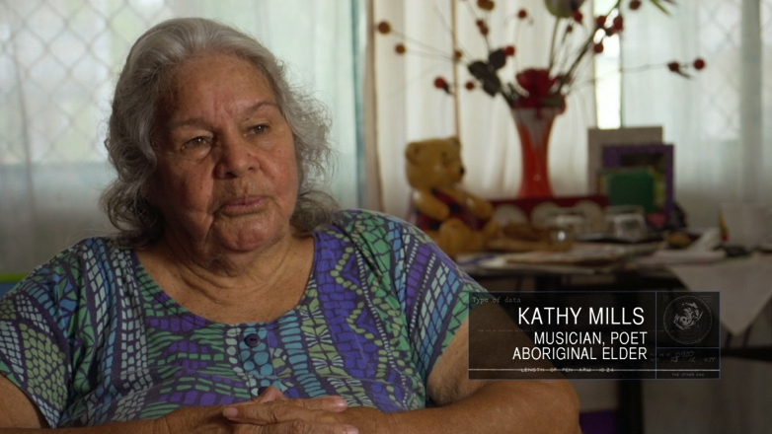
KATHY MILLS
Aunty Kathy Mills is an Aboriginal poet, musician and singer, a mother of eight, grandmother of twenty eight and aunty to many. Her daughters are the well known singers – the Mills Sisters. Kathy has won many awards and was the first woman to be a member of the Northern Land Council. She wrote the song “Arafura Pearl” which features in Blown Away.
Kathy and her family survived Cyclone Tracy crammed into a small storeroom under their house.

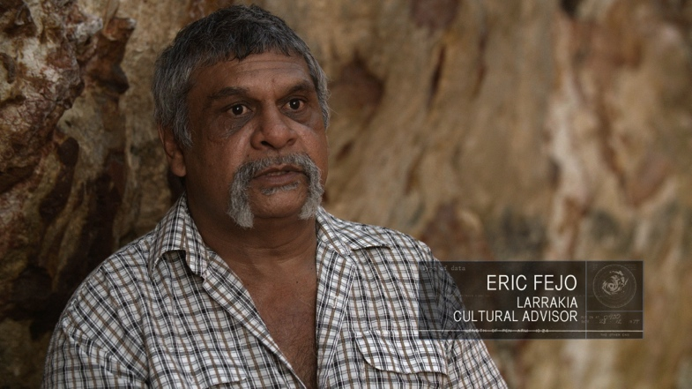
ERIC FEJO
Eric Fejo is a Larrakia Man who has worked as a custodian for Larrakia sacred sites with the Aboriginal Areas Protection Authority for many years. He is passionate about protecting and passing on knowledge about his country and is proud that he has never lived more than 20 miles away from where he was born.
Eric was only 10 years old during Cyclone Tracy and spent the night huddled up with his family in a room with a candle and kerosene lantern. He remembers when he went outside the following morning, it was like something you’d see in a war movie.

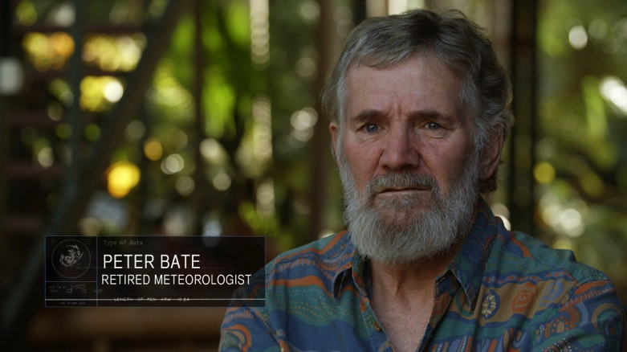
PETER BATE
Peter Bate was a Meteorologist at the Darwin Bureau of Meteorology from 1974 to 2003. He and his wife Helen lived through Cyclone Tracy in their then home in Alawa, which was damaged by the cyclone. Peter currently conducts regular tours of the Cyclone Tracy exhibit at the Museum and Art Gallery of the Northern Territory.

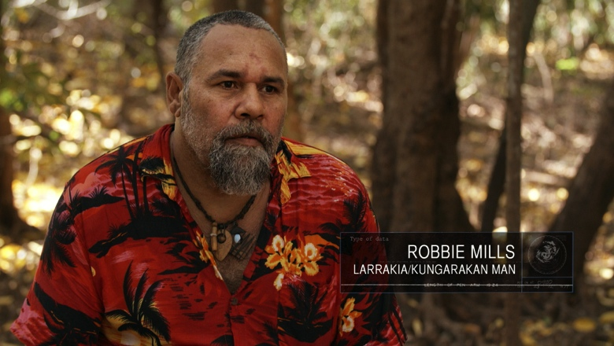
ROBBIE MILLS
Patj Patj Robbie Mills is a Larrakia/ Kungarakan Man, a professional musician and the owner operator of Batji Tours which was created to share his passion for all his family’s heritage and cultures, history and knowledge. Robbie spent the night of Cyclone Tracy in a storeroom under his house with his parents, 7 siblings, a dog and 3 cats.

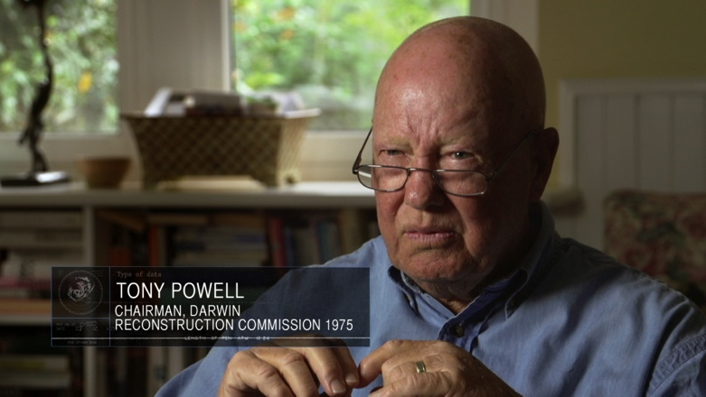
TONY POWELL
Tony Powell AO is a town planner and civil engineer who commenced his professional career in 1958 as a dam-site construction engineer with the Snowy Mountains Hydro-Electric Authority. He retired from private practice 58 years later on his 80th birthday in March this year. He has held five chief executive positions in that time spanning both public and private enterprise corporations, one of which was the Darwin Reconstruction Commission as its inaugural chairman and chief executive in 1975. At the same time he was also The Commissioner of the National Capital Development Commission based in Canberra and made extensive use of the Commission's staff in the setting up of the Darwin reconstruction program following the devastation of the city by Cyclone Tracy.

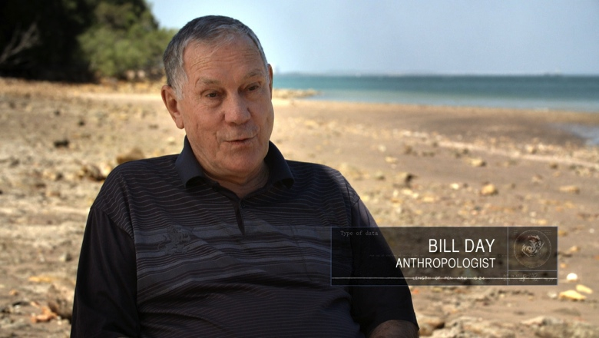
BILL DAY
Dr. Bill Day hitch-hiked north from Perth in 1969, looking for answers amongst the hippies on Darwin's Lameroo Beach. Instead, he took up the cause of the local Larrakia people living in camps on vacant Crown land in the suburbs of Darwin. For thirteen years he documented the Larrakia struggle for land rights in the Aboriginal rights newsletter Bunji.
The campaign took its toll on his family life and in 1989 Bill returned to Perth alone. In 1994, Aboriginal Studies Press published Bill's account of his Darwin experiences in his book, Bunji: a story of the Gwalwa Daraniki Movement. He returned to Darwin in 1996 to conduct fieldwork amongst the local 'long grass' people for his PhD thesis, ‘Fringe dwellers in Darwin: Cultural continuities or a culture of resistance?’ His graduation in 2001 began a new episode in his continuing involvement with the Aboriginal people of Darwin.

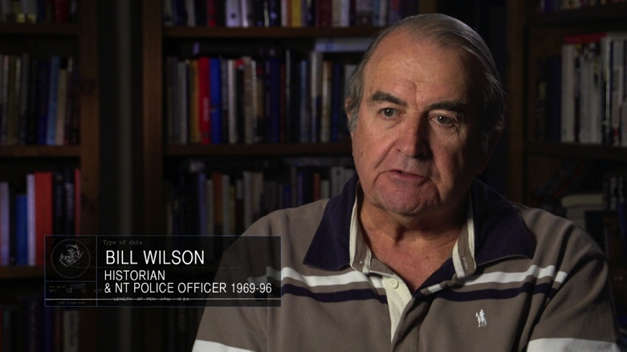
BILL WILSON
Dr. Bill Wilson APM OAM spent almost 40 years in the Northern Territory. He joined the Northern Territory Police in 1969 and served throughout the Territory before retiring with the rank of Assistant Commissioner in 1996. Following retirement he undertook a PhD in history at the Northern Territory University and lectured there in history and politics before taking up a role in the Support and Equity Division of the University. Bill has been awarded the Australian Police Medal and the Medal of the Order of Australia.
During Cyclone Tracy, Bill was a Sergeant in the Recruit Training Centre, lost his house and undertook a wide range of tasks prior to transferring to Adelaide for two years to continue training NT Police recruits there. He now lives with his wife Patricia in Beechworth, Victoria.

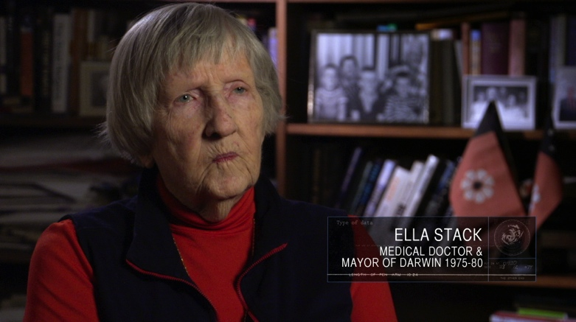
ELLA STACK
Dr. Ella Stack CBE and her family moved to Darwin in 1961 and she was soon one of only two private practitioners in Darwin. After Cyclone Tracy she chose to stay and provide medical support and to help with the reconstruction of the city.
In May 1975 she was elected the first woman Mayor of Darwin and became a member of the Darwin Reconstruction Commission. With self-government in 1979, Dr. Stack became Lord Mayor of Darwin. Later she became first Assistant Secretary of the Division of Aboriginal Health and then Secretary of the Department of Health of the Northern Territory.

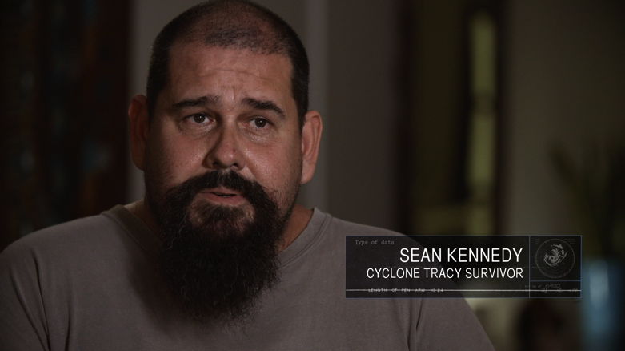
SEAN KENNEDY
Sean Kennedy was born in the old Darwin Hospital in 1971, the youngest of 7 children. His family survived Cyclone Tracy in their home in Anula, which was severely damaged. On the 31st of December 1974, Sean was evacuated with his mother and 5 siblings to Wagga Wagga, but his father and 2 oldest brothers stayed in Darwin for the cleanup. Sean always wanted to return home to Darwin and finally did so in 1994 when he was 23, and it has been his home ever since.

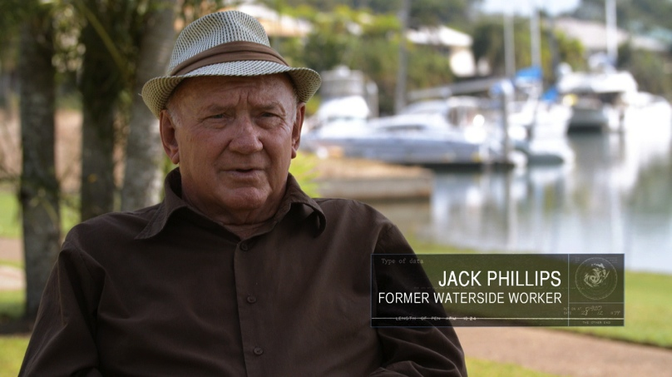
JACK PHILLIPS
Jack was a Waterside Worker at the Port of Darwin and a Union Official. He is also a passionate Aboriginal Rights Activist and fought for Gurindji and Larrakia peoples’ land rights claims.
On the day Cyclone Tracy struck Jack was told that all the boats had to leave Stokes Hill wharf. He let the mooring lines go for many boats which then tried to ride out the cyclone in the harbour or out at sea. Tragically, most of them didn’t return. Jack worked for many months in the clean up of Darwin after Cyclone Tracy.

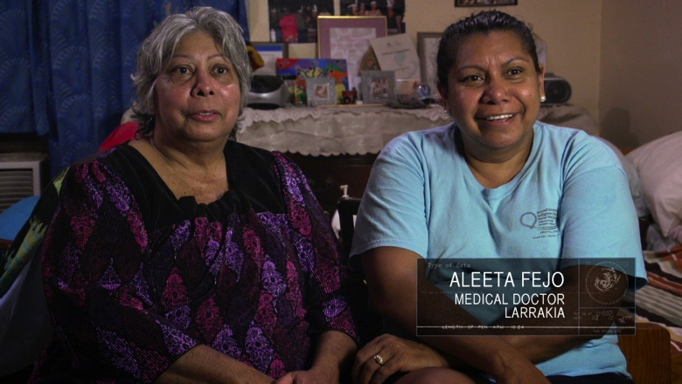
ALEETA FEJO ELLIOTT
Dr. Aleeta Fejo Elliott is married, has three children, a foster son and one granddaughter. Aleeta lives in Humpty Doo.
She is a Medical Practitoner. The NT’s first Aboriginal GP. She is passionate about improving Indigenous Health and has worked throughout Australia and especially the Top End as a GP and teacher of Indigenous Medical Students and GP Registrars.

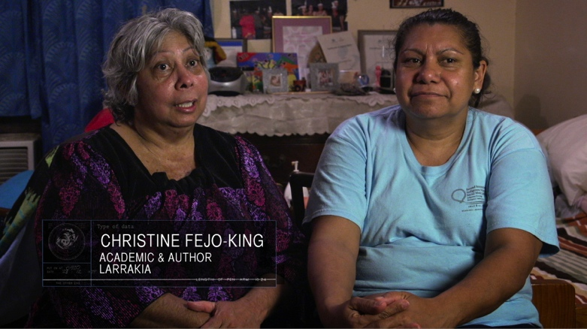
CHRISTINE FEJO-KING
Christine Fejo-King is married with three children. The oldest Jessica is completing her final year as a medical student at the ANU and will be the first Indigenous graduate from that medical school. Her second child, Kathleen has Downs Syndrome and needs a lot of care and is the centre of the family. Son Jad has a Sociology degree and recently married.
Christine is a social worker, completed a PhD in 2011, converted it to a book in 2011 and is currently the project manager leading the work on the 3rd International Indigenous Social Work Conference which will happen in Darwin in September, 2015.

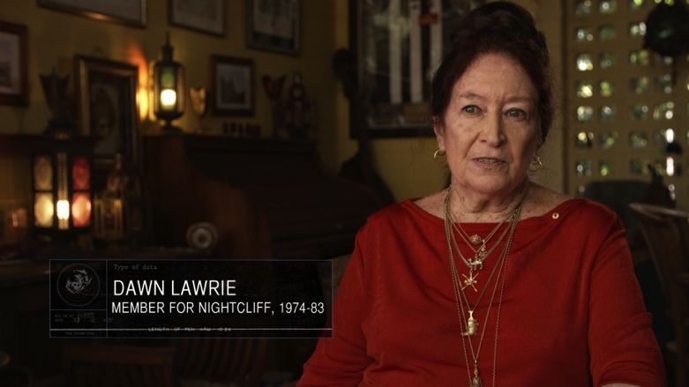
DAWN LAWRIE
Dawn Lawrie first arrived in the Territory about 1960, first living in Alice Springs and then moving to Darwin. She worked both for the government and for a private doctor, then married and had three children. In 1971 she stood as an Independent in the Darwin electorate of Nightcliff and won the seat, the second woman in Territory history to be elected to Parliament. She won again in October 1974 when she was elected to the Territory's first fully-elected Legislative Assembly.
She experienced Cyclone Tracy along with her family at their home in Nightcliff and in the aftermath took a leading role in protecting the rights of Darwin citizens. She championed many issues during her parliamentary career, including heritage matters, vagrancy and abortion reform. Dawn was re-elected in 1977 and 1980 but lost her seat in 1983. After a spell of running her own newspaper, she went on to become NT Human Rights Commissioner and later NT Anti-Discrimination Commissioner.
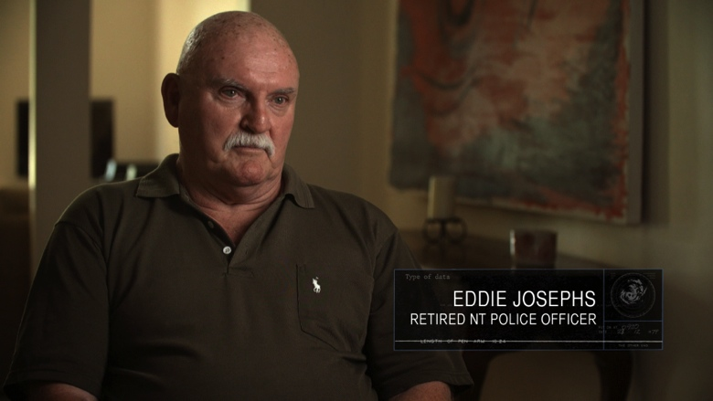
EDDIE JOSEPHS
Eddie Josephs is a Vietnam Veteran and was a member of the Northern Territory Police Force from 1969 to 2000. Eddie served mainly in General Duties and was promoted to Senior Constable, Sergeant, then Senior Sergeant, serving in Darwin, Adelaide River, Katherine, Borroloola, Harts Range, Hooker Creek (Lajimanu), Nhulunbuy and Groote Eylandt. After over 31 years as an NT Police Officer, Eddie retired in November 2000, and now lives in Darwin where he does voluntary work for the Darwin RSL as an advocate for service people in their dealings with Veterans’ Affairs.
Eddie survived Cyclone Tracy crammed into the hallway of a house in Nakara with 7 other people as the house was torn apart around them. In the days after Tracy, Eddie was involved in the search and rescue of people in the wreckage.

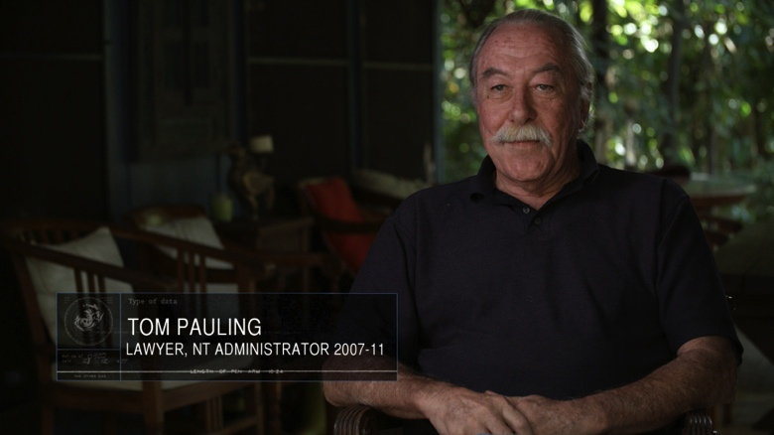
TOM PAULING
Tom Pauling AO QC has had a long career in both law and the performing arts since 1970, becoming Solicitor-General in 1988 and Administrator of the Northern Territory in 2007. He has appeared in or directed over 60 theatre productions in Darwin. His house in Leichhardt Crescent Fannie Bay, co-owned with his friend Terence Coulehan, was unroofed by Cyclone Tracy but otherwise stood up well. At the time of Cyclone Tracy, Tom was in the RAAF Reserves and to his surprise was called up to work at the airport and assist with the evacuation of 20,000 people.

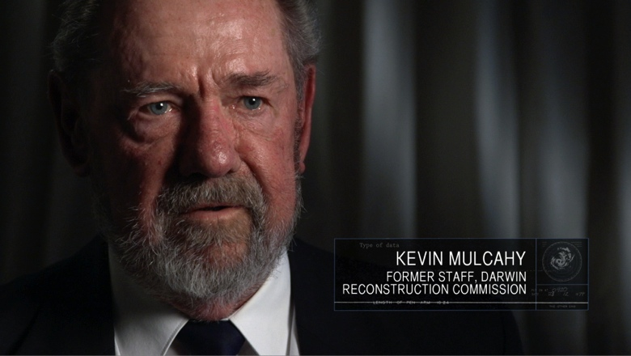
KEVIN MULCAHY
Kevin Mulcahy was born and bred in Canberra and spent most of his working life in the Commonwealth Public Service. He joined the National Capital Development Commission in 1970 and was a Senior Officer in the Finance area when he was sent to Darwin in March 1975.
Kevin was happy to be working on facilitating the reconstruction of Darwin, but was surprised to experience the aggressive attitude of some of the remaining locals towards those southerners who were trying to help them restore their lives. Kevin left the NCDC in 1978 to try life away from the bureaucracy but returned 3 years later as a consultant until the demise of the organization in 1988.

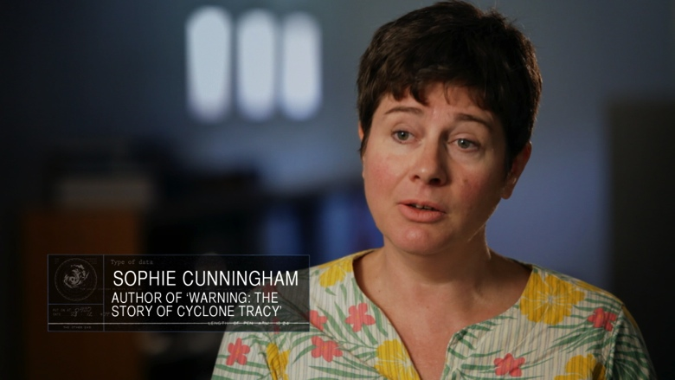
SOPHIE CUNNINGHAM
Sophie Cunningham has been on the publishing scene in Australia for thirty years. A former publisher and editor, she is the author of two novels, Geography (2004) and Bird (2008) and, as part of the New South City Series, wrote Melbourne (2011).
She is a former editor of Meanjin, and until recently was Chair of the Literature Board of the Australia Council. She is a founding member of The Stella Prize, a prize for Australian women's writing.
Her latest book Warning: The Story of Cyclone Tracy was published by Text Publishing in August 2014.
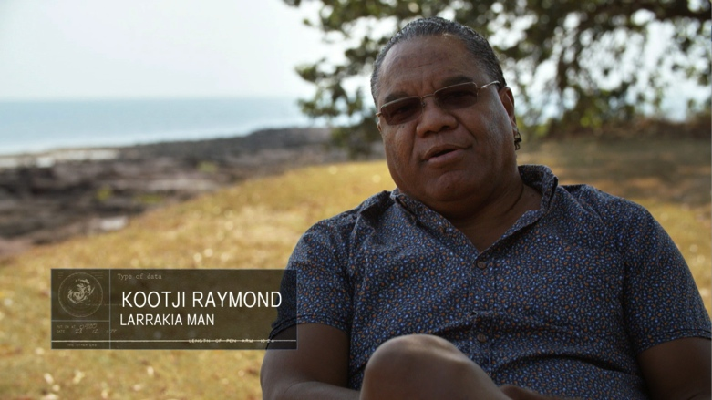
KOOTJI RAYMOND
Desmond “Kootji” Raymond is a Larrakia Man, and is owner/director of Bigapitja Pty Ltd which offers consultancy in the areas of art, business and culture.
Kootji has worked with filmmaker Paul Roberts to make a number of highly awarded films including Artists Up Front, Buffalo Legends and Land Of The Little Kings. He continues to paint and his art works have appeared in numerous exhibitions nationally. In 2003 he was awarded a Masters Degree in Fine Arts. Kootji has numerous production credits including Assistant Director on The Mary G Show and Director on Wrap Me Up In Paperbark among others.
Kootji spent the night of Cyclone Tracy with two women and their children huddled up against the wall with the double bed mattress over the top of them as protection.

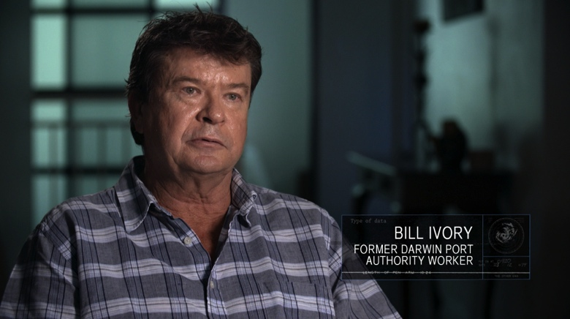
BILL IVORY
Bill was working as a Patrol Officer in Central Australia for the Department of Aboriginal Affairs when he received news that Cyclone Tracy had destroyed Darwin. Having grown up in Darwin he was keen to get back to his family and friends. He took two months leave and drove into Darwin but was quickly disorientated because all of the landmarks had been stripped away by the storm. He finally made it to his parents’ house and found his father mowing the lawn determined to get on with things. Bill got a job working for the Darwin Port authority on the rebuild of Darwin.

FEATURE VERSION ONLY
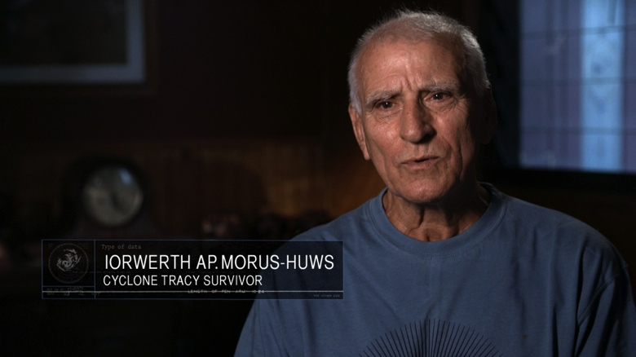
IORWERTH AP.MORUS-HUWS
Iorwerth Ap.Morus-Huws was born and grew up on Ynus Mon at the North Western tip of Wales. He emigrated to Australia when he was 21 and landed in Sydney where he lived for two years before travelling up to Darwin in an old 1950s small wheel base Land Rover with an old wooden 15ft caravan.
Iorwerth ran his own business, The Amaroo motel/cafe until it was very badly damaged by Cyclone Tracy – no more of the best hamburgers and steak sandwiches in Darwin. After Cyclone Tracy, he got a job as a ground steward with T.A.A. and worked there for just under 15 years before transferring to Australian Airlines and then Qantas. He then worked as purchasing manager for Gate Gourmet at Darwin Airport for 25 years before retiring.
FEATURE VERSION ONLY
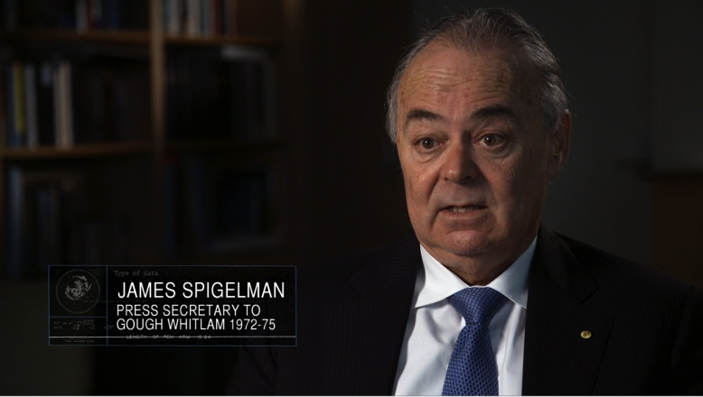
JAMES SPIGELMAN
James Spigelman AC QC is a former Australian judge. He served as Lieutenant Governor of New South Wales and Chief Justice of the Supreme Court of New South Wales from 1998 until 2011. He was appointed to the Court of Final Appeal of Hong Kong in 2013. James Spigelman is currently chairman of the Australian Broadcasting Corporation.
From 1972 to 1975, he served as Senior Advisor and Principal Private Secretary to the Prime Minister Gough Whitlam.

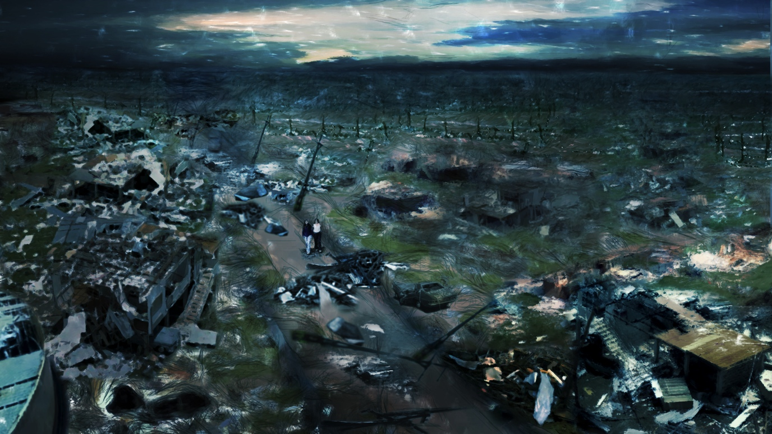

BIOGRAPHIES - CREW

Writer/Director Danielle MacLean
Producers Rachel Clements & James Bradley
Editor James Bradley
Animator Melissa Huni Bolliger
Director of Photography Tim Alewood
Sound Recordist David Tranter
Sound Designer Mike Gissing
Original Music Caitlin Yeo

DANIELLE MACLEAN – Writer/Director
Danielle MacLean is an Indigenous writer/director and producer from Darwin. Danielle worked at CAAMA Productions in Central Australia for over six years: first as a production assistant and then as a writer/director. She wrote and directed many CAAMA productions including the documentary For Who I Am: Bonita Mabo, and the short drama My Colour Your Kind which screened at numerous short film festivals (Telluride, Clermont-Ferrand and Oberhausen) and for which she was nominated for an AFI Award and a Film Critics of Australia Award.
Since leaving CAAMA Productions in 1999, Danielle has been a freelance writer/director. She wrote & directed the 50 minute drama Queen of Hearts for which she won the AFI for non-feature screenplay, she won an AWGIE Award for her writing on Double Trouble (a children’s drama series for Channel 9 and Disney Australasia), and also wrote an episode of the award winning Redfern Now.
Danielle wrote and produced the documentary Croker Island Exodus which screened in competition at the 2012 Sydney Film Festival, played at Melbourne Film Festival and was broadcast on the ABC.
In 2014 Danielle wrote three episodes of 8MMM Aboriginal Radio, an Indigenous comedy series to be broadcast on ABC2.
Her most recent documentary Blown Away (writer/director), examines many of the myths about the disaster that was Cyclone Tracy and its aftermath. Blown Away will be broadcast on ABC TV at the end of 2014 to coincide with the 40th anniversary of the disaster.

JAMES BRADLEY – PRODUCER / EDITOR
James Bradley is a filmmaker with over 30 years experience and a reputation for telling powerful stories. He has a great passion for Indigenous people and cultures and has edited many award-winning Australian Indigenous projects including the dramatic feature Radiance and documentaries Dhakiyarr vs The King, 5 Seasons, Mr Patterns and art + soul.
James shared the 1994 AFI Best Documentary Award for co-directing 50 Years Of Silence and won the 2005 AFI Non-Feature Editing Award for Mr Patterns. In 2005 he was also awarded ASE accreditation by the Australian Screen Editors Guild.
James has taught at METRO Screen, the University of Western Sydney, AFTRS, and Macquarie University and has been a mentor at workshops for the Screen Australia Indigenous Department.
In 2007 James produced Indigenous director Sonja Dare’s comedic documentary Destiny In Alice and in 2011 he produced and directed the highly acclaimed documentary Ochre and Ink, the extraordinary story of Chinese-Australian artist Zhou Xiaoping and his 23-year collaboration with Aboriginal artists. After a couple of years working on Blown Away, James is currently developing several documentary projects including Welcome to Babel, My Life, My Art and a series about Chinese Students in Australia.

RACHEL CLEMENTS – PRODUCER
Rachel wrote & produced her first short film Flasher in 1996, winning Most Popular Film at the Qld New Filmmaker Awards. She moved to London where she worked for Miramax Films and MTV, returning to Australia to attend AFTRS in 1999. She graduated in 2001 with an MA in Producing; she was the recipient of the inaugural FFC Creative Producer Award. From 2001-2004, Rachel produced award winning short films funded by Screen NSW and the AFC including Tree (Sundance FF) and Soul Mates (nominated for an IF Award).
From 2004 to 2009, Rachel worked at CAAMA, Australia’s largest Aboriginal multimedia company, producing award-winning shows including Double Trouble, the first Aboriginal (children’s) drama series for network TV (Channel 9, Disney), and documentaries including Karli Jalangu and Cheeky Dog (both Sydney Film Festival). Recently, Rachel produced Ochre and Ink (for ABC, 2011) which won many awards including Aspen, FIFO and Balinale IFF. And Big Name No Blanket (for ABC, 2013) which screened in competition at the Sydney Film Festival and was nominated for ATOM and Deadly Awards.

In total, Rachel has produced or executive produced 30 documentary films for broadcast, a 13 x 30 min children’s television drama series, 65 hours of magazine style television for NITV, and a 6 x 30 min comedy drama series. Rachel has executive produced documentaries commissioned by ABC and NITV, including Urrpeye (Messenger), NITV’s launch documentary. Rachel’s films have been broadcast in over 27 countries, and she has attended festivals and markets with her films including Cannes, Sundance, MIPCOM and Sichuan.
Still based in Alice Springs, Rachel is currently producing 8MMM Aboriginal Radio, the first Aboriginal comedy narrative series, for the ABC.

TIM ALEWOOD – DIRECTOR OF PHOTOGRAPHY

Tim is an award winning cinematographer whose works spans documentary, television, commercials and drama. He's a AFTRS cinematography graduate, and has filmed extensively throughout the world.

Some of Tim's TV and documentary projects include 4 seasons of 'Mythbusters' in San Francisco for the Discovery network, 'Goldtown' a mining documentary set in Kalgoorlie for National Geographic and numerous shark specials all over the world. Tim was co cinematographer on the acclaimed documentary 'Big Name No Blanket' about George from the Warumpi band which screened at the Sydney Film Festival.
He has won 2 golden tripods at the ACS awards, and has a passion for timelapse photography. He has also exhibited stills in Sydney, Melbourne, Canberra and San Francisco.
DAVID TRANTER – SOUND RECORDIST

Based in Alice Springs, David Tranter is Australia’s leading Aboriginal sound recordist. With a career spanning more than 20 years, he has recorded sound all over Australia, in cities and the remotest areas, in New York, Paris and Beijing. David’s work includes feature drama films (Samson and Delilah and Here I Am), television drama series (The Alice and Double Trouble), short drama films (Green Bush, Nana, Plains Empty and Jacob), and over 200 documentaries (recent work includes Songlines to the Seine, Running for New York, My Brother Vinnie, art + soul and First Australians). He won an AFI Award and an Australian Screen Sound Award in 2009 for his work on Samson and Delilah, and was also nominated for an IF Award.

David began directing documentaries in 2004. He directed Willaberta Jack in 2006 for the ABC, and has made 4 Nganampa Anwernekenhe documentaries for Imparja Television and ABC. His film Karli Jalungu: Boomerang Today was screened at Sydney Film Festival and ImagiNative in Canada.

MICHAEL GISSING – SOUND DESIGNER

Michael Gissing is one of the most experienced and highly regarded sound designers and mixers in Australia, and has mixed over 800 documentary sound tracks. He started his career in the 1970s working at Channel 10 in Sydney as a colour grader, sound recordist and cameraman. After 5 years he left to form an Independent facilities company and continued to work on documentaries as a sound recordist. In 1984 he pioneered the use of digital sound in film and soon started a new company called Digital City Studios in Sydney’s Kings Cross. Over the next 13 years the team at Digital City tracklayed and mixed over 500 documentaries.
In 2003 Digital City Studios moved to Clareville on Sydney's northern beaches and in 2006 Mike added a video online facility and added colour grading and picture on-lining to his repertoire. In 2008 Mike relocated to Tasmania and set up his post-production facility on his farm near Cygnet, south of Hobart. Mike continues to do documentary and drama post-production and also engages in training and mentor-ship programs with Wide Angle and Screen Tasmania. Filmmakers from all over Australia continue to flock to his studio near Cygnet for sound and/or video finishing on their films.
Mike now also manages a small scale organic farm and is producing a series of multimedia programs to promote the preservation of Wilderness areas and National Parks.

CAITLIN YEO – ORIGINAL MUSIC
"I love telling stories with music"
Caitlin Yeo has composed the music many film projects including the critically acclaimed feature film The Rocket, prime time channel 7 Tele-movie The Killing Field, documentaries Bomb Harvest, Ochre and Ink, My America, and Footy Chicks, and feature films All My Friends are Leaving Brisbane, Black and White and Sex, and Jucy.
Since graduating from Screen Composition at AFTRS in 2003, Caitlin has won two APRA-AGSC Screen Music Awards (2013 Feature Score of the Year for The Rocket, and 2007 Best Music for a documentary for Bomb Harvest) and received 4 other APRA Screen Music award nominations. In 2011, Caitlin was also awarded the APRA Professional Development Award, which garnered her a spot at the prestigious ASCAP Film and TV Scoring Workshop in Los Angeles. Caitlin also recieved a 2014 AACTA nomination for Best Original Score for The Rocket and won a FCCA (Film Critics Circle Award) for The Rocket, and best music for Photocopier at both the LA Reel Film Festival and the 20th WOW Film Festival.
2014 has been a stellar year of work, including her collaboration with Basil Hogios for the Tele-movie The Killing Field, (which earned a 2014 APRA Screen Music nomination for best music for a Telemovie), a kids series, and a number of documentaries. Caitlin has just completed a series for SBS which will air early 2015.
Caitlin is also a lecturer at AIM (The Australian Institute of Music) in Composition, Production and Film Music Theory.
MELISSA HUNI BOLLIGER – ANIMATOR
Huni Bolliger is a Darwin based animator, writer and filmmaker. She began her career as an art teacher and then worked as a video and photography teacher in remote regions of the Northern Territory for many years. She taught herself animation as a way of combining her love of art and story telling. Following the success of her initial films, she completed a Masters of Film Television and Animation at the Victorian College of the Arts in 2008.
Huni’s first animation The Red Thread won Best Film and Best Screenplay at the Northern Territory Fistful of Films competition. The following year she won the Pick of the Crop Award and Best Film for her second animated film Love from the See. Her Masters film The Dressmaker’s Daughter won a Digital Pictures Script Award for Best Animation Script and the E.H Shepherd Award for Best Visualisation of a Script. She was also nominated for The Most Promising Student Award at VCA. The Dressmaker’s Daughter again took the top prize for Best Film and Best Animation at the Fistful of Films competition. The film then traveled to over thirty international film festivals winning a Special Jury Prize for artistic merit at the Hiroshima International Animation Festival in 2010.
Huni went on to work on a slate of video and animation projects including the documentaries On Her Shoulders, Nerve and Sophat and Nasear.
She has recently received Screen Territory funding to write her first feature animation film script.

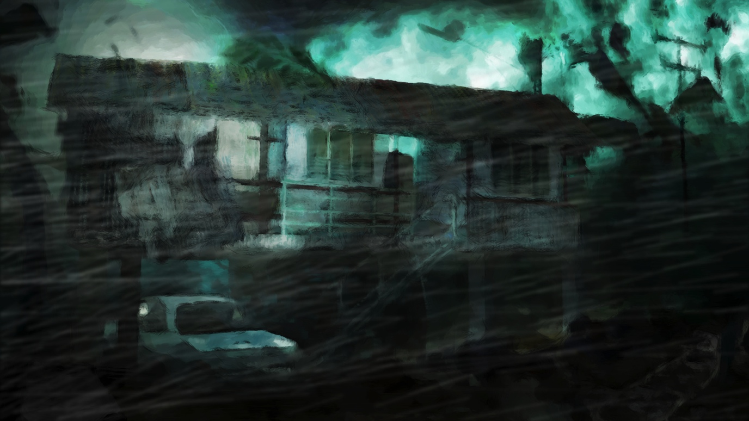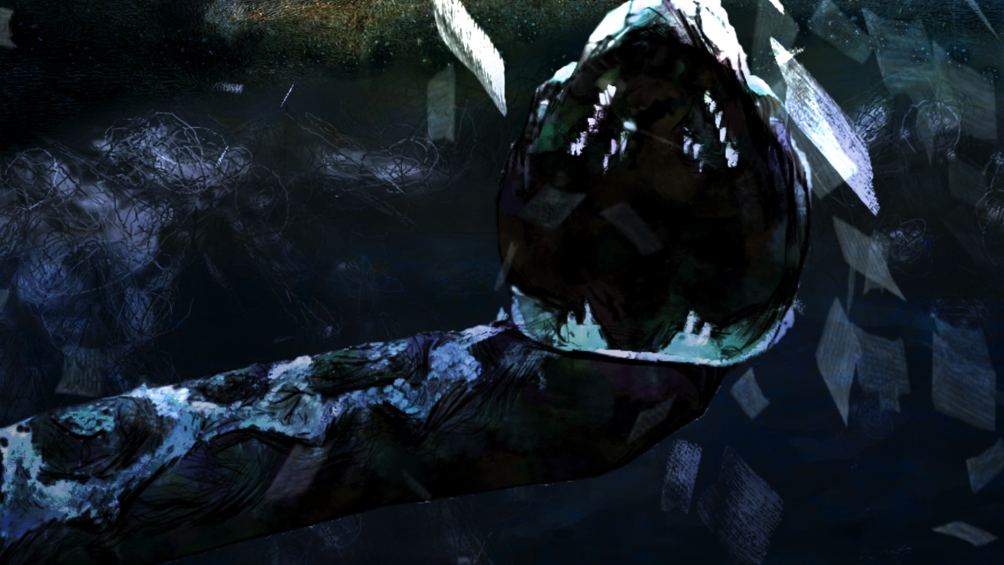

KEY BIBLIOGRAPHIC REFERENCES

Publications
“Warning: The Story of Cyclone Tracy”, by Sophie Cunningham, Text Publishing Co, 2014
“Darwin”, by Tess Lea, NewSouth Books, 2014
“Is there Anyone Alive in There”, by Dr E Stack, Darwin Historical Society, 2014

Websites
http://artsandmuseums.nt.gov.au/__data/assets/pdf_file/0020/145307/Cyclone-Tracy-Guide.pdf - Bibliography of Tracy books by NT Library
https://www.facebook.com/groups/cyclonetracy/ - Cyclone Tracy Survivors Facebook page
http://www.naa.gov.au/Images/cyclone-tracy-3_tcm16-45402.pdf - the rebuild of Darwin
https://griffithreview.com/articles/disappeared/ - Griffith Review article
http://www.nt.gov.au/justice/courtsupp/coroner/findings/2005/cyclone_tracey.pdf -
Coroner’s Report

Films
Film Australia Collection, National Film and Sound Archive of Australia
“Cyclone Tracy - Darwin, Christmas 1974” (1975, 9 mins)
“When Will The Birds Return” (1975, 50 mins)
“Home Sweet Home” (1975, 44 mins)
“Tracy’s Birthday” (1976, 28 mins)
Australian Broadcasting Corporation
“Chequerboard: It’s One of the Better Pieces of Wreckage” (1975, 42 mins)
“The Darwin Story” (1975, 29 mins)
“Challenge: Broken City” (1975, 27 mins)
“This Day Tonight: Darwin Revisited” (1975, 26 mins)
PBL Productions
“Cyclone Tracy” miniseries (1988, 3 x 120 min)
HISTORICAL BACKGROUND INFORMATION

Blown Away is an historical story of national importance. Following on from the Brisbane floods of January 1974 in which 14 people lost their lives, it was the first time that a natural disaster had driven an Australian city to its knees. With a death toll of 71 people, in the remote location of Darwin compounded with the damage of the storm in which almost 100% of the population were affected, Tracy lead to national and state driven policies regarding the management of such monumental catastrophes.
Cyclone Tracy was the time that Darwin ‘came of age’. In the days following the storm, the people of Darwin showed the rest of Australia, indeed the world, that they were able to band together and throw away social, geographical, financial and racial divides in order to work together as a community. It is an inspiring and moving story of determination and grit.

However, there are also stories of stupidity, mismanagement and bullying from both the Darwinian community and local government and the Whitlam Labor federal government. The mass evacuation, while a great achievement in organisation and the largest in Australia’s history, caused untold turmoil and suffering for many families who were separated and torn away from their communities.

There are very few recorded stories from Aboriginal survivors. Indeed, some believe that deaths of “Long Grass” Aboriginal people were not included in the final casualty list. In Blown Away, we include Aboriginal stories from people who lived through the storm, as well as looking at traditional Aboriginal beliefs that explain the cyclone and resulting devastation from a cultural perspective.

The rebuild of Darwin was a political minefield. Whitlam had promised to rebuild the city in 5 years and subsequently a collection of Canberra-based public servants were relocated to Darwin to form the Darwin Reconstruction Commission (DRC) and lead the way. Old-time Darwinians loathed and spurned the blow-ins and made it impossible for the rebuild to start. History books blow over this period with a short statement about the DRC not having achieved anything in the first year but then they completed the rebuild in 3 years. It’s astounding to think about. After the first year of management by Canberra, when control of the rebuild had been given back to locals, they were able to achieve the almost impossible. Was it heroism, was it a dogmatic refusal of locals to compromise and accept help, was it a frontier boys-club reclaiming their community?

Extraordinary archival footage, dramatic animation interlaced with in-depth interviews tells a powerful story revealing a new story of Tracy. December 2014 will be the 40 year anniversary of the event, and it is time that Australia reflects back on a monumental incident of Australian history with new eyes.

The Cyclone

It began as cloud mass over the Arafura Sea. A tropical low-pressure system that soon developed a circular centre. And as the pressure continued to fall and spiraling clouds were observed, it was designated a tropical cyclone. For the people in its path – the survivors - it would come to be known as something else. Quite simply… Tracy.

Tracy was a comparatively small storm cell, but she packed an extraordinarily powerful punch, with excessively strong and destructive winds.

The first warning for the cyclone was issued on the 21st December 1974. After watching a depression form over the Arafura Sea then begin to spin-up, the Bureau of Meteorology designated the storm a tropical cyclone at 10pm, and called her Tracy. At that point, it was 700km Northeast of Darwin. The following morning, the storm appeared on Darwin radar, but moving in a Southwesterly direction, it passed to the North of Darwin later that day and continued going.

Most people assumed that the danger had passed, maybe a reasonable conclusion given the false alarm over Cyclone Selma earlier in the month. However, as the Christmas celebrations swung into high gear, Tracy suddenly changed direction. In the early hours of the 24th December, the cyclone rounded Cape Fourcroy and began cutting a path to the Southeast… Heading straight for Darwin.

The city had had a number of close calls before, but still no-one believed that the storm would hit the city. So, as the pressure at the centre of the storm continued falling and the swirling winds picked up speed, the Xmas preparations and parties continued. By late afternoon Darwin was overcast and by nightfall it was raining heavily and starting to blow. Then, between 10pm and 12pm, the winds really began to bite and the people of Darwin were in no doubt. Rather than passing them by, Cyclone Tracy was going to run straight over the top of them.

As the wind and rain built, roofs were peeled off, cars shunted along streets and steel poles wrenched and twisted like pipe-cleaners. Then, at around 3am on Christmas morning, everything seemed to ease up. Shell-shocked residents crept out of hiding to assess the damaged and give thanks for their survival. But their relief was premature. They were only in the eye of the storm and by 3.30am Darwin Airport was recording gusts of up to 217km/p/h, until the instruments failed.

Darwin was in the grip of a vicious monster and she wouldn’t let go until 6.30 on Christmas morning.

The Territory

The Northern Territory in 1974 was still a frontier – still rugged, still unforgiving, still wild. However, it was also idyllic, a magnet for a rogue’s gallery of misfits, runaways and iconoclasts. Darwin was a place where people could come to reinvent themselves and start again. In many ways, it was a last bastion of independent living. Only the most adventurous, hardiest of souls would settle in Darwin, eager to live a different kind of life and test themselves in an extreme place. It bred in the people a pragmatism and resilience that was hard to find anywhere else in Australia. At the same time, the place bonded them profoundly too.

In the twenty years prior to Tracy, Darwin had undergone a rapid expansion. The city had literally sprung up from the old town and, consequently, many of the structures were loosely designed. This would result in its annihilation. Arriving late on Christmas Day to assess the damage, Major General Alan Stretton, Director-General of the Natural Disasters Association, declared that it was like arriving in a war zone.

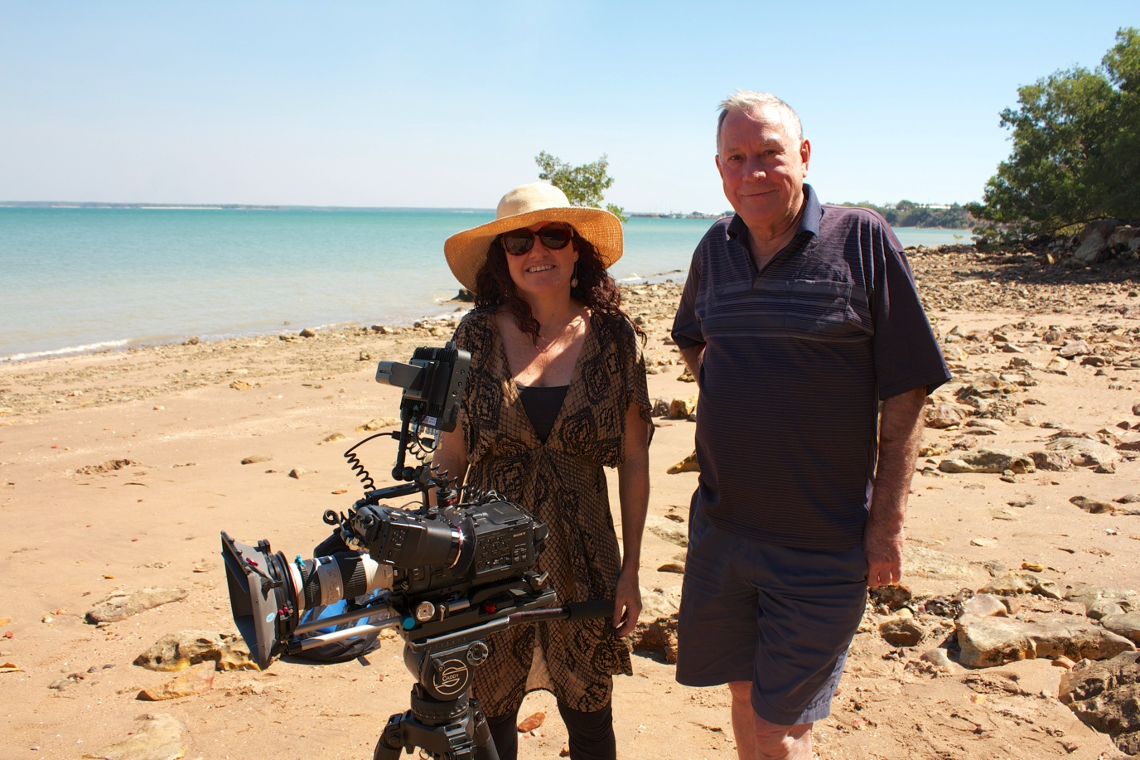
Danielle MacLean (Writer/Director) with Bill Day on Lameroo Beach, Darwin

The Facts

The eye of the storm was 12 kilometres across.

Associated storm gales extended 48 kilometres from the centre.

255 millimetres of rain fell in 12 hours overnight.

There were 145 serious injuries requiring hospitalization and a further 500 injuries requiring treatment.

The death toll was 71. With 49 fatalities on land and 22 at sea.

70% of houses failed structurally. 90% were uninhabitable.

Damage bill was $800 million – in 1975.

The pre cyclone population of Darwin was 45,000. Post cyclone, 30,000 people were evacuated over 11 days, leaving a skeleton population to begin the task of rebuilding.

Tracy’s Itinerary

Dec 1 - Cyclone Selma forms.

Dec 2 – Selma 300 kms West of Darwin.

Dec 3 – 10am – Cyclone 100 kms west.

A warning siren goes – but it’s a warning for Cyclone Selma. People go about their holiday season revelry. Then Selma does a u-turn and blows back west snuffing itself out.

Dec 20 – Fri – Meteorologists notice low pressure system over the Arafura sea.

Dec 21 – Low begins to spin up with cold winds blowing down from the north. Tropical storm is formed.

4pm – First Tropical Cyclone alert issued. Aimed at the islands to the north.

10pm – Newest satellite images come in and the cell pressure has lowered, started spinning up – and moving. Officially designated tropical cyclone and named. Tracy.

12am – Cyclone Tracy 250 kms from Darwin.
Tracked by radar at the airport. Radar Operator takes polaroid pictures of the screen every half hour to and faxes them to the mets in town.

Dec 22 – 10am – Cyclone Tracy alert No 2 issued.

1.30pm – The eye of the storm identified. 25 kms across.
The eye is used to track the cyclone, giving less of an indication of when the leading edge of the storm – where the destructive winds were – would hit communities.

* Most people who were leaving town for Christmas drove or flew out over the weekend.

Dec 23 – Mon - First light – Storm hammering Melville Island.

Lunchtime – Earth tremor shakes Darwin.
A high-rise building wall cracks from top to bottom.
Many of the 1950s houses – built on piers shake violently.

6pm - The western edge of Melville Island is smashed by the cyclone. Buildings destroyed. Weather station records 220mm of rain in 24 hours.

4pm - 7pm – Tracy almost standing still.

7pm – Tracy starts moving again. Average speed of 5 kph.

7pm-12am – Tracy appears to be moving w/sw – Darwin in no immediate danger.

Dec 24 - Midnight – 1.30am – Tracy moves parallel to the coastline and stops, loitering with intent.

3.30am – Cape Fourcroy weather recording station – winds 100 kph.
6.30am - Cape Fourcroy weather recording station – winds 110 kph.
9.30am - Cape Fourcroy weather recording station – winds 120 kph.
* Tracy is spinning up faster, gathering strength.

7am – Cyclone warning No. 14 issued. Tracy expected to be 100 kms west of Darwin at 6pm.

9.15am – The mets realise that Tracy is now heading for Darwin.

Morning – Harbourmaster Carl Allridge orders the larger vessels out of the harbour.

12.30pm – The mets issue a cyclone warning for Darwin on the ABC.

Afternoon - Carl Allridge orders the remaining boats out of the wharves and to their cyclone mooring, or out to sea.

* After lunch, many companies and government agencies break for Christmas and the parties really crank up.

The mets have a Christmas party.

3pm – Tracy 80kms from Darwin.

4pm - Cyclone warning No. 17.

5pm – Getting dark because of the weather. (Usually dark around 6pm)

7pm – Cyclone warning No. 18.

9pm - 12am – Cyclone warnings issued every half hour.

9pm – Tracy 50kms from Darwin.

10pm – 11pm – Power lines are stating to come down. Many areas in Darwin are staring to experience blackouts.

Sheet lightning is ripping through the sky constantly now.

11.30 – Radio announces that Tracy is about an hour away.

Powerlines begin being stripped from their poles.

Dec 25

12am – The barometric pressure plummets and the winds ramp up.

1am – Cyclone Tracy slams into Darwin with full force.
First places hit: Port and harbour area, the CBD, the Larrakeyah, Stuart Park, Parap and Fannie Bay areas.
Then: the RAAF Base and Ludmilla, Nightcliff and Rapid Creek.
Some houses were spared by geographical features like small hills etc.
But the overall effect was complete ferocious devastation.

* In the 24 hours from Dec 24 9am – Dec 25 9am, 280mm rain fall. Barometric pressure falls to an all time low of 955 millibars. The pressure gradient is at times vertical. (Wind speed and force is determined by the pressure gradient at the centre of the storm. At its worst, Cyclone Tracy has a gradient of 3 millibars per kilometre, with a 1 millibar per kilometre average.)

First Wind – front edge of the Cyclone
Sustained winds of 120kph and gusts of up to 150kph

1.30 – All of Darwin is blacked out as the power station fails.

Cyclone Tracy followed a trochoidal path. She moved in an omega-like direction (a horseshoe with the curve uppermost), but on top of that, rotated in and around that line. This meant that she could be in one part of a suburb and not another.

The wind would rip the roofs off houses. The ceilings would then get soaked and collapse. That saves a lot of lives as the broken ceilings would provide cover and shelter from flying debris for people huddling beneath.

BUT if the wind got hold of the walls, it would rip out the end of buildings and that debris would become airborne, smashing into neighbouring roofs and weakening them. They would then fly off and the whole process would begin again. It created a snowballing wave of destruction up and down streets and suburbs.

The change in air pressure would also aid in the storm’s destructive power as it would bow and flex walls.

The pressure would also vary wildly within structures. At times people’s ears would pop and at others they would feel like they were being sucked towards doors and windows.

2.30am – 3.30am 105mm of rain falls.

The Eye – the eerie quiet in the middle of the storm

3am

It’s deathly quiet. There is no wind or rain, very little sound.

Second Wind – back edge of the Cyclone (The real hammer blow)
Gusts of up to 280kph

The first winds had built up over an hour. The second winds arrived very suddenly and bit deep. After the silence of the eye, it was a “devil’s roar”. And all the debris that was now lying around was picked up and became weaponised – airborne and swirling, cutting down anything – and anyone in its path.

The rain was horizontal, blinding everyone. Leaving cover meant the risk of impaling, blunt force trauma, being snatched by the winds. Many adults recalled paying for the first time since they were children.

4am – The wind rapidly veers around to the west and the winds started to die down.

6.30am – Tracy was officially over.

The Aftermath

As the rescue effort swung into action, the true spirit of the Northern Territory came to the fore. Over the course of eleven days, 30,000 people were treated, fed and evacuated. In the most massive humanitarian effort Australia has ever seen, an entire city of people were cared for. Planes were taking off every ninety minutes from Darwin Airport, convoys of cars were met in major reception centres along their routes, from Katherine, to Tennant Creek to Alice Springs.

The Federal Government declares a state of quasi martial law. The police are given special powers. The final official count of deaths is 66 people, with 6 missing persons unaccounted for.

Post-Script

In 2005, in the Coroner’s Court in Darwin, a sad postscript to the tragedy of Cyclone Tracy was added. After a day of witnesses and hearings, the Coroner made a determination on the fate of six missing person files that remained open…

… They had all perished in the seas of Darwin harbour, whipped up by the cyclone.

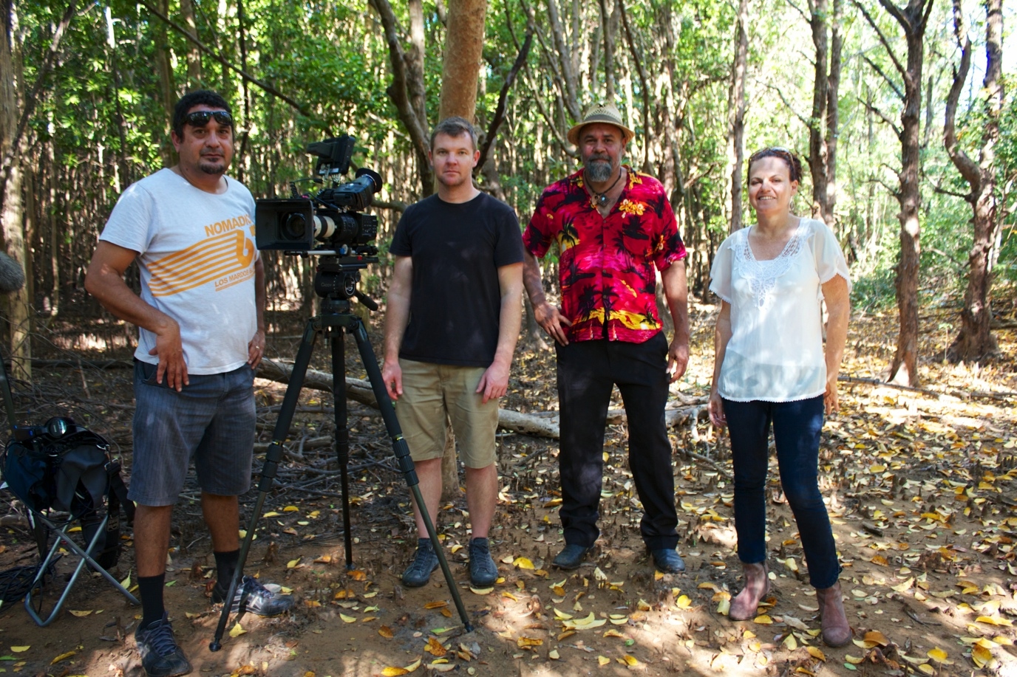
David Tranter (Sound Recordist), Tim Alewood (Cinematographer), Robbie Mills (Larrakia Elder), Danielle MacLean (Writer/Director)

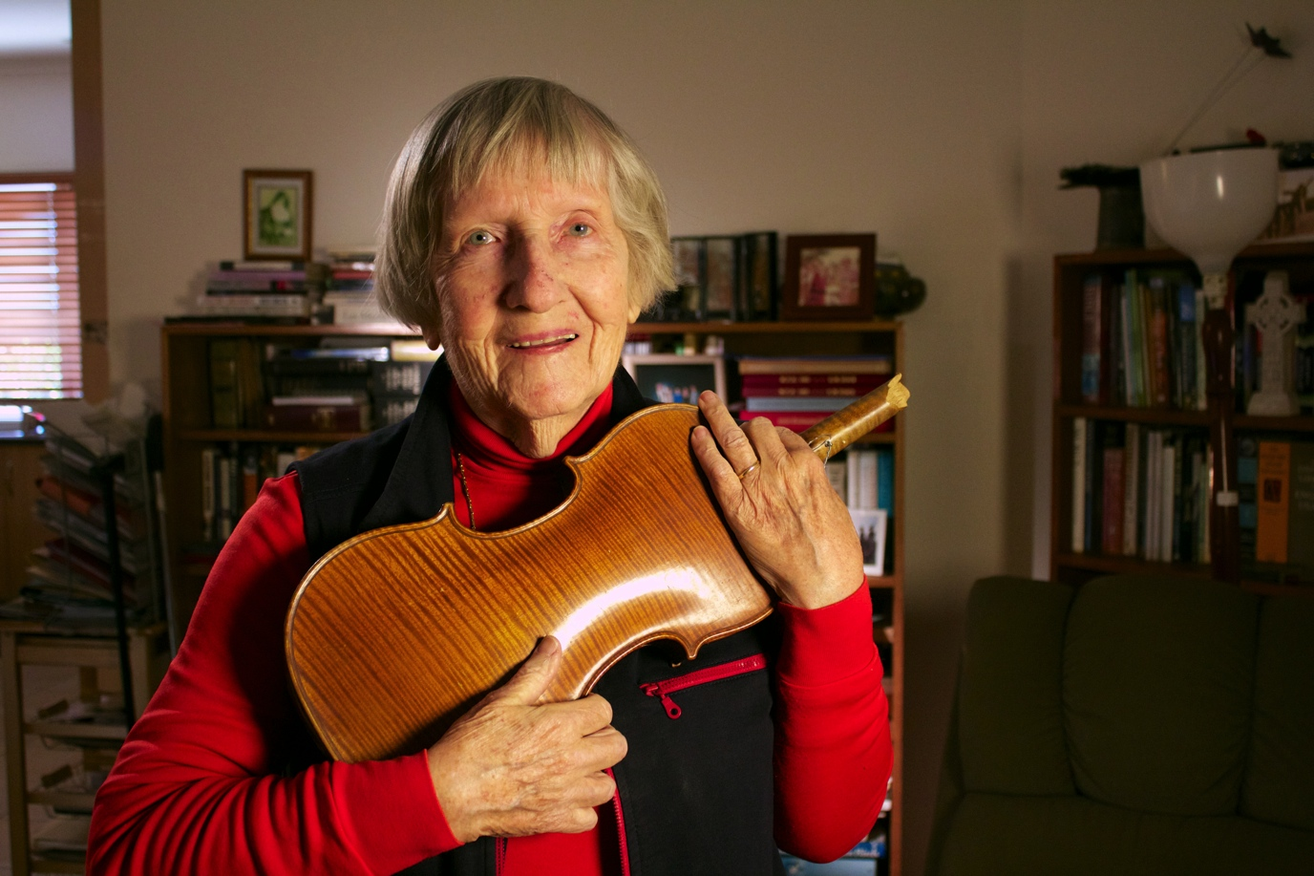
Dr. Ella Stack with her broken violin she found in the rubble several days after Cyclone Tracy

INDIGENOUS CULTURAL PROTOCOL
All representation of Indigenous people, music, art, culture and places remain in the control of the appropriate Indigenous people and can not be used for any other purpose outside of Blown Away without permission from the appropriate people. This includes any interpretations of traditional art, music or culture discussed in the film, including interpretation of Old Man Rock.

CREDIT LINES

Credit Line for Production
SCREEN AUSTRALIA in association with the AUSTRALIAN BROADCASTING CORPORATION, SCREEN TERRITORY, BRINDLE FILMS and NIRVANA FILMS present a National Documentary Program. Writer/Director DANIELLE MACLEAN, Producers RACHEL CLEMENTS and JAMES BRADLEY, Editor JAMES BRADLEY ASE, Director of Photography TIM ALEWOOD, Animation MELISSA HUNI BOLLIGER, Composer CAITLIN YEO, Sound Designer & Mixer MICHAEL GISSING, Sound Recordist DAVID TRANTER, Titles and Graphics KINGDOM OF LUDD
© 2014 Brindle Films Pty Ltd, Nirvana Films Pty Ltd, Screen Australia and the Australian Broadcasting Corporation

Credit Line for Publicity
Writer/Director DANIELLE MACLEAN, Producers RACHEL CLEMENTS and JAMES BRADLEY, Editor JAMES BRADLEY ASE, Director of Photography TIM ALEWOOD, Animation MELISSA HUNI BOLLIGER, Composer CAITLIN YEO, Sound Designer & Mixer MICHAEL GISSING, Sound Recordist DAVID TRANTER, Titles and Graphics KINGDOM OF LUDD

LOGOS

CONTACTS FOR PRESS/PUBLICITY

PRODUCERS
Rachel Clements 0414-484-472, rachelclements@ozemail.com.au
James Bradley 0417-692-743, nirvana9@mac.com

PRODUCTION COMPANY Brindle Films Pty Ltd
PO Box 5188
Alice Springs NT 0871

Nirvana Films Pty Ltd
72 Carlotta Street
Greenwich NSW 2062

