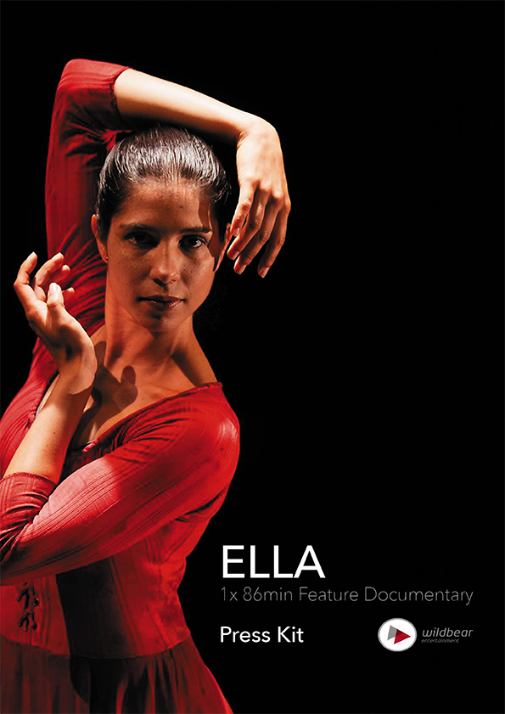

INDEX

* CONTACT DETAILS AND TECHNICAL INFORMATION………………………… P3
* PROGRAM DESCRIPTIONS.…………………………………..…………………… P4-6
* KEY CAST BIOGRAPHIES………………………………………..………………… P7-9
* DIRECTOR’S STATEMENT………………………………………..………………… P10
* PRODUCER’S STATEMENT………………………………………..………………. P11
* KEY CREATIVES CREDITS………………………………..………………………… P12
* DIRECTOR AND PRODUCER BIOGRAPHIES……………………………………. P13
* PRODUCTION CREDITS…………….……………………..……………………….. P14-22

# CONTACT DETAILS AND TECHNICAL INFORMATION

Production Company

WildBear Entertainment Pty Ltd

Address PO Box 6160,

Woolloongabba, QLD 4102

AUSTRALIA

Phone: +61 (0)7 3891 7779

Email [veronica.fury@wildbear.tv](mailto:veronica.fury@wildbear.tv)

Distributors and Sales Agents

Ronin Films

Address: Unit 8/29 Buckland Street,

Mitchell ACT 2911

AUSTRALIA

Phone: + 61 (0)2 6248 0851

Web: [http://www.roninfilms.com.au](mailto:http://www.roninfilms.com.au)

Technical Information

Production Format: 2K DCI Scope

Frame Rate: 24fps

Release Format: DCP

Sound Configuration: 5.1 Audio and Stereo Mix

Duration: 86’

Production Format: 2K DCI Scope

Frame Rate: 25fps

Release Formats: ProResQT

Sound Configuration: 5.1 Audio and Stereo Mix

Duration: 83’

Date of Production: 2015

Release Date: 2016

ISAN: ISAN 0000-0004-34BF-0000-L-0000-0000-B

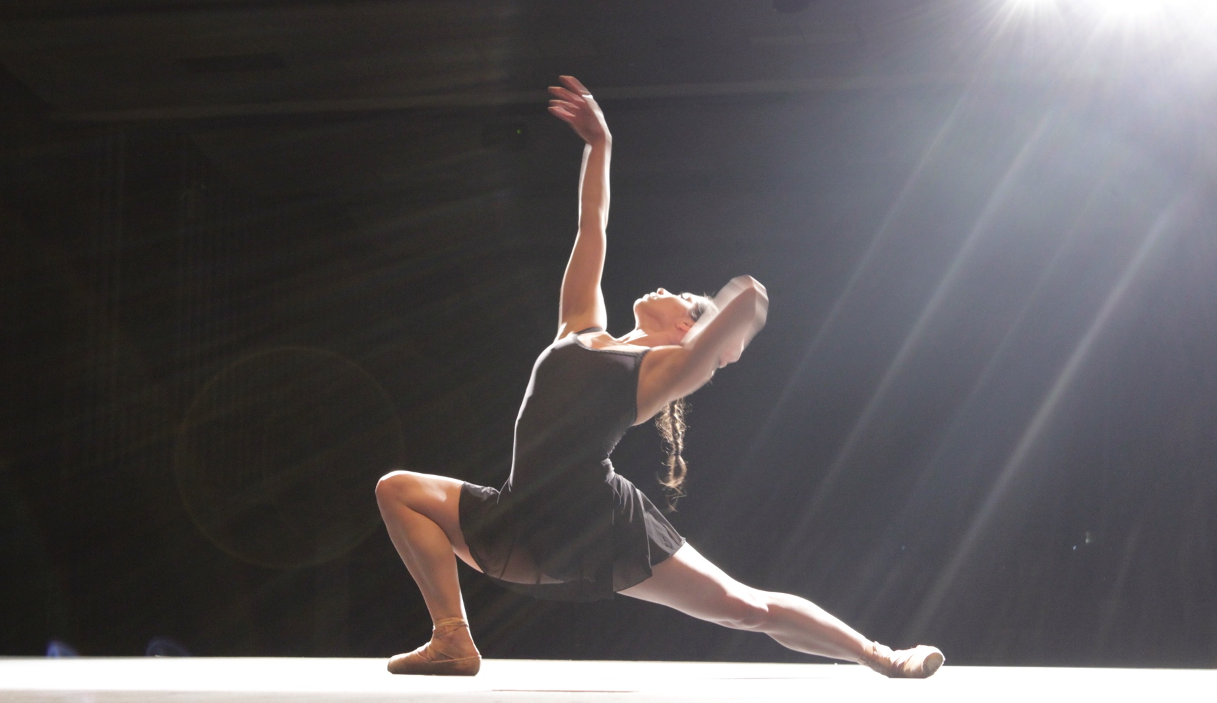

# PROGRAM DESCRIPTIONS

Logline:

An intimate and inspirational journey of the first Indigenous dancer to be invited into The Australian Ballet in its 50 year history

Short Synopsis:

In October 2012, Ella Havelka became the first Indigenous dancer to be invited into The Australian Ballet in its 50 year history. It was an announcement that made news headlines nationwide. A descendant of the Wiradjuri people, we follow Ella’s inspirational journey from the regional town of Dubbo and onto the world stage of The Australian Ballet. Featuring intimate interviews, dynamic dance sequences, and a stunning array of archival material, this moving documentary follows Ella as she explores her cultural identity and gives us a rare glimpse into life as an elite ballet dancer within the largest company in the southern hemisphere.

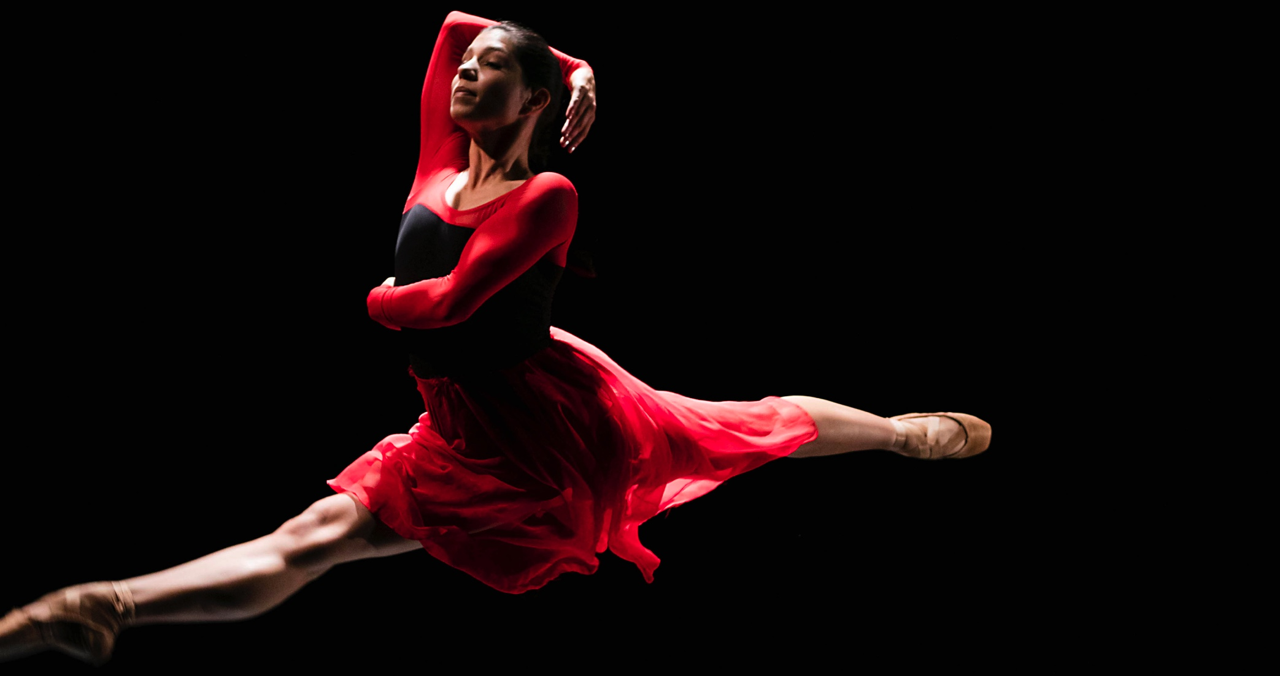

Long Synopsis:

*“I often feel like I am dancing between two worlds and struggling to find where I fit in. It’s not until I can really blend my two different worlds together that I feel like I can accomplish what I want as a dancer … to really tell my own story.”* **Ella Havelka**

In October 2012, Ella Havelka became the first Indigenous dancer to be invited into The Australian Ballet, an announcement that made news headlines nationwide. However it was a homecoming for Ella, who had always dreamed of joining the company.

Ella is the descendant of the Wiradjuri people from Dubbo in country NSW. The daughter of Janna a single mother, her introduction into the world of dance began with Physical Culture, where she rose to compete at a national level. Then one day Ella watched a video that Janna brought home from the local library of a performance of *Swan Lake* and ballet called to her - she was hooked. Janna got her into classes at the Dubbo Ballet Studio and with the help of scholarships and hand-me-down tutus Ella devoted her life to dance. She quickly started winning local Eisteddfods and was soon dancing six days a week.

The Dubbo community was elated when Ella was accepted into The Australian Ballet School in Melbourne at the age of 14, where she honed her craft in an intensely competitive environment. However, upon graduation after four arduous years she was devastated not to be offered a position in The Australian Ballet core company. But this was not the end of her dream. In 2009 Ella joined Bangarra - the prestigious Sydney based Indigenous dance company - where she learnt not only the very different rigors of contemporary dance, but began a powerful and moving journey of self discovery into her Indigenous heritage.

It was not until Bangarra did a joint performance with The Australian Ballet *Warumuk - in the dark night* in 2012 - that the calling of the ballet was reignited within Ella. In an historic occasion, The Australian Ballet Artistic Director, David McAllister, invited her to join the core company. Ella accepts this position and becomes the first Indigenous dancer to join The Australian Ballet in its 50 year history.

This feature documentary follows Ella as she faces the challenges of adapting back to being *en pointe* after four years of barefoot dancing with Bangarra. We see her face the fierce competition for the best positions and roles - she even questions her own role as the first Indigenous dancer in The Australian Ballet. We also go with The Australian Ballet on their highly esteemed 2015 international tour to China where Ella finally gets to dance in Graeme Murphy’s enchanting interpretation of *Swan Lake* in Beijing. Ella’s childhood dream has come true.

Woven throughout this inspiring dance story is a touching and heart breaking personal journey back to her roots. We join Ella and Janna on a road trip through her country, traditional Wiradjuri land, where Ella reconnects with her Indigenous culture - learning traditional language, basket weaving with Elders and visiting the gravesites of her ancestors for the first time. She also explores her childhood. Both Ella and Janna give intimate accounts of the circumstances surrounding her birth. For Ella never knew her father even though he lived in the same town. However after his death Ella was given a scrapbook of clippings that he kept of her whole career. She feels now he was always with her.

But ultimately in this film we follow Ella as she finds her own identity by choreographing her own dance. Using a unique blend of Bangarra’s contemporary Indigenous style and traditional western ballet Ella finally expresses herself in her own way.

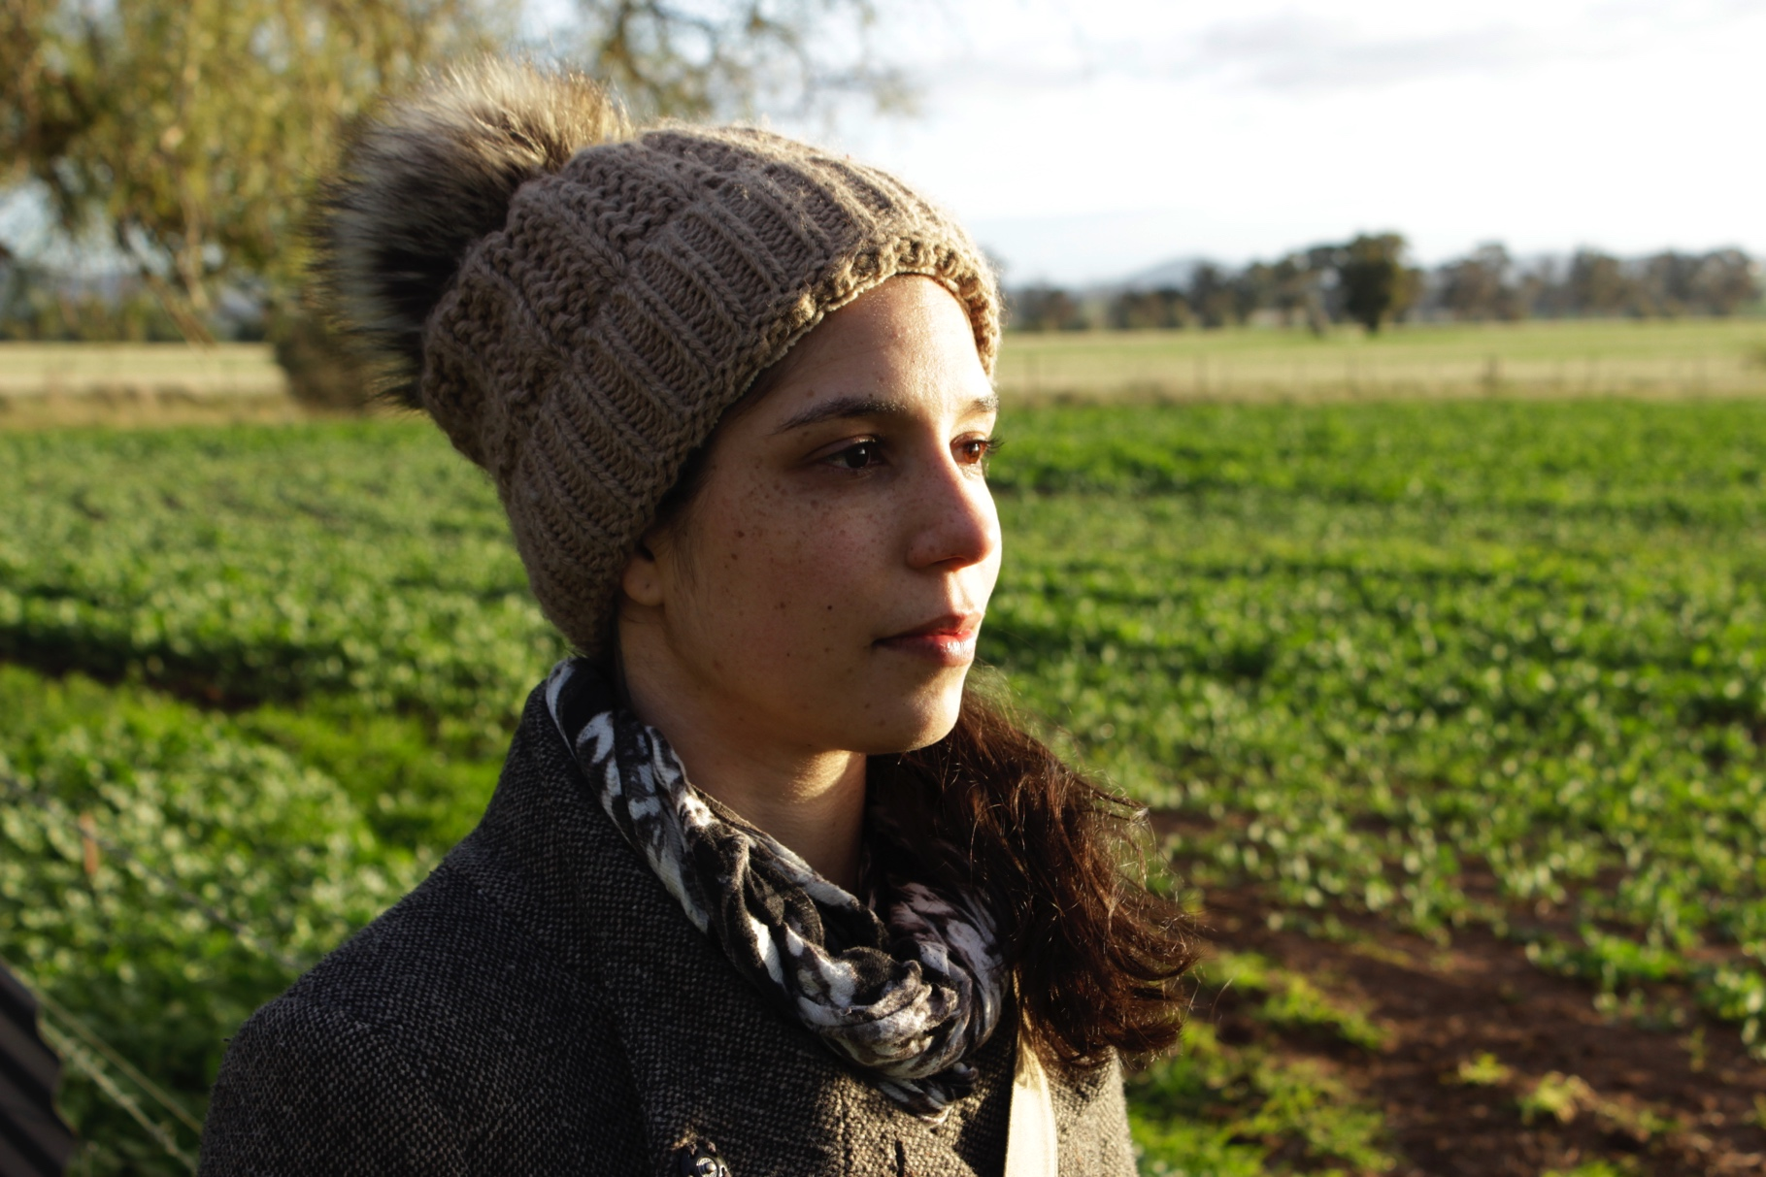Featuring intimate interviews, dynamic dance sequences, and a stunning array of archival material, this moving documentary follows Ella as she explores her cultural identity and offers a rare glimpse into her life as an elite ballet dancer within the largest company in the southern hemisphere.

# Macintosh HD:Users:Production:Desktop:_MG_2953.JPGKEY CAST BIOGRAPHIES

FEATURING – Ella Havelka

<https://australianballet.com.au/artist/ella-havelka>

Born in Dubbo, Ella is a descendant of the Wiradjuri people. She graduated from The Australian Ballet School in 2007 after touring with The Dancers Company. Ella made her first appearance with Bangarra Dance Theatre in *Fire – A Retrospective* in 2009, and was nominated by *Dance Australia* magazine as Dancer to Watch. Between 2009 and 2012 she danced with Bangarra in *Mathinna*, a program that included *earth & sky, Spirit and Terrain*. In 2012, Ella performed in Australia and New York with Bangarra and The Australian Ballet in *Warumuk – in the dark night*, a collaborative work created by Stephen Page for The Australian Ballet’s 50th anniversary celebrations. She joined The Australian Ballet in 2013.

REPERTOIRE HIGHLIGHTS

Lead Hungarian in Graeme Murphy’s *Swan Lake* 2015, Stanton Welch’s *La Bayadère* 2014

Garry Stewart’s *Monument* 2013, *Paquita* 2013, Stephen Page’s *Waramuk – in the dark night 2012*

YOU MAY NOT KNOW

Ella likes to practise traditional Aboriginal basket weaving; she also paints, and designs Lino prints. Some of her work is on display at the Wagga Wagga Art Gallery.

*“Being a ballerina with The Australian Ballet has always been a dream. I feel very privileged to have had the opportunities I’ve had. I can only hope to inspire others within the Aboriginal*

*community to pursue their own dreams by my pursuing mine.”*

*–* Ella Havelka

The Australian Ballet

<https://australianballet.com.au/>

The Australian Ballet exists to inspire, delight and challenge audiences through the power of its performances.

The Australian Ballet is one of the world’s premier ballet companies and has delivered extraordinary performances for over 50 years. A commitment to artistic excellence, a spirited style and a willingness to take risks have defined the company from its earliest days, both onstage and off.

The company regularly represents Australia on the world stage and has performed to critical acclaim in 87 cities worldwide including New York, Shanghai, Tokyo, London and Paris. Caring for tradition yet daring to be different, The Australian Ballet performs beloved classical ballets and commissions new work annually. The Australian Ballet presents upwards of 250 shows and 1,700 education and audience engagement events each year.

In addition to 80 exceptional dancers, The Australian Ballet employs master craftspeople and leaders in injury prevention, dance education, marketing and philanthropy as well as an orchestra of 62 musicians (Orchestra Victoria).

Moving effortlessly between the great classical ballets and new contemporary commissions, the company has a uniquely Australian style, powered by artistry and athleticism.

David McAllister AM

<https://australianballet.com.au/artist/david-mcallister>

Born in Perth, David McAllister joined The Australian Ballet in 1983 and was promoted to principal artist in 1989. During his time with the company, he danced many principal roles, including those in *The Sleeping Beauty, Don Quixote, Coppélia, Manon, La Sylphide*, John Cranko's *Onegin* and *Romeo and Juliet*, and Jiří Kylián's *Stepping Stones*; in 1985 he won Bronze at the Fifth International Ballet Competition in Moscow.

Throughout his career, David made numerous guest appearances worldwide, dancing with Bolshoi Ballet, the Kirov Ballet, the Georgian State Ballet, The National Ballet of Canada, Birmingham Royal Ballet, Singapore Dance Theatre and, in 1992, as part of a Royal Gala performance in London in the presence of the Princess of Wales. In 2000, he completed a Graduate Diploma in Arts and Entertainment Management and in 2001, took his final bow as a dancer. In July of that year, David became Artistic Director of The Australian Ballet. He was awarded a Member of the Order of Australia in the 2004 Australia Day Honours List. In 2015, David premiered a new production of *The Sleeping Beauty* for The Australian Ballet.

Stephen Page

http://bangarra.com.au/people/executives/stephen-page

Born in Brisbane, Stephen is a descendant of the Nunukul people and the Munaldjali clan of the Yugambeh Nation from SE Queensland.

In 1991 Stephen was appointed Artistic Director of Bangarra and has built a strong reputation touring throughout Australia and the world, including New York, Washington, Paris, London and Germany. Memorable works *Ochres, Skin* (‘Best New Australian Work’ and ‘Best Dance Work’, 2001 Helpmann Awards), *Bush* (‘Best Dance Work’, 2004 Helpmann Awards), *Mathinna* (‘Best Dance Work’ and ‘Best Choreography’, 2009 Helpmann Awards) have become milestones in Australian performing arts.

For The Australian Ballet, Stephen has choreographed *Rites* to Stravinsky’s score incorporating dancers from Bangarra and he directed the Indigenous sections for the 2000 Sydney Olympic Games Opening and Closing Ceremonies. As Artistic Director of the 2004 Adelaide Festival of the Arts, Stephen was praised for reinvigorating the event with an impressive and highly successful world-class program. Stephen’s film and theatre credits include the contemporary operatic film *Black River*, numerous music video clips, directing his brother David Page in the highly acclaimed production *Page 8* which toured Australia and the UK and choreography for the feature films *Bran Nue Dae* (2009) and *The Sapphires* (2011).

In 2011, his 20th year as Artistic Director, Stephen choreographed *ID, (Belong)* and developed the concept of *Bloodland* in collaboration with Wayne Blair and Kathy Balngayngu Marika, directing the production for Sydney Theatre. In celebration of The Australian Ballet’s 50th anniversary in 2012, Stephen was invited to create a new work *Warumuk – in the dark night* bringing together dancers from the Ballet and Bangarra, performed in Melbourne, Sydney and New York. Stephen made his directorial debut in 2012, directing the chapter Sand in the feature film *The Turning* and was Artistic Associate for Sydney Theatre Company’s production of *The Secret River* as part of the Sydney Festival. That same year Stephen received the NAIDOC Award for Artist of the Year and won a Helpmann Award for Best Choreography in a Dance or Physical Theatre work for *ID (Belong).*

In 2013 Stephen choreographed *Blak* with dancer/choreographer Daniel Riley, commissioned *Dance Clan 3*, a new work choreographed by Bangarra’s women featuring in the inaugural Corroboree Sydney and accepted the Australian Arts in Asia Award – Dance, for Bangarra’s 2012/13 tour to Mongolia, Vietnam and Thailand with Spirit.

In 2014 Stephen choreographed Bangarra’s acclaimed new work *Patyegarang*. This production celebrated Bangarra’s 25th anniversary and was seen by over 36,000 people nationally, making it Bangarra’s most successful season yet. That same year, Stephen led the company’s largest ever regional tour, performing in regional centres and remote Aboriginal and Torres Strait Islander communities over nine weeks.

In 2016, Stephen celebrates his 25th year as Artistic Director of Bangarra Dance Theatre. He will choreograph his 23rd work for the company, a new work for the triple bill *OUR land people stories* which will premiere in June 2016 at the Sydney Opera House.

# **DIRECTOR’S STATEMENT**

In the past there have been Indigenous dancers in The Australian Ballet School, but Ella Havelka is the first Indigenous dancer to be admitted into the company. Underpinning this historic achievement is a story of many layers of personal determination and discovery, as an Indigenous girl from the country follows an unusual path to success crossing cultures and dance sectors.

To me this project explores the question of Identity. Who is Ella, what is her connection with family and Country, and how does this differ from the ballet world? Ella is becoming a role model, not only to aspiring ballet dancers but also to Aboriginal and Torres Strait Islander People. It’s a huge responsibility and undoubtedly a weight on her shoulders. Being Indigenous and with limited opportunities to formally study dance, her achievement will inspire and catch the attention of many people, especially her peers who will look up to her. But who is this dancer? Ella is a person who has family, friends and needs to live and enjoy the pleasures of everyday life, but the world of dance, especially professional ballet, is a world of rigours, stresses, dedication and huge competition. It involves irregular hours, demanding work schedule and complete devotion. When I first met Ella two years ago I was struck by her down to earth outlook on life, which is not always easy to maintain in such an intense and creative environment. How has she managed to keep her feet on the ground (even if en pointe)?

Ella is also an Indigenous Australian, and must balance the tradition and heritage that comes with it. In our conversations Ella has been articulate and insightful about the realities of these worlds, and her personal struggle to find balance. Will she thrive? How will she juggle all these aspects of her life? Will she consolidate her identity in the ballet, her family and her community? I like telling stories about ‘connection’ - how is Ella connected to her family, her friends and culture. Ella’s mother Jenna has been very influential in her life; we’ll also see her back-story. We will showcase Ella’s Indigenous dance background with the world acclaimed artistic Director of Bangarra, Stephen Page. Ella’s hobby of basket weaving is a visual symbol of these strands and connections coming together to create the whole throughout the film. Like many of her generation Ella is working to regain her cultural knowledge before the Elders are gone, and their knowledge is lost with them.

*Ella* has been in development since early 2012. We have worked closely with The Australian Ballet who have generously granted us privileged access to the backrooms and processes of a professional dance company, including accompanying them on tour in China in 2015 and exclusive interviews with Artistic Director David McAllister and artistic staff from the company.

The supporting elements of Ella’s life and career as discussed above will be scaffolded around the footage of a dance choreographed by Ella: adding layers of information and investment within the audience piece by piece until we build to the climax of the dance itself: the work; the sacrifice; the two opposite but compelling traditions of Aboriginal and Torres Strait Islander culture and western ballet; and the call of family are all interwoven, symbolised by her basket weaving, to create the solid base which gives Ella the strength to express beauty and art through movement for the joy of all who see her.

This is Ella’s own unique story. **Douglas Watkin**

**Director**

# **PRODUCER’S STATEMENT**

When I produce a feature documentary I am always excited - and still surprised - by the amazing stories I get to facilitate onto the big screen. And I am very proud of *Ella*.

*Ella* is a beautiful film. It’s quite subtle. But is engaging and cinematic. Directed by Indigenous Director Douglas Watkin, beautifully shot by DOP Lucas Tomoana and craftfully edited by Axel Grigor. All with limited time – limited budget – limited access due to Ella’s hectic workload.

The music was provided by recently deceased Bangarra powerhouse composer David Page. A tragic loss but we are honored to represent his work here with Ella. Composer Stephen Francis stepped in and provided opening and closing tracks for us. A very moving collaboration.

The personal story of Ella is inspiring. Ella herself is just a wonderful young woman who has been following her dream. Her personality, her character, her spirit is so real, so warm and engaging. The film is raw and sincere. The documentary steps into Ella’s amazing backstory as well as offering unique behind the scenes looks at her life in The Australian Ballet. She talks intimately about being torn between two worlds - western ballet and her indigenous heritage. I thank Director Douglas Watkin for the trust he and Ella established – a strong connection as filmmaker and subject.

Yes the story is quite a subtle one – but in that it is also strong. Very moving. The moments that really touch are her connection to her Indigenous heritage while on a road trip with her beloved mum. The twist that Ella didn’t know her father even thought they lived in the same country town, but that he kept a scrap book of her life.

There is a rich array to archival material. The artistic journey and extreme heights of her elite performances. The honesty of her own story and choreography.

The cultural strand is also subtle but strong. It is an Indigenous film but it is a universal story – a powerful cultural message is interwoven throughout the film. She shares the struggles she faces dances between two worlds – between western ballet and more traditional cultural dance.

The film was quite challenging to produce on every level. But we got there in the end. We sincerely appreciate the ongoing support from State funding body Screen Queensland, and for Ronin for believing in the scope of this film. We are very very grateful for MIFF Premiere Fund and Screen Australia involvement. We give great thanks to Ella Havelka and to The Australian Ballet who trusted us and let us into their world. Thanks to my broader WildBear team too for their endless support.

**Veronica Fury**

**Producer**

**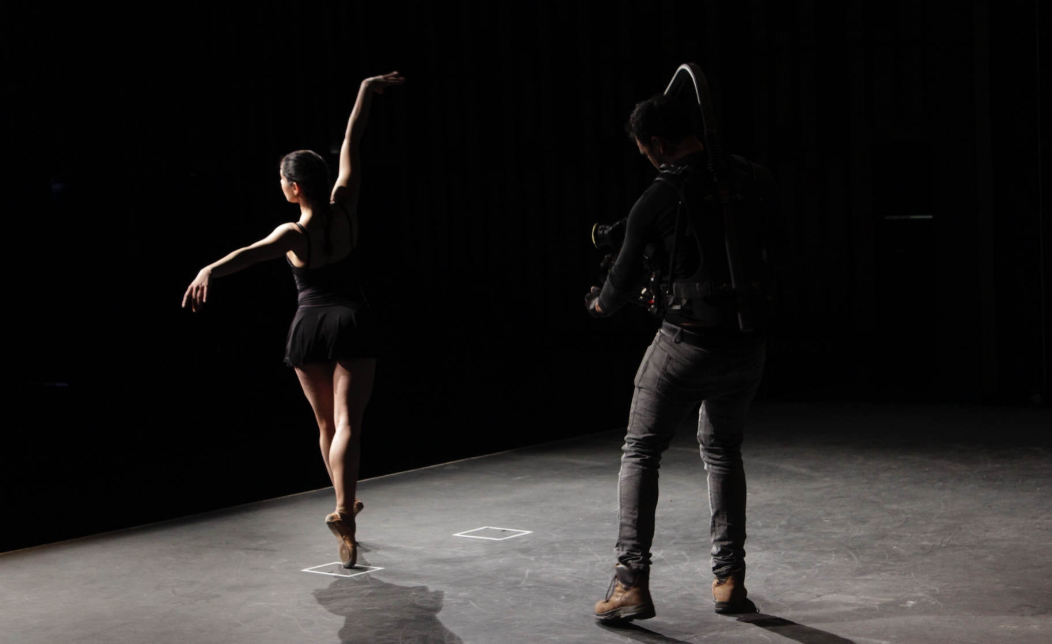**

# **KEY CREATIVE CREDITS**

Director

DOUGLAS WATKIN

Producer

VERONICA FURY

Film Editor

AXEL GRIGOR

Director of Photography

LUCAS TOMOANA

Featured Music

DAVID PAGE

STEPHEN FRANCIS

Co-Writers

DOUGLAS WATKIN

MURRAY POWER

AXEL GRIGOR

VERONICA FURY

Co-Producers

DENA CURTIS

LAWRENCE JOHNSTON

BIRD CAN SING

Associate Producer

MURRAY POWER

# **DIRECTOR AND PRODUCER BIOGRAPHIES**

DIRECTOR - Douglas Watkin

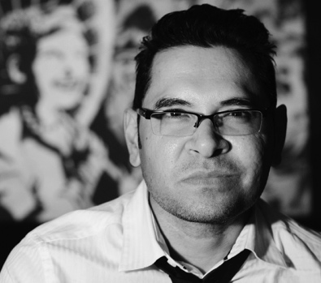Brisbane-based filmmaker Douglas Watkin, born in Cairns 1973, began his career working in broadcast television doing news reports for SBS. Douglas has been actively working in the filmmaking industry for over 20 years.

Douglas has travelled nationally and internationally shooting and producing stories on wide ranging events, people and places including stories of Indigenous Australia. He has also written and produced dramas that have screened in film festivals around the world.

He is an experienced broadcast Director who has directed and written many short form documentaries for NITV and ABC including: The Hidden Truth (ABC), Our Town: Shepparton (ABC), This is Badu (NITV) and Born in this Skin (ABC) to name a few, and has worked with Wildbear Entertainment previously on Constructive Mob (ABC), Keep In Touch (NITV), Soldier Proof (NITV), Malaytown (NITV) and Blue Warriors (NITV). He has also written and directed series for the NITV ANZAC series and the award winning Black Diggers of Logan series with Logan City Council.

Douglas has taken the next step into a longer form of story telling in feature documentary filmmaking. Ella offers him a higher profile in the industry both here and abroad.

**PRODUCER - Veronica Fury**

<http://www.imdb.me/veronicafury>

Veronica Fury is an Australian Producer and a Principal of WildBear Entertainment. WildBear Entertainment was formed when Australian production companies WildFury and Bearcage merged in 2014. The merger combines the skills and experience of respected producers Veronica Fury, Tina Dalton, Serge Ou, and Michael Tear.

Veronica produces award-winning screen content for audiences around the world, working with television broadcasters like ABC, Discovery, NITV and SBS in Australia and major international broadcasters such as ZDF Arte, TG4 and Arte France, just to name a few. The WildBear group also works with leading broadcasters including National Geographic, Discovery, CCTV9, FINAS Malaysia, PBS, Beijing TV, and the Nine Network.

Veronica has produced over 60 hours of feature documentary and factual TV projects including high profile feature doc, *Electric Boogaloo: The Wild, Untold Story of Cannon Films* (2014) which was produced for RatPac Documentary Films, Mongrel Media, Umbrella Entertainment and Melbourne International Film Festival Premiere Fund; and had its world Premiere at TIFF. Along with Lawrence Johnston she produced *Neon* for Melbourne International Film Festival. Veronica has a large slate of projects in various stages of production, financing and development.

# **ELLA**

# **PRODUCTION CREDITS**

PRE-PRESENTATION CREDITS

Ronin

Screen Australia

Screen Queensland

WildBear Entertainment

MIFF

PRESENTATION CREDITS

Card 1

Aboriginal and Torres Strait Islander viewers should exercise caution

when watching this program as it may contain images of deceased persons.

Card 2

SCREEN AUSTRALIA

Card 3

SCREEN QUEENSLAND

Card 4

AND

WILDBEAR ENTERTAINMENT

PRESENT

Card 5

IN ASSOCIATION WITH MELBOURNE INTERNATIONAL

FILM FESTIVAL PREMIERE FUND

TITLE

ELLA

CLOSING CREDITS

Director

DOUGLAS WATKIN

Producer

VERONICA FURY

Film Editor

AXEL GRIGOR

Director of Photography

LUCAS TOMOANA

Featured Music

DAVID PAGE

STEPHEN FRANCIS

By watching this film legally, you have supported thousands of jobs – of creatives, distributors and crew – as listed below.

|  |  |
| --- | --- |
|  | |
| Co-Writers | DOUGLAS WATKIN  MURRAY POWER  AXEL GRIGOR  VERONICA FURY |
|  |  |
| Executive Producer  Co-Producers  Associate Producer  Associate Producer  Courtesy of The Australian Ballet | MICHAEL TEAR  DENA CURTIS  LAWRENCE JOHNSTON  BIRD CAN SING  MURRAY POWER  ROBYN FINCHAM |
| Interviewees | ELLA HAVELKA  JANNA HAVELKA  DAVID MCALLISTER AM  STEVEN HEATHCOTE AM  STEPHEN PAGE  SUZANNE DUFFY |
|  |  |
| Production Managers | SALLY WORTLEY  SAM MOOR  JULIANNE LAWSON  RHEA STEPHENSON  REBECCA SINCLAIR |
|  |  |
| Production Coordinators | SHIRIN EDWARDS  RHEA STEPHENSON |
|  |  |
| Production Assistant | CHLOE HUME |
|  |  |
| Additional Camera | KENT MARCUS  PAUL COSTELLO  JOHN WHEELER ACS |
| Second Unit  Producer  Dance Sequence Director  DOP  Steadicam Operator  1st AC/Focus Puller  2nd AC/Data Wrangler  Location Technician | BENGAR FILMS  MELINA FLOOD  BEN GARTLAND  JOHN WHEELER  HARRY PANAGIOTDIS  CAMERA DUNN  NICK WELLER  GAVIN FAULL |
|  |  |
| Sound Recordist | CHRISTOPHER GILLETTE |
|  |  |
| Additional Sound | PIOTR WASILEWSKI  GRAHAM WYSE  JASON WAGNER  DAVID SIMS  DAVID TRANTER  ZHU WEI |
|  |  |
| Archive Researchers | RHEA STEPHENSON  SHIRIN EDWARDS |
|  |  |
| Stills Photographers | CHRISTOPHER GILLETTE  LYNETTE WILLS PHOTOGRAPHY |
|  |  |
| Offline Post Production Facility  Assistant Editor | FARAWAY PRODUCTIONS  KAI-BIN WONG |
|  |  |
| Online Post Production Facility  CEO  Post Production Producers  Colourists  Re-Recording Mixer  Sound Editor  Foley  Conform  VFX Compositor | SOUNDFIRM  ROGER SAVAGE  ROSS MITCHELL  HELEN FIELD  JONATHAN BURTON  SARAH SPARNANN  CHRIS GOODES, CAS  DAVID WILLIAMS  MARIO VACCARO  ALEX FRANCIS  TIM MORTON  RUI LI |
|  |  |
| Equipment Hire | LEMAC  PONY FILMS  THE FRONT |
|  |  |
| WILDBEAR  Principals  Chief Operating Officer  Financial Controller  Head of Production Finance  Head of Corporate  Head of Production  Head of Development  Post Production Supervisor  Trailer Editor  Production Accountants  Legals | ENTERTAINMENT  MICHAEL TEAR  BETTINA DALTON  VERONICA FURY  SERGE OU  NUNZIO GAMBALE  CAROLINE NICHOLS  MIRANDA FELTON  WAYNE BROWN  JAMES SUTHERLAND  HARRIET PIKE  MATT NIGHTINGALE  CHRIS BAMFORD  SARAH WOODS  RYAN FERNANDEZ  TIM DINGWALL  BEN DUFF |
|  |  |
| Lawyers | LLOYD HART/RUSSELL ALLEN – LLOYD HART LAWYERS  SHAUN MILLER – SHAUN MILLER LAWYERS  MARSHAL & DENT |
|  |  |
| Transcriber | STACEY ERBACHER |
|  |  |
| Insurance | HISCOX  ARTHUR J GALLAGHER |
|  |  |
| Travel Agent | CORPORATE TRAVELLER |
|  |  |

FEATURED MUSIC BY DAVID PAGE

I am – Belong

Yearning – Birth, Blak

Lore, Cool Down

Terrain, Reborn

Terrain, Salt

Yearning, Unearthed, Blak

Terrain, Deluge

Music used with permission of

Sony/ATV Music Publishing (Australia) Pty Ltd

ELLA’S CHOREOGRAPHY MUSIC BY STEPHEN FRANCIS

Crayfish

Additional Vocals, Elaine Crombie

ADDITIONAL MUSIC

Audio Network

Big Bang & Fuzz

National Ballet of China Symphony Orchestra

Australian Opera and Ballet Orchestra

Orchestra Victoria

*Don Quixote* music supplied with the kind permission of International Arts

ABC Classics

THE AUSTRALIAN BALLET PERFORMANCES

*The Sleeping Beauty (2015)*  
Choreography Marius Petipa  
Production and additional choreography David McAllister  
Music Piotr Ilyich Tchaikovsky  
Costume and set design Gabriela Tylesova  
Dramaturge Lucas Jervies  
Lighting design Jon Buswell

Performed by The Australian Ballet

with

Australian Opera and Ballet Orchestra

Conducted by Nicolette Fraillon

*Swan Lake (2015)*

Choreography Graeme Murphy  
Music Piotr Ilyich Tchaikovsky  
Concept Graeme Murphy, Janet Vernon and Kristian Fredrikson  
Creative associate Janet Vernon  
Set and costume design Kristian Fredrikson  
Lighting design Damien Cooper

Lighting reproduced by Graham Silver

Performed by The Australian Ballet

with

National Ballet of China Symphony Orchestra

Conducted by Nicolette Fraillon

*Don Quixote (2013)*

Production and choreography Rudolf Nureyev after Marius Petipa

Music Ludwig (Léon) Minkus, arrangement by John Lanchbery

Costume design Barry Kay, Set design Anne Fraser

Lighting Francis Croese

Lighting reproduced by Graham Silver

Performed by The Australian Ballet

with

Orchestra Victoria

Conducted by Nicolette Fraillon

*Infinity – Waramuk – in the dark night (2012)*

Choreography Stephen Page

Music David Page

Orchestration Jessica Wells

Sound Design Bob Scott

Costume Design Jennifer Irwin

Set Design Jacob Nash

Lighting Design Padraig O Suilleavhain

Performed by Jake Mangakahia and Ella Havelka

The Australian Ballet

with

Orchestra Victoria

Conducted by Nicolette Fraillon

*Swan Lake (2012)*

Choreography Stephen Baynes

Music Piotr Ilyich Tchaikovsky

Costume and set design Hugh Colman

Lighting design Rachel Burke

Performed by The Australian Ballet

with

Orchestra Victoria

Conducted by Nicolette Fraillon

*Swan Lake* *(1983)*

Choreography Anne Woolliams

Music Piotr Ilyich Tchaikovsky

Production designer Tom Lingwood

Performed by The Australian Ballet

with

The Elizabethan Melbourne Orchestra

Conducted by Ormsby Wilkins

BANGARRA PERFORMANCES

Bangarra Dance Theatre footage courtesy of Bangarra

Terrain, Choreography by Frances Rings (2012)

ID – Belong, Choreography by Stephen Page (2011)

About – Belong, Choreography by Elma Kris (2011)

Blak, Choreography by Stephen Page & Daniel Riley (2013)

Terrain rehearsals, Bangarra studios, Choreography by Frances Rings (2012)

Ella Havelka dancing in Yirrkala North East Arnhem Land

Belong rehearsals, Bangarra studios, Choreography by Stephen Page (2011)

ARCHIVE COURTESY OF

AussieTheatre.com

ABC

Andy Solo

Bangarra

Channel Nine

Content Mint

Copyright Agency

Dubbo Ballet Studio

Erin Jones

Fairfax

Jacob Nash courtesy of Bangarra Dance Theatre

Koorie Mail

SBS

Chris McCormack/Newspix

Darren England/Newspix

Simon & Nasht

State Library of New South Wales

State Library of Victoria

The Apiary

The Australian Ballet

The Australian Ballet School

The Dubbo Eisteddford

The Herald Sun, Sally Bennett, The Australian Ballet Company has Welcomed its First Aboriginal Dancer Ella Havelka, 9/12/2012

The Sunday Telegraph, Zoe Neuman, Ella makes historic leap to Australian Ballet, 7/10/2012

SPECIAL THANKS TO THE AUSTRALIAN BALLET

Ella Havelka

Dancers of The Australian Ballet

David McAllister AM

Nicolette Fraillon

Steven Heathcote AM

Megan Connelly

Staff of The Australian Ballet

The Australian Ballet School

Sean Miller

THANK YOU

Bangarra Dance Theatre, Anna Bloomfield,

Deborah Brown, Fiona Cameron, Liz Cameron, Theresa Cheah,

Cieron Cody, Colour City Dance, Kim Constable, Cutting Edge,

Deli 100 Catering, Jo Dillon, Mark Dunning, Linda Elliott, Fats Digital,

Hannah Fitzpatrick, , Olivia Frayman, Peter Gordan, Sam Griffin,

Hand of Weaving, Amanda Harris, Lynda Hume, Dan Lake, Rodney Law, Chris Leahy,

Graeme Mason, Kasie Moore, Margaret Murphy, National Centre of Performing Arts Beijing, National Theatre St Kilda, Stephen Page, Andrew Pike, Jamie Perrow, Penny Smallacombe,

Greg Snell, Rachel See, Stephen Shen, Liz Stevens, Sydney Harbour Foreshore Authority,

Sydney Opera House, Symmetry Media Pty Ltd, Ben Tait, The National Theatre, Tracey Vieira, Adrian Tobin, Michael Walsh, Grant Weir, Norm Wilkinson, Cathy Wright, Weihua Yi, Vivien Yu,

WELCOME

GETANO WATKIN

IN MEMORY OF DAVID PAGE

1961 - 2016

***Card 1***

**PRODUCED BY**

 

***Card 2***

PRODUCED IN CO-OPERATION WITH

***Macintosh HD:Users:WildBear:Downloads:TAB_Logo_3_lines_grey.eps***

***Card 3***

******

***Card 4***

DEVELOPED AND PRODUCED WITH THE ASSISTANCE OF



***Card 5***

**FINANCED IN ASSOCIATION WITH**



© 2016 WildBear Entertainment Pty Ltd, Filmfest Ltd, Soundfirm Pty Ltd and

Screen Queensland Pty Ltd