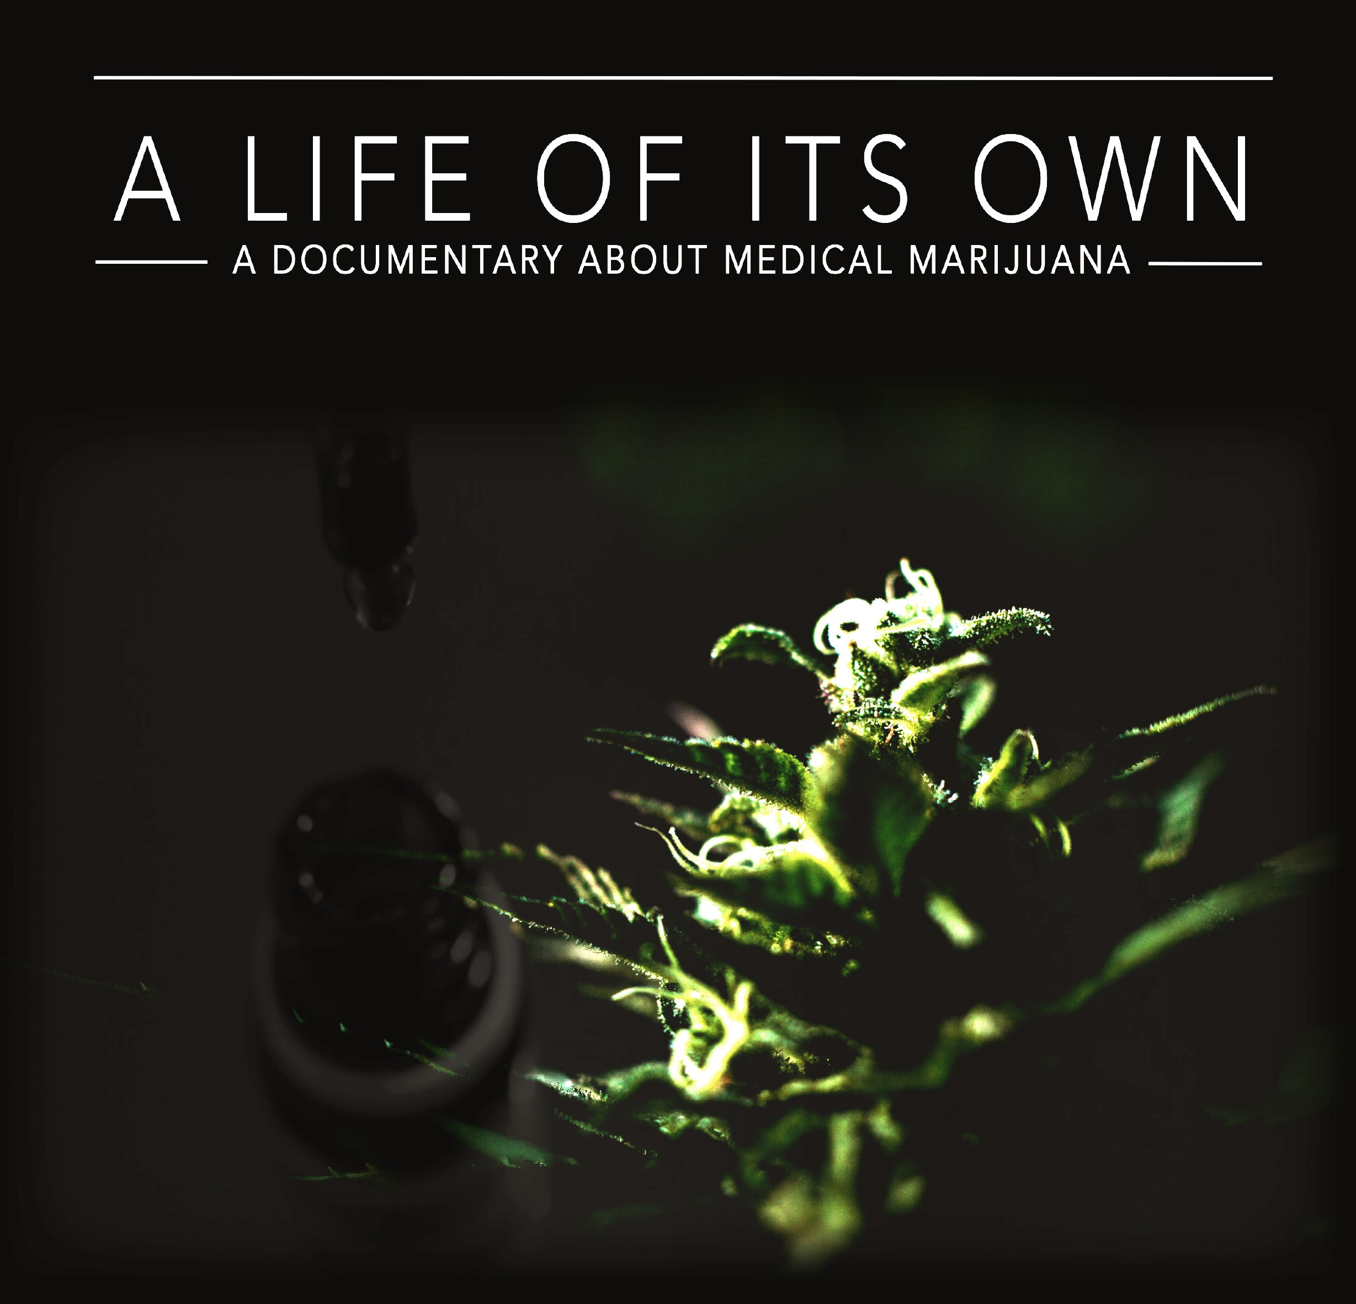
PRESS KIT
Running time: 81 mins

Writer, Director, Producer
HELEN KAPALOS

Executive Producer
HELEN KAPALOS
Supervising Producer
JIM SULLIVAN

PRESS CONTACT:
Helen Kapalos
hkapalos@gmail.com
www.alifeofitsown.com.au

DISTRIBUTION CONTACT:
Andrew Pike – Ronin Films
andrew.pike@roninfilms.com.au
www.roninfilms.com.au

ONE SENTENCE SYNOPSIS

A Life of Its Own is a feature documentary directed and produced by Helen Kapalos which aims to provide clarity and understanding of one of Australia’s most stigmatised and controversial issues – medical marijuana.

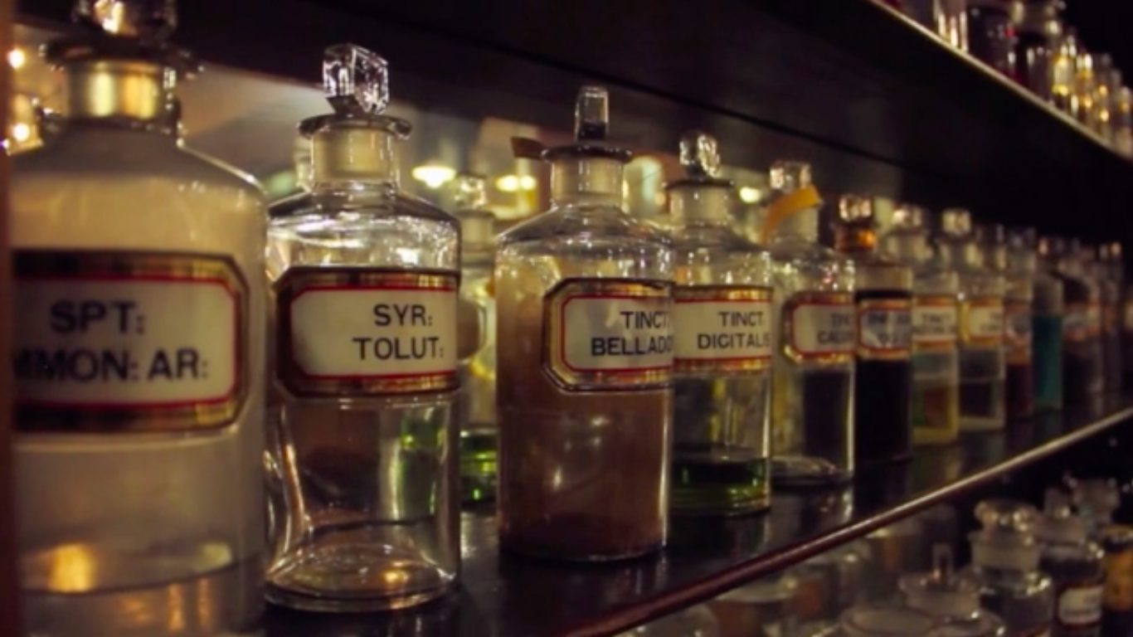

SHORT SYNOPSIS

A Life of Its Own aims to provide clarity and understanding of one of Australia’s most stigmatized and controversial issues – medicinal cannabis. Award-winning journalist, Helen Kapalos, takes the audience on a wide-ranging voyage of discovery about medicinal cannabis, addressing the complex issues facing its use. The film was inspired during the making of a network news TV story which detailed a young man's difficult decision to use cannabis for his terminal illness and to ease the debilitating nausea he experienced following chemotherapy – made all the more poignant because the young man’s father served for decades as a drug-squad police chief. In the weeks after the story was aired thousands of people came forward speaking of their own experience with medicinal cannabis. The story had unwittingly unearthed a silent majority - personal stories of patients suffering a range of illnesses, from intractable epilepsy to rare genetic diseases. Against the anecdotal evidence of benefits, the film discusses the lack of clinical evidence, the limitations of present drug regulation, the rise of a black market in medicinal cannabis, and the ongoing social stigma. The testimony of medical professionals, scientists, lawyers and politicians brings a balance to the debate.

Of particular impact is a rare insight into the medicinal cannabis research being carried out in Israel. This country is now recognized as a world leader in the development of specialized strains of medicinal cannabis, and their use in the treatment of a wide range of maladies.

Currently the climate around medicinal cannabis is shifting, with Australia moving towards limited reform. A Life of Its Own demonstrates there is still a gap between legislation, and the reality for many people whose lives are affected by the issue. Around the world the debate is being mobilised by those who've experienced success from the plant as medicine - with calls to make the wider community aware of its therapeutic value.
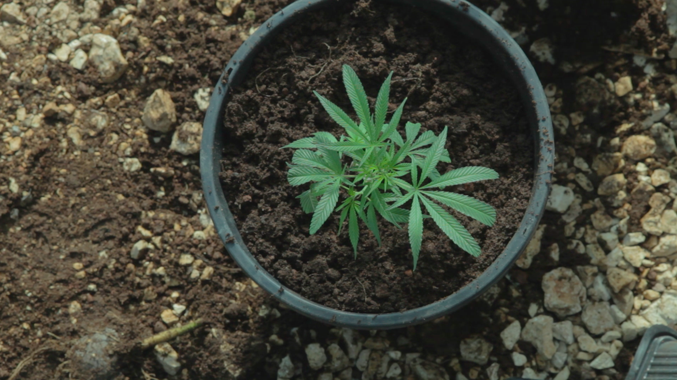

LONG SYNOPSIS

A Life of Its Own aims to provide clarity and understanding of one of Australia’s most stigmatized and controversial issues – medicinal cannabis. Award winning journalist, Helen Kapalos, takes the audience on a wide-ranging voyage of discovery about medicinal cannabis, addressing the complex issues facing its use today. The film was inspired by a network TV story in which a young man diagnosed with a terminal disease speaks about his difficult decision to use cannabis to ease his debilitating nausea following chemotherapy – a story made all the more poignant because the young man’s father is a former drug-squad police chief. The emotional result mirrors others portrayed sensitively throughout the film: personal stories of patients suffering a range of illnesses, from intractable epilepsy to rare genetic diseases. Presenting testimony of medical professionals, scientists, lawyers and politicians in Australia and overseas, A Life of Its Own seeks to present a clearer understanding of where the medical profession currently stands on the use of medicinal cannabis, and what legal and social obstacles may be preventing Australia from moving forward.

The film takes the viewer on an international journey, gaining a rare insight into the work being carried out in Israel – recognized as a world-leader into both the research and use of medicinal cannabis. There, specialised strains of medicinal cannabis are being developed, and government-controlled clinics provide treatment for a wide range of maladies. Researchers explain the relatively recent understanding of how the elements of cannabis react with human physiology, but stress the need for more wide-ranging studies of potential benefits, studies which have yet to be conducted on a large scale. The international experiences place the Australian debate within a broader context, and gives some clarity into how the plant went from general medical use early last century, to being demonized by drug laws – some of which were driven by protection for the synthetic fibre industry.

A Life of Its Own provides a thought-provoking case - contrasting the weight of anecdotal evidence against the absence of clinical research called for by the medical establishment.
In spite of the obstacles of drug laws, the film does show how a global shift in the scientific community’s understanding of medicinal cannabis is slowly taking place, and how Australia - influenced by determined and unintended advocates - is moving forward towards limited reform.

Director’s Statement

Helen Kapalos, Director

This documentary was conceptualised following a series of stories I worked on during my time as an investigative reporter on a major Australian network, stories which affected me profoundly. At the centre of those stories was 24-year-old Dan Haslam, struggling with the final stages of bowel cancer. A reluctant user, medicinal cannabis gave him instant relief during chemotherapy. This is the story of how Australia took up the debate with fervour. For Dan’s mum, Lucy, it led to a life-changing quest for answers and for the truth. The journey took me to the largest human trials in the world in Israel, where medicinal cannabis is legally administered and has been studied by leading scientists for more than 5 decades.
For me this revealed the full story of how science can work effectively with human trials. I was also astounded at the difference in the attitudes of doctors, in exploring the merit of medicinal cannabis as a genuinely alternative medication for patients. For me the Israeli model combined a tight regulatory framework, allowing the science to be practically applied, and exemplified a compassionate and humanitarian approach.

As a journalist, it was a story that I felt I had to tell in a more extended form than I had been able to within the parameters of a commercial TV network. It was an incredibly rewarding story to explore which will stay with me for many years to come as this plays out in a global setting. There’s much that needs to shift, including attitudes in some sections of the community as well as the medical profession. We all deserve the best options in healthcare. Furthermore, we have the right to know what those options are. The title reflects the life-enhancing properties of this ancient plant, and a story which indeed took on a life of its own.

LEGISLATION

In February 2016, the Australian parliament amended the Narcotic Drugs Act 1967 to permit legally-grown cannabis for the manufacture of medicinal cannabis products in Australia. The amendments also worked towards decriminalising the possession of cannabis for medicinal purposes. These amendments were designed to facilitate access to medicinal cannabis by people with painful and chronic illness, and had by bi-partisan support in parliament.

The amendments to the legislation allow the cultivation and production of cannabis and cannabis resin for medicinal as well as scientific purposes via a national licensing and permit scheme. Licences to cultivate medicinal cannabis will be a Commonwealth Government responsibility. Patients with a valid prescription can possess and use medicinal cannabis products manufactured from cannabis legally cultivated in Australia, provided the supply has been authorised under the Therapeutic Goods Act 1989 and relevant state and territory legislation. The Therapeutic Goods Act sets out requirements for supplying, importing, exporting, manufacturing and advertising therapeutic goods and establishes standards for the quality of therapeutic goods. On 5 April 2016, the Therapeutic Goods Administration (TGA) announced that medicinal cannabis would be classified as a Schedule 8 (S8) controlled drug from 1 June 2016. Schedule 8 drugs include medicines like morphine and dexamphetamine. Once in S8, medicinal cannabis products would be treated as controlled drugs and could be potentially prescribed by a medical practitioner.

Australia remains committed to upholding its strict international obligations to drug safety. The Secretary of the Department of Health has strict control over the level of production. Recreational cannabis cultivation and use remains illegal with state-based criminal laws still in place.
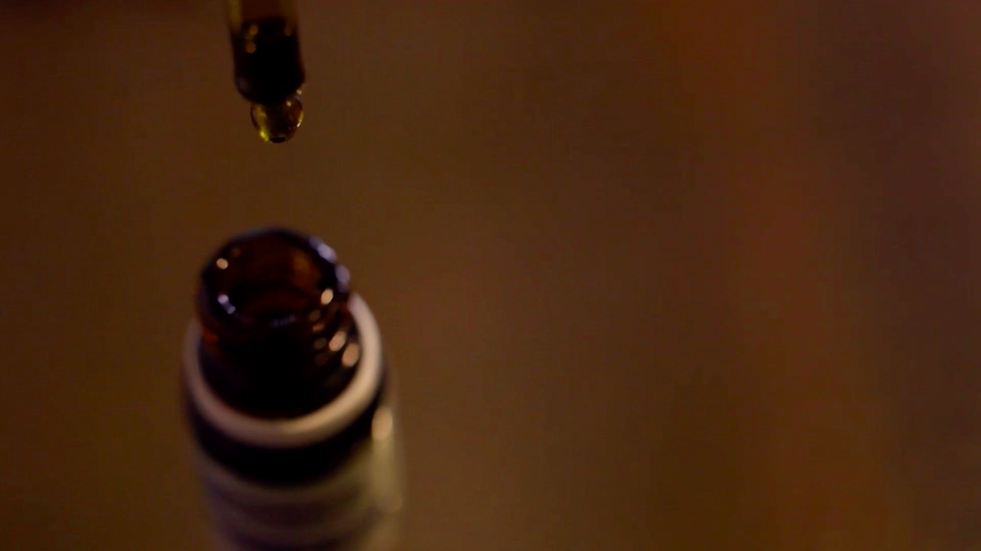

AUSTRALIAN STATE LAWS

In order for the changes in legislation to properly take effect, new legislation approving the manufacture and use of medicinal cannabis still needs to be passed by the states. Victoria has already made the necessary changes to its legislation, and NSW, Queensland and Tasmania are on the way to doing the same.
VICTORIA
On 6 October 2015 the Victorian Government announced that it would legalise access to medicinal cannabis in exceptional circumstances from 2017. The Access to Medicinal Cannabis Bill was introduced into Parliament on 8 December 2015 and was passed by Parliament on 12 April 2016. These legislative changes aim to establish a medicinal cannabis model that covers cultivation, manufacture and supply of medicinal cannabis products for patients in exceptional circumstances. It will determine patient eligibility and provide clinical oversight with advice from specialists, general practitioners, nurses and pharmacists.

NEW SOUTH WALES

The NSW Government announced the establishment of the Centre for Medicinal Cannabis Research and Innovation and is investing $9 million over the next five years on clinical trials of cannabis products. The trials will explore the use of cannabis and/or cannabis products in providing relief for patients suffering from severe paediatric epilepsy, chemotherapy-induced nausea and vomiting, and for symptom relief for those with terminal illness. The NSW Government has also developed the Terminal Illness Cannabis Scheme (TICS) to extend compassion to adults with a terminal illness.
TASMANIA
The Tasmanian Government is developing a Controlled Access Scheme (CAS) to allow patients to access unregistered medicinal cannabis products under prescription from their treating medical specialist, in limited circumstances where conventional treatment has been unsuccessful. The CAS will facilitate access to medicinal cannabis products grown lawfully under Commonwealth licenses, once they come onto the market.

QUEENSLAND
In 2015, The Queensland government amended the Health (Drugs and Poisons) Regulation 1996 to allow for the use of medicinal cannabis in clinical trials and is supportive of the Commonwealth government’s national licensing scheme.

We would also like to acknowledge the numerous medical professionals, researchers, and policy makers who contributed to the film:

- Professor Nicholas Lintzeris, Addiction Specialist, the University of Sydney
- Mike Baird, MP, Premier of New South Wales
- Emeritus Professor Laurence Mather, Anaesthesia, the University of Sydney
- Dr David Bearman, M.D, USA
- Dr David Caldicott, Addiction Specialist, Australian National University
- Prof Ingrid Scheffer, Paediatric Neurologist, the University of Melbourne and Florey Institute of Neuroscience and Mental Health.
- Prof Nick Talben, Royal Australasian College of Physicians
- Dr Robert Melamede, CEO, Cannabis Science
- Dr Alex Wodak, Physician, Australian Drug Reform Foundation
- Prof. Raphael Mechoulam, Chemist, Hebrew University
- Dr Michael Dor, Senior Medical Advisor, Israeli Health Ministry
- Dr. Andrew Katelaris
- Greg Barns, Human Rights Barrister
- Mark Heinrich, Cannabis Oil Producer
- Prof Tally Lerman-Sagie, Neurologist, Edith Wolfson Medical Centre.
- Dr. David Penington AC, Melbourne Medical School
- Dr. Noa Cohen, Biologist, Hebrew University of Jerusalem
- Ma’ayan Weisberg, Project Manager, Tikun Olam
- Inbal Sikorin, Nurse, Tikun Olam
- Dr. Moshe Inbar, Director of Oncology', Sourasky Medical Center
- Dr. Saxon Smith, AMA President, The University of Sydney

FULL CREDITS

Writer, Director, Producer
HELEN KAPALOS

Executive Producer
HELEN KAPALOS

Supervising Producer
JIM SULLIVAN

Israel Film Crew

Director of Photography
OMER MESSINGER

Sound
SHIMON FREIMAN

Hebrew Translator
TAMIR ALONI
Sydney Film Crew

Cameraman
MARK CAMWELL
MAX POLLEY

Sound
GREG NORTHAM
SAM BEATTIE
GLEN FITZPATRICK

Canberra Film Crew

Cameraman
ROBB SHAW-VELZEN

Sound
JIMMY GRAHAM

Melbourne Film Crew
Cameramen
ANDREW BRODERICK
TRAVIS CROSBIE
RODERRICK SOTA
ALEX TROUP
PAUL CANANZI

Tasmania Film Crew

Cameraman
TROY MELVILLE

Sound
DAVID TOTTIE
GEORGE GOERRS
Tasmania Transfers
DAVE FLOWERS

Tamworth Film Crew

Cameramen
PAUL SPURLING
TONY WHITTAKER
MATT FOLEY

Sound
DARREN SHINE

Additional Writing
JIM SULLIVAN

Editor
WAYNE HYETT A.S.E

Fine Cut Editor
ALEX ARCHER

Post Production Facility
CITY POST

Colourist

DEE MCCLELLAND

Online Editor
BELINDA FITHIW
Graphics
JUMBLA

Editing Assists
SALLY BLENHEIM
BILL KALAJDZIOVSK
Sound Design
LABSONICS
STEVE WITHEROW

Original Music
LAURENCE SCHUBERTH

Production Music
AUDIO NETWORK
UNIVERSAL MUSIC PUBLISHING

End Credit Music
PATRICK BERNARD
‘SHIVA SHAKTI

