PRESS KIT

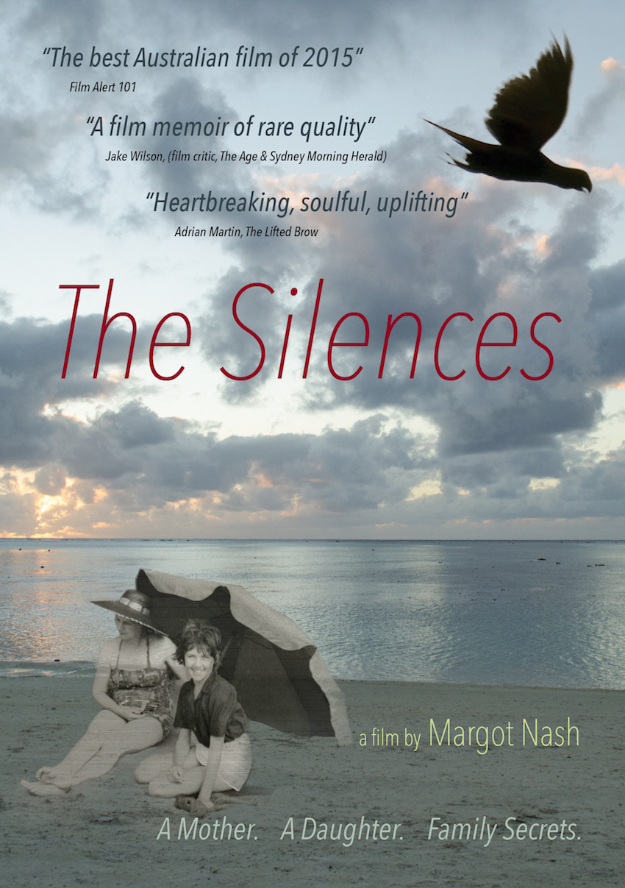

Distributed by Ronin Films: PO Box 680 Mitchell ACT 2911 [www.roninfilms.com.au](http://www.roninfilms.com.au/)

Ph: 02 6248 0851Fax: 02 6249 1640

Synopsis:

A film about family secrets and the ties of love, loss and kinship between a mother and daughter.

The Silences is a personal essay documentary about the tangled bonds, secret histories and unspoken traumas of family life that stretches from New Zealand to the Australian suburbs. It is an exploration of early childhood and the “silences” of the past that resonate in the present.  It draws upon a wealth of photographs, letters, oral histories, documentary footage and clips from the filmmaker’s previous work. It unfolds a mother’s story of lost opportunities, lost love and grief; a father’s story of work, mental illness and war; and a daughter’s story of trying to piece together a more complex picture of the confusing ties of love, loss and kinship between a mother and daughter.

Festivals, Awards and Events

Awards 2016   
AWGIE AWARD Documentary Broadcast or Exhibition  
Best Feature - 2nd Reel Sydney Festival of World Cinema   
Trophy Award- WAYMI (World Association of Young People who have a Mentally Ill Parent)   
Finalist Australian Directors Guild Awards – Feature Documentary   
2015   
Finalist Australian Teachers of Media Awards - Documentary Biography

Festivals and screenings

2016  
Soroptimist Int – fundraiser – Zenith Theatre Chatswood,   
Queensland Film Festival  
Griffith University – research seminar screening,   
Reel Sydney Festival of World Cinema – opening night film  
American Documentary Film Festival, Palm Springs – Official selection  
Between Past and Present: the films of Margot Nash - Melbourne Cinematheque, ACMI May 18th   
*The Silences* (2015) *Shadow Panic* (1989) *Vacant Possession* (1994)  
Ozdox The Australian Documentary Forum: International Women’s Day screening   
The Golden Age Cinema, Sydney  
2nd Reel Sydney Festival of World Cinema, Sutherland - Official Selection  
Queensland Film Festival - Official Selection

Australian Cinema Release: April/May: Cremorne Orpheum, Sydney, Cinema Nova, Melbourne, The Arc Canberra, The Mercury Adelaide, The Regal Newcastle

2015   
NZIFF (Auckland, Wellington, Christchurch, Dunedin) Official Selection  
MIFF (Melbourne International Film Festival) Official Selection - Australian Showcase   
Adelaide Film Festival - Australian Showcase, Official Selection  
Canberra International Film Festival- Official Selection  
Local Heroes: documentary community film event , Erskinville Town Hall (preview)  
The Golden Age Cinema, Sydney (preview)

Conferences and talks  
2016 ASPERA (Australian Screen Production Education & Research Association) conference, Canberra  
2015 Talking Pictures – True to Life: Meet the Documentary Filmmakers MIFF.   
2015 Camera Stylo – Sydney University *Building The Silences*  
2014 – Sightlines RMIT – *The Silences:* *a personal essay documentary (work in progress)*

Director’s Statement

*The Silences* is part memoir and part meditation on memory, history and photography*.* It investigates family secrets through an excavation of the repressed and hidden histories in my family, in particular the history of trauma and mental illness. It draws on family photographs, oral histories, my parents’ letters, documentary video footage I shot over a seven-year period and clips from my own body of work as a filmmaker.

Previously I had directed short films, documentaries and two feature dramas *Vacant Possession* (1994) and *Call Me Mum* (2005). I wanted to make a third feature and wrote a fictional screenplay called *My Mother Eve.* It was inspired by my conflicted relationship with my mother and also by my life as a young actress in Melbourne in the early 1970s. It was a big budget period film and raising the money proved difficult. I decided to reimagine it as a low-budget compilation documentary. I had a wealth of still photographs as well as oral history recordings I had made with both my mother and my sister and I had my own films to draw on as archival sources. I also had a background as a film editor.

Making ‘The Silences’ meant stepping back into my family history and questioning the narratives I had grown up with. Family stories always seemed set in stone yet I knew there were other stories, hovering in the background, if only I could find more evidence, if only I could remember. My memories of early childhood are different to my sister’s, yet we both grew up in the same terrifying household with its silences and tensions and both struggled with the reality of our father’s mental illness. Yet something was missing from this narrative. My relationship with my mother had always been fraught and after she died a part of me could not let go of trying to understand her. The relationship with the mother is the primary relationship and early childhood the cauldron that forms us all. Many women of my mother’s generation lived lives of quiet desperation, producing daughters, like myself, who discovered feminism in the 1970s and became determined to uncover repression and speak. My mother talked constantly, but what lay behind her inability to speak about things that really mattered?

Making a personal essay documentary meant leaping headlong into the family and the archives and the self. I wanted to embark on a discovery-driven process where I could speak my ‘truth’ but allow that ‘truth’ to shift and change. Memory and history are arguably constructions, often told by unreliable narrators and always with a point of view so, while striving for historical veracity, I decided to add other ingredients to the mix such as images from my childhood that I had recreated and reimagined in other films to tell other stories.

Told in the aftermath of my mother’s death *The Silences* eschews happy endings and strives for a space to speak about psychological complexity and acceptance.

Cast and Crew

**Produced, Written and Directed** by Margot Nash

**Composer and Pianist** – Elizabeth Drake

**Editor** – Margot Nash

**Sound Mix and Picture Online** – Michael Gissing

**Location Camera & Sound** – Margot Nash

**Narration Recording** – Luke Bacon

**Additional Sound Design** – Liam Egan

**Dialogue Editing** – Megan Wedge

**Research** – Margot Nash, Natalie Krikowa, Melissa Ippolito

**Still photograph wrangling** – Margot Nash

**Producer's Assistant** – Melissa Ippolito

**Web support and design** - Natalie Krikowa

**Bluray and DVD design** – Linda Dement

**Narration** - Margot Nash

**Actors** (appearing in clips from the following films)

*Vacant Possession (Margot Nash 1994)*

**Tessa** *-* Pamela Rabe

**Frank -** John Stanton

**Joyce -** Toni Scanlan

**Young Tessa** -Melissa Ippolito

**Young Kate -** Shelley McShane

*Shadow Panic (Margot Nash 1989)*   
**The Redhead** Robin Laurie

**The Child**, Elizabeth and Sandra Cooke

*Speaking Out (Margot Nash 1986)*

**Girl in telephone box** - Michela Noonan

**Girl on train** - Kathy Bain

*Call Me Mum (Margot Nash 2005*)

**Dellmay** *-* Lynette Curran

*We Aim To Please (Robin Laurie and Margot Nash 1976)*

Robin Laurie and Margot Nash

©As If Productions 2015 73min 16:9 Dolby Digital 5.1 2015

Margot Nash [asif@netspace.net.au](mailto:asif@netspace.net.au) (m) 0400717123 [www.margotnash.com](http://www.margotnash.com)

The Silences – Reviews (selected)

Phillipa Hawker – The Age & Sydney Morning Herald - The Silences review: a complex tale framed by hatred and longing. <http://ow.ly/XFs3301gBTj>

Adrian Martin – The Lifted Brow – Call her Mum: Margot Nash’s ‘The Silences’.  
<http://ow.ly/yQG3301gBWt>

Keith Gallash- Realtime Arts – Love and Pain: a crystalline memoir .  
<http://ow.ly/9ePp301gBZ5>

Felicity Ford - Senses of Cinema – Abandonment, Loss and Longing in Margot Nash’s The Silences.

<http://ow.ly/33vr301gC28>

Stephen Gaunson – Film Alert 101 – Defending Cinephilia (10) Stephen Gaunson on the Australian Cinema 2015

<http://ow.ly/hWk3301gC4w>

Dasha Romanowski - The Adelaide Review – The Silences review.

<http://ow.ly/BXCo301gC6S>

The Silences – Radio and pod casts (selected)

[The Silences Interview with director Margot Nash on The Final Cut with Jason Di Rosso on ABC RN](https://radio.abc.net.au/programitem/pgX4V0nOmG?play=true)<http://ow.ly/Uo2K301gBvO>

[RRR Margot Nash on Film Buffs Forecast](http://www.rrr.org.au/whats-going-on/news/margot-nash-on-film-buff-s-forecast/)

<http://ow.ly/XaOx301gBz6>

[The Silences 2SCR Real Radio - Margot Nash interview with Jess Kalijman](http://www.2ser.com/programs/new-music/item/21770-the-silence)

<http://ow.ly/Bbpe301gBHO>

3CR Annie McLoughlin The Silences Margot Nash<http://ow.ly/S03n301gBKi>

Radio NZ Nights interview  
<http://ow.ly/Mf5M301gBLW>

[The Movie Pack #16 - Interview with Margot Nash (Writer/Director/Academic) at MIFF](http://www.stitcher.com/podcast/the-movie-pack/e/16-margot-nash-writerdirectoracademic-40062536)  
<http://ow.ly/tDjn301gBNv>

Pod cast interview with Margot Nash at MIFF <http://ow.ly/oubs301gBQL>

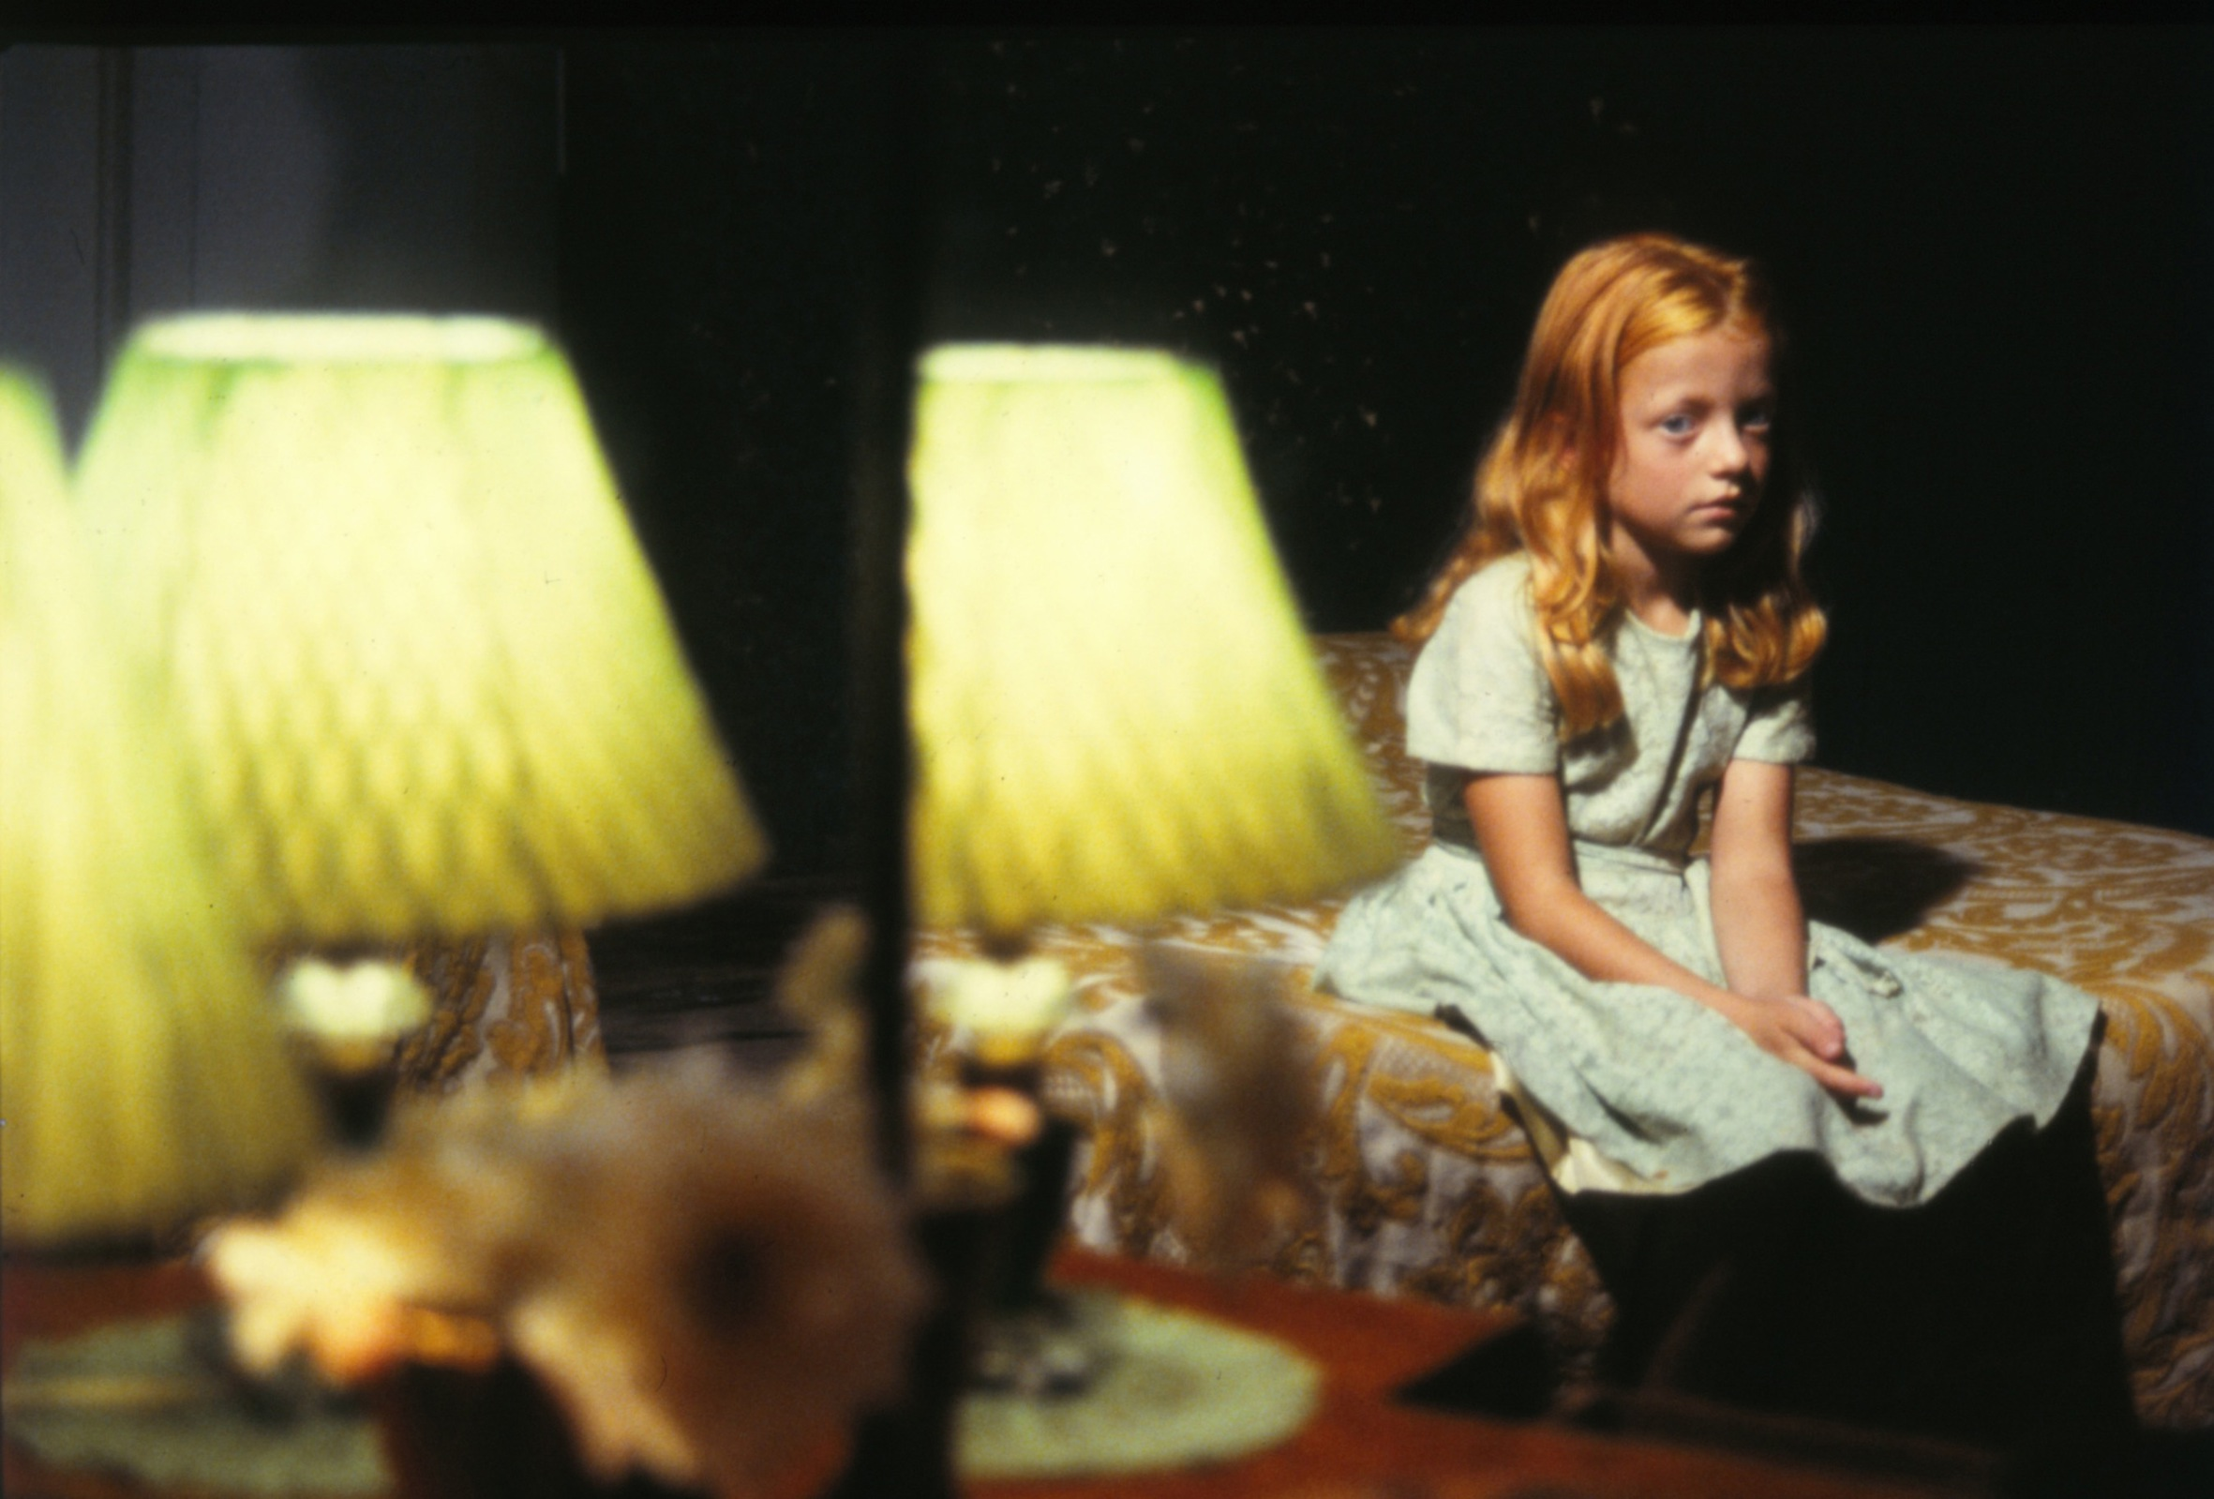

**The Child**

Elizabeth Cooke as The Child *Shadow Panic (Margot Nash 1989)*

Photo: Corrie Ancone

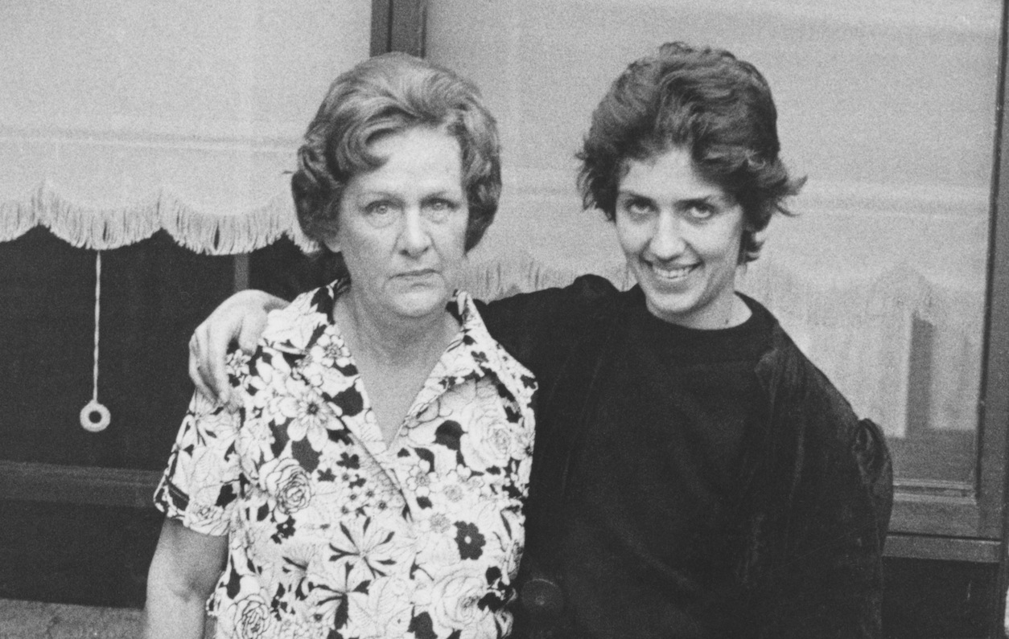

**Ethel and Margot 1976 (detail)**

Photo: Ponch Hawkes *Our Mum’s and Us Series 1976*

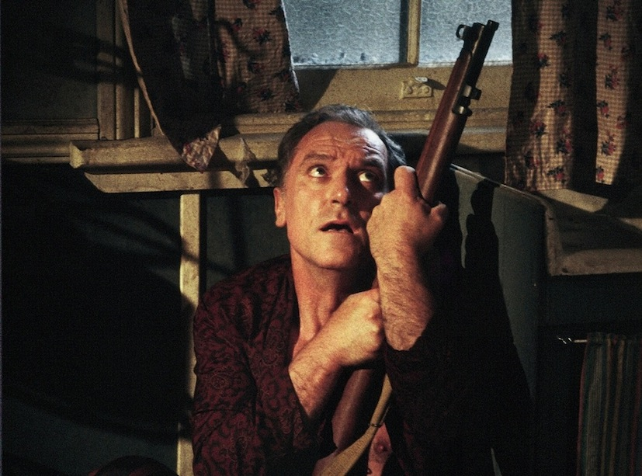

**The Father**

John Stanton as Frank *Vacant Possession (Margot Nash 1994)*

Photo: Corrie Ancone

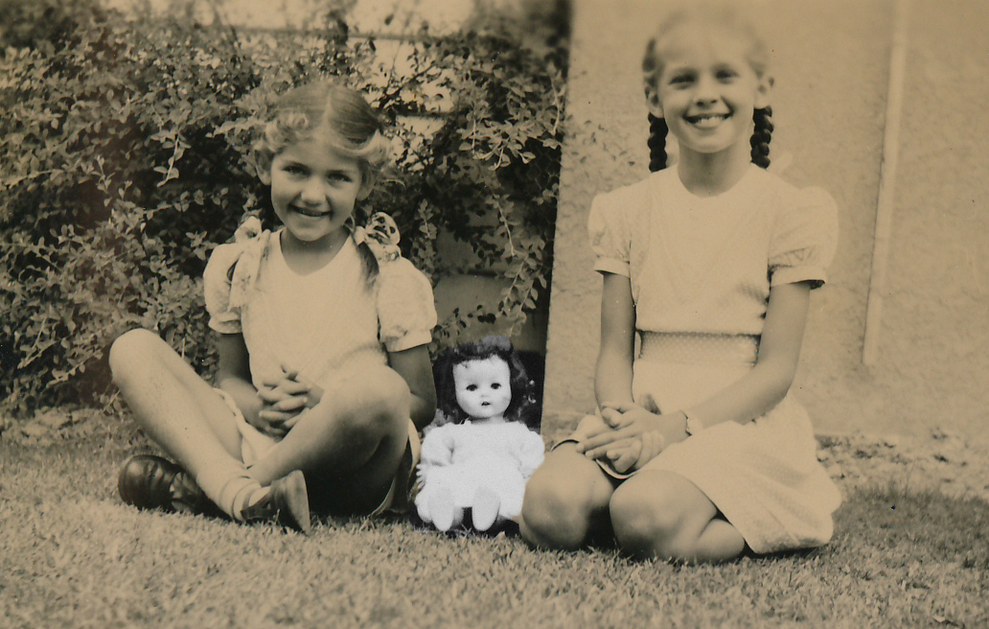

**Sisters** Margot and Diana c 1955

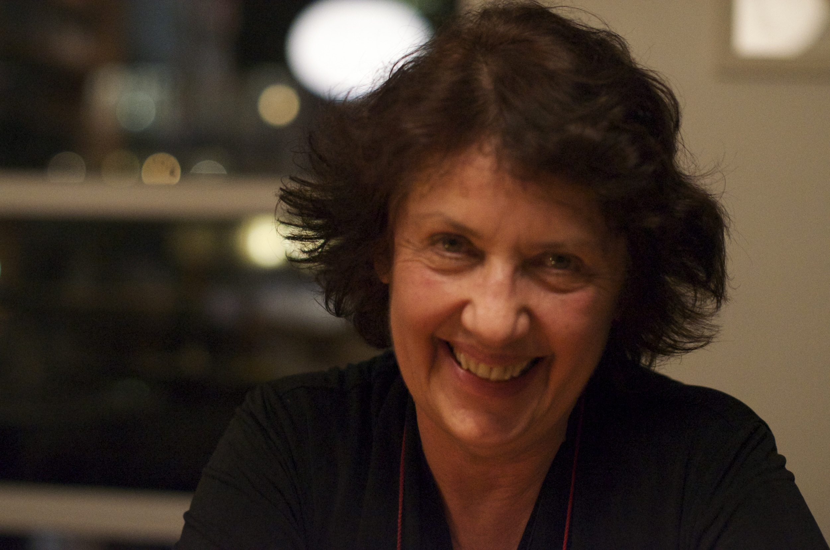

Producer/Director Margot Nash

Short Biography and Filmography

Margot Nash is a filmmaker and a Senior Lecturer in the School of Communications at the University of Technology, Sydney. She has produced, written and directed a number of award-winning films as well as working as a cinematographer and a film editor. Her credits include the experimental shorts *Shadow Panic* (prod/dir 1989) and *We Aim To Please* (co filmmaker 1976), the feature documentary *For Love Or Money* co filmmaker (1982) and the feature dramas *Vacant Possession* (dir/wr 1994) and *Call Me Mum* (dir 2005). In 2012 she was Filmmaker in Residence at Zürich University of the Arts where she began developing *The Silences*.

**THE SILENCES** (2015) **CALL ME MUM** (2005) **WORK** (1997) **CULTURAL PATTERNS**  (1995) **VACANT POSSESSION** (1994), **POSITIVE WOMEN** (1993), **SHADOW PANIC** (1989)**, SPEAKING OUT** (1986), **TENO** (1884), **FOR LOVE OR MONEY** (1983) co filmmaker **BREAD AND DRIPPING** (1982) co filmmaker **WE AIM TO PLEASE** (1976)co filmmaker

Long Biography

Margot Nash was born in Christchurch, New Zealand. Her family later relocated to Australia and she grew up in Melbourne. She began her career as an actor in theatre and television, starting out at the Melbourne Theatre Company and then joined the Australian Performing Group at the Pram Factory in Melbourne in the 1970s where she began videotaping shows and taking still photographs. After moving to Sydney she joined the Sydney Filmmakers Co op and began freelancing in the independent film sector.

She has produced, written and directed a number of award-winning films as well as working as a cinematographer and a film editor. Her first film, **We Aim To Please** about female sexualitywas made collaboratively with performer Robin Laurie. **We Aim To Please** won a Jury Prize at L’Homme Regarde Homme film festival in Paris in 1978. **We Aim To Please** has been restored by the National Film and Sound Archive and is represented in Screen Worlds, a permanent exhibition about the history of the moving image in Australia at ACMI (Australian Centre for the Moving Image) in Melbourne. Margot was co filmmaker and editor on the feature documentary **For Love or Money** (1982) about the history of women and work in Australia. **For Love or Money** screened internationally at festivals including Berlin, Toronto and the Tokyo International Women’s Film Festival. It received a UN Media Peace prize in 1985 and in 2010 and 2011 screened in Sydney on International Women’s Day.

Her short documentary **Teno** won the Jury Prize for Direction and Best Documentary in the ATOM (Australian Teachers of Media) Awards in 1984. Her experimental drama **Shadow Panic** (1989) won a Red Ribbon for Film as Art at the American Film and Video Festival, an AFI (Australian Film Institute) Award for Best Cinematography and an ATOM (Australian Teachers of Media) Award for Best Innovative Film. It screened internationally at festivals including London, Hawaii and Clermont Ferrand.

In 1994 Margot wrote and directed **Vacant Possession**, a feature drama about family, racial conflict and the complexities of reconciliation for which she was nominated for Best Directing and Best Original Screenplay in the AFI awards. Vacant Possession screened at festivals including Chicago, Hawaii and Asia Pacific and in 1996 won a Speciale Mention du Jury at the Films De Femmes festival in Créteil. In 1999 **For Love Or Money**, **Shadow Panic** and **Vacant Possession** screened as part of a ‘Tribute to Australian and NZ Women Filmmakers’ at Créteil in Paris. In 2005 Margot directed **Call Me Mum** for SBS Independent. **Call Me Mum** screened at festivals including Sydney, Adelaide and Créteil, won two AFI Awards in the telemovie category.

Margot has worked as a consultant and a mentor for Indigenous filmmakers and between 1996 and 2001 she worked in the Pacific running documentary training workshops for Pacific Island women television producers. She is currently working as a Senior Lecturer in the School of Communications at the University of Technology, Sydney. In 2012 she was the Filmmaker in Residence at Zürich University of the Arts where she began developing **The Silences**.

Filmography

**THE SILENCES** (2015) 73min personal essay documentary. Prod, Wr, Dir, Margot Nash   
As If Productions

*A film about family secrets and the ties of love, loss and kinship between a mother and daughter.*

**Awards** 2015 Finalist ATOM (Australian Teachers of Media) Awards

**Awards**2016AWGIE AWARD Documentary Broadcast or Exhibition  
Best Feature - 2nd Reel Sydney Festival of World Cinema   
Finalist Australian Directors Guild Awards – Feature Documentary  
Trophy Award- WAYMI (World Association of Young People who have a Mentally Ill Parent)   
2015 Finalist Australian Teachers of Media Awards - Documentary Biography  
 **Festivals and screenings**2016 Soroptimist Int fundraiser Zenith Theatre Chatwood  
Queensland Film Festival - Official Selection,   
2nd Reel Sydney Festival of World Cinema, Sutherland Sydney   
Ozdox The Australian Documentary Forum: International Women’s Day screening AFTRS March 8.   
American Documentary Film Festival, Palm Springs - March 30 – April 4   
Between Past and Present: the films of Margot Nash - Melbourne Cinematheque, ACMI May 18th   
2015 The Golden Age cinema (preview)  
Local Heroes, Erskinville (preview)   
Canberra International Film Festival  
Adelaide Film Festival - Australian Showcase,   
MIFF (Melbourne International Film Festival) Official Selection - Australian Showcase  
NZIFF (Auckland, Wellington, Christchurch, Dunedin) Official Selection

Australian Cinema Release: April/May 2016: Cremorne Orpheum, Sydney, Cinema Nova, Melbourne, The Arc Canberra, The Mercury Adelaide, The Regal Newcastle

**Conferences and talks**2016 ASPERA (Australian Screen Production Education & Research Association) conference, Canberra,   
Griffith Film School, Screening and Research Seminar, Brisbane   
2015 Talking Pictures – True to Life: Meet the Documentary Filmmakers MIFF.   
2015 Camera Stylo – Sydney University *Building The Silences*  
2014 – Sightlines RMIT – *The Silences:* *a personal essay documentary (work in progress)*

**CALL ME MUM** (2005) 76min feature drama. Director: Margot Nash. Writer: Kathleen Mary Fallon, Producer Michael McMahon, Big and Little Films.*When Kate decided to reunite her Torres Strait Islander foster son with his birth mother, dangerous family and racial tensions surface*.

**Awards**2007 AFI Awards: Best Supporting Actress Television Drama, Outstanding Achievement in Screen Craft Television (shared). Nominations: Best Actress Television Drama, Best Supporting Actress Television Drama. 2006 Short-listed NSW Premier’s Literary Awards, Nominated AWGIE Awards (telemovie)   
**Festivals and screenings**  
2009 European Association of Studies of Australia 10th Biennial Conference Palma Spain,Seen and Heard: Festival of Women’s films, Sydney, Peer reviewed ASPERA2008 Sydney Writers Festival Bangarra Theatre and The Edge Katoomba; IAPL - Global Arts Local Knowledge Conference, Melbourne; Reconciliation week, Department of Victorian Communities ACMI   
2007 Cinema des Antipodes, Saint Tropez, FRANCE; Ordinary Lives - Narratives of Disability University of SOUTH AUSTRALIA; NAIDOC screening Australian Embassy PARIS; ADELAIDE Film Festival; Festival International de Films de Femmes du Créteil, PARIS (in competition International Long Feature and Grain du Cinepharge,) ANZJA Conference Sydney  
2006 SYDNEY Film Festival, WINNIPEG International Film Festival, The Female Eye TORONTO (in competition), Young at Heart Film Festival SYDNEY, Genres of History Conference ANU, Townsville Cultural Centre, TOWNSVILLE

**Broadcast:** SBS May 6th and Dec 9th 2007 and Sept 1st 2010 **Distribution:** Ronin Films

**WORK** (1997)Wr, Dir Margot Nash, Film Australia   
*Three ten-minute documentaries for schools about the changing nature of work. Part 1: The Vanishing Weekend. Part 2: Time is Money, Part 3 Work in Progress.*

**CULTURAL PATTERNS**  (1995) 26min documentary, Wr, Dir Margot Nash   
*The Australian episode of New Horizons: Human stories of economic change. The story of a successful Aboriginal design consultancy business.*

**Awards** Finalist: Oceana region Earth Vision 5th Global Environmental Film Festival

**VACANT POSSESSION** (1994) 95min feature drama. Wri and Dir Margot Nash, Prod John Winter. Wintertime Productions and As If Productions

*The story of two families: one white one Aboriginal both living in the shadow of the past. Weaving dream, memory and fantasy Vacant Possession is a story of conflict and the complexities of reconciliation.*

**Awards** 1998 Audience Award: La Mo-Viola Cinema Delle Donne – Torino, Italy.

1996 Speciale Mention du Jury: Films Des Femmes Créteil, France

AFI Nominations: Best Director, Best Original Screenplay, Best Editing, Best Sound

1995Voted most popular Australian film Sydney Film Festival.

**Festivals and screenings**   
2016 Between Past and Present: The films of Margot Nash - Melbourne Cinematheque, ACMI  
2015 National Film and Sound Archive, Canberra Film festival members screening  
2002 Buenos Aires 5th International Festival of Independent film. ARGENTINA

1999 Tribute to Australian & NZ Women Filmmakers: Films Des Femmes Créteil, FRANCE; Kino Xenix Screenings

1998Dreaming Reels – NFSA CANBERRA. Downloading Downunder Australian Film, Video and New Media AMSTERDAM

1997 Femme Totale – Dortmund GERMANY; La Mo-Viola Cinema Delle Donne – Torino ITALY; Ist

Women’s Film Festival Seoul – KOREA; Australian Film Festival Johannesburg SOUTH AFRICA.

1996PORTLAND;SEATTLE;Films Des Femmes CRÊTEIL;ADELAIDE;Strictly OZ USA – UCLA and WASHINGTON;SYD Travelling Film Fest; Oz: Adventures in Australian Filmmaking;New Australian films KOREA;New Delhi International Film Festival;Australian Identities, history and culture – DUBLIN; Arsenals Film Forum – LATVIA; Cinema Tout Ecran – GENEVA**,** OLDENBURG.

1995 CHICAGO; HAWAII; ASIA PACIFIC; SYDNEY; MELBOURNE; PERTH; BRISBANE,

**Theatrical release:** 1996 Sydney, Melbourne, Perth, Hobart, Cairns, Noosa, Darwin, Adelaide London

**Broadcast:** SBS Australia Day 2001; NAIDOC week July 2001

**Distribution:** Wintertime Films

**POSITIVE WOMEN** (1993)26min documentary.Writer, Director - As If Productions

*Made for HIV positive women and health workers.*

**Awards** British Medical Association Award

**SHADOW PANIC** (1989) 26min Experimental Drama – Prod, Wr, Dir, Margot Nash, As If Productions

*A short experimental film about internal and external states of emergency, about personal and collective shadows, about resistance and spirit.*

**Awards** 1990Red Ribbon (Film as Art): American Film and Video Festival; Innovative Award ATOM (Australian

Teachers of Media) Awards

1989 Best Cinematography AFI Australian Film Institute Awards; Certificate of Merit Melbourne Film Festival; Special Commendation for a New Australian Film Frames Festival Adelaide; Best Experimental Nomination AFI Awards; Finalist Dendy Awards Sydney Film Festival.

**Festivals and screenings**   
2016 Green Screen IMA Brisbane  
Between Past and Present: The films of Margot Nash - Melbourne Cinematheque, ACMI  
2008 UWA Vision, Memory, Spectacle - Aust Women’s and Gender Studies Conference

1999Films Des Femmes Créteil FRANCE: Tribute to Aust & NZ women.

1998 Downloading Downunder: Australian Film and New Media AMSTERDAM

1989Australian Film Institute; BFI Short Film Season; Experimental Media Arts;LONDON; HAWAII; MELBOURNE; SYDNEY; SPOLETO FRINGE;

1990Films Des Femmes Créteil, FRANCE; CLERMONT FERRAND; WELLINGTON; FRAMES Film Festival Adelaide; INSIGHT Women’s Festival Canada; American Film and Video Festival; Australia Teachers of Media Inc; Edmonton International Student Festival

1991IMAGES Festival of Independent Film and Video Toronto

**Theatrical release**: Australia and UK. Screened theatrically in 1989 in London supporting Chantal Ackerman’s feature ‘American Stories.’ **Distribution:** As If Productions **Broadcast**: SBS

**SPEAKING OUT** (1986) 26 min Dramatised documentary. Wr, Dir, Prod Margot Nash, As If Productions   
*A short documentary about young girls in care and at risk.***Awards** Best Documentary: Australian Video Festival 1987

**TENO** (1884) 13 min Documentary. Writer, Director Margot Nash - Film Australia

*A short documentary about repetitive strain injuries.***Awards** Best Documentary and Jury Prize for Direction: Australian Teachers of Media ATOM Awards. Editing Nomination: AFI Awards. Certificate of Creative Excellence: US Industrial Film Festival. Honourable Mention: San Francisco Film Festival.

**FOR LOVE OR MONEY** (1983)109min 16mmcompilation documentary.Co filmmaker, editor

A film by Megan McMurchy, Margot Nash, Margot Oliver, Jeni ThornleyFlashback Films.

*A history of women and work in Australia.***Awards**

1985 Gold Citation: United Nations Media Peace Prize: Television. 1984 Best Feature Documentary: International Women’s Cinema Encounter Florence. Best Documentary and Best Screenplay Nominations: AFI Awards,

**Festivals and screenings**  
2015 Women’s Gaze and the Feminist Film Archive, Future Feminist Archive exhibition SCA Sydney  
2011 International Women’s Day Centenary screening Parkes Film Festival.

2010 International Women’s Day and Women’s History month: ANU and Canberra Grammar School.

2009 Seen and Heard Women’s film festival, International Women’s Day, Avoca Beach Cinema Sydney;

1999 Tribute to Aust & NZ women Films Des Femmes Créteil, FRANCE

1998 BARCELONA **1988** ‘BACK OF BEYOND’ UCLA; NYON; LISBON

1987 WOMEN IN THE DIRECTORS CHAIR Chicago

1986 SCOTTSDALE USA; US FILM FESTIVAL Salt Lake City

1985 Films Des Femmes Créteil, FRANCE ; VALLADOLID; International Women’s Film Forum NAIROBI; ST KILDA; TOKYO International Women’s Film Festival

1984 BERLIN; TORONTO, MONTREAL; AUCKLAND; CAMBRIDGE; PORTUGAL; UPPSALA; WELLINGTON; WOMEN MAKE MOVIES San Francisco,

**Theatrical release**: Australia 1983 UK 1984 **Broadcast:** Australia (ABC), Denmark, Eire, Greece.  
**Distribution:** Ronin Films

**BREAD AND DRIPPING** (1982) 17min documentaryCo filmmaker, editor Wimmins films

*A short documentary about women in the 1930s Depression.*

**Festivals and screenings**  
MELB, WELLINGTON 1983 TYNESIDE 1984 CINEMA DU REEL 2009SEEN AND HEARD film festival, Sydney.

**WE AIM TO PLEASE** (1976) 13min 16mm Experimental short - Co filmmaker with Robin LaurieAs If Productions

*A short experimental film about female sexuality*

**Awards** Jury Prize: L’Homme Regarde L’Homme Film Festival Paris.

**Festivals and screenings**  
2015 Women’s Gaze and the Feminist Film Archive, Future Feminist Archive exhibition SCA Sydney  
2014 The form that accommodates the mess - IMA (Institute of Modern Art) Brisbane2009 Screen Worlds ACMI (Australian Centre for the Moving Image) Melbourne – permanent exhibition

2008 Australian Perspectives: New and Archival queer shorts ACMI

2005 Resistance: a screen history of Australian counter cultural movements ACMI

1999The Wild and Wonderful 70’s Chauvel SYDNEY

1996 Valladolid SPAIN; Filmoteca MADRID

1994 BARCELONA; *Women and Film: The Hidden (A) Gender* ADELAIDE;

1990 INSIGHT Women’s Film Festival-Canada

1989 OTHER PLEASURES Modern Image Makers Melbourne

1987 SPOLETO FRINGE Melb

1982 Gay Film Festival LONDON

1981 1st International Feminist Film and Video Conference AMSTERDAM

1979 Bergama Festival of Third Theatre ITALY; Women’s Arts Festival, Christchurch NEW ZEALAND

1978 L’Homme Regarde L’Homme Paris; La Rochelle Avant Garde Film Festival PARIS; World Congress of Sociology FINLAND

1977 WOMEN WAVES Sydney Filmmakers Cooperative national tour of short films **Distribution:** As If Productions