PRESS KIT

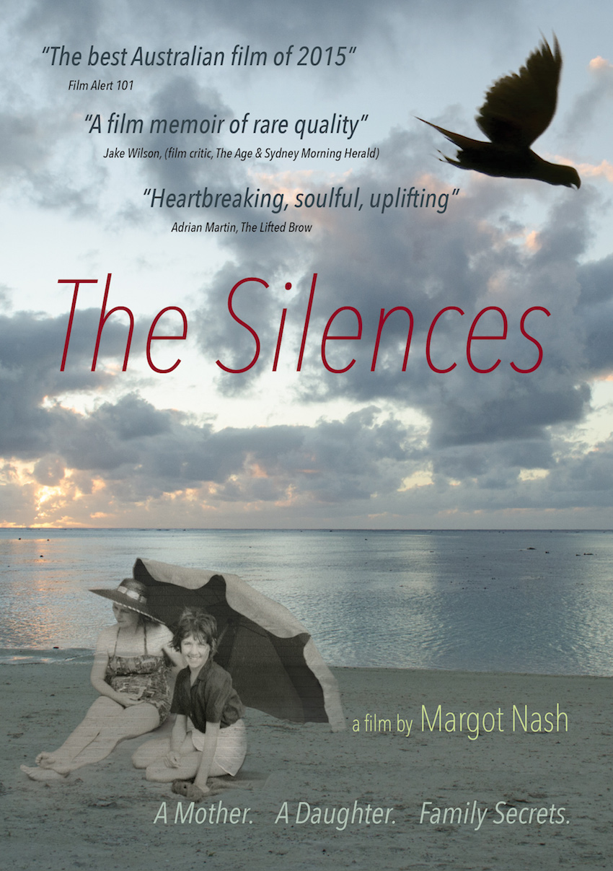

Distributed by Ronin Films: PO Box 680 Mitchell ACT 2911 www.roninfilms.com.au
Ph: 02 6248 0851Fax: 02 6249 1640

Synopsis:
A film about family secrets and the ties of love, loss and kinship between a mother and daughter.

The Silences is a personal essay documentary about the tangled bonds, secret histories and unspoken traumas of family life that stretches from New Zealand to the Australian suburbs. It is an exploration of early childhood and the “silences” of the past that resonate in the present. It draws upon a wealth of photographs, letters, oral histories, documentary footage and clips from the filmmaker’s previous work. It unfolds a mother’s story of lost opportunities, lost love and grief; a father’s story of work, mental illness and war; and a daughter’s story of trying to piece together a more complex picture of the confusing ties of love, loss and kinship between a mother and daughter.

Festivals, Awards and Events
Awards
2016
AWGIE AWARD Documentary Broadcast or Exhibition
Best Feature - 2nd Reel Sydney Festival of World Cinema
Trophy Award- WAYMI (World Association of Young People who have a Mentally Ill Parent)
Finalist Australian Directors Guild Awards – Feature Documentary
2015
Finalist Australian Teachers of Media Awards - Documentary Biography
Festivals and screenings
2016
Soroptimist Int – fundraiser – Zenith Theatre Chatswood,
Queensland Film Festival
Griffith University – research seminar screening,
Reel Sydney Festival of World Cinema – opening night film
American Documentary Film Festival, Palm Springs – Official selection
Between Past and Present: the films of Margot Nash - Melbourne Cinematheque, ACMI May 18th
The Silences (2015) Shadow Panic (1989) Vacant Possession (1994)
Ozdox The Australian Documentary Forum: International Women’s Day screening
The Golden Age Cinema, Sydney
2nd Reel Sydney Festival of World Cinema, Sutherland - Official Selection
Queensland Film Festival - Official Selection
Australian Cinema Release: April/May: Cremorne Orpheum, Sydney, Cinema Nova, Melbourne, The Arc Canberra, The Mercury Adelaide, The Regal Newcastle
2015
NZIFF (Auckland, Wellington, Christchurch, Dunedin) Official Selection
MIFF (Melbourne International Film Festival) Official Selection - Australian Showcase
Adelaide Film Festival - Australian Showcase, Official Selection
Canberra International Film Festival- Official Selection
Local Heroes: documentary community film event , Erskinville Town Hall (preview)
The Golden Age Cinema, Sydney (preview)
Conferences and talks
2016 ASPERA (Australian Screen Production Education & Research Association) conference, Canberra
2015 Talking Pictures – True to Life: Meet the Documentary Filmmakers MIFF.
2015 Camera Stylo – Sydney University Building The Silences
2014 – Sightlines RMIT – The Silences: a personal essay documentary (work in progress)

Director’s Statement
The Silences is part memoir and part meditation on memory, history and photography. It investigates family secrets through an excavation of the repressed and hidden histories in my family, in particular the history of trauma and mental illness. It draws on family photographs, oral histories, my parents’ letters, documentary video footage I shot over a seven-year period and clips from my own body of work as a filmmaker.

Previously I had directed short films, documentaries and two feature dramas Vacant Possession (1994) and Call Me Mum (2005). I wanted to make a third feature and wrote a fictional screenplay called My Mother Eve. It was inspired by my conflicted relationship with my mother and also by my life as a young actress in Melbourne in the early 1970s. It was a big budget period film and raising the money proved difficult. I decided to reimagine it as a low-budget compilation documentary. I had a wealth of still photographs as well as oral history recordings I had made with both my mother and my sister and I had my own films to draw on as archival sources. I also had a background as a film editor.

Making ‘The Silences’ meant stepping back into my family history and questioning the narratives I had grown up with. Family stories always seemed set in stone yet I knew there were other stories, hovering in the background, if only I could find more evidence, if only I could remember. My memories of early childhood are different to my sister’s, yet we both grew up in the same terrifying household with its silences and tensions and both struggled with the reality of our father’s mental illness. Yet something was missing from this narrative. My relationship with my mother had always been fraught and after she died a part of me could not let go of trying to understand her. The relationship with the mother is the primary relationship and early childhood the cauldron that forms us all. Many women of my mother’s generation lived lives of quiet desperation, producing daughters, like myself, who discovered feminism in the 1970s and became determined to uncover repression and speak. My mother talked constantly, but what lay behind her inability to speak about things that really mattered?

Making a personal essay documentary meant leaping headlong into the family and the archives and the self. I wanted to embark on a discovery-driven process where I could speak my ‘truth’ but allow that ‘truth’ to shift and change. Memory and history are arguably constructions, often told by unreliable narrators and always with a point of view so, while striving for historical veracity, I decided to add other ingredients to the mix such as images from my childhood that I had recreated and reimagined in other films to tell other stories.

Told in the aftermath of my mother’s death The Silences eschews happy endings and strives for a space to speak about psychological complexity and acceptance.

Cast and Crew

Produced, Written and Directed by Margot Nash
Composer and Pianist – Elizabeth Drake
Editor – Margot Nash
Sound Mix and Picture Online – Michael Gissing
Location Camera & Sound – Margot Nash
Narration Recording – Luke Bacon
Additional Sound Design – Liam Egan
Dialogue Editing – Megan Wedge
Research – Margot Nash, Natalie Krikowa, Melissa Ippolito
Still photograph wrangling – Margot Nash
Producer's Assistant – Melissa Ippolito
Web support and design - Natalie Krikowa
Bluray and DVD design – Linda Dement
Narration - Margot Nash

Actors (appearing in clips from the following films)

Vacant Possession (Margot Nash 1994)
Tessa - Pamela Rabe
Frank - John Stanton
Joyce - Toni Scanlan
Young Tessa - Melissa Ippolito
Young Kate - Shelley McShane

Shadow Panic (Margot Nash 1989)
The Redhead Robin Laurie
The Child, Elizabeth and Sandra Cooke

Speaking Out (Margot Nash 1986)
Girl in telephone box - Michela Noonan
Girl on train - Kathy Bain

Call Me Mum (Margot Nash 2005)
Dellmay - Lynette Curran

We Aim To Please (Robin Laurie and Margot Nash 1976)
Robin Laurie and Margot Nash

©As If Productions 2015 73min 16:9 Dolby Digital 5.1 2015
Margot Nash asif@netspace.net.au (m) 0400717123 www.margotnash.com

The Silences – Reviews (selected)

Phillipa Hawker – The Age & Sydney Morning Herald - The Silences review: a complex tale framed by hatred and longing. http://ow.ly/XFs3301gBTj
Adrian Martin – The Lifted Brow – Call her Mum: Margot Nash’s ‘The Silences’.
http://ow.ly/yQG3301gBWt
Keith Gallash- Realtime Arts – Love and Pain: a crystalline memoir .
http://ow.ly/9ePp301gBZ5

Felicity Ford - Senses of Cinema – Abandonment, Loss and Longing in Margot Nash’s The Silences.
http://ow.ly/33vr301gC28
Stephen Gaunson – Film Alert 101 – Defending Cinephilia (10) Stephen Gaunson on the Australian Cinema 2015
http://ow.ly/hWk3301gC4w
Dasha Romanowski - The Adelaide Review – The Silences review.
http://ow.ly/BXCo301gC6S

The Silences – Radio and pod casts (selected)

The Silences Interview with director Margot Nash on The Final Cut with Jason Di Rosso on ABC RN http://ow.ly/Uo2K301gBvO

RRR Margot Nash on Film Buffs Forecast
http://ow.ly/XaOx301gBz6

The Silences 2SCR Real Radio - Margot Nash interview with Jess Kalijman
http://ow.ly/Bbpe301gBHO

3CR Annie McLoughlin The Silences Margot Nash
http://ow.ly/S03n301gBKi

Radio NZ Nights interview
http://ow.ly/Mf5M301gBLW

The Movie Pack #16 - Interview with Margot Nash (Writer/Director/Academic) at MIFF
http://ow.ly/tDjn301gBNv

Pod cast interview with Margot Nash at MIFF http://ow.ly/oubs301gBQL

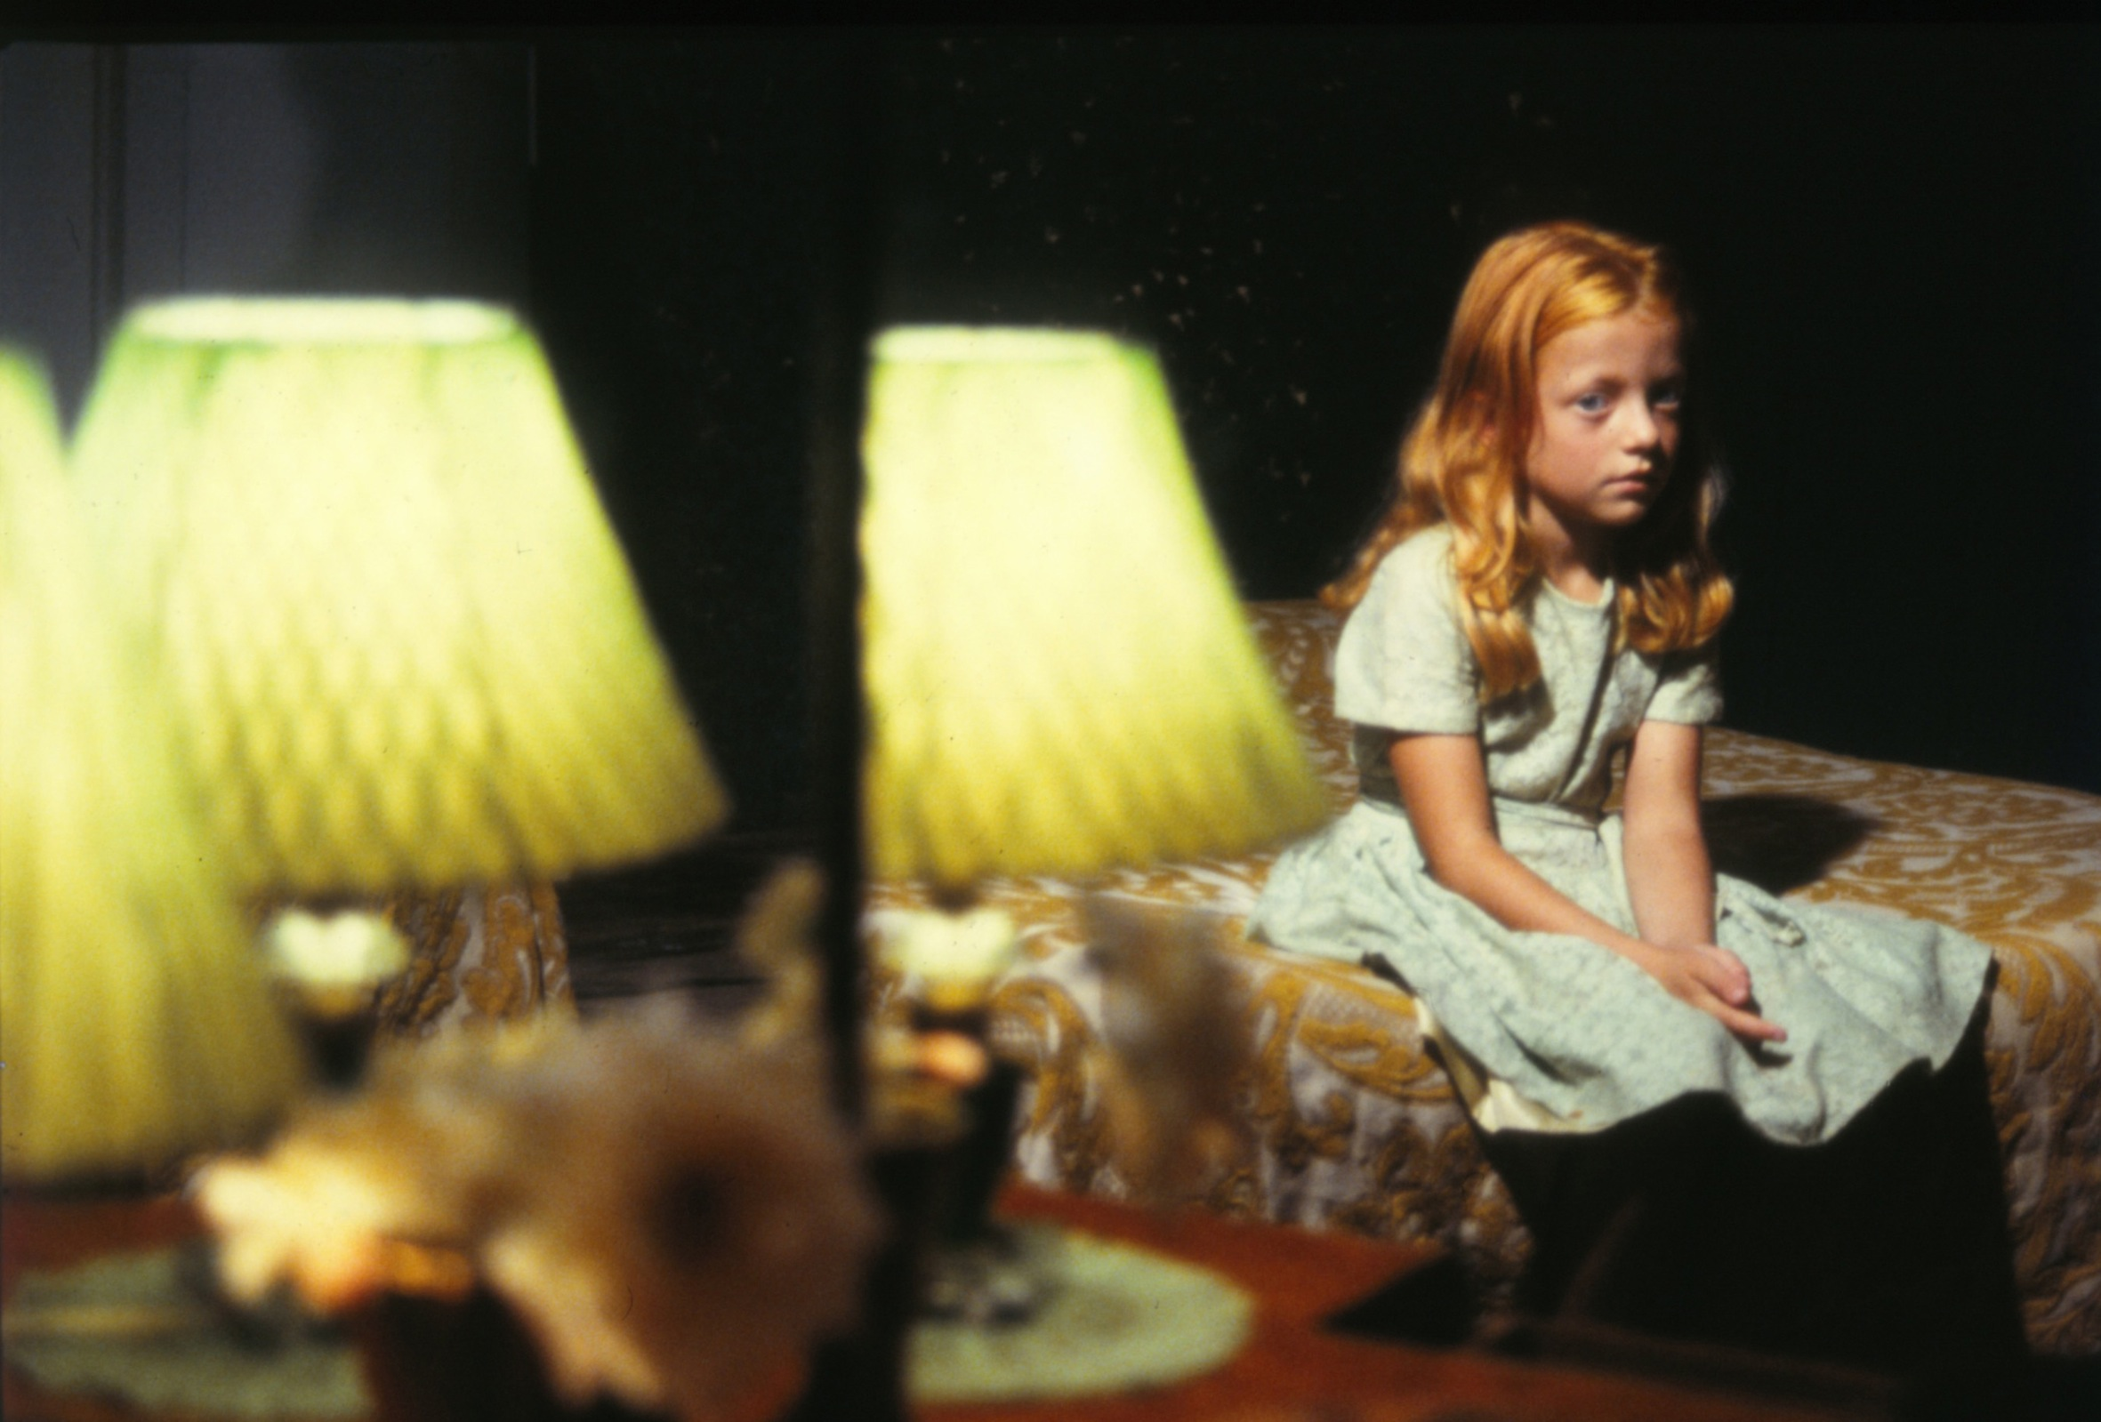

The Child
Elizabeth Cooke as The Child Shadow Panic (Margot Nash 1989)
Photo: Corrie Ancone

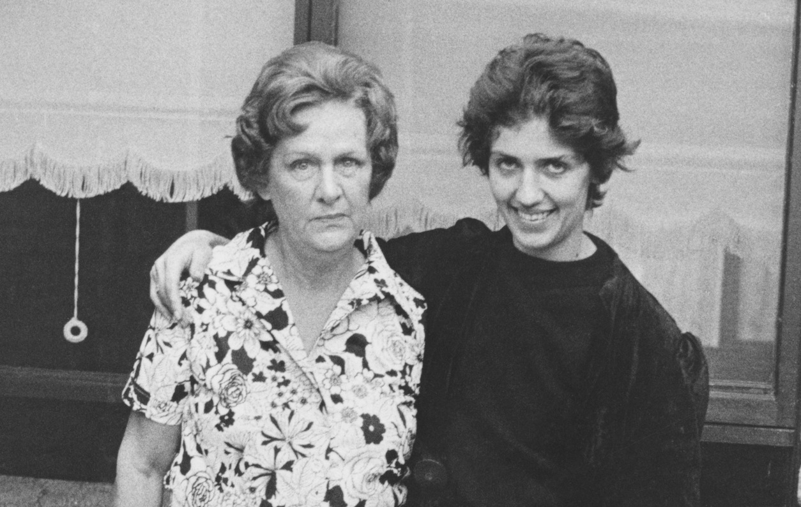

Ethel and Margot 1976 (detail)
Photo: Ponch Hawkes Our Mum’s and Us Series 1976

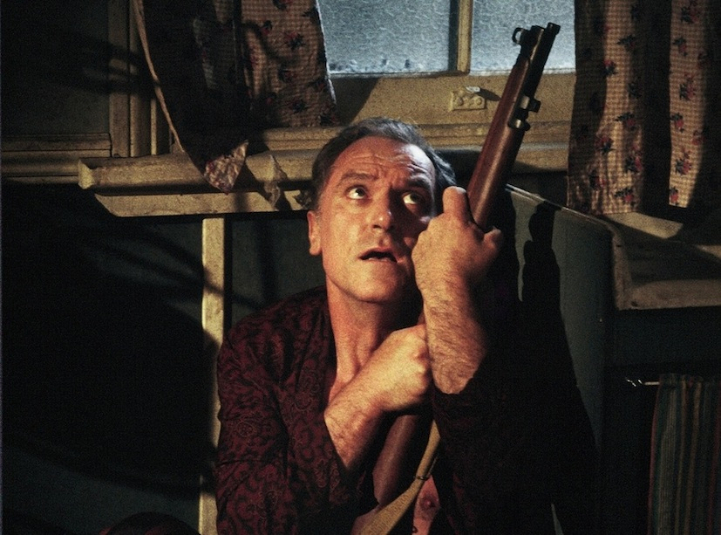

The Father
John Stanton as Frank Vacant Possession (Margot Nash 1994)
Photo: Corrie Ancone

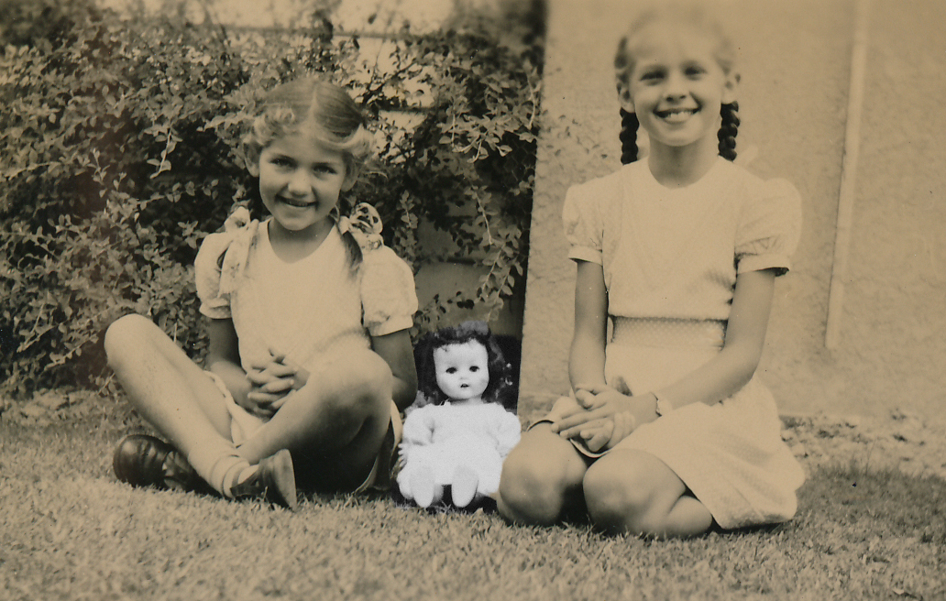

Sisters Margot and Diana c 1955

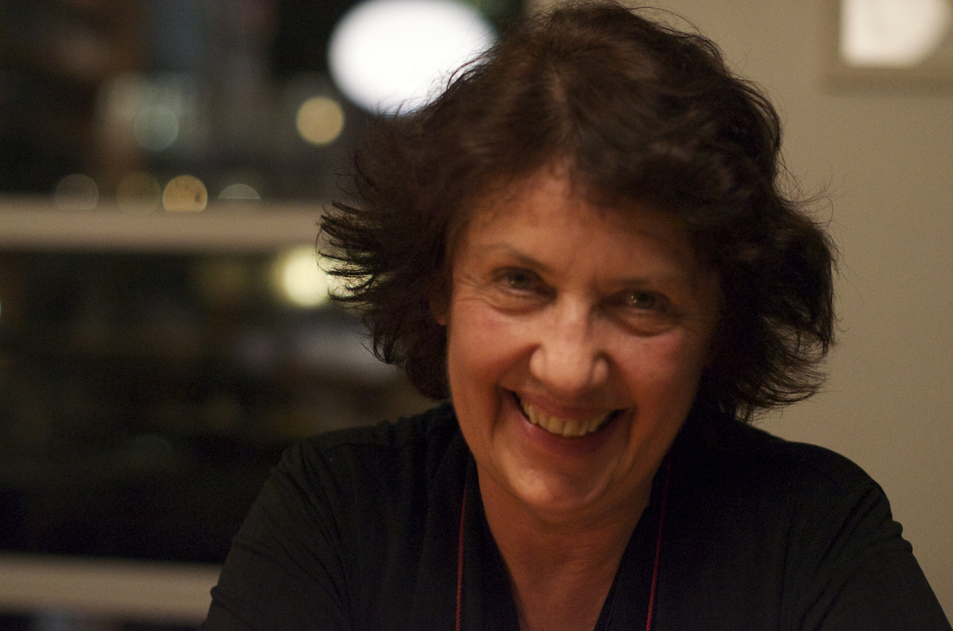

Producer/Director Margot Nash

Short Biography and Filmography

Margot Nash is a filmmaker and a Senior Lecturer in the School of Communications at the University of Technology, Sydney. She has produced, written and directed a number of award-winning films as well as working as a cinematographer and a film editor. Her credits include the experimental shorts Shadow Panic (prod/dir 1989) and We Aim To Please (co filmmaker 1976), the feature documentary For Love Or Money co filmmaker (1982) and the feature dramas Vacant Possession (dir/wr 1994) and Call Me Mum (dir 2005). In 2012 she was Filmmaker in Residence at Zürich University of the Arts where she began developing The Silences.

THE SILENCES (2015) CALL ME MUM (2005) WORK (1997) CULTURAL PATTERNS (1995) VACANT POSSESSION (1994), POSITIVE WOMEN (1993), SHADOW PANIC (1989), SPEAKING OUT (1986), TENO (1884), FOR LOVE OR MONEY (1983) co filmmaker BREAD AND DRIPPING (1982) co filmmaker WE AIM TO PLEASE (1976) co filmmaker

Long Biography

Margot Nash was born in Christchurch, New Zealand. Her family later relocated to Australia and she grew up in Melbourne. She began her career as an actor in theatre and television, starting out at the Melbourne Theatre Company and then joined the Australian Performing Group at the Pram Factory in Melbourne in the 1970s where she began videotaping shows and taking still photographs. After moving to Sydney she joined the Sydney Filmmakers Co op and began freelancing in the independent film sector.

She has produced, written and directed a number of award-winning films as well as working as a cinematographer and a film editor. Her first film, We Aim To Please about female sexuality was made collaboratively with performer Robin Laurie. We Aim To Please won a Jury Prize at L’Homme Regarde Homme film festival in Paris in 1978. We Aim To Please has been restored by the National Film and Sound Archive and is represented in Screen Worlds, a permanent exhibition about the history of the moving image in Australia at ACMI (Australian Centre for the Moving Image) in Melbourne. Margot was co filmmaker and editor on the feature documentary For Love or Money (1982) about the history of women and work in Australia. For Love or Money screened internationally at festivals including Berlin, Toronto and the Tokyo International Women’s Film Festival. It received a UN Media Peace prize in 1985 and in 2010 and 2011 screened in Sydney on International Women’s Day.

Her short documentary Teno won the Jury Prize for Direction and Best Documentary in the ATOM (Australian Teachers of Media) Awards in 1984. Her experimental drama Shadow Panic (1989) won a Red Ribbon for Film as Art at the American Film and Video Festival, an AFI (Australian Film Institute) Award for Best Cinematography and an ATOM (Australian Teachers of Media) Award for Best Innovative Film. It screened internationally at festivals including London, Hawaii and Clermont Ferrand.

In 1994 Margot wrote and directed Vacant Possession, a feature drama about family, racial conflict and the complexities of reconciliation for which she was nominated for Best Directing and Best Original Screenplay in the AFI awards. Vacant Possession screened at festivals including Chicago, Hawaii and Asia Pacific and in 1996 won a Speciale Mention du Jury at the Films De Femmes festival in Créteil. In 1999 For Love Or Money, Shadow Panic and Vacant Possession screened as part of a ‘Tribute to Australian and NZ Women Filmmakers’ at Créteil in Paris. In 2005 Margot directed Call Me Mum for SBS Independent. Call Me Mum screened at festivals including Sydney, Adelaide and Créteil, won two AFI Awards in the telemovie category.

Margot has worked as a consultant and a mentor for Indigenous filmmakers and between 1996 and 2001 she worked in the Pacific running documentary training workshops for Pacific Island women television producers. She is currently working as a Senior Lecturer in the School of Communications at the University of Technology, Sydney. In 2012 she was the Filmmaker in Residence at Zürich University of the Arts where she began developing The Silences.

Filmography

THE SILENCES (2015) 73min personal essay documentary. Prod, Wr, Dir, Margot Nash
As If Productions
A film about family secrets and the ties of love, loss and kinship between a mother and daughter.
Awards 2015 Finalist ATOM (Australian Teachers of Media) Awards
Awards
2016 AWGIE AWARD Documentary Broadcast or Exhibition
Best Feature - 2nd Reel Sydney Festival of World Cinema
Finalist Australian Directors Guild Awards – Feature Documentary
Trophy Award- WAYMI (World Association of Young People who have a Mentally Ill Parent)
2015 Finalist Australian Teachers of Media Awards - Documentary Biography
Festivals and screenings
2016 Soroptimist Int fundraiser Zenith Theatre Chatwood
Queensland Film Festival - Official Selection,
2nd Reel Sydney Festival of World Cinema, Sutherland Sydney
Ozdox The Australian Documentary Forum: International Women’s Day screening AFTRS March 8.
American Documentary Film Festival, Palm Springs - March 30 – April 4
Between Past and Present: the films of Margot Nash - Melbourne Cinematheque, ACMI May 18th
2015 The Golden Age cinema (preview)
Local Heroes, Erskinville (preview)
Canberra International Film Festival
Adelaide Film Festival - Australian Showcase,
MIFF (Melbourne International Film Festival) Official Selection - Australian Showcase
NZIFF (Auckland, Wellington, Christchurch, Dunedin) Official Selection
Australian Cinema Release: April/May 2016: Cremorne Orpheum, Sydney, Cinema Nova, Melbourne, The Arc Canberra, The Mercury Adelaide, The Regal Newcastle
Conferences and talks
2016 ASPERA (Australian Screen Production Education & Research Association) conference, Canberra,
Griffith Film School, Screening and Research Seminar, Brisbane
2015 Talking Pictures – True to Life: Meet the Documentary Filmmakers MIFF.
2015 Camera Stylo – Sydney University Building The Silences
2014 – Sightlines RMIT – The Silences: a personal essay documentary (work in progress)
CALL ME MUM (2005) 76min feature drama. Director: Margot Nash. Writer: Kathleen Mary Fallon, Producer Michael McMahon, Big and Little Films.
When Kate decided to reunite her Torres Strait Islander foster son with his birth mother, dangerous family and racial tensions surface.
Awards
2007 AFI Awards: Best Supporting Actress Television Drama, Outstanding Achievement in Screen Craft Television (shared). Nominations: Best Actress Television Drama, Best Supporting Actress Television Drama. 2006 Short-listed NSW Premier’s Literary Awards, Nominated AWGIE Awards (telemovie)
Festivals and screenings
2009 European Association of Studies of Australia 10th Biennial Conference Palma Spain, Seen and Heard: Festival of Women’s films, Sydney, Peer reviewed ASPERA
2008 Sydney Writers Festival Bangarra Theatre and The Edge Katoomba; IAPL - Global Arts Local Knowledge Conference, Melbourne; Reconciliation week, Department of Victorian Communities ACMI
2007 Cinema des Antipodes, Saint Tropez, FRANCE; Ordinary Lives - Narratives of Disability University of SOUTH AUSTRALIA; NAIDOC screening Australian Embassy PARIS; ADELAIDE Film Festival; Festival International de Films de Femmes du Créteil, PARIS (in competition International Long Feature and Grain du Cinepharge,) ANZJA Conference Sydney
2006 SYDNEY Film Festival, WINNIPEG International Film Festival, The Female Eye TORONTO (in competition), Young at Heart Film Festival SYDNEY, Genres of History Conference ANU, Townsville Cultural Centre, TOWNSVILLE
Broadcast: SBS May 6th and Dec 9th 2007 and Sept 1st 2010 Distribution: Ronin Films
WORK (1997) Wr, Dir Margot Nash, Film Australia
Three ten-minute documentaries for schools about the changing nature of work. Part 1: The Vanishing Weekend. Part 2: Time is Money, Part 3 Work in Progress.

CULTURAL PATTERNS (1995) 26min documentary, Wr, Dir Margot Nash
The Australian episode of New Horizons: Human stories of economic change. The story of a successful Aboriginal design consultancy business.
Awards Finalist: Oceana region Earth Vision 5th Global Environmental Film Festival

VACANT POSSESSION (1994) 95min feature drama. Wri and Dir Margot Nash, Prod John Winter. Wintertime Productions and As If Productions
The story of two families: one white one Aboriginal both living in the shadow of the past. Weaving dream, memory and fantasy Vacant Possession is a story of conflict and the complexities of reconciliation.
Awards 1998 Audience Award: La Mo-Viola Cinema Delle Donne – Torino, Italy.
1996 Speciale Mention du Jury: Films Des Femmes Créteil, France
AFI Nominations: Best Director, Best Original Screenplay, Best Editing, Best Sound
1995 Voted most popular Australian film Sydney Film Festival.
Festivals and screenings
2016 Between Past and Present: The films of Margot Nash - Melbourne Cinematheque, ACMI
2015 National Film and Sound Archive, Canberra Film festival members screening
2002 Buenos Aires 5th International Festival of Independent film. ARGENTINA
1999 Tribute to Australian & NZ Women Filmmakers: Films Des Femmes Créteil, FRANCE; Kino Xenix Screenings
1998 Dreaming Reels – NFSA CANBERRA. Downloading Downunder Australian Film, Video and New Media AMSTERDAM
1997 Femme Totale – Dortmund GERMANY; La Mo-Viola Cinema Delle Donne – Torino ITALY; Ist
Women’s Film Festival Seoul – KOREA; Australian Film Festival Johannesburg SOUTH AFRICA.
1996 PORTLAND; SEATTLE; Films Des Femmes CRÊTEIL; ADELAIDE; Strictly OZ USA – UCLA and WASHINGTON; SYD Travelling Film Fest; Oz: Adventures in Australian Filmmaking; New Australian films KOREA; New Delhi International Film Festival; Australian Identities, history and culture – DUBLIN; Arsenals Film Forum – LATVIA; Cinema Tout Ecran – GENEVA, OLDENBURG.
1995 CHICAGO; HAWAII; ASIA PACIFIC; SYDNEY; MELBOURNE; PERTH; BRISBANE,
Theatrical release: 1996 Sydney, Melbourne, Perth, Hobart, Cairns, Noosa, Darwin, Adelaide London
Broadcast: SBS Australia Day 2001; NAIDOC week July 2001
Distribution: Wintertime Films
POSITIVE WOMEN (1993) 26min documentary. Writer, Director - As If Productions
Made for HIV positive women and health workers.
Awards British Medical Association Award

SHADOW PANIC (1989) 26min Experimental Drama – Prod, Wr, Dir, Margot Nash, As If Productions
A short experimental film about internal and external states of emergency, about personal and collective shadows, about resistance and spirit.
Awards 1990 Red Ribbon (Film as Art): American Film and Video Festival; Innovative Award ATOM (Australian
Teachers of Media) Awards
1989 Best Cinematography AFI Australian Film Institute Awards; Certificate of Merit Melbourne Film Festival; Special Commendation for a New Australian Film Frames Festival Adelaide; Best Experimental Nomination AFI Awards; Finalist Dendy Awards Sydney Film Festival.

Festivals and screenings
2016 Green Screen IMA Brisbane
Between Past and Present: The films of Margot Nash - Melbourne Cinematheque, ACMI
2008 UWA Vision, Memory, Spectacle - Aust Women’s and Gender Studies Conference
1999 Films Des Femmes Créteil FRANCE: Tribute to Aust & NZ women.
1998 Downloading Downunder: Australian Film and New Media AMSTERDAM
1989 Australian Film Institute; BFI Short Film Season; Experimental Media Arts; LONDON; HAWAII; MELBOURNE; SYDNEY; SPOLETO FRINGE;
1990 Films Des Femmes Créteil, FRANCE; CLERMONT FERRAND; WELLINGTON; FRAMES Film Festival Adelaide; INSIGHT Women’s Festival Canada; American Film and Video Festival; Australia Teachers of Media Inc; Edmonton International Student Festival
1991 IMAGES Festival of Independent Film and Video Toronto
Theatrical release: Australia and UK. Screened theatrically in 1989 in London supporting Chantal Ackerman’s feature ‘American Stories.’ Distribution: As If Productions Broadcast: SBS

SPEAKING OUT (1986) 26 min Dramatised documentary. Wr, Dir, Prod Margot Nash, As If Productions
A short documentary about young girls in care and at risk.
Awards Best Documentary: Australian Video Festival 1987

TENO (1884) 13 min Documentary. Writer, Director Margot Nash - Film Australia
A short documentary about repetitive strain injuries.
Awards Best Documentary and Jury Prize for Direction: Australian Teachers of Media ATOM Awards. Editing Nomination: AFI Awards. Certificate of Creative Excellence: US Industrial Film Festival. Honourable Mention: San Francisco Film Festival.

FOR LOVE OR MONEY (1983) 109min 16mm compilation documentary. Co filmmaker, editor
A film by Megan McMurchy, Margot Nash, Margot Oliver, Jeni Thornley Flashback Films.
A history of women and work in Australia.
Awards
1985 Gold Citation: United Nations Media Peace Prize: Television. 1984 Best Feature Documentary: International Women’s Cinema Encounter Florence. Best Documentary and Best Screenplay Nominations: AFI Awards,
Festivals and screenings
2015 Women’s Gaze and the Feminist Film Archive, Future Feminist Archive exhibition SCA Sydney
2011 International Women’s Day Centenary screening Parkes Film Festival.
2010 International Women’s Day and Women’s History month: ANU and Canberra Grammar School.
2009 Seen and Heard Women’s film festival, International Women’s Day, Avoca Beach Cinema Sydney;
1999 Tribute to Aust & NZ women Films Des Femmes Créteil, FRANCE
1998 BARCELONA 1988 ‘BACK OF BEYOND’ UCLA; NYON; LISBON
1987 WOMEN IN THE DIRECTORS CHAIR Chicago
1986 SCOTTSDALE USA; US FILM FESTIVAL Salt Lake City
1985 Films Des Femmes Créteil, FRANCE ; VALLADOLID; International Women’s Film Forum NAIROBI; ST KILDA; TOKYO International Women’s Film Festival
1984 BERLIN; TORONTO, MONTREAL; AUCKLAND; CAMBRIDGE; PORTUGAL; UPPSALA; WELLINGTON; WOMEN MAKE MOVIES San Francisco,
Theatrical release: Australia 1983 UK 1984 Broadcast: Australia (ABC), Denmark, Eire, Greece.
Distribution: Ronin Films
BREAD AND DRIPPING (1982) 17min documentary Co filmmaker, editor Wimmins films
A short documentary about women in the 1930s Depression.
Festivals and screenings
MELB, WELLINGTON 1983 TYNESIDE 1984 CINEMA DU REEL 2009 SEEN AND HEARD film festival, Sydney.

WE AIM TO PLEASE (1976) 13min 16mm Experimental short - Co filmmaker with Robin Laurie As If Productions
A short experimental film about female sexuality
Awards Jury Prize: L’Homme Regarde L’Homme Film Festival Paris.

Festivals and screenings
2015 Women’s Gaze and the Feminist Film Archive, Future Feminist Archive exhibition SCA Sydney
2014 The form that accommodates the mess - IMA (Institute of Modern Art) Brisbane
2009 Screen Worlds ACMI (Australian Centre for the Moving Image) Melbourne – permanent exhibition
2008 Australian Perspectives: New and Archival queer shorts ACMI
2005 Resistance: a screen history of Australian counter cultural movements ACMI
1999 The Wild and Wonderful 70’s Chauvel SYDNEY
1996 Valladolid SPAIN; Filmoteca MADRID
1994 BARCELONA; Women and Film: The Hidden (A) Gender ADELAIDE;
1990 INSIGHT Women’s Film Festival-Canada
1989 OTHER PLEASURES Modern Image Makers Melbourne
1987 SPOLETO FRINGE Melb
1982 Gay Film Festival LONDON
1981 1st International Feminist Film and Video Conference AMSTERDAM
1979 Bergama Festival of Third Theatre ITALY; Women’s Arts Festival, Christchurch NEW ZEALAND
1978 L’Homme Regarde L’Homme Paris; La Rochelle Avant Garde Film Festival PARIS; World Congress of Sociology FINLAND
1977 WOMEN WAVES Sydney Filmmakers Cooperative national tour of short films
Distribution: As If Productions

