**NEON**

**PRESS KIT**

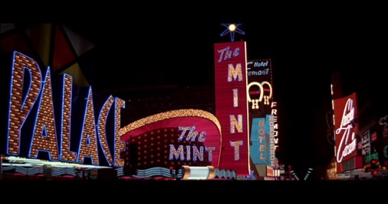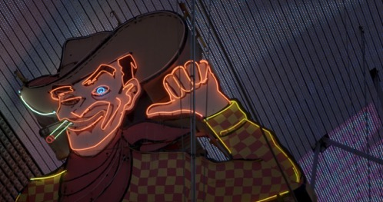

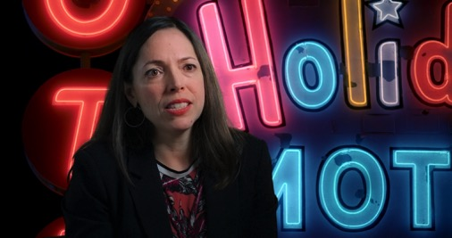

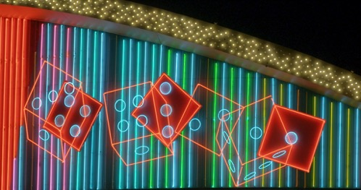

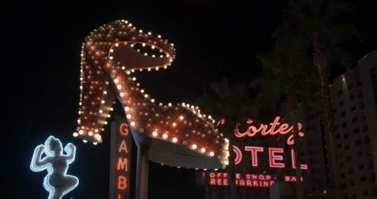

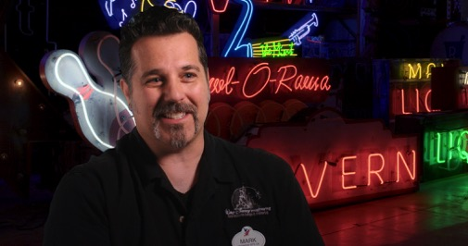

**WildBear Entertainment**

**1/33a Logan Rd, Woolloongabba QLD 4102**

**Ph: +61 7 3891 7779**

# Contents Page

Contents Page 2

Contact Details 3

Distributors and Sales Agents 3

Synopsis: Logline and One Paragraph 5

Synopsis: One Page 6

Director’s Statement 7

Producer’s Statement 9

Key Creative Credits 10

Director’s Biography 12

Producer’s Biography 13

Key Creatives 14

The Neon People 16

Selected Interviewee Biographies 17

Final End Credits 19

# Contact Details

**Production Company**

WildBear Entertainment

Address: PO Box 6160, Woolloongabba, Queensland

4102 Australia

Phone: +61 (0) 7 3891 7779

Web: <http://www.widlbear.tv>

Veronica Fury - Producer

Address: PO Box 6160, Woolloongabba, Queensland

4102 Australia

Phone: +61 (0) 7 3891 7779

Email: [veronica.fury@wildbear.tv](mailto:veronica.fury@wildbear.tv)

**Technical Information**

Production and Release Formats: DCP - 2048 x1080 Flat

HDCAM - 16:9

ProRes QT - 16:9

Frame Rate: 24

Sound Configuration: 5.1 and Stereo Mix

Date of Production: 2015

Release Date: 2015

Duration: 84’

ISAN: 0000-0004-0663-0000-6-0000-0000-J

# Distributors and Sales Agents

**Australia and New Zealand Sales**

Ronin Films

Address: Unit 8/29 Buckland Street, Mitchell ACT

2911, Australia

Phone: +61 2 6248 0851

Web: <http://www.roninfilms.com.au>

**Rest of World Sales**

Mongrel Media

Address: 1352 Dundas St. West, Toronto, ON,

M6J 1Y2, Canada

Phone: 416 516 9775

Web” [www.mongrelmedia.com/international](http://www.mongrelmedia.com/international" \t "_blank)

# Synopsis: Logline and One Paragraph

**One Line Synopsis**

**NEON** is a celebration of the beauty, invention, design and heritage of the neon sign from internationally award-winning Director Lawrence Johnston.

**One Paragraph Synopsis**

**NEON** celebrates the beauty, colour and vibrant history of the neon sign from an international perspective as we face a world where it will soon be lost and superceded by L.E.D. signage.  Neon is 100 years old and the craft and construction has changed very little, making neon one the greenest forms of light ever produced and an amazing and enduring force of colour and light in the visual landscapes of our lives.

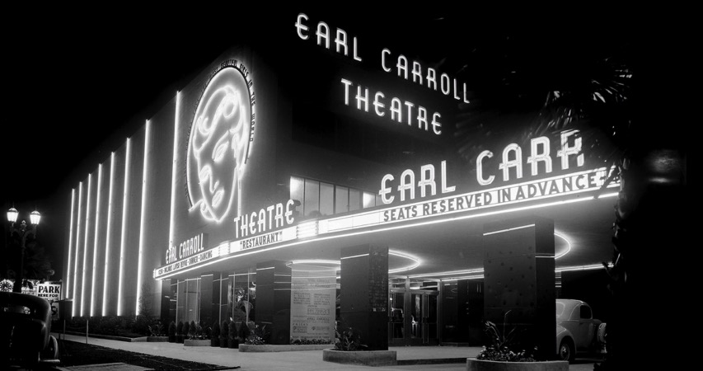

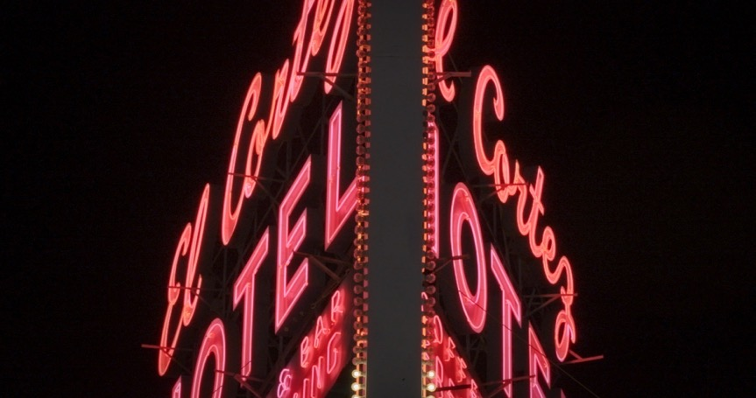

# Synopsis: One Page

**One Page Synopsis**

**NEON** is a visually stunning and informative celebration of the beauty, colour and vibrant history of the neon sign from an international perspective in a world where it will soon be lost and superceded by L.E.D. signage.

From the beginning of time man has always been guided by signs to help us find our way, in the light of day, but particularly at night, and neon has always done this with great beauty and dynamism for the last 100 years. As society progressed along with commerce, neon signs became bigger, more vibrant, colourful, elaborate and competitive in attracting the general public to GO, BUY, SEE, WANT!

The first illuminated signs in the world were incandescent following the invention of the light bulb by Thomas Edison, but neon was the future, bigger, brighter, more beautiful, and most importantly lasted longer. Like a number of inventions of the 20th Century, neon was the dynamic result of a number of experiments by a variety of nationalities all fighting for the limelight at the same time, the German Heinrich Geissler, the British Henry Moore and Croatian Nikola Tesla.  Finally it was the entrepreneurial Georges Claude from France who won, when he first bought neon to the world at the Paris Motor Show in 1910.  A neon rainbow spread like wildfire ‘neonizing’ the world following its debut in Jazz Age America.

The evolution of neon has mirrored the evolution of global commerce and society throughout the twentieth century into this new millennium. Apart from the content of history, invention, design and heritage, **NEON** is an amazing and sumptuous visual travelogue celebrating the invention and popularization of neon from Las Vegas to New York, from Hong Kong to Havana.  We explore why neon has had its periods where it has fallen out of popularity and then risen up again.  We meet those people who have designed and produced neon, with it’s myriad of colour and meaning, from commercial signage to the work of world famous neon artists Tracey Emin and Bruce Nauman, then move on to 3Heritage Activists who now recognize the cultural value of neon, by ‘saving signs’ at places like ‘The Boneyard’ in Las Vegas.

With the advent of unecological LED signs, neon is now on the brink of disappearing. Neon is 100 years old and the beauty, craft and construction has changed very little, making neon one the greenest forms of light ever produced and an enduring force of amazing colour and light in the visual landscapes of our lives. Neon still has the ‘buzz’!

**NEON** is the latest film from internationally award-winning Director Lawrence

Johnston (Eternity, Fallout) in collaboration with Producer Veronica Fury from WildBear Entertainment (Electric Boogaloo).

# Director’s Statement

**Lawrence Johnston**

**NEON** has come out of a love I have had for neon for many years.  Like many of the people interviewed in the film, I love everything about it I had included neon signs in my first documentary ETERNITY (1994) this was the story of Arthur Stace who wrote the word Eternity across the sidewalks of Sydney.  One of my favourite neon signs in Sydney was the Chateau Tanunda Sign in Hyde Park.  There is also one now long gone which featured a neon man hitting a neon golf ball across the expanse of a building on Broadway. In my feature documentary NIGHT (2007) we also included a montage of neon signs.  As we photographed these for both films I started to do some research into the history of neon and one thing that amazed me was the longevity of some of these signs which also lead me into educating myself about the technology of neon and how long lasting it can be if not broken. So I would say that ETERNITY, NIGHT and NEON would be a trilogy of ‘City Symphony’ films that follow a tradition, particularly in America, of films which have been made which celebrate the life, vibrancy and progress of the city and how the urban elements affect our daily lives.

The most dynamic neon story is the American story and this was something we discovered throughout the development of the film.  While neon signs have spread worldwide, it was the debut of neon in the U.S. that I chose to tell and by making this film, like some of the people saving signs, we too are documenting and saving these signs which are fast disappearing and the medium of cinema is a perfect way to document and transport the beauty of these images and stories to a wide audience.

**NEON** was shot on a low-budget with minimal crew over 3 weeks in the United States in November of 2014.  We interviewed 30 people for the film from various walks of life who tied into the neon story.  These were conducted in the limited cities we were able to film in, Los Angeles where the Museum of Neon Art is located.  Las Vegas, world famous for it’s neon in the heyday of casino culture, but also now the home to ‘The Boneyard’ where signs have been saved since the late 1980’s.  We also travelled to Cincinnati to The American Sign Museum founded by Tod Swormstedt, whose beautiful museum is featured in the film, then on to New York where we learned that while neon is popular, it is dwindling, given the ever changing nature of the city in regard to real-estate.  Signs are certainly not like buildings which are given first priority in terms of heritage issues.

This is the third collaboration with D.O.P Eron Sheean who shot the very personal film I made on my family for SBS Television, THE DREAM OF LOVE, as well as ONCE A QUEEN, about the hometown Jacaranda Queens.  This is also my fourth collaboration with Editor Bill Murphy, LIFE, NIGHT, FALLOUT and both collaborations on neon were instrumental in bringing the film together both visually and narratively.  **NEON** is the first film I have made with Producer Veronica Fury and WildBear Entertainment.  I talked to a few producers

about the project, who had seemed to have no connection to the subject, nor have any idea how to raise the finance, but it was Veronica who immediately became excited by neon, had an appreciation of the subject, story and visuals and could see the potential in it as a film.  These elements have come together to produce what I believe is a beautiful film which will appeal to many worldwide.

**Lawrence Johnston**

**Director/ Writer/ Co-Producer**

# Film:CURRENT_PROJECTS:PROJECTS_IN PRODUCTION:Neon:Production Stills:Production Stills:Radio City Music Hall.jpg

# Producer’s Statement

**Veronica Fury**

I was pitched **NEON** by renowned documentarian Lawrence Johnston in 2013. Lawrence had been developing the feature documentary and needed a Producer. I was familiar with Lawrence’s previous documentaries Fallout, Night and Eternity and knew **NEON** had the potential to be as successful and appeal to an international audience.

Lawrence had been on my radar as a director I had always wanted to work with and I was thrilled when he pitched **NEON** to me. **NEON** struck me as a unique and cinematically beautiful film, which had not been done previously.

MIFF Premiere Fund came on board to support the film, which was a real coup. **NEON** is my fifth feature documentary for MIFF Premiere Fund and I am excited to be collaborating with MIFF once again. The film also received support from Screen Queensland and Film Victoria. Ronin Films came on as the ANZ distributor and Mongrel Media as the international distributor.

With funding secured it was now time to start production. Lawrence Johnston and the crew set out on a 3 week trip to the US filming in Los Angeles, Las Vegas, Cincinnati and New York. During filming Lawrence interviewed over 25 interviewees who had their own perspective on the history and art of neon. Following filming, Lawrence and the editor Bill Murphy spent 3 months cutting and finessing the story.

Featuring personal interviews, beautiful footage of neon, rare archival material and a beautiful music score composed by Antony Partos, **NEON** is an entertaining and ethereal documentary which shines a light on an art form which is relatively unknown and taken for granted. I look forward to sharing the film with audiences around the world and hope they enjoy watching it.

**Veronica Fury**

**Producer**

# Key Creative Credits

Writer Director

Lawrence Johnston

Produced By

Veronica Fury

Lawrence Johnston

Director of Photography

Eron Sheean

Edited by

Bill Murphy

Music Composed by

Antony Partos

Additional Music

Cezary Skubiszewski

Music Supervisor

Andrew Kotatko

Sound Recordist

James Portanier

Production Manager

Sally Wortley

INTERNATIONAL SALES BY

MONGREL INTERNATIONAL

AUSTRALIAN AND NEW ZEALAND DISTRIBUTOR

RONIN FILMS

DEVELOPED WITH THE ASSISTANCE OF

SCREEN AUSTRALIA

DEVELOPED AND PRODUCED WITH THE ASSISTANCE OF

FILM VICTORIA

CO-FINANCED BY AND PRODUCED WITH THE ASSISTANCE OF

SCREEN QUEENSLAND

Produced with the financial assistance of

**The** **Melbourne International Film Festival (MIFF) Premiere Fund**

An initiative of the State Government of Victoria, Australia

**MIFF Premiere Fund Executive Producer: Mark Woods**

© WildBear Entertainment Pty Ltd, Screen Queensland Pty Ltd, FilmFest

Limited trading as Melbourne International Film Festival 2015

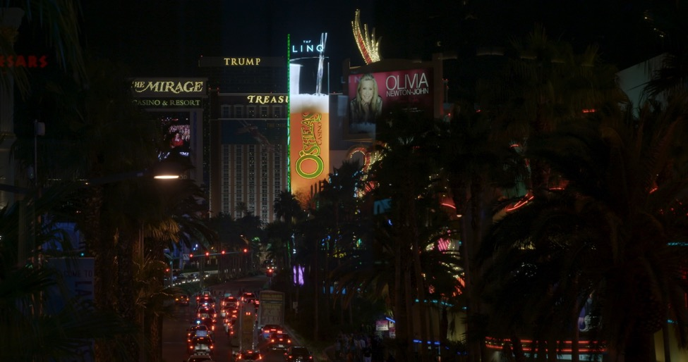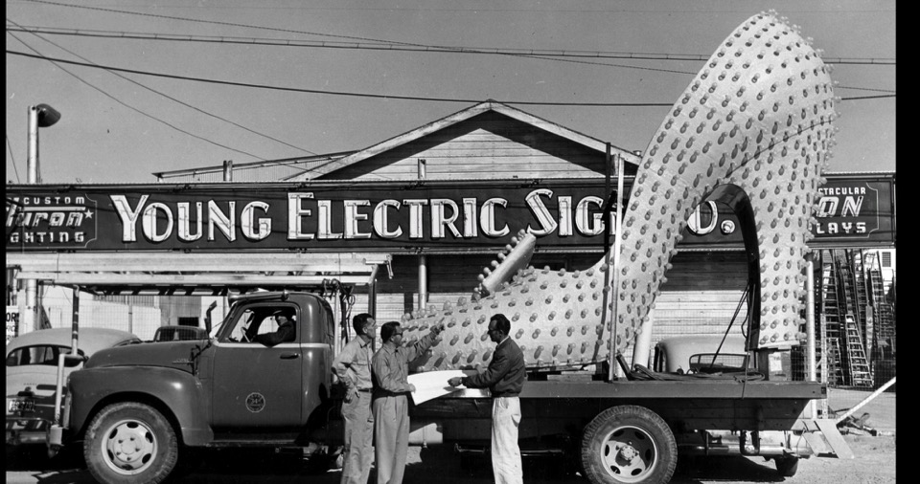

# Director’s Biography

**Lawrence Johnston**

Lawrence Johnston is an internationally award-winning Writer, Director and Producer who began his career as a Film Repairer at 20th Century-Fox. He is a graduate of the prestigious Swinburne Film and Television School in Melbourne Australia with a Bachelor of Arts in Film and Television. He has worked in both drama and documentary. His films have been screened and awarded at Cannes, Toronto, Berlin, Telluride, Chicago and London Film Festivals among many others.

His first film, the short dramatic feature, Night Out was an Official Selection at the 1990 Cannes Film Festival (Un Certain Regard) and named ‘one of the year’s ten best’ in the New York Village Voice. He followed this with the short feature Eternity which won the Best Feature Award at the Los Angeles International Documentary Association and Best Cinematography at the 1995 Australian Film Institute Awards for Oscar Winning Cinematographer Dion Beebe (Chicago, Into The Woods), and was named ‘one of the year’s ten best’ in WHO Magazine. His debut feature film Life won the FIPRESCI International Critic’s Prize at the 1997 Toronto Film Festival and was nominated for four Australian Oscars and four Australian Film Critic’s Circle Awards including Best Actor, Best Screenplay, Best Editing and Best Cinematography for Mandy Walker (Lantana, Australia).

Lawrence’s work has been shown in major retrospectives on Australia Cinema at the Museum of Modern Art in New York. He has also worked as a Development and Production Executive at Screen Australia between the production of his films. His other credits are The Dream of Love and Once a Queen, both for SBS Television as well as his second feature film, Night which he wrote, directed and co-produced.

Night had its international premiere at The 2007 Toronto International Film Festival was In Competition at IDFA in Amsterdam and also recently released theatrically in the United States.

In 2013 he completed the feature documentary Fallout based on Nevil Shute’s famous novel On The Beach and the Hollywood film made in Australia starring Ava Gardner and Gregory Peck. Lawrence is currently in development of the feature drama Love Me Tender.

**NEON is Lawrence’s fourth feature documentary.**

# Producer’s Biography

**Veronica Fury**

Veronica Fury is an Australian Producer and a Principal of WildBear Entertainment. WildBear Entertainment was formed when Australian production companies WildFury and Bearcage merged in 2014. The merger combines the skills and experience of respected producers Veronica Fury, Tina Dalton, Serge Ou, and Michael Tear. Former CEO of Southern Star, Hugh Marks, is Chair of the Company.

Veronica produces award-winning screen content for audiences around the world, working with television broadcasters like ABC and SBS in Australia and major international broadcasters such as ZDF Arte, TG4 and Arte France, just to name a few. The WildBear group also works with leading broadcasters including National Geographic, Discovery, CCTV9, FINAS Malaysia, PBS, Beijing TV, and the Nine Network.

Projects Veronica has produced include Black Soldier Blues (2006), The Glamour Game Series (2007), Fairweather Man (2008 - NSW Premier’s Literary Award), World Champion Santa (2009), Constructive Mob (2010), Machete Maidens Unleashed! (2010 – Toronto International Film Festival), Bringing Uncle Home (2011), The Trouble with St Mary’s (2011), The Curse of the Gothic Symphony (2011 – AWGIE Award, ATOM Award, ACCTA Award Nomination) Dancing Down Under (2012 – ATOM Award), The First Fagin (2012), ABC 3 on 3 (2013), Mysteries of the Human Voice (2013), Comic Book Heroes (2013), Outside Chance (2013), and My Big Fat Bar Mitzvah (2013).

Veronica's most recent feature, Electric Boogaloo: The Wild, Untold Story of Cannon Films was produced for RatPac Documentary Films, Mongrel Media, Umbrella Entertainment and Melbourne International Film Festival Premiere Fund; and had its world Premiere at TIFF 2014. She also recently executive produced the medical studio show Save Your Life Tonight for ABC 1 and Opening Shot documentary Crack Up for ABC 2.

She is producing Snake Sheila for Animal Planet, and is executive producing Big Art for Studio and Ella’s Journey for Ronin Films.

**NEON is Veronica’s fifth feature documentary.**

# Key Creatives

**Director of Photography – Eron Sheean**

Born in Melbourne, Australia, Eron Sheean is a writer/director with a unique background in puppet animation, sculpture and cinematography. His short films have screened and won prizes at numerous international film festivals including Sundance, Berlin, Telluride, Chicago and Hawaii International.

Sheean made his feature debut with Errors of the Human Body in 2013, set within the mysterious world of genetic engineering and developed at the Max Planck Institute of Molecular Cell Biology and Genetics in Germany. Errors premiered at the Fantasia Film Festival to critical acclaim and screened at numerous others, including Melbourne International, Rio International, Rotterdam and Fantastic Fest, Austin. Errors was released theatrically in the US through IFC films in 2013, with releases in the UK, Japan, Australia, and New Zealand and more territories to follow.

Sheean formerly headed up development at Instinctive Films GmbH for five years in Berlin, Germany, where he co-wrote the feature film The Divide for Xavier Gens (Frontier(s), Hitman), and was co-producer and 2nd unit director.

Having recently moved to London, Sheean is developing a number of original screenplays for his future projects, as well as working for a variety of production companies as a screenwriter for hire.

When not writing and directing, he shoots for other people, having recently shot the high-end feature documentary **NEON** in the United States for The award winning director, Lawrence Johnston, and the German component for Tim Slade’s award documentary, The Destruction of Memory.

**Editor – Bill Murphy**

Bill Murphy ASE has edited many award winning films across many genres, including an Oscar winner an Emmy winner and multiple other Australian and international award winners. He has been invited to work on feature films and works for theatre in Asia, Europe and the UK.

His most notable works include Mary and Max (Dir. Adam Elliot, 2009), Half Light (Dir. [Craig Rosenberg](http://www.imdb.com/name/nm0742194/?ref_=tt_ov_dr), 2006), Harvie Krumpet (Dir. Adam Elliot, 2003) and Romper Stomper (Dir. [Geoffrey Wright](http://www.imdb.com/name/nm0942408/?ref_=tt_ov_dr), 1992) to name only a few. Bill is also an established documentary editor. His documentary credits include Croker Island Exodus ([Steven McGregor](http://www.imdb.com/name/nm2341237/?ref_=tt_ov_dr), 2012), Big Name No Blanket (Dir. [Steven McGregor](http://www.imdb.com/name/nm2341237/?ref_=tt_ov_dr), 2013) and Whatever Happened to Brenda Hean? (Dir. [Scott Millwood](http://www.imdb.com/name/nm1573840/?ref_=tt_ov_dr), 2010). Bill has worked with Director Lawrence Johnston previously on the feature documentary Night (2008).

**Composer – Antony Partos**

Antony Partos is one of Australia’s most awarded film composers. His passion lies in creating innovative scores that morph acoustic with an eclectic mix of bespoke elements. His feature film credits include the Sundance Festival winning film, Animal Kingdom (starring Guy Pearce and Oscar nominee Jacki Weaver), The Home Song Stories (starring AFI winner Joan Chen), Disgrace (starring Oscar nominee John Malkovich), Unfinished Sky and Accidents Happen (starring Oscar Winner Geena Davis), David's Michod's The Rover (starring Robert Patterson and Guy Pearce) and the upcoming American indie film 99 Homes (Starring Andrew Garfield and Michael Shannon) directed by Ramin Bahrani.

Upcoming releases include the epic feature documentary Sherpa, the feature film Taboo, Redfern Now telemovie along with the TV series Rake, Jack Irish And Love Child.

**Sound Recordist – James Portanier**

Starting his career over ten years ago in the humble position of ‘runner two’ at a busy Melbourne based TVC production house, James ‘Jimi Woo’ Portanier has used his steady footing in production to grow and develop into a multi-skilled film-practitioner whose skills have seen him jump into large Hollywood productions such as Where The Wild Things Are and The Pacific to small independent features such as Noise, Dying Breed and Long Weekend, and everything in between. He currently freelances as an offline editor, sound-recordist and video producer across a range of broadcast mediums both abroad and from his headquarters ‘Wootown Studios’.

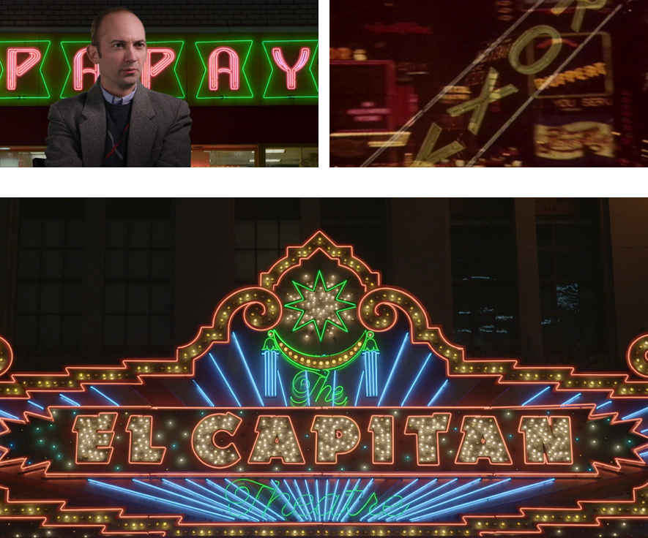

# The Neon People

|  |  |
| --- | --- |
| David Ablon | Nancy Deaner |
| Dydia DeLyser | Michael Flechtner |
| Candice Gawne | Kenny Greenberg |
| Paul Greenstein | Alan Hess |
| Rick Juleen | Danielle Kelly |
| Kim Koga | Lili Lakich |
| Eric Lynxwiler | Cork Marcheschi |
| Karla Murray | James J. Murray |
| Adolfo V. Nodal | Charles Phoenix |
| Mark R. Panelli | Thomas E. Rinaldi |
| Debra Jane Seltzer | Tama Starr |
| Tod Swormstedt | Darcy Tell |

**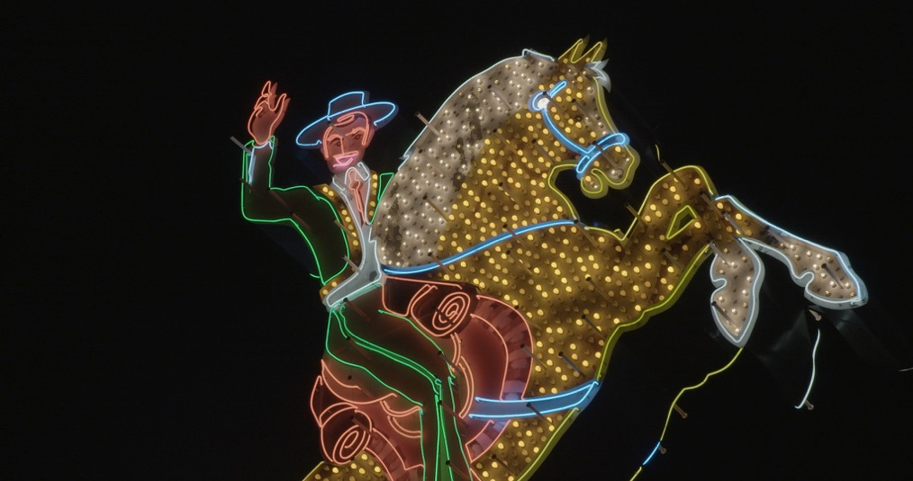**

# Selected Interviewee Biographies

**Alphabetical Order**

**ALAN HESS**

Architect and historian Alan Hess is the architecture critic of the San Jose Mercury News. He has written nineteen books on Modern architecture and urbanism in the mid-twentieth century. His latest book, Frank Lloyd Wright: Natural Design, Organic Architecture was published in October 2012.

He has written monographs on architects Oscar Niemeyer, Frank Lloyd Wright, and John Lautner, as well as architectural histories of Las Vegas and Palm Springs. Hess’ other books include Googie Redux: Ultramodern Roadside Architecture, Forgotten Modern, and The Ranch House. He is currently researching the architecture of Irvine, California, one of the United States’ largest master-planned communities of the 1960s and 1970s.

Hess was a National Arts Journalism Program Fellow at Columbia University's School of Journalism, and received a grant from the Graham Foundation for Advanced Studies in the Fine Arts to research the work of Brazilian landscape architect Roberto Burle Marx. He has a M. Arch degree from the Graduate School of Architecture and Urban Planning, UCLA.

Hess has been active in the preservation of post-World War II architecture, qualifying several significant buildings for the National Register of Historic Places, including the oldest McDonald’s drive-in restaurant (1953, Downey, CA), Edward Durell Stone’s Stuart Pharmaceutical factory (1958, Pasadena, CA), Wurdeman and Becket’s Bullock’s Pasadena (1947, Pasadena, CA), and Edward Varney’s Hotel Valley Ho (1957, Scottsdale, AZ).

**DANIELLE KELLY**

Danielle Kelly is the Executive Director of the Las Vegas Museum of Neon Art and Boneyard whose mission is to save and exhibit historic neon signs.

**LILI LAKICH**

Lili Lakich is an American artist best known for her work in neon sculpture. She is the founder of the Museum of Neon Art (MONA) in Los Angeles.  Her sculptures have been included in major publications on contemporary sculpture, neon sculpture and feminist art including Signs, and in many private and corporate collections.  She has had solo shows in Tokyo, Paris and Los Angeles.

**ERIC LYNXWILER**

Eric Lynxwiler grew up in Southern California and spent one school year working at Knott’s Berry Farm's shooting gallery while earning his degree in urban anthropology at UCLA. Popular host of Los Angeles's renowned Neon Cruise and board member emeritus of the Museum of Neon Art, Lynxwiler co authored the celebrated book Wilshire Boulevard: Grand Concourse of Los Angeles.

**JAMES AND KARLA MURRARY**

James and Karla Murray are New York based professional photographers and authors. Their critically acclaimed books New York Nights and Store Front: The Disappearing Face of New York as well as their graffiti publication Broken Windows have set the standard for urban documentation. New York Nights was the winner of the prestigious New York Society Library's 2012 New York City Book Award. James and Karla Murray’s work has been exhibited widely in major institutions and galleries, including solo exhibitions at the Brooklyn Historical Society, Clic Gallery in New York City, and Fotogalerie Im Blauen Haus in Munich, Germany and group shows at the New-York Historical Society. Their photographs are included in the permanent collections of major institutions, including the Smithsonian Center for Folklife and Cultural Heritage, the New York Public Library, and NYU Langone Medical Center. Their photography has appeared in the New York Times, New York Post, Daily News, and The New Yorker. They are represented by Clic Gallery in New York City. James and Karla live in Manhattan with their dog Hudson.

**THOMAS E. RINALDI**

Raised near Poughkeepsie in upstate New York, Thomas E. Rinaldi visited New York City frequently before moving there in 2004. His life-long interest in the city’s built landscape drove him to pursue a career in architecture: he works as a designer for Thornton Tomasetti, a leading engineering and architecture firm. Rinaldi holds degrees in history from Georgetown University and in historic preservation from Columbia University. He is the co-author, with Robert J. Yasinsac, of Hudson Valley Ruins: Forgotten Landmarks of an American Landscape and the author of New York Neon.

**TAMA STARR**

Tama Starr is the president of Artkraft Strauss, located in Manhattan. Throughout the twentieth century, the company was the preeminent designer and creator of Times Square's signs and displays, and was also responsible for the annual midnight ball-lowering that signalled the arrival of the new year.

Starr is also known as a satirist and social commentator. Her work has appeared in the Wall Street Journal, Washington Post, Reader's Digest, Partisan Review, Reason Magazine, and elsewhere. She has published three books, among these is Signs and Wonders: the Spectacular Marketing of America, which was published by Doubleday/Currency.

# Final End Credits

|  |  |  |  |
| --- | --- | --- | --- |
|  | **STATIC CARDS- SINGLE FRAME CREDITS** | |  |
|  |  | |  |
|  |  | |  |
|  | Written and Directed by | |  |
|  | LAWRENCE JOHNSTON | |  |
|  |  | |  |
|  |  | |  |
|  | Produced by | |  |
|  | VERONICA FURY | |  |
|  | LAWRENCE JOHNSTON | |  |
|  |  | |  |
|  |  | |  |
|  | Director of Photography | |  |
|  | ERON SHEEAN | |  |
|  |  | |  |
|  |  | |  |
|  | Edited by | |  |
|  | BILL MURPHY ASE | |  |
|  |  | |  |
|  |  | |  |
|  | Music Composed by | |  |
|  | ANTONY PARTOS | |  |
|  |  | |  |
|  |  | |  |
|  | Additional Music | |  |
|  | CEZARY SKUBISZEWSKI | |  |
|  |  | |  |
|  |  | |  |
|  | Music Supervisor | |  |
|  | ANDREW KOTATKO | |  |
|  |  | |  |
|  |  | |  |
|  | Sound Recordist | |  |
|  | JAMES PORTANIER | |  |
|  |  | |  |
|  |  | |  |
|  | Production Manager | |  |
|  | SALLY WORTLEY | |  |
|  |  | |  |
|  |  |
|  |  |
|  | **THE NEON PEOPLE** | |  |
|  |  | |  |
|  | David Ablon | Nancy Deaner |  |
|  | Dydia DeLyser | Michael Flechtner |  |
|  | Candice Gawne | Kenny Greenberg |  |
|  | Paul Greenstein | Alan Hess |  |
|  | Rick Juleen | Danielle Kelly |  |
|  | Kim Koga | Lili Lakich |  |
|  | Eric Lynxwiler | Cork Marcheschi |  |
|  | Karla Murray | James J. Murray |  |
|  | Adolfo V. Nodal | Charles Phoenix |  |
|  | Mark R. Panelli | Thomas E. Rinaldi |  |
|  | Debra Jane Seltzer | Tama Starr |  |
|  | Tod Swormstedt | Darcy Tell |  |
|  |  |  |  |
|  | **MUSIC RECORDED AND PRODUCED AT SONAR MUSIC** | |  |
|  |  |  |  |
|  | Arranger | Graham Jesse |  |
|  | Piano | Antony Partos |  |
|  | Bass | Emile Nelson |  |
|  | Drums | Hamish Stuart |  |
|  | Guitar | Sam Rollings |  |
|  | Vibes | Andrew Wilkie |  |
|  | Saxophone | Graham Jesse |  |
|  | Violin | Lisa Stewart |  |
|  | Viola | Stefan Duwe |  |
|  |  |  |  |
|  | Music Producer | Wes Chew |  |
|  | Music Engineer | Tim Bridge |  |
|  |  |  |  |
|  | Executive Producer | Michael Tear |  |
|  |  |  |  |
|  | Marketing Consultant | Andrew Pike |  |
|  |  |  |  |
|  | Research and Archival Research | Lawrence Johnston |  |
|  |  |  |  |
|  | Additional Archival Research | Sally Wortley |  |
|  |  | Shirin Edwards |  |
|  |  | Penny Chai |  |
|  |  |  |  |
|  | Second Camera Operator | Barry Conrad |  |
|  |  |  |  |
|  | Production Co-ordinator | Shirin Edwards |  |
|  |  | Jay Ooi |  |
|  |  |  |  |
|  | Production Assistant | Phillapa Tanner |  |
|  |  |  |  |
|  | Producer Assistant | Gulnaz Caplice |  |
|  |  |  |  |
|  | Production Runner/ Driver | James Portanier |  |
|  |  |  |  |
|  | **WILDBEAR ENTERTAINMENT** | |  |
|  |  |  |  |
|  | Principals | Bettina Dalton |  |
|  |  | Veronica Fury |  |
|  |  | Hugh Marks |  |
|  |  | Serge Ou |  |
|  |  | Michael Tear |  |
|  | Chief Operating Officer | Nunzio Gambale |  |
|  | Head of Production | James Sutherland |  |
|  | Head of Corporate | Wayne Brown |  |
|  | Head of Development | Harriet Pike |  |
|  |  |  |  |
|  | Post Production Facility | WildBear Entertainment |  |
|  | Post Production Supervisor | Matt Nightingale |  |
|  | Online Conform | Mina Reyad |  |
|  |  | Rebecca Lyons Wright |  |
|  |  | Robert Perry |  |
|  |  | Cameron Kirby |  |
|  | Graphics | Mina Reyad |  |
|  |  | Rebecca Lyons Wright |  |
|  | Colourist | Ed Saltau |  |
|  | Re-Recording Mixing Engineer | Naimat Ahmed |  |
|  |  |  |  |
|  | Editing Facility | Jump Cut Post Production | |
|  |  |  |  |
|  | Equipment Hire | Stray Angel Films, Los Angeles | |
|  |  | Precision Video Service, Las Vegas | |
|  |  | Midwest Grip and Lighting, Cincinnati | |
|  |  | Hotcam, New York |  |
|  |  | Adorama Rental, New York | |
|  |  |  |  |
|  | Head of Finance | Miranda Felton |  |
|  | Accounts Assistant | Sarah Woods |  |
|  |  |  |  |
|  | Legal Advisors | Bryce Menzies, Marshalls + Dent | |
|  |  | Clement Dunn, Marshalls + Dent | |
|  | Business Affairs | Tim Dingwall |  |
|  |  |  |  |
|  | Transcribers | Heather Davis |  |
|  |  | Atalanti Dionysus |  |
|  |  | Michele Flynn |  |
|  |  | Kathy Guerin |  |
|  |  | Bridget Haylock |  |
|  |  |  |  |
|  | Travel Agent | Corporate Traveller |  |
|  | Insurance Broker | OAMPS Insurance Broker | |
|  | Completion Guaranty provided through | First Australia Completion | |
|  |  | Bond Company Pty Ltd |  |
|  |  |  |  |
|  | **ADDITIONAL MUSIC** | |  |
|  |  | |  |
|  | "Je Chante" | |  |
|  | Written by Charles Trenet and Paul Misraki | |  |
|  | Performed by Charles Trenet | |  |
| Published by Éditions Raoul Breton, | | | |
|  | Used with the permission of Fable Music Pty Ltd (Australia) | |  |
| Courtesy of Select-Audio Visual Distribution / Naxos Nostalgia | | | |
|  |  | |  |
|  | **ARCHIVAL FOOTAGE** | |  |
|  |  | |  |
|  | Times Square Spectacular Footage | |  |
|  | Courtesy of Artkraft Strauss Archive | |  |
|  | "Manhatta" | |  |
|  | Courtesy Bruce Posner, Anthology Film Archives, | |  |
|  | British Film Institute, DTS Digital Images, | |  |
|  | Lane Collection at Museum of Fine Arts Boston, | |  |
|  | Library of Congress, Museum of Modern Art, | |  |
|  | National Gallery of Art, and EYE Film Institute Netherlands | |  |
|  | Manhatta © 2008 Bruce Posner. All Rights Reserved | |  |
|  |  | |  |
|  | "Skipping Girl" | |  |
|  | Courtesy of Chris Rangé | |  |
|  |  | |  |
|  | "Paris at Night" | |  |
|  | Courtesy of Critical Past | |  |
|  |  | |  |
|  | Los Angeles Museum of Neon Art footage | |  |
|  | Courtesy of David Witham | |  |
|  |  | |  |
|  | Times Square Footage | |  |
|  | Courtesy of Framepool | |  |
|  |  | |  |
|  | "Living in the British Commonwealth, Canada" | |  |
|  | Courtesy of Getty Images / BBC MG | |  |
|  |  | |  |
|  | "Seeing Paris: Part One: On the Bourlevards" | |  |
|  | Courtesy of Getty Image | |  |
|  |  |  |  |
|  | "Paris the Beautiful" and "Arial Trip Over New York" | |  |
|  | Courtesy of Global Image Works, LLC | |  |
|  |  |  |  |
|  | "Allens Sweets Sign" Footage | |  |
|  | Greg Brown and Philippa Hawker | |  |
|  |  |  |  |
|  | Broadway New York and London Piccadilly Circus Footage | |  |
|  | Courtesy of Huntley Film Archives Ltd | |  |
|  | and Kino Library Ltd | |  |
|  |  | |  |
|  | "Our Neon City" and "The Making of Neon Signs" | |  |
|  | Courtesy of M+/West Kowloon Cultural District | |  |
|  | Video Produced by: CPAK Studio | |  |
|  |  | |  |
|  | "Big Neon Signs of Dontonbori at Night Osaka Japan" | |  |
|  | Courtesy of www.osakanight.com | |  |
|  |  | |  |
|  | Times Square, Las Vegas and Cuba Footage | |  |
|  | Courtesy of Producers Library | |  |
|  |  | |  |
|  | "Out of the Dark" | |  |
|  | Courtesy of Quality Information Publishers | |  |
|  |  | |  |
|  | "Cars" and "Cars Land" | |  |
|  | Clips Courtesy of Walt Disney Studios | |  |
|  |  | |  |
|  | "The Mint" and "Boulder Club" | |  |
|  | Courtesy of The Young Electric Sign Company (YESCO) | |  |
|  |  | |  |
|  | **ARCHIVAL PHOTOGRAPHS** | |  |
|  |  |  |  |
| Neon Photographs and Graphics | | Times Square Images | |
| Courtesy of The American Sign Museum | | Courtesy of Artkraft Strauss Archive | |
|  |  |  |  |
| Los Angeles Theater | | California State Library, | |
| Courtesy of The Mott/Merge Collection, | | Sacramento, California | |
| California History Room | |  | |
|  | |  | |
| Claude Neon Signs | | Downtown Los Angeles | |
| Courtesy of Claude Neon Federal Signs | | Courtesy of © Dick Whittington Studio/Corbis | |
|  | |  | |
| Neon Sign Photographs | | Los Angeles Neon Photographs | |
| Courtesy of Debra Jane Seltzer | | Courtesy of Eric Lynxwiler | |
|  | |  | |
| Academy Theatre, Los Angeles | | New York Store Front Photographs | |
| Julius Shulman Collection | | Courtesy of James and Karla Murray | |
| Courtesy of Getty Research Institute, | |  | |
| Los Angeles (2004.R.10) | | Los Angeles at Night | |
| © J. Paul Getty Trust. | | Courtesy of Los Angeles Library | |
|  | |  | |
| "Chicago World Fair, 1893. / Court of Honor" | | Beautifully Illuminated Festival Hall from West Cascade, | |
| and "Tesla with Wireless Light" | | and Machinery Building at Night | |
| Kenneth M. Swezey Papers | | Larry Zim World’s Fair Collection | |
| Courtesy of Archives Center | | Courtesy of Archives Center | |
| National Museum of American History | | National Museum of American History | |
| Smithsonian Institution | | Smithsonian Institution | |
|  | |  | |
| George Claude (1870-1960) | | Earl Carroll Theatre, Los Angeles | |
| Courtesy of Smithsonian Institution Archive. | | Courtesy of Maynard L. Parker, photographer. | |
|  | | The Huntington Library, San Marino, California | |
|  | |  | |
| "Commercial Cooking (Simon's Drive-in)" | | Nikola Tesla Photographs | |
| Courtesy of Southern California Edison Archive | | Courtesy of The Tesla Collection | |
| The Huntington Library, San Mrino, California | | ©1997 by the Tesla Wardenclyffe Project. All rights reserved | |
|  | |  | |
| "New York Neon" Book Cover and | | Helix Theatre, Los Angeles | |
| New York Neon Photographs Courtesy of Thomas E. Rinaldi | | and Newsreel Theatre "Rio" | |
|  | | S. Charles Lee Papers Collection | |
|  | | Courtesy of Department of Special Collections | |
|  | | Charles E. Young Research Library | |
|  | | University of California, Los Angeles | |
|  | |  | |
| Exterior View of the Los Angeles Examiner Building at Night | | Exterior View of the Los Angeles Examiner Building at Night | |
| Courtesy of University of Southern California | | Courtesy of University of Southern California | |
| on behalf of the USC Libraries Special Collections | | on behalf of the USC Libraries Special Collections | |
|  | |  | |
| Las Vegas Casino Photographs | | Neon Production Photographs of | |
| Courtesy of The University of Las Vegas, | | Courtesy of The Yesco Sign Company (YESCO) | |
| UNLV Special Collections | |  | |
|  | |  | |
| Exterior View of the Los Angeles Examiner Building at Night | | Exterior View of the Los Angeles Examiner Building at Night | |
| Courtesy of University of Southern California | | Courtesy of University of Southern California | |
| on behalf of the USC Libraries Special Collections | | on behalf of the USC Libraries Special Collections | |
|  | |  | |
| Las Vegas Casino Photographs | | Neon Production Photographs of | |
| Courtesy of The University of Las Vegas, | | Courtesy of The Yesco Sign Company (YESCO) | |
| UNLV Special Collections | |  | |
|  | |  | |
|  | Léon Gimpel Neon Autochromes | |  |
|  | Courtesy of Société Française de Photographie, Paris | |  |
|  | |  | |
| Léon GIMPEL | | Léon GIMPEL | |
| Illuminations, La Maison de la Chemise | | Premiere application du Néon à la decoration | |
| 2 décembre 1925 (0806-A-385) | | de la façade du Grand Palais | |
|  | | 18 décembre 1910 (806-A-353) | |
|  | |  | |
| Léon GIMPEL | | Léon GIMPEL | |
| Tube de néon raréfié illuminé par le passage d’un courant | | N.5583 – Paris | |
| à haute fréquence | | LIP au Negre | |
| Coloration rouge obtenue par de l’azote au moyen | | 10 décembre 1925 (0806-A-390) | |
| de charbon et du froid obtenu grâce á l’air liquide | |  | |
| 5 janvier 1911 (806-A-861) | |  | |
|  | |  | |
| Léon GIMPEL | | Léon GIMPEL | |
| N.5500 – Paris | | N.5568 – Paris | |
| Photo Muguet | | Gaumont Palace | |
| 28 novembre 1925 (0806-A-394) | | 12 décembre 1925 (0806-A-1422) | |
|  | |  | |
| Léon GIMPEL | | Léon GIMPEL | |
| N.5551 – Paris | | N.4882 – Paris | |
| La Chrysler Six | | #Façade illuminée du Cinéma Aubert Palace | |
| Citroen | | Boulevard des Itialens #30x40 | |
| 5 décembre 1925 (0806-A-399) | | 19 novembre 1922 (0806-A-347) | |
|  | |  | |
| Léon GIMPEL | | Léon GIMPEL | |
| N.5490 – Paris | | N.5570 – Paris | |
| Taverne Olympia | | Le Rat Mort | |
| 28 novembre 1925 (0806-A-346) | | 12 décembre 1925 (0806-A-402) Léon GIMPEL | |
|  | |  | |
| Léon GIMPEL | | Léon GIMPEL | |
| N.5539 - Paris | | N.5469 - Paris | |
| Les enseignes au néon sur les Boulevards; | | 24 novembre 1925 (0806-A-368) | |
| vue prise à l’angle de la rue des Italiens | |  | |
| 3 décembre 1925 (0806-A-355) | |  | |
|  |  |  |  |
|  | Léon GIMPEL | |  |
|  | Enseigne lumineuse animée sur la façade de | |  |
|  | la gare du Nord (Paz and Silva) | |  |
|  | 7 Mai 1930 (0806-PP-451) | |  |
|  | |  | |
|  | NEON ARTWORKS | |  |
|  |  |  |  |
| "Its not me Thats Crying Its my Soul", 2011 by Tracey Emin | | "Neon", 1965 by Joesph Kosuth | |
| © Tracey Emin/ DACS, Licensed by Viscopy, 2015 | | © Joseph Kosuth/ ARS. Licensed by Viscopy, 2015 | |
|  | |  | |
| "None Sing, Neon Sign", 1970 by Bruce Nauman | | "Raw-War", 1970 by Bruce Nauman | |
| Photograph Courtesy of Adalberto Tiburzi | | Courtesy of The Baltimore Museum of Art | |
| © Bruce Nauman/ ARS. Licensed by Viscopy, 2015 | | Gift of Leo Castelli, New York, BMA 1982.148 | |
|  | | Photograph by Mitro Hood | |
|  | | © Bruce Nauman/ ARS. Licensed by Viscopy, 2015 | |
|  | |  | |
| "The True Artist Helps the World | | "Struttura al Neon per la IX Triennale di Milano", | |
| by Revealing Mystic Truths",1967 by Bruce Nauman | | 1951 by Lucio Fontana | |
| "100 Live and Die", 1984 by Bruce Nauman | | Photograph Courtesy of | |
| "Mean Clown Welcome", 1985 by Bruce Nauman | | © Fondazione Lucio Fontana | |
| "Sex and Death", 1985 by Bruce Nauman | | © Lucio Fontana/ SIAE. Licensed by Viscopy, 2015 | |
| "Setting a Good Corner (Allegory and | |  | |
| Metaphor)", 1999 by Bruce Nauman | |  | |
| © Bruce Nauman/ ARS. Licensed by Viscopy, 2015 | |  | |
|  | |  | |
| "Struttura al Neon per la IX Triennale di Milano", | | "The Leap" 2007 by Stephen Antonakos | |
| 1951 by Lucio Fontana | | Courtesy of Stephen Antonakos | |
| Courtesy of Gagosian Gallery | | Photograph by Maria Stefossi | |
| Photograph by Robert McKeever | | Photograph Copyright © 2007 Maria Stefossi, Athens | |
| © Fondazione Lucio Fontana | |  | |
| © Lucio Fontana/ SIAE. Licensed by Viscopy, 2015 | |  | |
|  | |  | |
| "Mona", 1981 and | | "Dog Eat Dog", 1999, by Michael Flechtner | |
| "Vacancy/No Vancancy", 1972 by Lili Lakitch | | Artwork and Photograph | |
| Artwork and Photograph | | Courtesy of Michael Flechtner | |
| Courtesy of Lili Lakitch | |  | |
|  | |  | |
| "Experience at Council Groves", 1982 by Cork Marcheschi | | "Neon Dragon", 2007 by Candice Gawne | |
| Artwork and Photograph | | Artwork and Photograph | |
| Courtesy of Cork Marcheschi | | Courtesy of Candice Gawne | |
|  | |  | |
|  | The Producers Wish to Thank | |  |
| American Sign Museum, The Neon Museum and Boneyard | | | |
| City of Las Vegas Clark County, Exclusive Studios, Film L.A., Freemont Street Experience | | | |
| Funkadelic Studios, The Museum of Neon Art, LA, Content Mint | | | |
|  |  | |  |
| Lizzette Atkins, Antonia Batsakis, Liz Cameron, Chantal Chateauneuf | | | |
| Matt Christensen and Fabiana Ubben - PBS Studios Las Vegas, Mary Chen | | | |
| Rudy Crisostomo, Jo Dillon, Mark Dunning | | | |
|  | Jeff Fischer - Walt Disney Rights Administration, Fiona Fry | |  |
| Sam Griffin, Su Kim-Chung - University of Las Vegas Archives | | | |
|  | Luce Le Bart, Jeni McMahon, Charlotte Mickie, Kasie Moore | |  |
| Rob Nice, David Noakes, Dawn Orlando, Anthony Palmer | | | |
| Andrew Pike, Paula Potter - Director of Legal Affairs, Walt Disney Clip Licensing | | | |
|  | Corrie Soeterboek, Caroline Verge, Tracey Vieira | |  |
|  | Frank Reifsnyder - Walt Disney Imagineering | |  |
|  | Lisa Schulte, Laurel Scribner - Walt Disney Imagineering | |  |
|  | David Swenson, Hiromi Takizawa | |  |
|  |  | |  |
| Jane and Grant Guy, Dean Dadson, William Tarlo, Amree Hewitt | | | |
| Melanie Turner, Lex Middleton, Shaun Miller, Penny Chai | | | |
| Tracie Mitchell, John Brumpton, David Helms, Brendon Williamson | | | |
| Trish and Ross Bowles, Anne and Rob Jefferies, Roberta Ciabarra | | | |
| Richard Sowada, James Nolen, Stephen Banham, Peter Kennedy | | | |
|  | Stephan Osdene, Donna Anderson, Darin Barnes | |  |
|  |  | |  |

AUSTRALIAN AND NEW ZEALAND DISTRIBUTOR



INTERNATIONAL SALES BY

Macintosh HD:Users:WildBear:Downloads:Mongrel_International (1).eps

DEVELOPED WITH THE ASSISTANCE OF SCREEN AUSTRALIA



DEVELOPED AND PRODUCED

WITH THE ASSISTANCE OF

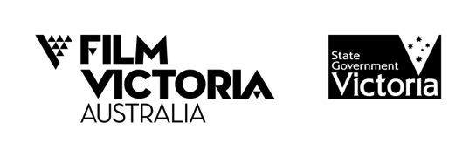

CO-FINANCED BY AND PRODUCED WITH THE ASSISTANCE OF

SCREEN QUEENSLAND



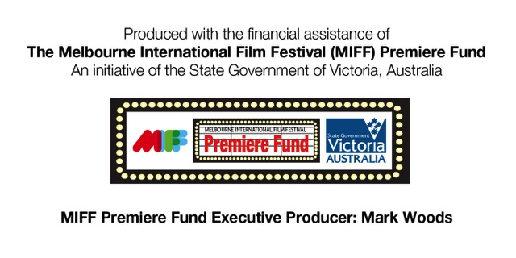



© WildBear Entertainment Pty Ltd, Screen Queensland Pty Ltd, FilmFest

Limited trading as Melbourne International Film Festival 2015